Supplementary Material

Weekday-to-weekend sleep duration patterns among young adults and outcomes related to health and academic performance

Authors

Cecilie L. Vestergaard^{1,2*}, Melanie R. Simpson^{3,4}, Børge Sivertsen^{1,5,6}, Håvard Kallestad^{1,2}, Knut Langsrud², Jan Scott^{1,7}, Øystein Vedaa^{6,8}

Affiliations

¹Department of Mental Health, Norwegian University of Science and Technology, Trondheim, Norway.
²Clinic of Mental Health Care, St. Olavs University Hospital, Østmarka, Trondheim, Norway.
³Department of Public Health and Nursing, Norwegian University of Science and Technology, Trondheim, Norway.
⁴Clinical Research Unit Central Norway, St. Olavs Hospital, Trondheim, Norway.
⁵Department of Research & Innovation, Helse-Fonna HF, Haugesund, Norway.
⁶Department of Health Promotion, Norwegian Institute of Public Health, Bergen, Norway.
⁷University of Newcastle, Newcastle, United Kingdom.
⁸Department of Psychosocial Science, University of Bergen, Norway
*Corresponding author: Cecilie L. Vestergaard. Email: cecilie.l.vestergaard@ntnu.no Address: AFFU, St. Olavs hospital, PO Box 3250 Torgarden, NO-7006 Trondheim, Norway

Figure S1: Weekday-to-weekend sleep duration patterns
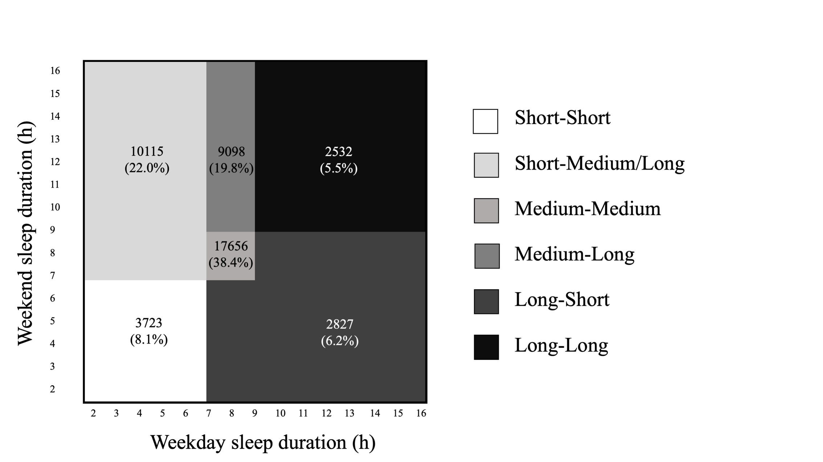
Distribution of weekday-to-weekend sleep duration patterns. Short sleep duration =<7 hours. Medium sleep duration = 7 to 9 hours. Long sleep= >9 hours. the figure is inspired by the visual presentation by Åkerstedt et al. 2019.
Table S1: Results from logistic regression analysis exploring 3 models with values representing odds ratio (OR). Medium-Medium sleep duration pattern (OR =1) is the reference category in all analyses.

 | N having the outcome tested within subgroup  (%) |  | Model 1 (unadjusted) |  |  | Model 2 (partly adjusted) ᵃ |  |  |  |  | Model 3 (fully adjusted) ᵇ
 | N having the outcome tested within subgroup  (%) |  | OR | 95% CI |  | OR | 95% CI |  |  |  | OR | 95% CI
Overweight or obesity (BMI). 1750 missing values
Reference group:
Medium-Medium sleepers
Short-Short | 5098 (29.9) |  | 1.51 | 1.40 to 1.63 |  | 1.25 |  | 1.15 to 1.35 |  |  | 1.23 | 1.13 to 1.33
Short-Medium/Long | 1391 (39.1) |  | 1.35 | 1.28 to 1.43 |  | 1.28 |  | 1.21 to 1.35 |  |  | 1.24 | 1.17 to 1.31
Long-Short | 3561 (36.7) |  | 1.25 | 1.15 to 1.37 |  | 1.19 |  | 1.09 to 1.30 |  |  | 1.17 | 1.07 to 1.28
Medium-Long | 942 (34.6) |  | 1.03 | 0.98 to 1.09 |  | 1.09 |  | 1.03 to 1.16 |  |  | 1.07 | 1.01 to 1.14
Long-Long | 2666 (30.5) |  | 1.07 | 0.98 to 1.18 |  | 1.11 |  | 1.01 to 1.22 |  |  | 1.08 | 0.98 to 1.19
Psychological distress (HSCL-25). 43 missing values
Reference group:
Medium-Medium sleepers
Short-Short | 3854 (21.8) |  | 3.41 | 3.16 to 3.68 |  | 3.06 |  | 2.82 to 3.33 |  |  | 3.04 | 2.80 to 3.30
Short-Medium/Long | 1806 (48.6) |  | 2.11 | 1.99 to 2.23 |  | 1.83 |  | 1.73 to 1.94 |  |  | 1.76 | 1.66 to 1.87
Long-Short | 3750 (37.1) |  | 1.39 | 1.26 to 1.52 |  | 1.20 |  | 1.09 to 1.33 |  |  | 1.19 | 1.08 to 1.31
Medium-Long | 787 (27.9) |  | 1.03 | 0.96 to 1.09 |  | 0.93 |  | 0.88 to 1.00 |  |  | 0.91 | 0.85 to 0.97
Long-Long | 2023 (22.3) |  | 1.14 | 1.03 to 1.26 |  | 0.96 |  | 0.87 to 1.07 |  |  | 0.92 | 0.83 to 1.02
Dissatisfaction with life (SWLS). 1052 missing values
Reference group:
Medium-Medium sleepers
Short-Short | 9518 (55.1) |  | 2.59 | 2.40 to 2.79 |  | 2.13 |  | 1.96 to 2.30 |  |  | 2.11 | 1.95 to 2.28
Short-Medium/Long | 2725 (74.7) |  | 1.72 | 1.63 to 1.81 |  | 1.50 |  | 1.41 to 1.58 |  |  | 1.44 | 1.37 to 1.53
Long-Short | 6766 (68.4) |  | 1.31 | 1.20 to 1.43 |  | 1.120 |  | 1.02 to 1.23 |  |  | 1.11 | 1.01 to 1.21
Medium-Long | 1681 (60.6) |  | 0.97 | 0.92 to 1.03 |  | 0.98 |  | 0.92 to 1.04 |  |  | 0.96 | 0.90 to 1.02
Long-Long | 4866 (55.0) |  | 1.11 | 1.01 to 1.22 |  | 1.04 |  | 0.95 to 1.15 |  |  | 1.01 | 0.91 to 1.11
Somatic symptom burden (SSS-8). 2760 missing values.
Reference group:
Medium-Medium sleepers
Short-Short | 4013 (24.2) |  | 3.51 | 3.24 to 3.79 |  | 3.21 |  | 2.95 to 3.49 |  |  | 3.17 | 2.92 to 3.45
Short-Medium/Long | 1836 (52.7) |  | 2.27 | 2.15 to 2.40 |  | 2.05 |  | 1.93 to 2.17 |  |  | 1.96 | 1.85 to 2.08
Long-Short | 3997 (42.0) |  | 1.41 | 1.28 to 1.54 |  | 1.25 |  | 1.13 to 1.38 |  |  | 1.23 | 1.12 to 1.36
Medium-Long | 808 (31.0) |  | 1.08 | 1.01 to 1.14 |  | 0.97 |  | 0.91 to 1.04 |  |  | 0.95 | 0.89 to 1.01
Long-Long | 2188 (25.5) |  | 1.15 | 1.05 to 1.28 |  | 0.97 |  | 0.87 to 1.07 |  |  | 0.93 | 0.83 to 1.03
Failed study exam (Yes/No). 0 missing values.
Reference group:
Medium-Medium sleepers
Short-Short | 5481 (31.0) |  | 1.52 | 1.41 to 1.63 |  | 1.32 |  | 1.22 to 1.42 |  |  | 1.30 | 1.20 to 1.40
Short-Medium/Long | 1511 (40.6) |  | 1.31 | 1.24 to 1.38 |  | 1.22 |  | 1.16 to 1.29 |  |  | 1.18 | 1.11 to 1.24
Long-Short | 3745 (37.0) |  | 1.29 | 1.18 to 1.40 |  | 1.23 |  | 1.13 to 1.34 |  |  | 1.21 | 1.11 to 1.33
Medium-Long | 1045 (37.0) |  | 0.91 | 0.86 to 0.96 |  | 0.96 |  | 0.90 to 1.01 |  |  | 0.93 | 0.88 to 0.99
Long-Long | 2666 (29.3) |  | 1.19 | 1.09 to 1.30 |  | 1.24 |  | 1.13 to 1.36 |  |  | 1.20 | 1.09 to 1.31
CI, confidence interval; OR, Odds ratio
ᵃ Background variables including sex, age, relationship status, care for children, financial difficulties, use of alcohol, physical activity, work with income, study program
ᵇ In addition to background variables, the model also adjusts for circadian chronotype and working night shifts

Table S2: Results from logistic regression analysis exploring 3 models with values representing odds ratio (OR). Short-Short sleep duration pattern (OR =1) is the reference category in all analyses.

 |  |  | Model 1 (unadjusted) |  |  |  |  | Model 2 (partly adjusted) ᵃ |  |  | Model 3 (fully adjusted) ᵇ
 |  |  | OR | 95% CI |  |  |  | OR | 95% CI |  | OR | 95% CI
Overweight or obesity (BMI). 1750 missing values
Reference group: Short-Short sleepers
Medium-Medium |  |  | 0.66 | 0.61 to 0.71 |  |  |  | 0.80 | 0.74 to 0.87 |  | 0.81 | 0.75 to 0.88
Short-Medium/Long |  |  | 0.90 | 0.83 to 0.97 |  |  |  | 1.02 | 0.94 to 1.11 |  | 1.01 | 0.93 to 1.10
Long-Short |  |  | 0.83 | 0.75 to 0.92 |  |  |  | 0.95 | 0.85 to 1.06 |  | 0.95 | 0.86 to 1.07
Medium-Long |  |  | 0.68 | 0.63 to 0.74 |  |  |  | 0.88 | 0.80 to 0.96 |  | 0.87 | 0.80 to 0.95
Long-Long |  |  | 0.71 | 0.63 to 0.79 |  |  |  | 0.89 | 0.79 to 1.00 |  | 0.88 | 0.78 to 0.99
Psychological distress (HSCL-25). 43 missing values
Reference group: Short-Short sleepers
Medium-Medium |  |  | 0.29 | 0.27 to 0.32 |  |  |  | 0.33 | 0.30 to 0.35 |  | 0.33 | 0.30 to 0.36
Short-Medium/Long |  |  | 0.62 | 0.57 to 0.67 |  |  |  | 0.60 | 0.55 to 0.65 |  | 0.58 | 0.53 to 0.63
Long-Short |  |  | 0.41 | 0.36 to 45 |  |  |  | 0.39 | 0.35 to 0.44 |  | 0.39 | 0.35 to 0.44
Medium-Long |  |  | 0.30 | 0.28 to 0.33 |  |  |  | 0.30 | 0.28 to 0.33 |  | 0.30 | 0.27 to 0.33
Long-Long |  |  | 0.33 | 0.30 to 0.37 |  |  |  | 0.31 | 0.28 to 0.35 |  | 0.30 | 0.27 to 0.34
Dissatisfaction with life (SWLS). 1052 missing values
Reference group: Short-Short sleepers
Medium-Medium |  |  | 0.39 | 0.36 to 0.42 |  |  |  | 0.47 | 0.43 to 0.51 |  | 0.47 | 0.44 to 0.51
Short-Medium/Long |  |  | 0.66 | 0.61 to 0.72 |  |  |  | 0.70 | 0.65 to 0.76 |  | 0.68 | 0.63 to 0.74
Long-Short |  |  | 0.50 | 0.45 to 0.56 |  |  |  | 0.53 | 0.47 to 0.59 |  | 0.53 | 0.47 to 0.59
Medium-Long |  |  | 0.37 | 0.35 to 0.41 |  |  |  | 0.46 | 0.42 to 0.50 |  | 0.45 | 0.42 to 0.50
Long-Long |  |  | 0.43 | 0.38 to 0.48 |  |  |  | 0.49 | 0.44 to 0.55 |  | 0.48 | 0.42 to 0.54
Somatic symptom burden (SSS-8). 2760 missing values.
Reference group: Short-Short sleepers
Medium-Medium |  |  | 0.28 | 0.25 to 0.31 |  |  |  | 0.31 | 0.29 to 0.34 |  | 0.31 | 0.29 to 0.34
Short-Medium/Long |  |  | 0.65 | 0.60 to 0.70 |  |  |  | 0.64 | 0.59 to 0.70 |  | 0.62 | 0.57 to 0.67
Long-Short |  |  | 0.40 | 0.36 to 0.45 |  |  |  | 0.39 | 0.35 to 0.44 |  | 0.39 | 0.35 to 0.44
Medium-Long |  |  | 0.31 | 0.28 to 0.33 |  |  |  | 0.30 | 0.28 to 0.33 |  | 0.30 | 0.27 to 0.33
Long-Long |  |  | 0.33 | 0.29 to 0.37 |  |  |  | 0.30 | 0.27 to 0.34 |  | 0.29 | 0.26 to 0.33
Failed study exam (Yes/No). 0 missing values.
Reference group: Short-Short sleepers
Medium-Medium |  |  | 0.66 | 0.61 to 0.71 |  |  |  | 0.76 | 0.70 to 0.82 |  | 0.77 | 0.71 to 0.83
Short-Medium/Long |  |  | 0.86 | 0.80 to 0.93 |  |  |  | 0.93 | 0.85 to 1.01 |  | 0.91 | 0.83 to 0.98
Long-Short |  |  | 0.85 | 0.76 to 0.94 |  |  |  | 0.93 | 0.84 to 1.04 |  | 0.94 | 0.84 to 1.04
Medium-Long |  |  | 0.60 | 0.55 to 0.65 |  |  |  | 0.73 | 0.67 to 0.79 |  | 0.72 | 0.66 to 0.78
Long-Long |  |  | 0.79 | 0.71 to 0.88 |  |  |  | 0.94 | 0.84 to 1.05 |  | 0.92 | 0.83 to 1.03
CI, confidence interval; OR, Odds ratio
ᵃ Background variables including sex, age, relationship status, care for children, financial difficulties, use of alcohol, physical activity, work with income, study program
ᵇ In addition to background variables, the model also adjusts for chronotype preference and working night shifts

