Supplementary material
Supplementary Figure 1. Known-groups validity – Radar plots showing mean MEQ dimension scores by a) 6-month PDC, b) 12-month PDC, c) clinician rating of adherence and d) disease severity according to RAPID-3 scores.
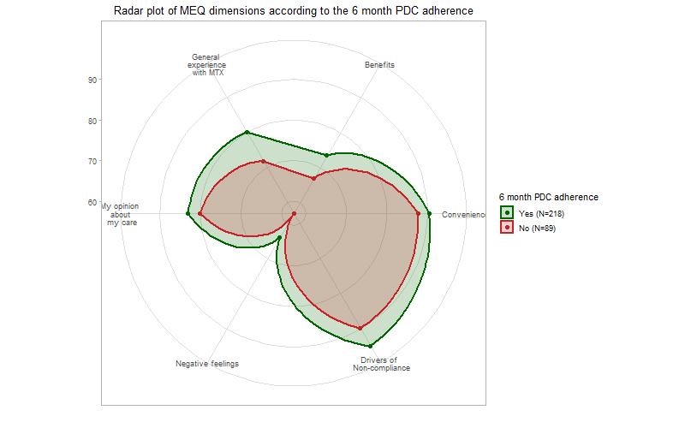
a)
b)
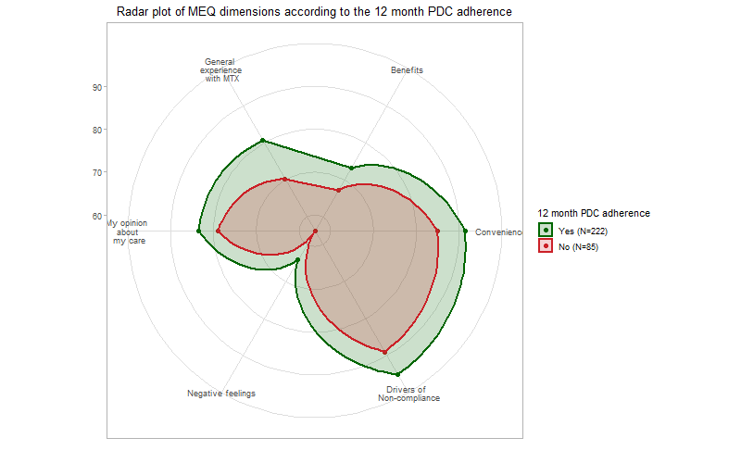
c)
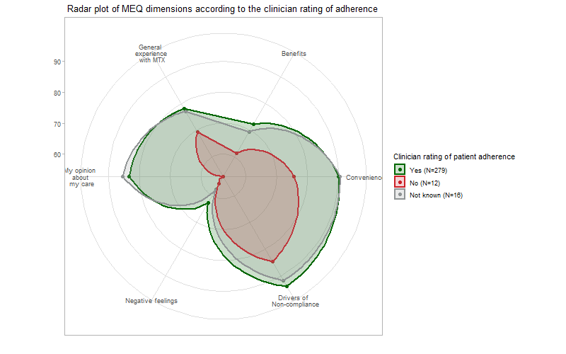
d)
