Additional File 1: Item characteristic curves

Physical function
Are you able to do chores such as vacuuming, housework, or light gardening?

Are you able to go up and down stairs normal pace?
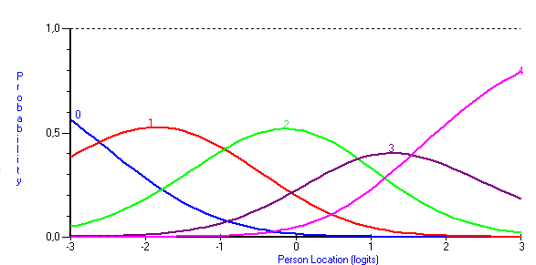

Are you able to go for a walk of at least 15 minutes?

Are you able to run errands and shop?

Anxiety
I felt fearful

I found it hard to focus on anything other than my anxiety

My worries overwhelmed me

I felt uneasy

Depression
I felt worthless

I felt helpless

I felt depressed

I felt hopeless

Fatigue
I felt fatigued

I have trouble starting things because I am tired

How run-down did you feel on average

How fatigued were you on average

Sleep disturbance
My sleep quality was…

My sleep was refreshing

I had a problem with my sleep

I had difficulty falling asleep

Ability to participate in social roles and activities
I have trouble doing all of my regular leisure activities and exercise

I have trouble doing all of my family activities that I want to do

I have trouble doing all of my usual work (including working at home)

I have trouble doing all of the activities with friends that I want to do

Pain interference
How much did pain interfere with your day to day activities

How much did pain interfere with work around the home

How much did pain interfere with your ability to participate in social activities

How much did pain interfere with your household chores

