Supplementary Table 1. Change from baseline to Month 3 in WPAI domain scores
WPAI domain |  | All patients | Patients with EM | Patients with CM
WPAI absenteeism | N | 315 | 188 | 127
 | Mean (SD) | -2.83 (16.69) | -3.59 (17.97) | -1.73 (14.64)
 | Missing, n (%) | 26 (8.25) | 17 (9.04) | 9 (7.09)
 | Ceiling, n (%) | 0 (0) | 0 (0) | 0 (0)
WPAI presenteeism | N | 315 | 188 | 127
 | Mean (SD) | -8.27 (28.64) | -10.83 (30.27) | -4.52 (25.73)
 | Missing, n (%) | 31 (9.84) | 19 (10.11) | 12 (9.45)
 | Ceiling, n (%) | 1 (0.32) | − | 1 (0.79)
WPAI overall work productivity loss | N | 315 | 188 | 127
 | Mean (SD) | -9.14 (30.97) | -11.88 (33.66) | -5.16 (26.21)
 | Missing, n (%) | 26 (8.25) | 17 (9.04) | 9 (7.09)
 | Ceiling, n (%) | 1 (0.32) | − | 1 (0.79)
WPAI non-work-related activity impairment | N | 463 | 270 | 193
 | Mean (SD) | -13.33 (29.70) | -16.17 (30.42) | -9.29 (28.23)
 | Missing, n (%) | 19 (4.10) | 9 (3.33) | 10 (5.18)
 | Ceiling, n (%) | 1 (0.22) | − | 1 (0.52)
WPAI scores are presented as % unit. “-” indicates missing data. Abbreviations: CM, chronic migraine; EM, episodic migraine; N, number of patients; n, number of patients in a subgroup, SD, standard deviation; WPAI, Work Productivity and Activity Impairment questionnaire.

Supplementary Table 2. Change in WPAI domain scores from baseline to Month 3 for responders and non-responders (EM)
 |  |  | LSM change in WPAI scores from baseline |  | LS mean change difference in WPAI scores between non-responder and responder
WPAI domain | Variables | Responder/  non-responder | LSM change (SE) | Within group  P-value | LS mean change  difference (SE) | P-value
WPAI presenteeism | MSQ-RFP domain | Non-responder | -3.057 (2.044) | 0.1366 | − | −
 |  | Responder | -26.099 (2.871) | <0.0001 | 23.042 (3.536) | 0.0000
 | MSQ-RFR domain | Non-responder | -4.438 (2.096) | 0.0357 | − | −
 |  | Responder | -24.075 (3.023) | <0.0001 | 19.637 (3.686) | 0.0000
 | Monthly migraine headache days by 50% | Non-responder | -5.495 (2.044) | 0.0079 | − | −
 |  | Responder | -24.672 (3.293) | <0.0001 | 19.177 (3.876) | 0.0000
WPAI overall work productivity loss | MSQ-RFP domain | Non-responder | -3.570 (2.225) | 0.1105 | − | −
 |  | Responder | -28.077 (3.114) | <0.0001 | 24.507 (3.842) | 0.0000
 | MSQ-RFR Domain | Non-responder | -4.882 (2.269) | 0.0329 | − | −
 |  | Responder | −26.256 (3.259) | <0.0001 | 21.374 (3.982) | 0.0000
 | Monthly migraine headache days by 50% | Non-responder | -6.596 (2.242) | 0.0037 | − | −
 |  | Responder | -25.427 (3.588) | <0.0001 | 18.831 (4.231) | 0.0000
WPAI non-work-related activity impairment | MSQ-RFP Domain | Non-responder | -10.359 (1.926) | <0.0001 | − | −
 |  | Responder | -26.320 (2.549) | <0.0001 | 15.962 (3.202) | 0.0000
 | MSQ-RFR Domain | Non-responder | -9.823 (1.843) | <0.0001 | − | −
 |  | Responder | -28.859 (2.607) | <0.0001 | 19.036 (3.192) | 0.0000
 | Monthly migraine headache days by 50% | Non-responder | -10.578 (1.837) | <0.0001 | − | −
 |  | Responder | -28.372 (2.715) | <0.0001 | 17.794 (3.279) | 0.0000
WPAI scores are presented as % unit.
ANCOVA models were utilized to examine differences in the change in WPAI presenteeism, overall productivity loss and non-work-related activity impairment from Baseline to Month 3 among patients in all anchor-based responder groups. The change in WPAI presenteeism, overall productivity loss, and non-work-related activity impairment were used as the dependent variable, while the responder group variable was used as the independent variable. Baseline WPAI presenteeism, overall productivity loss, and non-work-related activity impairment were adjusted for in the respective models. This was done by using SAS PROC MIXED.
Abbreviations: ANCOVA, analysis of covariance; EM, episodic migraine; LSM, least square mean; MSQ, Migraine-Specific Quality of Life questionnaire; RFP, Role Function-Preventive; RFR, Role Function-Restrictive; SE, standard error; WPAI, Work Productivity and Activity Impairment questionnaire.

Supplementary Table 3. Change in WPAI domain scores from baseline to Month 3 for responders and non-responders (CM)
 |  |  | LS mean change in WPAI scores from baseline |  |  | LS mean change difference in WPAI scores between non-responder and responder
WPAI domain | Variables | Responder/  non-responder | LSM change (SE) | Within group  P-value | LSM change  difference (SE) |  | P-value
WPAI presenteeism | MSQ-RFP domain | Non-responder | 0.594 (2.378) | 0.8032 | − |  | −
WPAI presenteeism |  | Responder | -19.016 (4.002) | <0.0001 | 19.610 (4.656) |  | 0.0001
 | MSQ-RFR domain | Non-responder | 0.949 (2.227) | 0.6709 | − |  | −
 |  | Responder | -24.216 (4.226) | <0.0001 | 25.164 (4.778) |  | 0.0000
 | Monthly migraine headache days by 50% | Non-responder | 1.302 (2.161) | 0.5480 | − |  | −
 |  | Responder | -26.605 (4.211) | <0.0001 | 27.908 (4.735) |  | 0.0000
WPAI overall work productivity loss | MSQ-RFP domain | Non-responder | -0.493 (2.471) | 0.8422 | − |  | −
WPAI overall work productivity loss |  | Responder | -18.245 (4.140) | <0.0001 | 17.752 (4.822) |  | 0.0004
WPAI overall work productivity loss | MSQ-RFR domain | Non-responder | 0.092 (2.318) | 0.9683 | − |  | −
WPAI overall work productivity loss |  | Responder | -23.730 (4.361) | <0.0001 | 23.822 (4.940) |  | 0.0000
 | Monthly migraine headache days by 50% | Non-responder | 0.943 (2.241) | 0.6747 | − |  | −
 |  | Responder | -26.739 (4.230) | <0.0001 | 27.682 (4.797) |  | 0.0000
WPAI non-work-related activity impairment | MSQ-RFP domain | Non-responder | -4.020 (2.092) | 0.0562 | − |  | −
WPAI non-work-related activity impairment |  | Responder | -21.240 (3.155) | <0.0001 | 17.219 (3.792) |  | 0.0000
WPAI non-work-related activity impairment | MSQ-RFR domain | Non-responder | -2.094 (1.870) | 0.2641 | − |  | −
WPAI non-work-related activity impairment |  | Responder | -29.526 (3.142) | <0.0001 | 27.432 (3.662) |  | 0.0000
WPAI non-work-related activity impairment | Monthly migraine headache days by 50% | Non-responder | -4.063 (1.941) | 0.0377 | − |  | -
WPAI non-work-related activity impairment |  | Responder | -26.307 (3.503) | <0.0001 | 22.244 (4.005) |  | 0.0000
WPAI scores are presented as % unit.
Abbreviations: ANCOVA, analysis of covariance, CM, chronic migraine, LSM, least squares mean; MSQ, Migraine-Specific Quality of Life questionnaire; PGI-S, Patient Global Impression of Severity; RFP, role function-preventive; RFR, role function-restrictive; SE, standard error; WPAI, Work Productivity and Activity Impairment questionnaire.

Supplementary Table 4. ROC analyses for change in WPAI domain scores from baseline to Month 3 (EM)
WPAI domain | Dependent variable | Cut-off point | Sensitivity | Specificity | Positive  predictive  value | Negative  predictive  value | Youden  index | Phi  coefficient
WPAI presenteeism | Monthly migraine headache days by 50% | -40.02 | 0.4255 | 0.8607 | 0.5405 | 0.7955 | 0.2862 | 0.3101
 |  | -30.01 | 0.4681 | 0.7705 | 0.4400 | 0.7899 | 0.2386 | 0.2342
 |  | -20.01 | 0.5745 | 0.6639 | 0.3971 | 0.8020 | 0.2384 | 0.2178
 | MSQ-RFP domain | -40.04 | 0.4386 | 0.8929 | 0.6757 | 0.7576 | 0.3315 | 0.3789
 |  | -30.03 | 0.5263 | 0.8214 | 0.6000 | 0.7731 | 0.3477 | 0.3602
 |  | -20.02 | 0.6316 | 0.7143 | 0.5294 | 0.7921 | 0.3459 | 0.3335
 | MSQ-RFR domain | -40.00 | 0.4000 | 0.8684 | 0.5946 | 0.7500 | 0.2684 | 0.3041
 |  | -30.00 | 0.5091 | 0.8070 | 0.5600 | 0.7731 | 0.3161 | 0.3245
 |  | -20.00 | 0.6364 | 0.7105 | 0.5147 | 0.8020 | 0.3469 | 0.3314
WPAI non-work-related activity impairment | Monthly migraine headache days by 50% | -49.97 | 0.3049 | 0.8827 | 0.5435 | 0.7349 | 0.1876 | 0.2285
WPAI non-work-related activity impairment |  | -29.98 | 0.5122 | 0.7207 | 0.4565 | 0.7633 | 0.2329 | 0.2263
WPAI non-work-related activity impairment |  | -10.00 | 0.7927 | 0.4022 | 0.3779 | 0.8090 | 0.1949 | 0.1909
WPAI non-work-related activity impairment | MSQ-RFP domain | -40.01 | 0.4105 | 0.8313 | 0.5821 | 0.7113 | 0.2419 | 0.2664
WPAI non-work-related activity impairment |  | -30.01 | 0.5053 | 0.7349 | 0.5217 | 0.7219 | 0.2402 | 0.2419
WPAI non-work-related activity impairment |  | -20.00 | 0.6526 | 0.5783 | 0.4697 | 0.7442 | 0.2309 | 0.2223
WPAI non-work-related activity impairment | MSQ-RFR domain | -49.97 | 0.3218 | 0.8966 | 0.6087 | 0.7256 | 0.2184 | 0.2702
WPAI non-work-related activity impairment |  | -39.98 | 0.4483 | 0.8391 | 0.5821 | 0.7526 | 0.2874 | 0.3101
WPAI non-work-related activity impairment |  | -29.98 | 0.5402 | 0.7414 | 0.5109 | 0.7633 | 0.2816 | 0.2779
WPAI overall work productivity loss | Monthly migraine headache days by 50% | -33.89 | 0.4583 | 0.8130 | 0.4889 | 0.7937 | 0.2713 | 0.2769
WPAI overall work productivity loss |  | -23.37 | 0.5000 | 0.7724 | 0.4615 | 0.7983 | 0.2724 | 0.2660
WPAI overall work productivity loss |  | -20.07 | 0.5208 | 0.7561 | 0.4545 | 0.8017 | 0.2769 | 0.2664
WPAI overall work productivity loss | MSQ-RFP domain | -23.44 | 0.5690 | 0.8319 | 0.6346 | 0.7899 | 0.4008 | 0.4125
WPAI overall work productivity loss |  | -22.17 | 0.5862 | 0.8230 | 0.6296 | 0.7949 | 0.4092 | 0.4168
WPAI overall work productivity loss |  | -20.13 | 0.5862 | 0.8142 | 0.6182 | 0.7931 | 0.4004 | 0.4058
WPAI overall work productivity loss | MSQ-RFR domain | -23.37 | 0.5536 | 0.8174 | 0.5962 | 0.7899 | 0.3710 | 0.3784
WPAI overall work productivity loss |  | -19.35 | 0.6429 | 0.7304 | 0.5373 | 0.8077 | 0.3733 | 0.3589
WPAI overall work productivity loss |  | -18.16 | 0.6429 | 0.7217 | 0.5294 | 0.8058 | 0.3646 | 0.3496
WPAI scores are presented as % unit.
Abbreviations: MSQ, Migraine-Specific Quality of Life questionnaire; PGI-S, Patient Global Impression of Severity; RFP, role function-preventive; RFR, role function-restrictive; ROC, receiver-operator characteristic; WPAI, Work Productivity and Activity Impairment questionnaire.

Supplementary Table 5. ROC analyses for change in WPAI domain scores from baseline to Month 3 (CM)
WPAI domain | Dependent  variable | Cut-off point | Sensitivity | Specificity | Positive  predictive  value | Negative  predictive  value | Youden  index | Phi  coefficient
WPAI presenteeism | Monthly migraine headache days by 50% | -29.99 | 0.5000 | 0.8901 | 0.5455 | 0.8710 | 0.3901 | 0.4031
 | Monthly migraine headache days by 50% | -19.99 | 0.7083 | 0.8022 | 0.4857 | 0.9125 | 0.5105 | 0.4509
 |  | -10.00 | 0.8333 | 0.6484 | 0.3846 | 0.9365 | 0.4817 | 0.3933
 | MSQ-RFP domain | -30.02 | 0.4333 | 0.8941 | 0.5909 | 0.8172 | 0.3275 | 0.3656
 |  | -20.02 | 0.6000 | 0.8000 | 0.5143 | 0.8500 | 0.4000 | 0.3817
 |  | -10.01 | 0.7000 | 0.6353 | 0.4038 | 0.8571 | 0.3353 | 0.2958
 | MSQ-RFR domain | -29.98 | 0.4400 | 0.8778 | 0.5000 | 0.8495 | 0.3178 | 0.3332
 |  | -19.99 | 0.7200 | 0.8111 | 0.5143 | 0.9125 | 0.5311 | 0.4761
 |  | -9.99 | 0.7600 | 0.6333 | 0.3654 | 0.9048 | 0.3933 | 0.3260
WPAI non-work-related activity impairment | Monthly migraine headache days by 50% | -30.02 | 0.4884 | 0.8000 | 0.4286 | 0.8358 | 0.2884 | 0.2761
WPAI non-work-related activity impairment |  | -20.01 | 0.6744 | 0.7214 | 0.4265 | 0.8783 | 0.3958 | 0.3473
WPAI non-work-related activity impairment |  | -10.01 | 0.8140 | 0.5786 | 0.3723 | 0.9101 | 0.3925 | 0.3330
 | MSQ-RFP domain | -30.01 | 0.4643 | 0.8189 | 0.5306 | 0.7761 | 0.2832 | 0.2947
 |  | -20.00 | 0.6071 | 0.7323 | 0.5000 | 0.8087 | 0.3394 | 0.3237
 |  | -10.00 | 0.7500 | 0.5906 | 0.4468 | 0.8427 | 0.3406 | 0.3140
 | MSQ-RFR domain | -30.01 | 0.6042 | 0.8519 | 0.5918 | 0.8582 | 0.4560 | 0.4530
 |  | -20.01 | 0.7500 | 0.7630 | 0.5294 | 0.8957 | 0.5130 | 0.4669
 |  | -10.00 | 0.8542 | 0.6074 | 0.4362 | 0.9213 | 0.4616 | 0.4062
WPAI overall work productivity loss | Monthly migraine headache days by 50% | -19.79 | 0.7308 | 0.8370 | 0.5588 | 0.9167 | 0.5677 | 0.5196
 |  | -19.14 | 0.7308 | 0.8261 | 0.5429 | 0.9157 | 0.5569 | 0.5053
 |  | -18.57 | 0.7308 | 0.8152 | 0.5278 | 0.9146 | 0.5460 | 0.4915
 | MSQ-RFP domain | -23.97 | 0.5161 | 0.8966 | 0.6400 | 0.8387 | 0.4127 | 0.4445
 |  | -22.97 | 0.5484 | 0.8966 | 0.6538 | 0.8478 | 0.4449 | 0.4725
 |  | -21.97 | 0.5484 | 0.8851 | 0.6296 | 0.8462 | 0.4334 | 0.4541
 | MSQ-RFR domain | -20.01 | 0.6923 | 0.8370 | 0.5455 | 0.9059 | 0.5293 | 0.4887
 |  | -19.80 | 0.6923 | 0.8261 | 0.5294 | 0.9048 | 0.5184 | 0.4744
 |  | -19.15 | 0.6923 | 0.8152 | 0.5143 | 0.9036 | 0.5075 | 0.4605
WPAI scores are presented as % unit.
Abbreviations: CM, chronic migraine; MSQ, migraine-specific quality of life questionnaire; RFP, role function-preventive; RFR, role function-restrictive; WPAI, Work Productivity and Activity Impairment questionnaire.

Supplementary Table 6. Logistic regression of improvement in anchors on change from baseline to month 3 in WPAI domain scores
Independent variable | Dependent variable | N | C-statistic | OR (95% CI) | P-value
Overall
WPAI presenteeism | MSQ-RFP domain | 284 | 0.742 | 0.964 (0.953, 0.975) | <0.0001
 | MSQ-RFR domain | 284 | 0.737 | 0.966 (0.954, 0.977) | <0.0001
 | Monthly migraine headache days by 50% | 284 | 0.729 | 0.967 (0.956, 0.978) | <0.0001
WPAI overall work productivity loss | MSQ-RFP domain | 289 | 0.738 | 0.968 (0.958, 0.978) | <.0001
 | MSQ-RFR domain | 289 | 0.740 | 0.969 (0.959, 0.979) | <0.0001
 | Monthly migraine headache days by 50% | 289 | 0.725 | 0.972 (0.962, 0.982) | <0.0001
WPAI non-work-related activity impairment | MSQ-RFP domain | 444 | 0.696 | 0.975 (0.968, 0.983) | <0.0001
 | MSQ-RFR domain | 444 | 0.732 | 0.969 (0.961, 0.978) | <0.0001
 | Monthly migraine headache days by 50% | 444 | 0.690 | 0.976 (0.968, 0.984) | <0.0001
Patients with EM
WPAI presenteeism | MSQ-RFP domain | 169 | 0.751 | 0.963 (0.950, 0.977) | <0.0001
 | MSQ-RFR domain | 169 | 0.711 | 0.971 (0.958, 0.984) | <0.0001
 | Monthly migraine headache days by 50% | 169 | 0.675 | 0.976 (0.964, 0.989) | 0.0002
WPAI overall work productivity loss | MSQ-RFP domain | 171 | 0.757 | 0.968 (0.956, 0.980) | <.0001
 | MSQ-RFR domain | 171 | 0.722 | 0.973 (0.962, 0.985) | <0.0001
 | Monthly migraine headache days by 50% | 171 | 0.665 | 0.982 (0.971, 0.993) | 0.0010
WPAI non-work-related activity impairment | MSQ-RFP domain | 261 | 0.682 | 0.977 (0.968, 0.987) | <0.0001
 | MSQ-RFR domain | 261 | 0.676 | 0.978 (0.968, 0.987) | <0.0001
 | Monthly migraine headache days by 50% | 261 | 0.654 | 0.981 (0.972, 0.990) | <0.0001
Patients with CM
WPAI presenteeism | MSQ-RFP domain | 115 | 0.715 | 0.965 (0.946, 0.985) | 0.0006
 | MSQ-RFR domain | 115 | 0.774 | 0.955 (0.933, 0.977) | <0.0001
 | Monthly migraine headache days by 50% | 115 | 0.821 | 0.942 (0.918, 0.967) | <0.0001
WPAI overall work productivity loss | MSQ-RFP domain | 118 | 0.692 | 0.970 (0.953, 0.989) | 0.0015
 | MSQ-RFR domain | 118 | 0.758 | 0.961 (0.941, 0.981) | 0.0002
 | Monthly migraine headache days by 50% | 118 | 0.827 | 0.942 (0.918, 0.966) | <0.0001
WPAI non-work-related activity impairment | MSQ-RFP domain | 183 | 0.703 | 0.972 (0.959, 0.985) | <0.0001
 | MSQ-RFR domain | 183 | 0.809 | 0.952 (0.935, 0.968) | <0.0001
 | Monthly migraine headache days by 50% | 183 | 0.735 | 0.967 (0.953, 0.982) | <0.0001
Logistic regression with selected anchor as a dependent variable and WPAI domain scores as independent variable was used to estimate the threshold value of WPAI presenteeism, overall productivity loss and non-work-related activity impairment changes from baseline to Month 3; This provided the greatest discriminative ability between the responder and non-responder groups. The Concordance (C) statistic was used to evaluate adequacy of model fitting through AUC of ROC curve analysis. The AUC varied between 0.5 (no difference by chance) and 1.0; higher values indicate a better discrimination ability for predictive model. C-values of 0.5 indicated no difference by chance, 0.7 to 0.8 showed acceptable discrimination, 0.8 to 0.9 indicated excellent discrimination, and ≥0.9 showed outstanding discrimination.
Abbreviations: AUC, area-under-curve; CI, confidence interval; CM, chronic migraine; EM, episodic migraine; MSQ, Migraine-Specific Quality of Life questionnaire; N, number of patients; OR, odds ratio; PGI-S, patient global impression of severity; RFP, Role Function-Preventive; RFR, role function-restrictive; ROC, receiver-operator characteristic; SE, standard error; WPAI, Work Productivity and Activity Impairment questionnaire.

Supplementary Figure 1. Spearman correlations of baseline WPAI domain scores with MSQ, and monthly migraine headache days
- Correlation of WPAI Scores with MSQ_RFP, MSQ_RFR, and Migraine Headache Days – All Patients

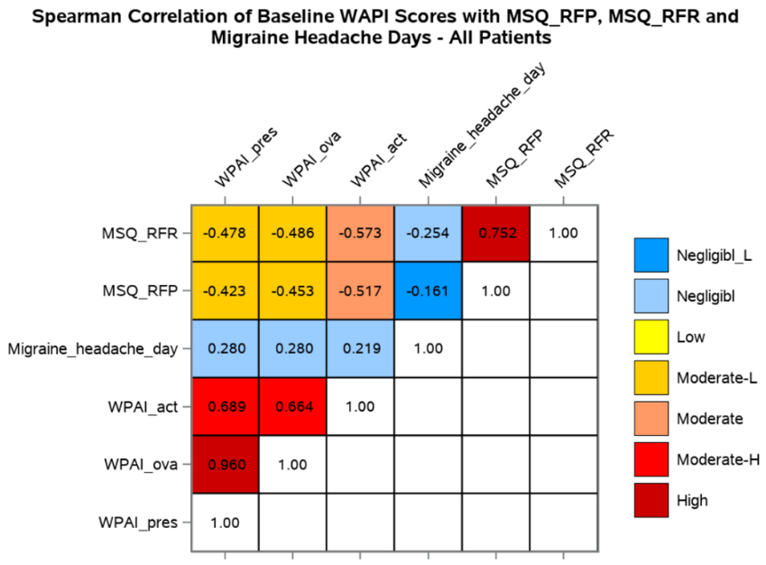

- Correlation of WPAI Scores with MSQ_RFP, MSQ_RFR, and Migraine Headache Days – EM Patients
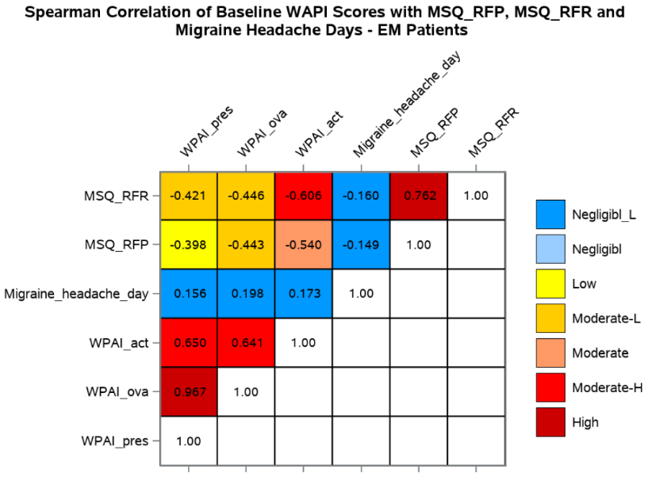

- Correlation of WPAI Scores with MSQ_RFP, MSQ_RFR, and Migraine Headache Days – All Patients

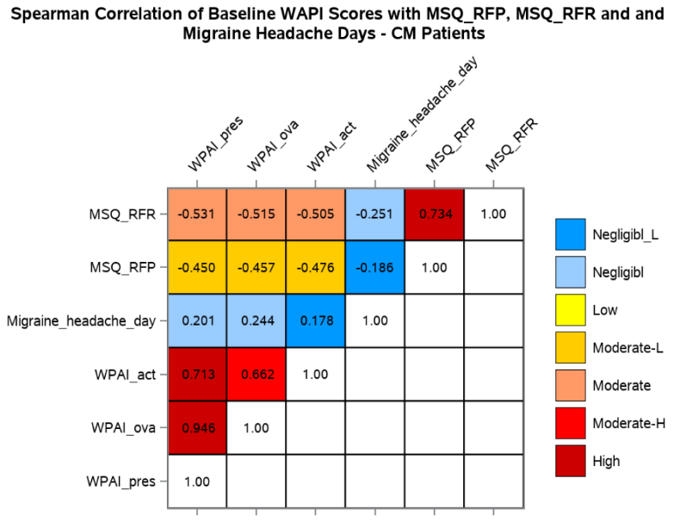

Negligible-L_: 0.0-0.2; Negligible: 0.2–0.3; Low: 0.3–0.4; Moderate-L: 0.4–0.5; Moderate: 0.5–0.6; Moderate-H: 0.6–0.7; High: 0.7–1
Abbreviations: MSQ, Migraine-Specific Quality of Life questionnaire; RFP, role function-preventive; RFR, role function-restrictive; WPAI, Work Productivity and Activity Impairment questionnaire; WPAI_act, WPAI non-work-related activity impairment; WPAI_ova, overall work productivity loss; WPAI_pres, WPAI presenteeism. Negligibl=Negligible

Supplementary Figure 2. Cumulative distribution function plots for change in WPAI from Baseline to Month 3
A. WPAI presenteeism and improvement of MSQ-RFP domain - Overall | B. WPAI presenteeism and improvement of MSQ-RFP domain - EM
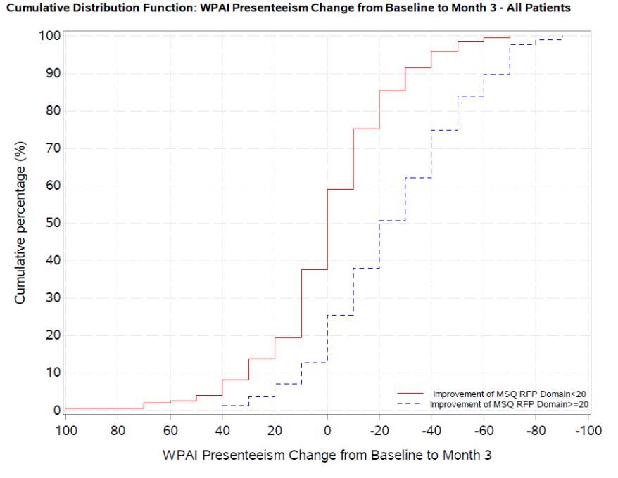 | 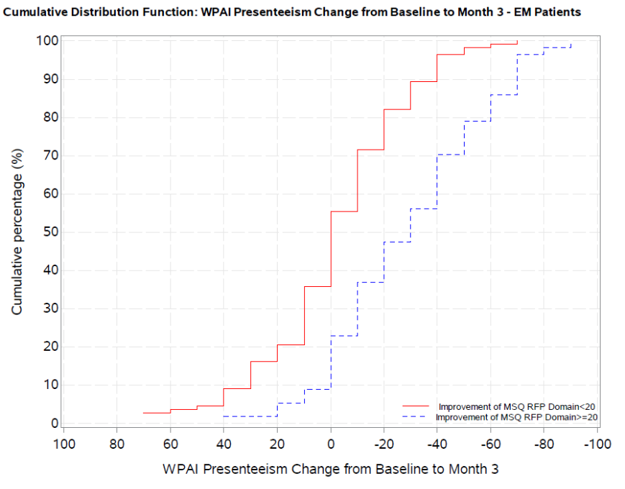

C. WPAI presenteeism and improvement of MSQ-RFP domain - CM | D. WPAI presenteeism and improvement of MSQ-RFR domain - Overall
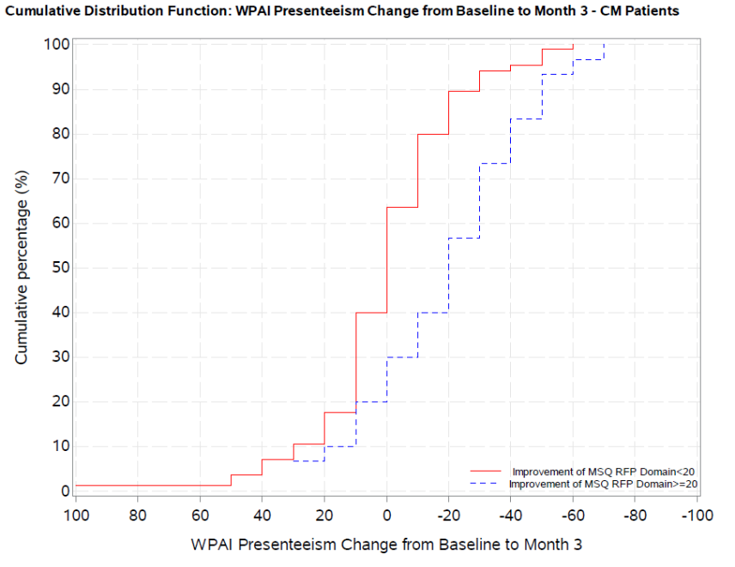 | 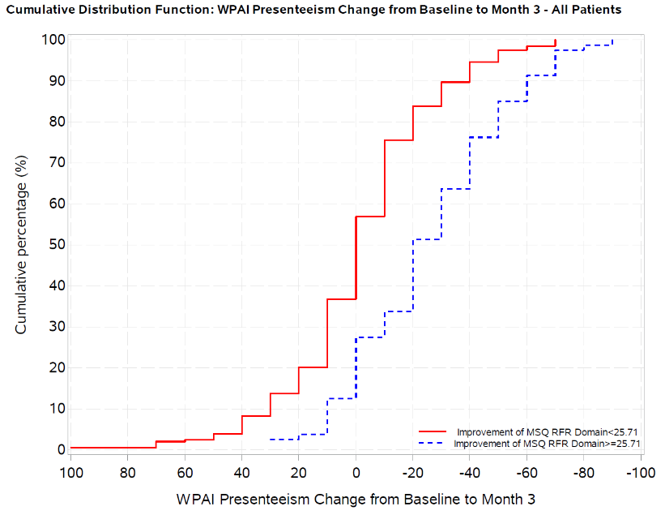

E. WPAI presenteeism and improvement of MSQ-RFR domain - EM | F. WPAI presenteeism and improvement of MSQ-RFR domain - CM
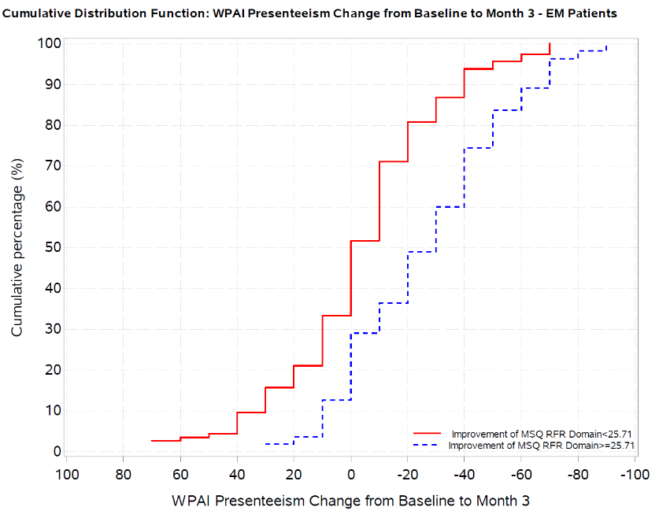 | 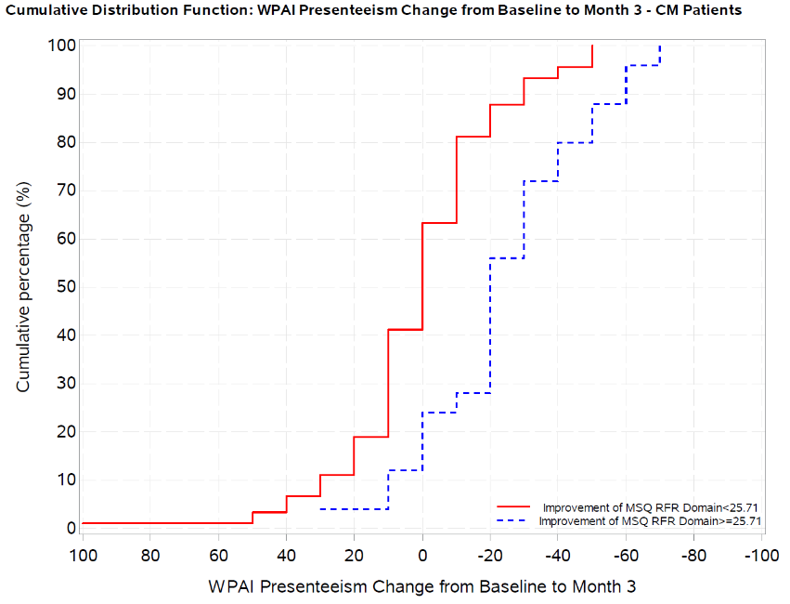

G. WPAI presenteeism and improvement of monthly headache days 50% - Overall | H. WPAI presenteeism and improvement of monthly headache days 50% - EM
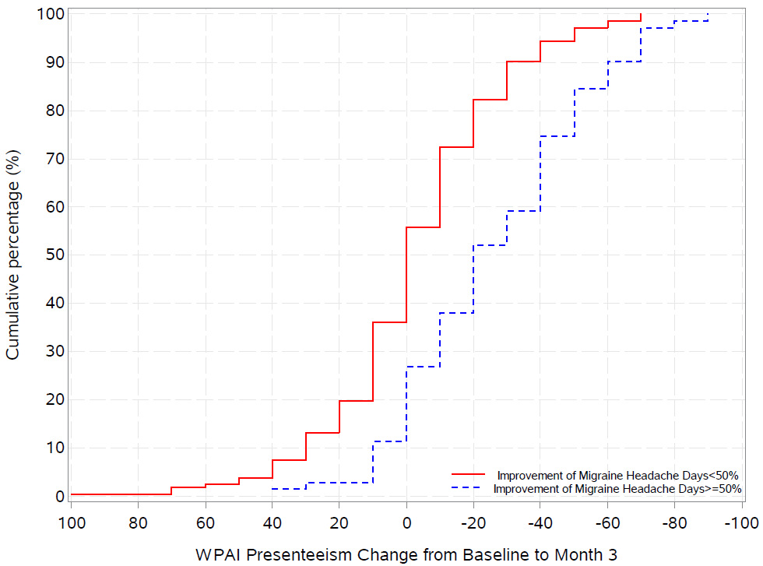 | 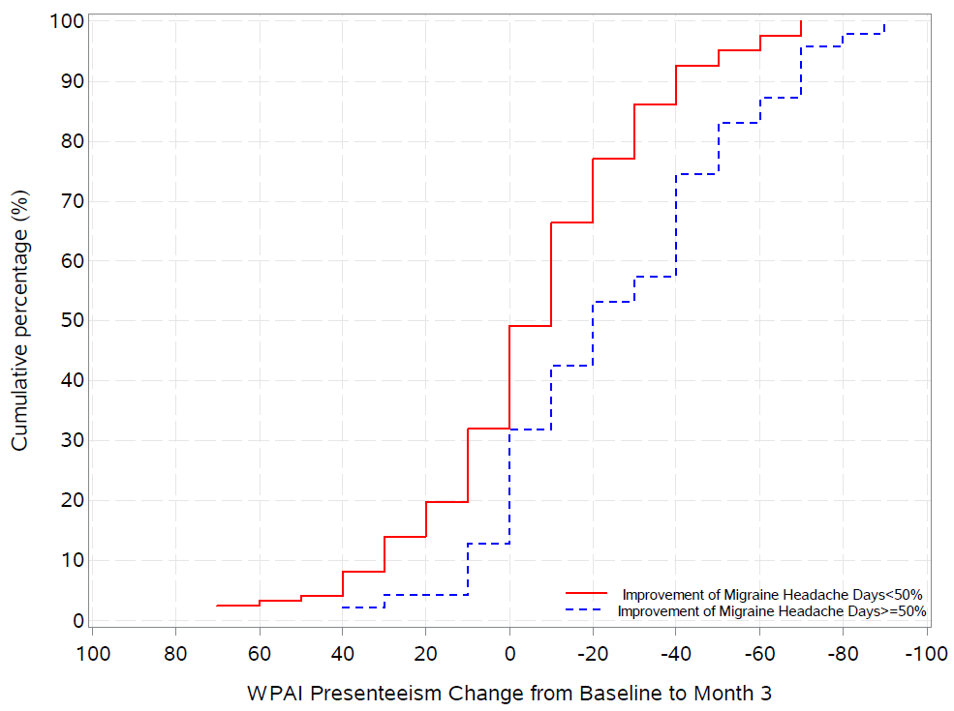

I. WPAI presenteeism and improvement of monthly headache days 50% - CM
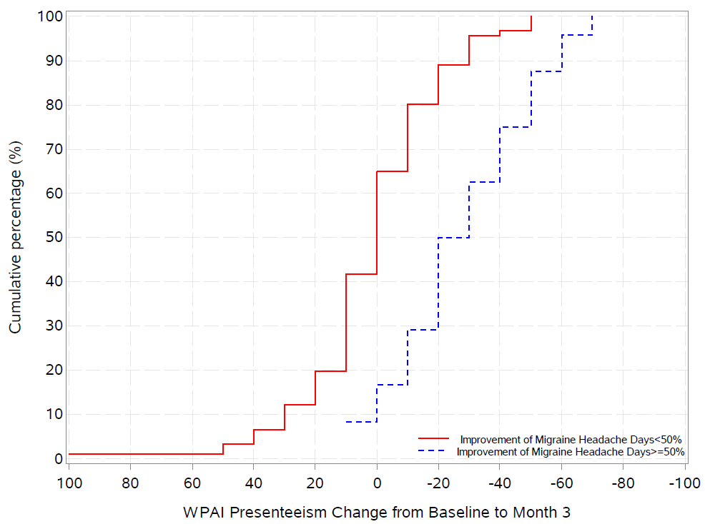

J. WPAI overall work productivity loss and improvement of migraine headache days 50% - Overall | K: WPAI overall work productivity loss and improvement of migraine headache days 50% - EM
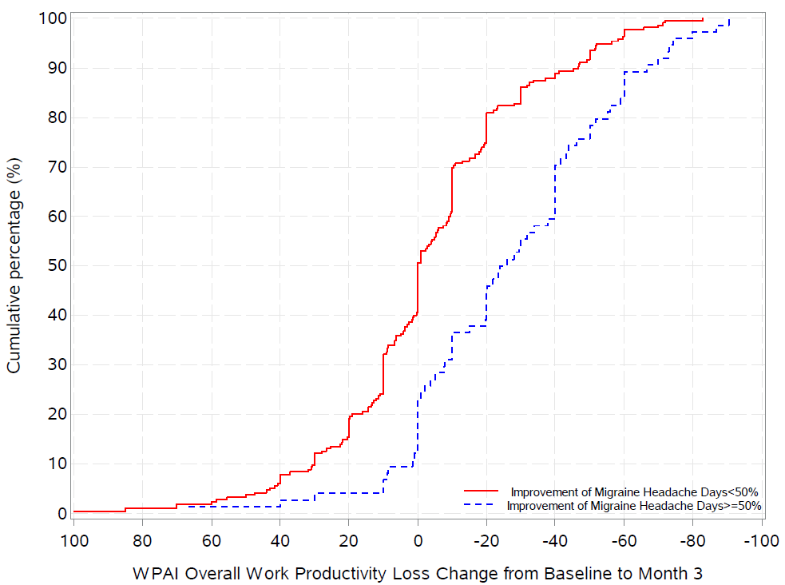 | 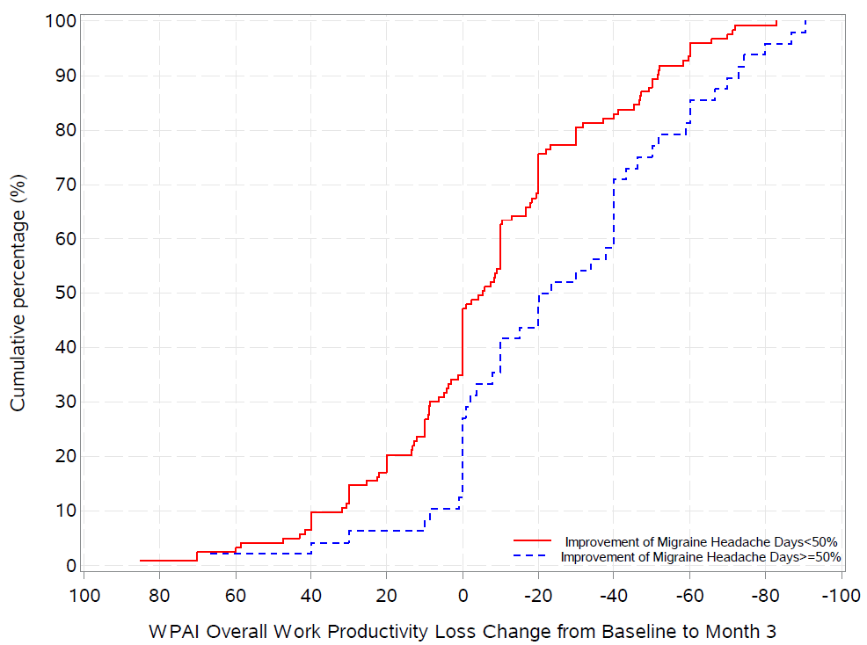

L. WPAI overall work productivity loss and improvement of migraine headache days 50% - CM | M: WPAI overall work productivity loss and improvement of MSQ-RFR - Overall
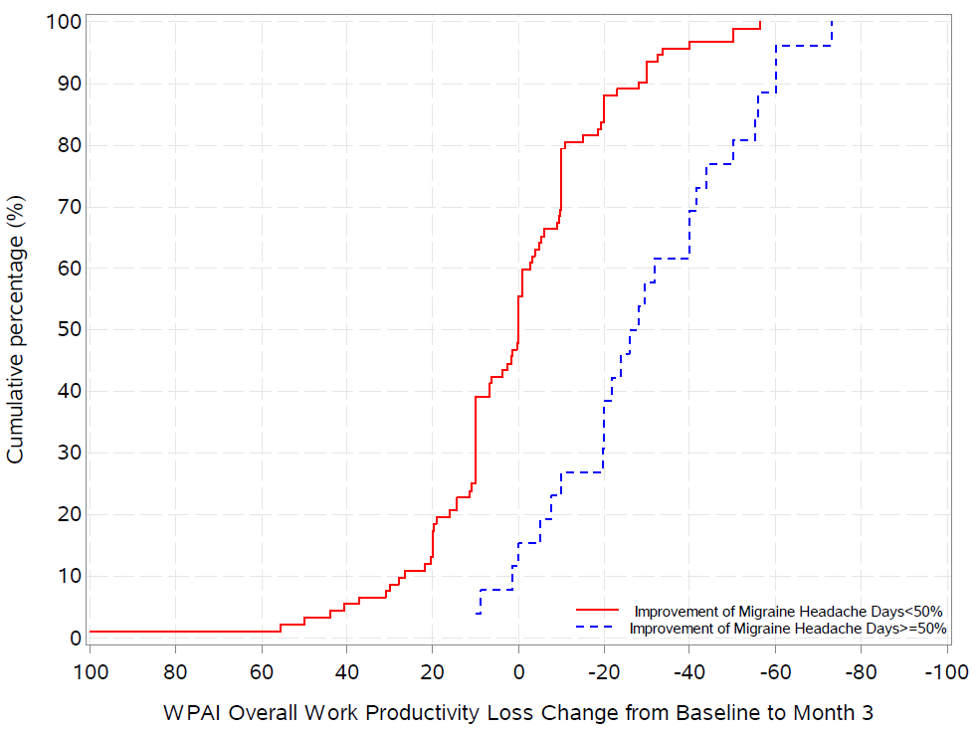 | 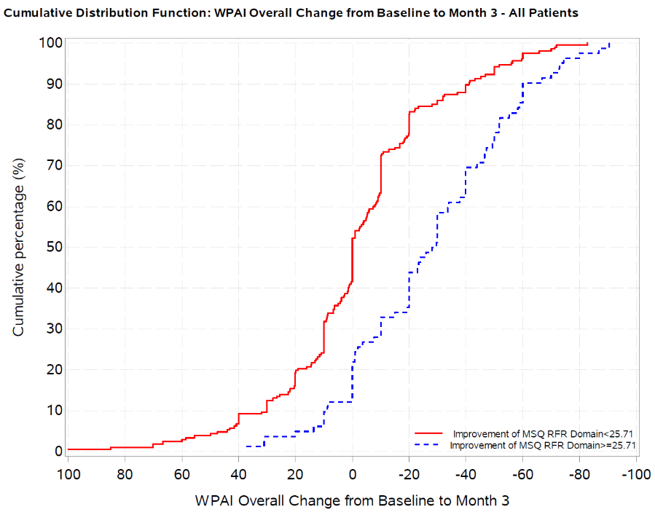

N: WPAI overall work productivity loss and improvement of MSQ-RFR - EM | O: WPAI overall work productivity loss and improvement of MSQ-RFR - CM
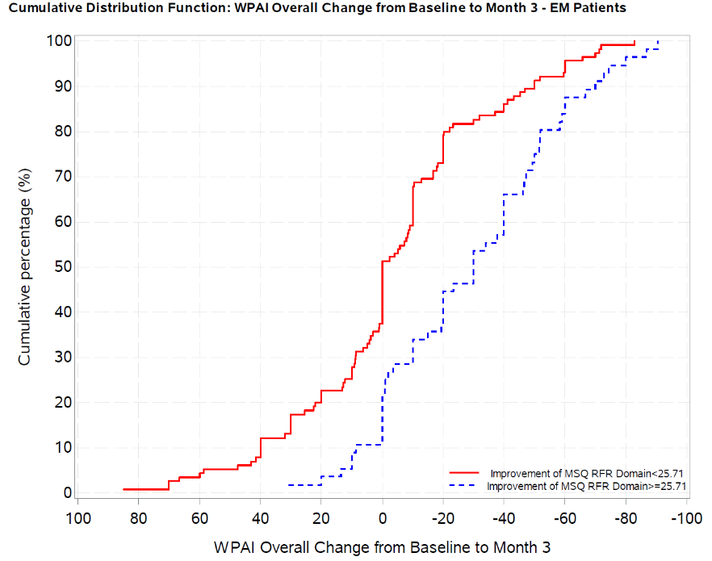 | 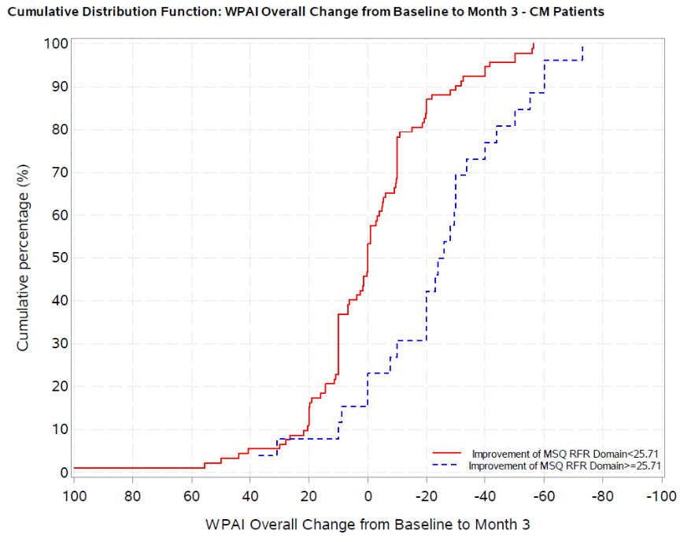

P. WPAI overall work productivity loss and improvement of MSQ-RFP - Overall | Q: WPAI overall work productivity loss and improvement of MSQ-RFP - CM
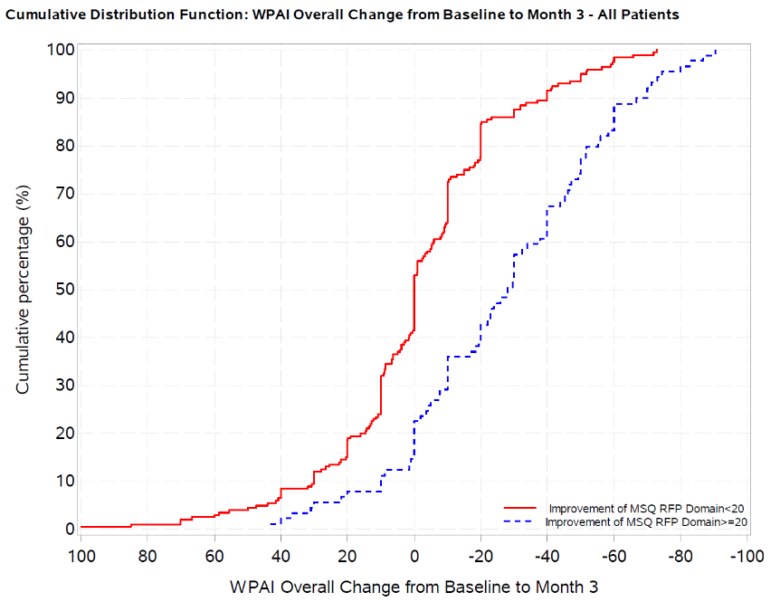 | 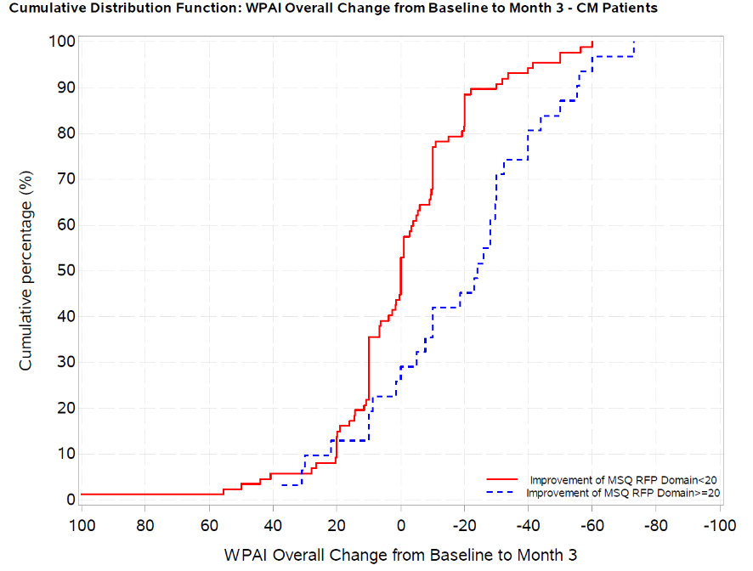

R: WPAI non-work-related activity impairment and improvement of migraine headache days-50% - Overall  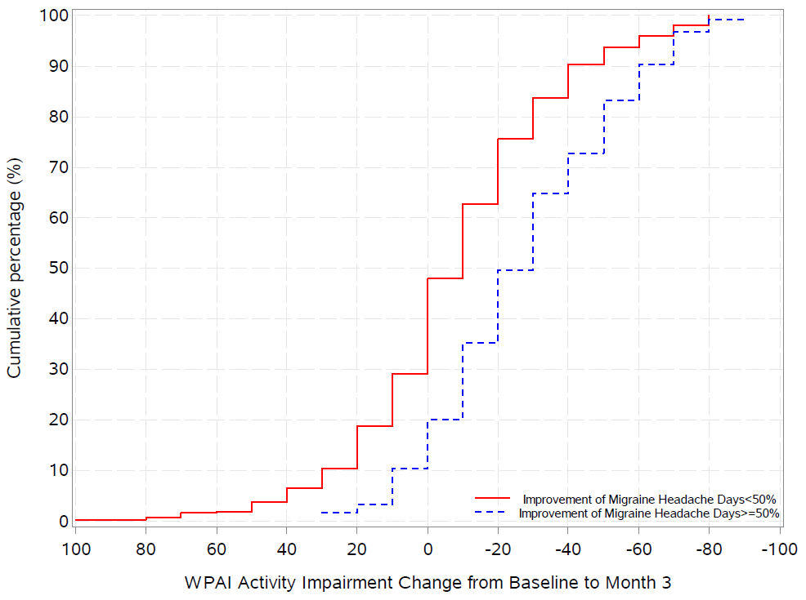 | RS: WPAI non-work-related activity impairment and improvement of migraine headache days - 50% - EM  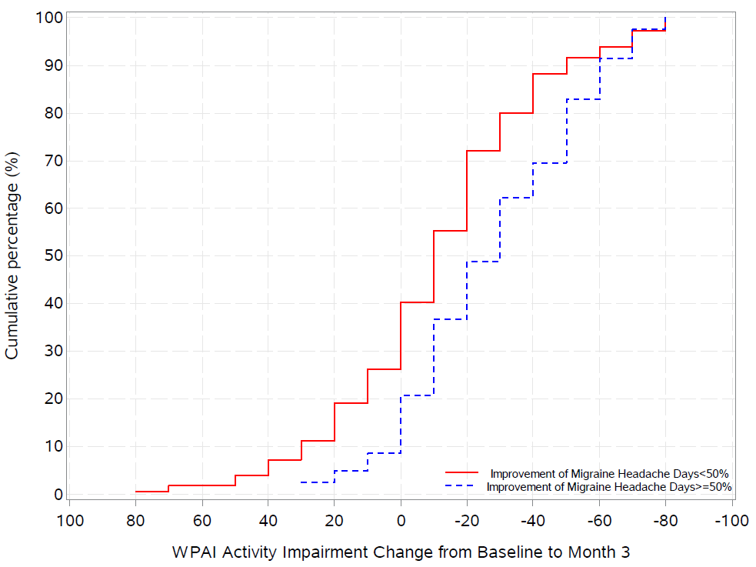
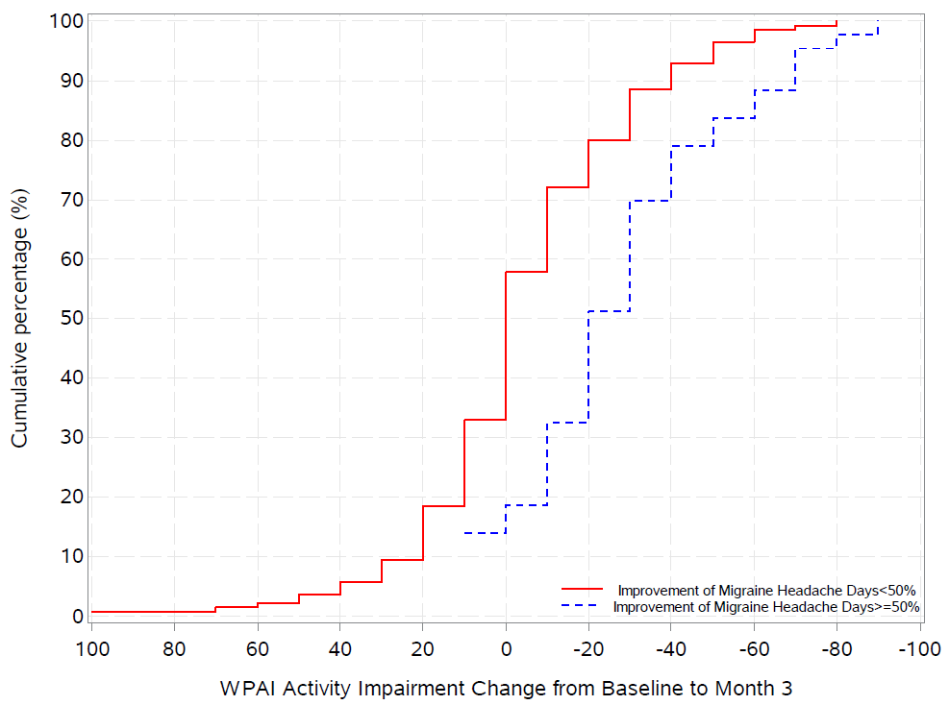
T: WPAI non-work-related activity impairment and improvement of migraine headache days-50% - CM
WPAI scores are presented as % unit.
Abbreviations: CM, chronic migraine; EM, episodic migraine; MSQ, Migraine-Specific Quality of Life questionnaire; RFP, role function-preventive; WPAI, Work Productivity and Activity Impairment questionnaire.

