Supplement
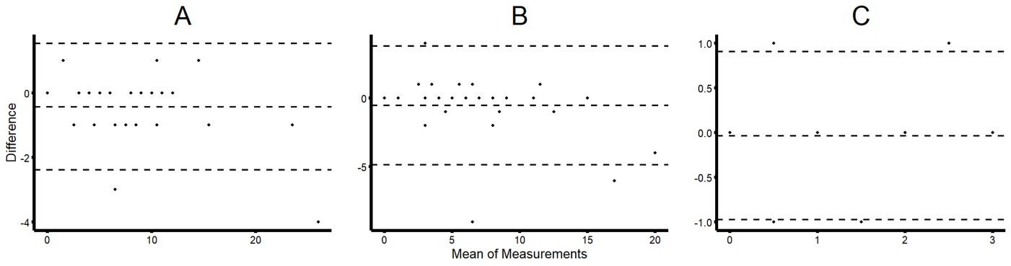Figure S1. Bland-Altman plots of the investigated scores. A) VCSS right leg, B) VCSS left leg, C) VDS
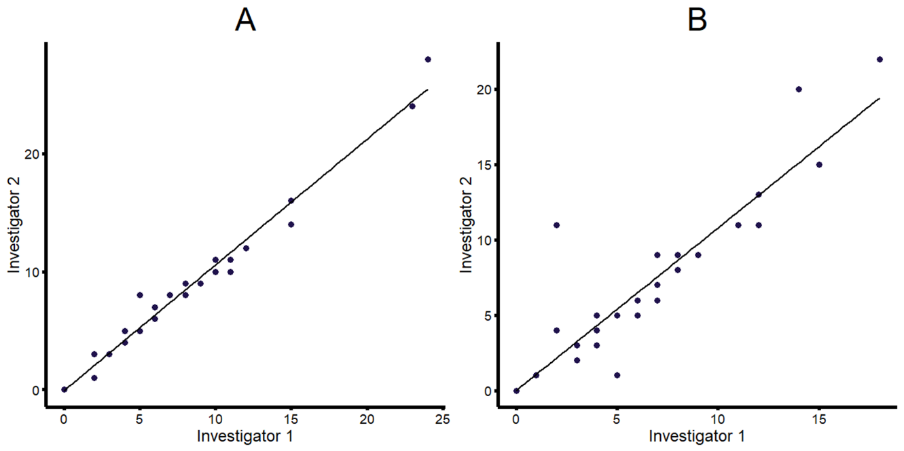Figure S2. VCSS scores of the first and second examination including linear regression trendlines. A) VCSS right leg, B) VCSS left leg.

