Supplementary Appendix

Supplementary Tables

Table S1. Signs and Symptoms Included in the SIC
Please rate the severity of each symptom you experienced (in the last 24 hours) | Ratingª
C1 Feeling generally unwell | 0-10
C2 Fatigue (tiredness) | 0-10
M1 Physical weakness | 0-10
R1 Cough | 0-10
R2 Shortness of breath (difficulty breathing) | 0-10
R3 Sore throat | 0-10
R4 Nasal congestion (stuffy nose) | 0-10
R5 Wheezing (whistling sound while breathing) | 0-10
R6 Runny nose | 0-10
R7 Sneezing | 0-10
R8 Chest congestion (mucus in chest) | 0-10
R9 Chest pain/pressure/tightness | 0-10
M2 Muscle aches/pains | 0-10
M3 Joint aches/pains | 0-10
N1 Headache | 0-10
N2 Feeling faint | 0-10
N3 Problems thinking clearly | 0-10
C3 Chills | 0-10
C4 Skin rash | 0-10
C5 Eye irritation/discharge | 0-10
G1 Diarrhea | 0-10
G2 Vomiting | 0-10
G3 Nausea | 0-10
G4 Abdominal/stomach pain | 0-10
G5 Loss of appetite | 0-10
C6 Fever, if yes, _____ degrees | Y/N
C7 Uncontrollable body shaking/shivering | Y/N
N4 Decreased sense of smell | Y/N
N5 Decreased sense of taste | Y/N
V1 Red or bruised feet or toes | Y/N
SIC, Symptoms of Infection with Coronavirus-19; C, Constitutional; M, Musculoskeletal; R, Respiratory; N, Neurologic; G, Gastrointestinal; V, Vascular.
ª0 to 10 ratings are defined as 0 (none) to 10 (worst possible). Y/N questions indicate yes or no for present or absent.

Table S2. Additional Survey Questions for Identifying Meaningful Reductions in Symptom Severity (Cross-sectional Study)
Symptom questions | - Which of the following symptoms would have to improve (become less severe) for you to return to your usual activities (your everyday activities prior to becoming sick with COVID-19)?
 | - Which of the following symptoms would need to be completely gone before you could return to your usual activities (your everyday activities prior to becoming sick with COVID-19)?
Access questions | - How easy or difficult was it for you to get your most recent test for COVID-19?
 | - Outside of your COVID-19 testing, did you seek medical care to treat your COVID-19 symptoms?
 | - How easy or difficult was it to access care for your COVID-19 symptoms?
 | - What barriers or obstacles to receiving care for your COVID-19 symptoms did you encounter?
COVID-19, coronavirus disease 2019.

Table S3. Frequently Endorsed SIC Item-level Responses (ENSEMBLE2 Phase 3 Trial; N = 130ª)
Symptom frequency,
n (%; N = 130ª)
SIC item | No | Yes
Feeling unwell | 39 (30.0) | 91 (70.0)
Cough | 42 (32.3) | 88 (67.7)
Headache | 43 (33.1) | 87 (66.9)
Fatigue | 54 (41.5) | 76 (58.5)
Sore throat | 66 (50.8) | 64 (49.2)
SIC, Symptoms of Infection with Coronavirus-19; COVID-19, coronavirus disease 2019; COVID-19, coronavirus disease 2019.
ªOf 183 participants with PCR-confirmed moderate to severe/critical COVID-19 occurring from Days 15 to 56 post–primary vaccination, 130 completed the SIC.

Table S4. Descriptive Statistics for the PGIS and PGIC
Patient Global Impression Item | n (%; N = 152) | Mean (SD)
PGIS – Overall Sample
0 (No symptoms) | 22 (14.5) | NA
1 (Mild) | 66 (43.4) | NA
2 (Moderate) | 54 (35.5) | NA
3 (Severe) | 10 (6.6) | NA
Age <65 years | 88 (57.9) | 1.24 (0.8)
Age ≥65 years | 64 (42.1) | 1.48 (0.8)
With no comorbidities | 79 (52.0) | 1.35 (0.8)
With comorbidities | 73 (48.0) | 1.33 (0.8)
PGIC – Overall Sample
0 (Much better) | 56 (36.8) | NA
1 (Moderately better) | 40 (26.3) | NA
2 (A little better) | 22 (14.5) | NA
3 (No change) | 13 (8.6) | NA
4 (A little worse) | 11 (7.2) | NA
5 (Moderately worse) | 9 (5.9) | NA
6 (Much worse) | 1 (0.7) | NA
Age <65 years | 88 (57.9) | 1.25 (1.6)
Age ≥65 years | 64 (42.1) | 1.69 (1.4)
With no comorbidities | 79 (52.0) | 1.37 (1.5)
With comorbidities | 73 (48.0) | 1.51 (1.6)
PGIS, Patient Global Impression of Severity; PGIC, Patient Global Impression of Change.

Table S5. Test-retest Reliability Among Stable Patients (ENSEMBLE2 Phase 3 Trial)
PGIS response of “no symptom” or “mild” at Day 1 and Day 2, N = 74 | ICC (95% CI)
SIC composite score
Constitutional | 0.54 (0.39-0.70)
Gastrointestinal | 0.67 (0.53-0.78)
Musculoskeletal | 0.60 (0.44-0.73)
Neurologic | 0.50 (0.34-0.66)
Respiratory | 0.73 (0.61-0.82)
Lower respiratory | 0.67 (0.54-0.78)
Upper respiratory | 0.72 (0.60-0.81)
Sensory | 0.75 (0.63-0.83)
Same PGIS response at Day 1 and Day 2, N = 80 | ICC (95% CI)
SIC composite score
Constitutional | 0.61 (0.46-0.73)
Gastrointestinal | 0.72 (0.61-0.81)
Musculoskeletal | 0.70 (0.57-0.80)
Neurologic | 0.52 (0.37-0.67)
Respiratory | 0.70 (0.58-0.80)
Lower respiratory | 0.64 (0.51-0.76)
Upper respiratory | 0.70 (0.58-0.80)
Sensory | 0.80 (0.70-0.86)
PGIS, Patient Global Impression of Severity; ICC, intraclass correlation coefficient; CI, confidence interval.
ICCs of 0.2 to 0.4 indicate fair agreement, 0.41 to 0.60 indicate moderate agreement, 0.61 to 0.80 indicate strong agreement, and 0.81 to 1.00 indicate near complete agreement.

Table S6. Mean Change in SIC Scores in Patients with PGIS Improvementª by Day (ENSEMBLE2 Trial)
SIC composite score | Day 1 to Day 2  (N = 20) | Day 1 to Day 3  (N = 23) | Day 1 to Day 5  (N = 28)
Constitutional | −1.39 | −1.53 | −1.65
Gastrointestinal | −0.36 | −0.21 | −0.64
Musculoskeletal | −1.02 | −1.77 | −2.11
Neurologic | −1.18 | −1.36 | −1.04
Respiratory | −1.09 | −0.94 | −0.98
Lower respiratory | −0.89 | −0.74 | −0.59
Upper respiratory | −1.35 | −1.20 | −1.47
Sensory | 0.00 | −0.22 | −0.36
SIC, Symptoms of Infection with Coronavirus-19; PGIS, Patient Global Impression of Severity.
ªImprovement is defined as a 1- or 2-point change in PGIS score.

Table S7. Representative Quotations From Exit Interviews
Participant no. | Comments
17 | I didn’t pass away or anything. I’m still here, so that’s good. Something like a 7. Because I did have to go to the hospital and be put on a ventilator. That’s bad. But like I said, it was nothing fatal or deathly, and I recovered just fine.
20 | I was going to say loss of smell. At first, that was the most bothersome, but then it was the headache. So, I would definitely say the headaches; that just completely immobilized me.
11 | The fever was very severe, and the shortness of breath, that was scaring the hell out of me. Because I was looking at, if I can't breathe, oh, shoot, this thing is taking me right now…
3 | [Which symptoms need to be completely gone?] I would say the headache. The stuffiness I could live with... if I was okay to go to work, but I was so stuffy, I [couldn’t] do it. It would suck [because] a mask on top of your face while you’re [stuffy]. That feels like, “Oh, my gosh. I can’t breathe.” I guess if I had to go to work, I wouldn’t want to go to work that way, and the headache just makes you not want to get up. I for sure would have wanted that gone.
18 | The difficulty breathing [needs to be gone]. Or just improved greatly. It would just be because I’m a single mom, so I do everything. So, if I’m sick, my son really can’t do much for himself like that. So, if I can’t breathe and make it to the kitchen and cook dinner, I’m really not much of a help right there, unfortunately.
17 | [Could she have answered the survey while most ill?] Yeah. If I was awake for a period of more than 2 hours, then yes…. When I woke up from every time I slept, that was kind of the worst grogginess that I had. Because it took me 30 minutes to actually wake up and kind of realize what’s going on… they would ask me when I wasn’t sleeping, obviously. But yeah, they would ask me or they’d be like, “Hold up fingers. How do you feel?”
5 | [Regarding taking the survey while ill] If he [spouse] read the questions and kind of took his time, I probably could, but the clarity would probably have been a little off or diminished, because I kind of… I call it COVID brain. I just was not thinking correctly.
COVID, coronavirus disease.

Supplementary Figure

Figure S1. SIC development schematic diagram.
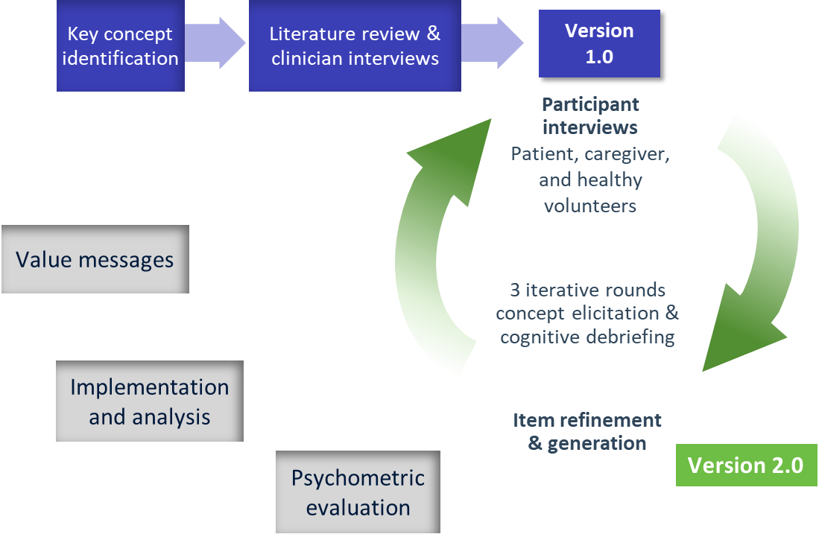

SIC, Symptoms of Infection with Coronavirus-19.

