Supplementary material
Establishing Clinically Meaningful Within-Individual Improvement Thresholds for Eight Patient-Reported Outcome Measures in People with Relapsing-Remitting Multiple Sclerosis

Figure S1: Empirical cumulative distribution functions (eCDFs) for change in PRO scores where anchor variables were available. (A) MSIS-29 v2 physical impact; (B) MSIS-29 v2 psychological impact (C) FSMC Cognitive Score; (D) FSMC Motor Score (E) FSMC Total Score; (F) MSPS Total Score (G) MSNQ
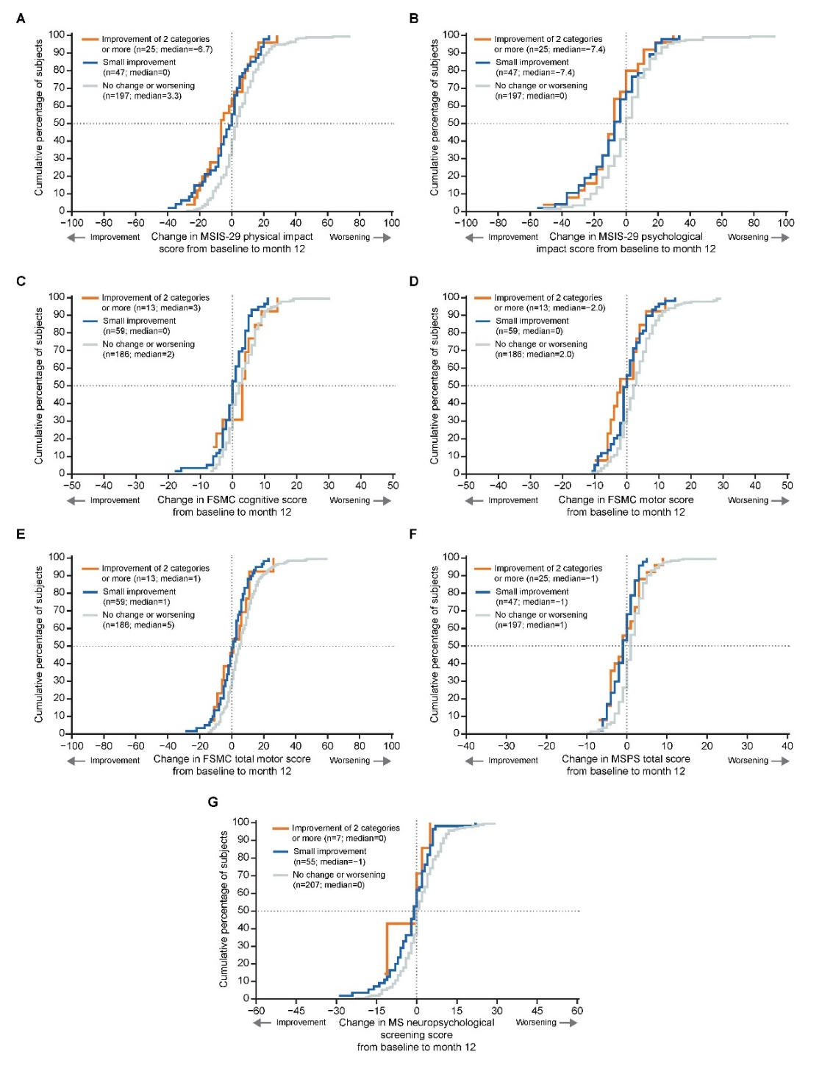
FSMC, Fatigue Scale for Motor and Cognitive Functions; MSIS-29 v2, Multiple Sclerosis Impact Scale 29 items version 2; MSNQ, Multiple Sclerosis Neuropsychological Screening Questionnaire; MSPS, Multiple Sclerosis Performance Scale; PDDS, Patient-Determined Disease Steps; PRO, patient-reported outcome

Figure S2. Responders for (A) multi-item and (B) single-item PROs using recommended meaningful within-individual improvement thresholds
The percentage of responders was calculated at Month 10 for TSQM v1.4 scores, at Month 11 for FSMC and HRPQ-MS v2 scores, and at Month 12 for all other PRO scores, for the recommended PRO responder definition. FSMC, Fatigue Scale for Motor and Cognitive functions; HADS, Hospital Anxiety and Depression Scale; HRPQ, Health-Related Productivity Questionnaire in Multiple Sclerosis version 2; LW, lost work; MSIS-29 v2, Multiple Sclerosis Impact Scale 29 items version 2; MSNQ, Multiple Sclerosis Neuropsychological Screening Questionnaire; MSPS, Multiple Sclerosis Performance Scale; PDDS, Patient-Determined Disease Steps; PRO, patient-reported outcome; TSQM v1.4, Treatment Satisfaction Questionnaire with Medication version 1.4.

Table S1. Correlation coefficients between change in anchor variables and the change in the corresponding PRO scoresª
Score | N | Anchor variables
Score | N | Change in PDDS^{b} | Change in MSPS Fatigue item^{b} | Change in MSPS Cognition item^{b}
Change in MSIS-29 v2 physical impact score | 269 | 0.27 | - | -
Change in MSIS-29 v2 psychological impact score | 269 | 0.18 | - | -
Change in MSPS Total score | 269 | 0.31 | - | -
Change in FSMC Cognitive score | 282 | - | 0.20 | -
Change in FSMC Physical score | 282 | - | 0.26 | -
Change in FSMC Total score | 282 | - | 0.25 | -
Change in MSNQ Total score | 269 | - | - | 0.25
ªFrom baseline to Month 11 for FSMC scores, to Month 12 for all other scores; ^{b}Spearman rank-order correlation coefficient. FSMC, Fatigue Scale for Motor and Cognitive functions; MSIS-29 v2, Multiple Sclerosis Impact Scale 29 items version 2; MSNQ, Multiple Sclerosis Neuropsychological Screening Questionnaire; MSPS, Multiple Sclerosis Performance Scale; PDDS, Patient-Determined Disease Steps; PRO, patient-reported outcome.

