Supplementary Material

Supplementary methods

Participant eligibility criteria
Participants were eligible for inclusion in the study if they met the following criteria:
- Willing and able to provide electronic informed consent.
- ≥18 years old.
- Experiencing known symptom(s) of long COVID that cannot be explained by an alternative diagnosis.
- Willing and able to participate in a 60-minute audio recorded one-on-one interview.
- Able to speak, read, write, and understand English.
- Has access to the internet (e.g., computer or telephone app) to complete an electronic consent form and to participate in the interview.
- Was not vaccinated at the time of COVID-19 infection or 90 days thereafter.
- The initial COVID-19 infection was at least 180 days prior.
- Must have received their final dose (including booster shots) of the COVID-19 vaccination at least 4 weeks prior to scheduling the interview.
- Must have ≥1 risk factor for severe COVID-19. Risk factors are defined as follows:
  - Age ≥50 years.
  - Obesity, defined as body mass index (BMI) ≥30 kg/m² OR
  - Cardiovascular disease, including hypertension
  - Chronic lung disease, including asthma
  - Type 1 or type 2 diabetes mellitus
  - Chronic kidney disease, including those on dialysis
  - Chronic liver disease
  - Immunosuppressed because of treatments received or pre-existing conditions (e.g., cancer treatment, bone marrow or organ transplantation, immune deficiencies, HIV (if poorly controlled or evidence of AIDS), sickle cell anemia, thalassemia, and prolonged use of immune-weakening medications).
- Participants recruited from agencies (not Regeneron Pharmaceutical, Inc. clinical trials) were required to complete a clinician-signed confirmation of diagnosis form that stated that the symptoms could not be explained by an alternative diagnosis in the clinician’s opinion.
Participants meeting the following criteria were excluded from the study:
- Concomitant illness(es) that in the recruiter or investigator’s judgment would have confounded the researchers’ understanding and description of their long COVID disease experience.

Exploratory RMT analyses
Exploratory RMT analysis was used to enable the development of an equal interval measurement scale that works the same for all patients, regardless of their ability level. Targeting within RMT was evaluated through the examination of the relative person and item threshold histograms. Person and item location histograms were plotted against the same measurement continuum on the log-odds (logit) scale. The relative distributions displaying the person and item locations informed the adequacy of the sample for evaluating the scale and the adequacy of the scale for measuring the sample. A scale with adequate targeting was expected to have an item distribution that spans the full range of person locations. A sample with adequate targeting was expected to have a distribution that closely matches the item distribution. A comparison of the person and item mean locations was also used to assess targeting. The item location mean was always set at zero logits. A person location mean proximal to the item mean indicated adequate targeting. A mistargeted scale or one with inconsistent coverage of the sample might fail to pick up changes in person locations.
For analyses of item thresholds during the evaluation of the measurement continuum, the use of response categories for each item scored with successive integer scores (e.g., 0, 1, 2, 3, 4) hypothesized a continuum of increasing impact, from less to more, in terms of the measured subdomain. This hypothesis was tested by examining the ordering of thresholds (or points of crossover between two adjacent response categories) ascertained by the exploratory RMT analysis. A threshold is the point on the measurement continuum at which the probability of responding to adjacent categories (e.g., ‘mild’ and ‘moderate’) is equal. Disordered thresholds imply scoring functions that are not working as intended. In addition, item and threshold maps may help provide a sense of symptom progression. Tests of local dependency LD were done to determine whether the response to any item directly impacted any other item in the subscale. RMT analysis determines this effect by examining the residual correlations. Item pairs with potential dependence were flagged.
The RMT scale items were expected to work well together clinically and statistically to determine whether items defined a cohesive continuum. Statistical indicators of item cohesiveness examined the goodness-of-fit of the observed rating scale data to the requirements of the RMT model. Fit residual estimates were recommended to lie between +2.5 and –2.5. Chi-square values summarized the difference between the observed mean scores for each item within groups of people (class intervals) with similar levels of the construct under measurement with the scores expected by the RMT model. Significant chi-square values indicated differences between observed scores and expected values that exceeded chance expectations.

Table S1 SE-LC19 questionnaire items

SE-LC19 questionnaire items
Fever | Ringing or buzzing in the ears | Feeling lightheaded | Rash
Cough | Sore throat | Diarrhea | Red or watery eyes
Phlegm | Altered or loss of taste | Nausea | Difficulty sleeping
Shortness of breath or difficulty breathing | Altered or loss of smell | Vomiting | Pins and needles or numbness
Chills | Loss of appetite | Dizziness | Feeling irritable
Fatigue | Confusion | Pressure or tightness in chest | Feeling depressed
Headache | Brain fog | Chest pain | Feeling anxious
Runny nose | Loss of concentration | Rapid, strong or irregular heartbeat | Hair loss
Sneezing | Memory problems | Body aches such as muscle pain or joint pain | Sweats
Earache | Inability to find the right words | Stomach ache | Hot flushes

Table S2 Overview of clinician sample characteristics

Current position(s) | Specialty/training | Number of years practicing | Number of long COVID-19 patients treated per week
Attending physician at academic medical center | Pulmonary and critical care | 30 years | 40
Solo private practice | General medicine | 20 years | 20
Attending physician in emergency department | Emergency medicine | 15 years | Missing
Registered nurse at a hospital | Registered nurse | 30 years | 10–20
Registered nurse at a hospital | Registered nurse | 26 years | Missing

Table S3 Evaluation of item fit for SE-LC19 subscales

Item | Statement | Location | Standard error | Fit residual | Chi² | Probability
Neurocognitive subscale
SE11 | Ringing or buzzing in the ears | 0.573 | 0.234 | –0.221 | 1.653 | 0.4376
SE16 | Confusion | 0.604 | 0.269 | –0.983 | 3.337 | 0.1886
SE17 | Brain fog | –0.612 | 0.286 | –1.066 | 3.381 | 0.1844
SE18 | Loss of concentration | –0.479 | 0.264 | –1.33 | 1.807 | 0.4051
SE19 | Memory problems | –0.65 | 0.263 | –0.45 | 1.197 | 0.5497
SE20 | Inability to find the right words | –0.106 | 0.255 | 1.378 | 2.213 | 0.3306
SE34 | Pins and needles or numbness | 0.348 | 0.239 | 1.908 | 3.735 | 0.1545
SE38 | Hair loss | 0.322 | 0.235 | 2.062 | 1.361 | 0.5063
Respiratory subscale
SE2 | Cough | 1.018 | 0.287 | –0.136 | 2.852 | 0.2403
SE3 | Phlegm | –2.073 | 0.238 | 0.235 | 4.076 | 0.1303
SE4 | Shortness of breath or difficulty breathing | –2.305 | 0.312 | 0.093 | 0.332 | 0.8471
SE8 | Runny nose | –0.695 | 0.315 | –0.490 | 1.930 | 0.3809
SE9 | Sneezing | 1.399 | 0.354 | –0.238 | 0.589 | 0.7450
SE12 | Sore throat | 1.595 | 0.387 | 0.214 | 1.091 | 0.5795
SE26 | Pressure or tightness in chest | 0.350 | 0.292 | –0.275 | 0.826 | 0.6617
SE27 | Chest pain | 0.711 | 0.358 | –0.589 | 0.623 | 0.7322
Impact subscale
SE33 | Difficulty sleeping | –1.525 | 0.2 | –0.267 | 0.853 | 0.6529
SE35 | Feeling irritable | 1.022 | 0.288 | 0.78 | 0.072 | 0.9645
SE36 | Feeling depressed | –0.308 | 0.258 | –0.022 | 1.643 | 0.4398
SE37 | Feeling anxious | 0.811 | 0.271 | 1.607 | 0.326 | 0.8494
Most relevant symptoms subscale
SE6 | Fatigue | –0.92 | 0.246 | 0.546 | 0.567 | 0.7533
SE7 | Headache | 0.377 | 0.236 | 0.128 | 0.509 | 0.7754
SE13 | Altered or loss of taste | 0.633 | 0.229 | –0.763 | 3.445 | 0.1787
SE14 | Altered or loss of smell | 0.509 | 0.214 | –0.355 | 0.6 | 0.7407
SE17 | Brain fog | –0.343 | 0.256 | –0.833 | 2.442 | 0.2950
SE19 | Memory problems | –0.414 | 0.238 | 0.279 | 4.527 | 0.1040
SE20 | Inability to find the right words | –0.057 | 0.237 | 0.362 | 0.598 | 0.7414
SE38 | Hair loss | 0.366 | 0.221 | 1.837 | 1.259 | 0.5328
Systemic subscale
SE1 | Fever | 0.228 | 0.263 | 1.512 | 21.455 | <0.0001
SE5 | Chills | 2.01 | 0.448 | –0.459 | 0.864 | 0.6492
SE6 | Fatigue | –1.511 | 0.24 | 0.382 | 0.804 | 0.6689
SE7 | Headache | -0.398 | 0.209 | –0.163 | 0.853 | 0.6526
SE15 | Loss of appetite | 0.344 | 0.237 | –0.616 | 0.851 | 0.6536
SE21 | Feeling lightheaded | 0.654 | 0.243 | 0.057 | 0.74 | 0.6907
SE25 | Dizziness | 0.19 | 0.243 | –1.083 | 4.683 | 0.0962
SE28 | Rapid, strong, or irregular heartbeat | 0.196 | 0.25 | –0.963 | 1.461 | 0.4816
SE29 | Body aches such as muscle pain or joint pain | –1.045 | 0.192 | 0.28 | 0.104 | 0.9493
SE34 | Pins and needles or numbness | –0.287 | 0.218 | –0.392 | 2.152 | 0.3410
SE39 | Sweats | –0.005 | 0.232 | 0.712 | 1.695 | 0.4286
SE40 | Hot flushes | –0.376 | 0.197 | 0.394 | 1.449 | 0.4846
Recommended range for fit residuals is –2.5 to +2.5.

Fig. S1: Scale-to-sample targeting for (A) neuro-cognitive subscale, (B) systemic subscale, (C) respiratory subscale, (D) impact subscale, and (E) most relevant symptoms subscale

A
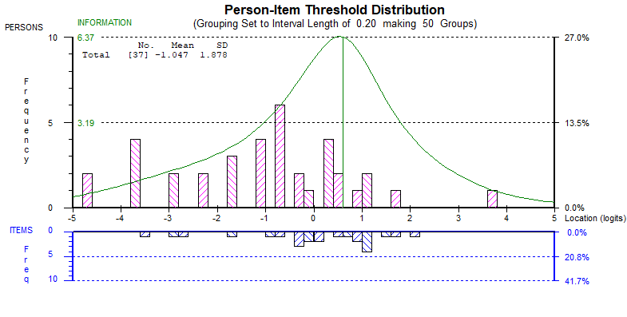
B
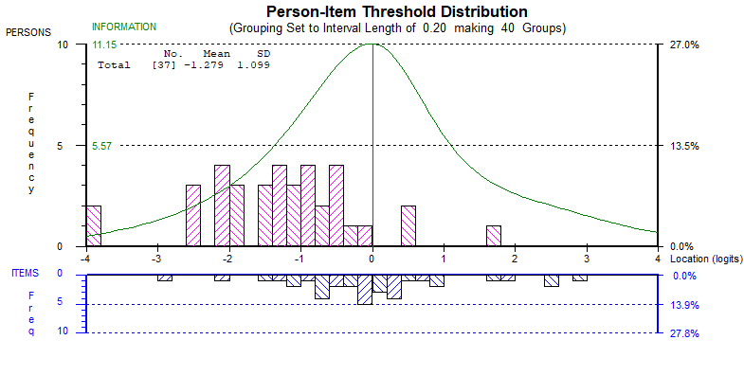

C
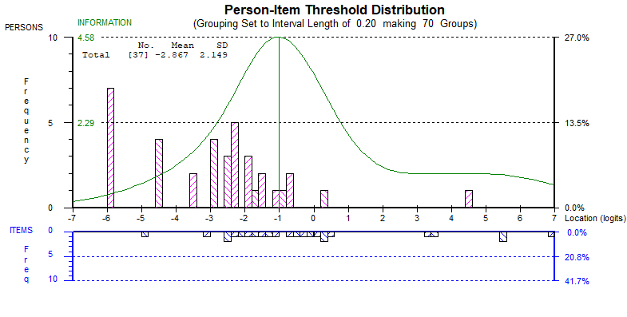
D
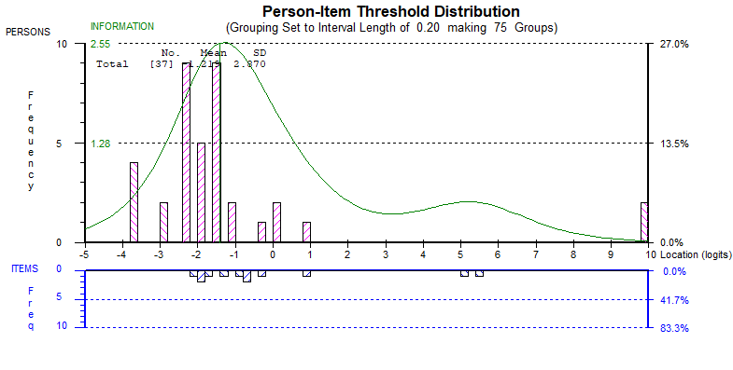

E
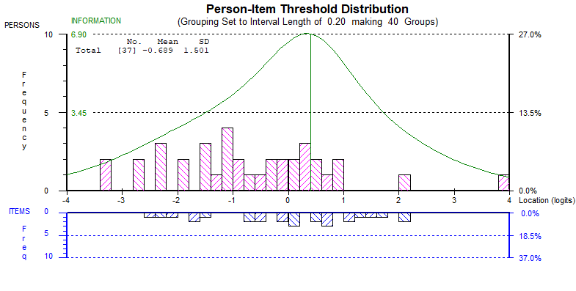
SD standard deviation.

