Supplementary Material
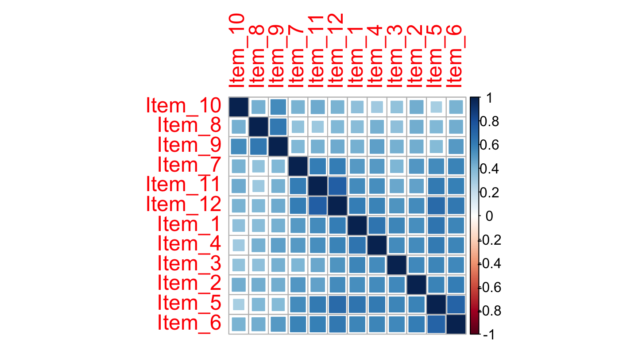 | 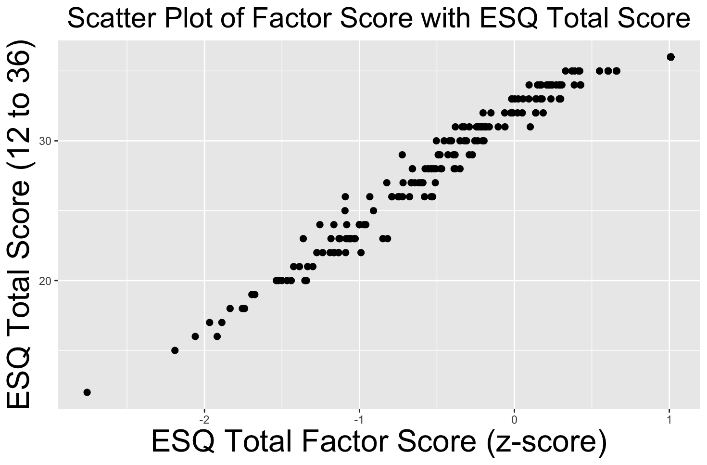
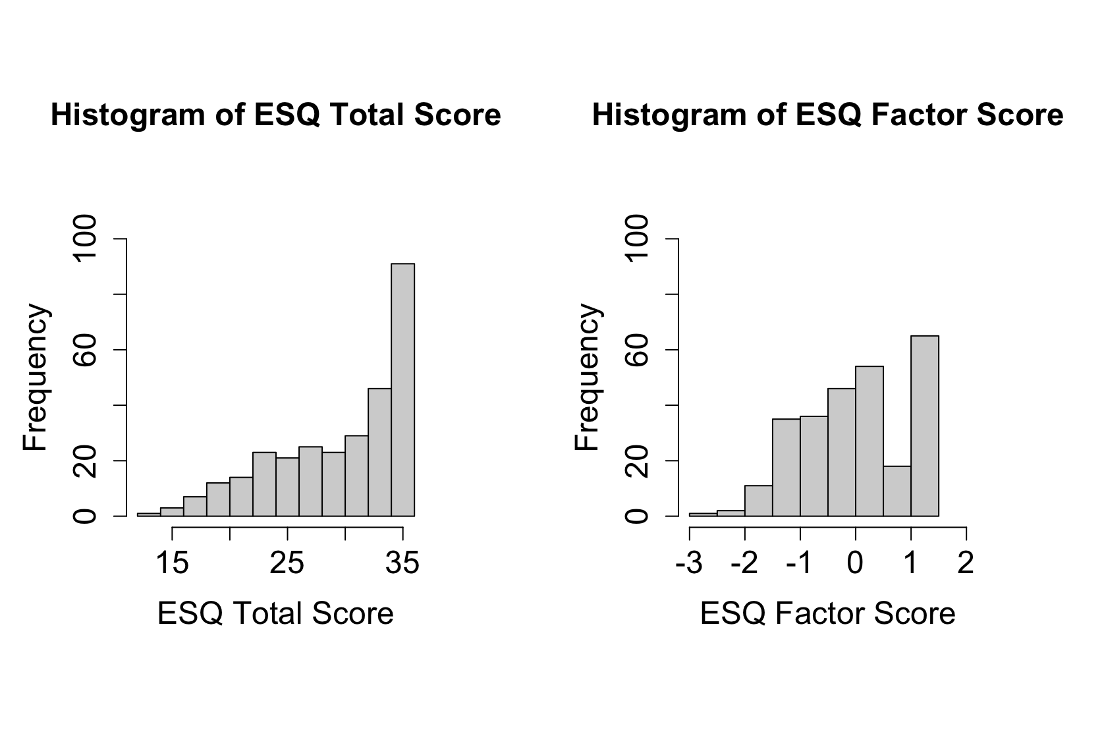

Supplemental Figure S1. Correlation matrix, histograms of the summed-based score and IRT-based score and scatter plot showing the association between summed score and IRT-based score

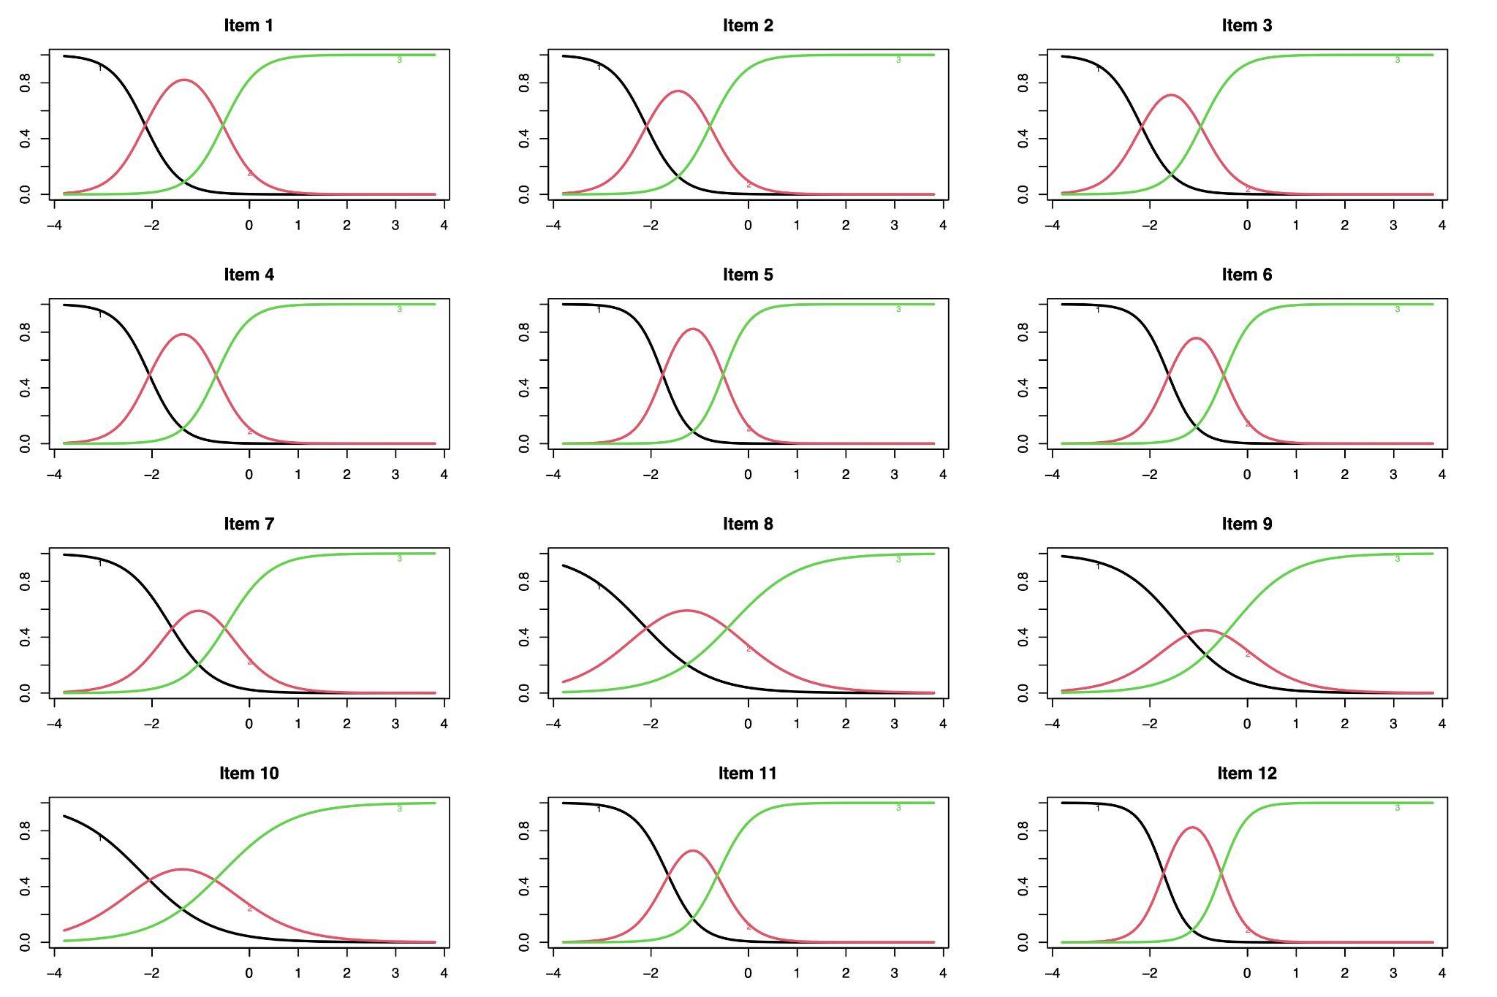

Supplemental Figure S2: Item Response Characteristic Curves (unidimensional solution)

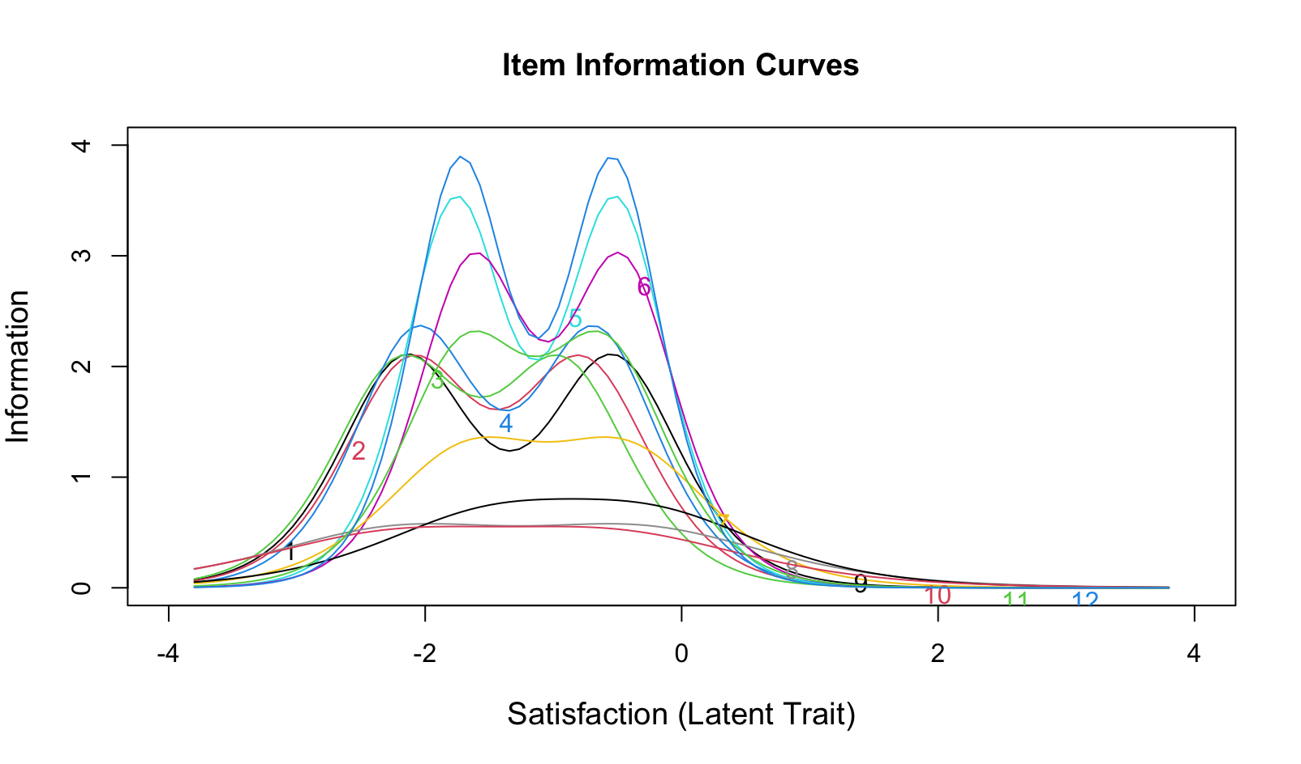

Supplemental Figure S3. Item Information Curves (unidimensional solution)

