Appendix 2. PROMIS Short Forms and Task Difficulty Scale Linked to Text Responses: Overlap, Distinct Coverage, and Uncaptured Activity Limitations

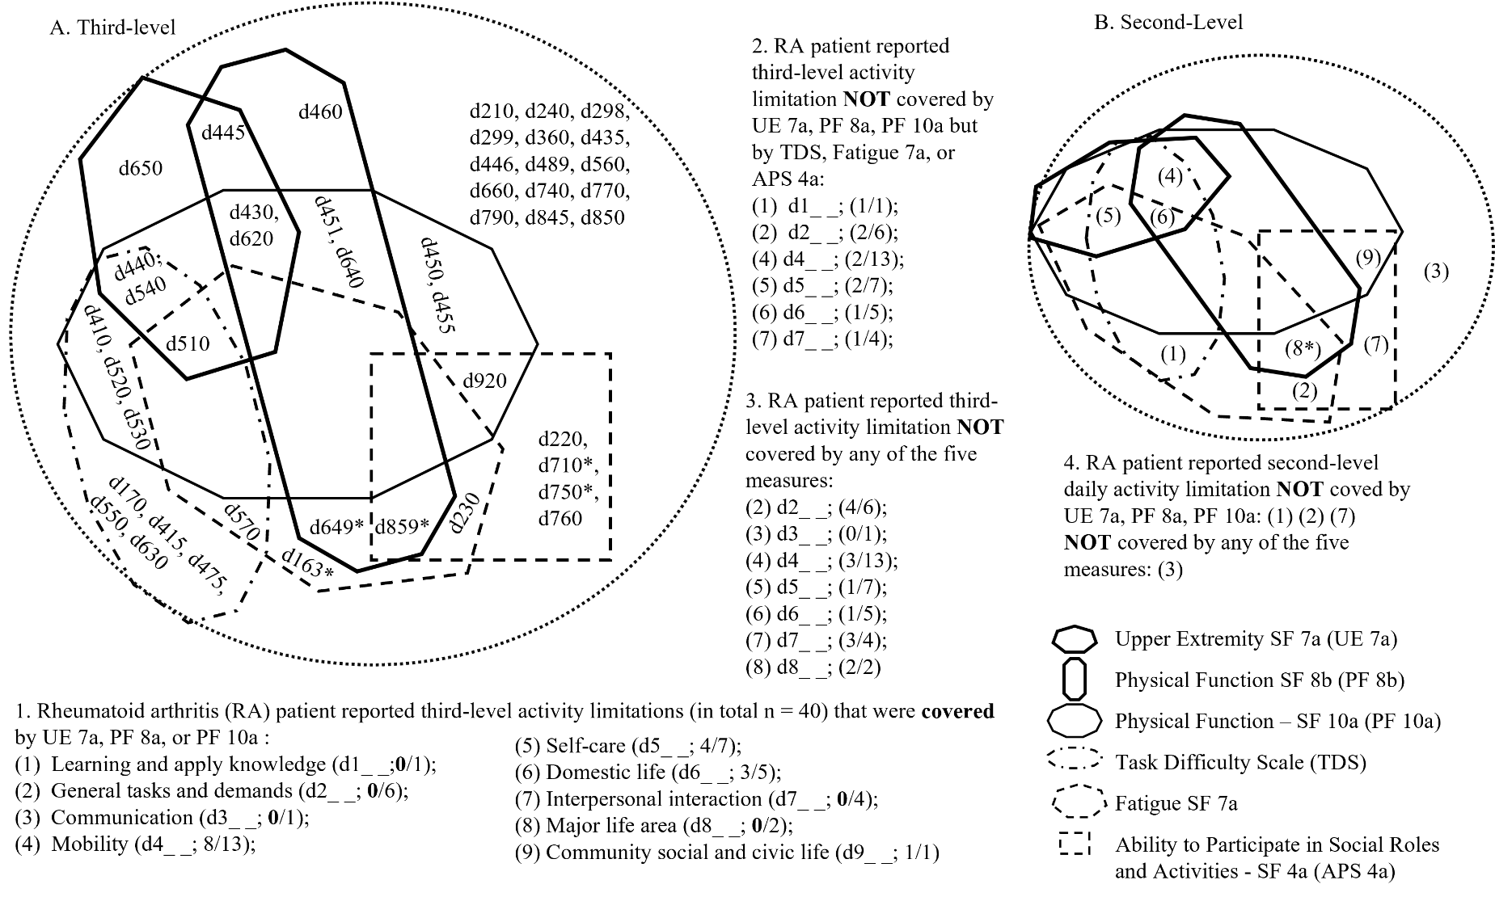

(1) Learning and applying knowledge
d163 Thinking*
d170 Writing
(2) General tasks and demands
d210 Undertaking a single task
d220 Undertaking multiple tasks
d230 Carrying out daily routine
d240 Handling stress and other psychological demands
d298 Other specified general tasks and demands
d299 General tasks and demands, unspecified
(3) Communication
d360 Using communication devices and techniques
(4) Mobility-Changing and maintaining body position
d410 Changing basic body position
415 Maintaining body position
Mobility-Carrying, moving and handling objects
d430 Lifting and carrying objects
d435 Moving objects with lower extremities
d440 Fine hand use
d445 Hand and arm use
d446 Fine foot use
Mobility-Walking and moving
d450 Walking
d451 Going up and down stairs
d455 Moving around
d460 Moving around in different locations
Mobility-Moving around using transportation
d475 Driving
d489 Moving around using transportation, other specified and unspecified
(5) Self-care
d510 Washing oneself
d520 Caring for body parts
d530 Toileting
d540 Dressing
d550 Eating
d560 Drinking
d570 Looking after one's health
(6) Domestic life-Acquisition of necessities
d620 Acquisition of goods and services
Domestic life- Household tasks
d630 Preparing meals
d640 Doing housework
d649 Household tasks, other specified and unspecified*
Domestic life-Caring for household objects and assisting others
d650 Caring for household objects
d660 Assisting others
(7) Interpersonal interactions and relationships-Particular interpersonal relationships
d710 Basic interpersonal interactions*
d740 Formal relationships
d750 Informal social relationships*
d760 Family relationships
d770 Intimate relationships
d799 Interpersonal interactions and relationships, unspecified
(8) Major life areas-Work and employment
d845 Acquiring, keeping and terminating a job
d850 Remunerative employment
d859 Work and employment, other specified and unspecified*
(9) Community social and civic life
d920 Recreation and leisure
* These third-level subcategories were not linked to the text response to the open-ended question but linked to the PROMIS short form measures

