ADDITIONAL FILE 1. SUPPLEMENTARY MATERIALS
TABLE OF CONTENTS
Table S1. Details of responses given to PRO-CTCAE items at visit 1 2
Table S2. Details of responses given to PRO-CTCAE items (excluded in short form) at visit 1 5
Table S3. Details of responses given to HADS items 7
Table S4. Details of responses given to OV28 items 8
Table S5. Summary of scores of Symptoms scale and Functional scale of OV28 questionnaire 9
Table S6. Known-group validity analysis for dichotomous PRO-CTCAE symptoms 10
Figure S1. Description of significant associations between PRO-CTCAE items and PGIC quality of life score 11
Figure S2. Description of significant associations between PRO-CTCAE items and PGIC physical condition score 12
Figure S3. Description of significant associations between PRO-CTCAE items and PGIC emotional status score 13

Table S1. Details of responses given to PRO-CTCAE items at visit 1

PROCTCAE ITEM | Never/  None/  Not at all/  No |  | Rarely/  Mild/  A little bit/  Yes |  | Occasionally/  Moderate/  Somewhat |  | Frequently/  Severe/  Quite a bit |  | Almost constantly/  Very severe/  Very much |  | Not pertinent/  Not sexually  Active | I prefer not  to answer | Missing
Dry Mouth (S) | 121 | (56.5%) | 60 | (28.0%) | 25 | (11.7%) | 5 | (2.3%) | 3 | (1.4%)
Sore mouth (S) | 183 | (85.5%) | 24 | (11.2%) | 4 | (1.9%) | 2 | (0.9%) | 1 | (0.5%)
Sore mouth (I) | 193 | (90.2%) | 16 | (7.5%) | 5 | (2.3%)
Voice changes (P) | 175 | (81.8%) | 39 | (18.2%)
Dysgeusia (S) | 137 | (64.0%) | 57 | (26.6%) | 13 | (6.1%) | 5 | (2.3%) | 2 | (0.9%)
Appetite (S) | 124 | (57.9%) | 56 | (26.2%) | 23 | (10.7%) | 10 | (4.7%) | 1 | (0.5%)
Appetite (I) | 159 | (74.3%) | 41 | (19.2%) | 10 | (4.7%) | 4 | (1.9%)
Nausea (F) | 98 | (45.8%) | 57 | (26.6%) | 38 | (17.8%) | 13 | (6.1%) | 8 | (3.7%)
Nausea (S) | 127 | (59.3%) | 62 | (29.0%) | 18 | (8.4%) | 5 | (2.3%) | 2 | (0.9%)
Vomiting (F) | 185 | (86.4%) | 13 | (6.1%) | 12 | (5.6%) | 4 | (1.9%)
Vomiting (S) | 190 | (88.8%) | 16 | (7.5%) | 4 | (1.9%) | 4 | (1.9%)
Heartburn (F) | 126 | (58.9%) | 49 | (22.9%) | 31 | (14.5%) | 8 | (3.7%)
Heartburn (S) | 146 | (68.2%) | 52 | (24.3%) | 14 | (6.5%) | 2 | (0.9%)
Flatulence (P) | 100 | (46.7%) | 114 | (53.3%)
Bloating (F) | 60 | (28.0%) | 59 | (27.6%) | 55 | (25.7%) | 29 | (13.6%) | 11 | (5.1%)
Bloating (S) | 99 | (46.3%) | 78 | (36.4%) | 23 | (10.7%) | 13 | (6.1%) | 1 | (0.5%)
Constipation (S) | 86 | (40.2%) | 70 | (32.7%) | 31 | (14.5%) | 24 | (11.2%) | 3 | (1.4%)
Diarrhoea (F) | 137 | (64.0%) | 36 | (16.8%) | 22 | (10.3%) | 11 | (5.1%) | 8 | (3.7%)
Abdominal pain (F) | 110 | (51.4%) | 55 | (25.7%) | 34 | (15.9%) | 13 | (6.1%) | 2 | (0.9%)
Abdominal pain (S) | 131 | (61.2%) | 59 | (27.6%) | 17 | (7.9%) | 6 | (2.8%) | 1 | (0.5%)
Abdominal pain (I) | 162 | (75.7%) | 38 | (17.8%) | 9 | (4.2%) | 4 | (1.9%) | 1 | (0.5%)
Dyspnoea (S) | 109 | (50.9%) | 76 | (35.5%) | 21 | (9.8%) | 5 | (2.3%) | 3 | (1.4%)
Dyspnoea (I) | 140 | (65.4%) | 56 | (26.2%) | 12 | (5.6%) | 2 | (0.9%) | 4 | (1.9%)
Arm/leg swelling (F) | 154 | (72.0%) | 24 | (11.2%) | 21 | (9.8%) | 10 | (4.7%) | 5 | (2.3%)
Arm/leg swelling (S) | 167 | (78.0%) | 30 | (14.0%) | 10 | (4.7%) | 4 | (1.9%) | 3 | (1.4%)
Arm/leg swelling (I) | 184 | (86.0%) | 20 | (9.3%) | 6 | (2.8%) | 1 | (0.5%) | 3 | (1.4%)
Palpitations (F) | 119 | (55.6%) | 55 | (25.7%) | 34 | (15.9%) | 5 | (2.3%) | 1 | (0.5%)
Palpitations (S) | 158 | (73.8%) | 39 | (18.2%) | 13 | (6.1%) | 1 | (0.5%) | 3 | (1.4%)
Rash (P) | 169 | (79.0%) | 45 | (21.0%)
Dry Skin (S) | 93 | (43.5%) | 78 | (36.4%) | 27 | (12.6%) | 15 | (7.0%) | 1 | (0.5%)
Hair loss (A) | 105 | (49.1%) | 41 | (19.2%) | 15 | (7.0%) | 25 | (11.7%) | 28 | (13.1%)
Hand/foot syndrome (S) | 160 | (74.8%) | 38 | (17.8%) | 10 | (4.7%) | 4 | (1.9%) | 2 | (0.9%)
Sunlight sensitivity (P) | 178 | (83.2%) | 36 | (16.8%)
Hand/foot neuropathy (S) | 95 | (44.4%) | 82 | (38.3%) | 26 | (12.1%) | 10 | (4.7%) | 1 | (0.5%)
Hand/foot neuropathy (I) | 159 | (74.3%) | 39 | (18.2%) | 11 | (5.1%) | 4 | (1.9%) | 1 | (0.5%)
Blurry vision (S) | 137 | (64.0%) | 55 | (25.7%) | 16 | (7.5%) | 6 | (2.8%)
Blurry vision (I) | 168 | (78.5%) | 34 | (15.9%) | 10 | (4.7%) | 2 | (0.9%)
Concentration (S) | 115 | (53.7%) | 79 | (36.9%) | 14 | (6.5%) | 5 | (2.3%) | 1 | (0.5%)
Concentration (I) | 139 | (65.0%) | 57 | (26.6%) | 17 | (7.9%) | 1 | (0.5%)
Memory (S) | 123 | (57.5%) | 70 | (32.7%) | 18 | (8.4%) | 2 | (0.9%) | 1 | (0.5%)
Memory (I) | 152 | (71.0%) | 48 | (22.4%) | 12 | (5.6%) | 1 | (0.5%) | 1 | (0.5%)
Pain (F) | 72 | (33.6%) | 63 | (29.4%) | 47 | (22.0%) | 25 | (11.7%) | 7 | (3.3%)
Pain (S) | 101 | (47.2%) | 67 | (31.3%) | 30 | (14.0%) | 10 | (4.7%) | 6 | (2.8%)
Pain (I) | 118 | (55.1%) | 60 | (28.0%) | 23 | (10.7%) | 9 | (4.2%) | 4 | (1.9%)
Headache (F) | 113 | (52.8%) | 66 | (30.8%) | 27 | (12.6%) | 6 | (2.8%) | 2 | (0.9%)
Headache (S) | 135 | (63.1%) | 64 | (29.9%) | 10 | (4.7%) | 4 | (1.9%) | 1 | (0.5%)
Headache (I) | 160 | (74.8%) | 43 | (20.1%) | 10 | (4.7%) | 1 | (0.5%)
Muscle pain (F) | 80 | (37.4%) | 65 | (30.4%) | 46 | (21.5%) | 17 | (7.9%) | 6 | (2.8%)
Muscle pain (S) | 103 | (48.1%) | 70 | (32.7%) | 30 | (14.0%) | 8 | (3.7%) | 3 | (1.4%)
Muscle pain (I) | 130 | (60.7%) | 54 | (25.2%) | 23 | (10.7%) | 5 | (2.3%) | 2 | (0.9%)
Joint pain (F) | 77 | (36.0%) | 58 | (27.1%) | 48 | (22.4%) | 23 | (10.7%) | 8 | (3.7%)
Joint pain (S) | 99 | (46.3%) | 76 | (35.5%) | 28 | (13.1%) | 7 | (3.3%) | 4 | (1.9%)
Joint pain (I) | 127 | (59.3%) | 59 | (27.6%) | 22 | (10.3%) | 4 | (1.9%) | 2 | (0.9%)
Insomnia (S) | 65 | (30.4%) | 77 | (36.0%) | 44 | (20.6%) | 24 | (11.2%) | 4 | (1.9%)
Insomnia (I) | 106 | (49.5%) | 61 | (28.5%) | 37 | (17.3%) | 8 | (3.7%) | 2 | (0.9%)
Fatigue (S) | 44 | (20.6%) | 84 | (39.3%) | 51 | (23.8%) | 25 | (11.7%) | 10 | (4.7%)
Fatigue (I) | 65 | (30.4%) | 76 | (35.5%) | 47 | (22.0%) | 20 | (9.3%) | 6 | (2.8%)
Anxiety (F) | 75 | (35.0%) | 65 | (30.4%) | 50 | (23.4%) | 15 | (7.0%) | 9 | (4.2%)
Anxiety (S) | 92 | (43.0%) | 78 | (36.4%) | 29 | (13.6%) | 10 | (4.7%) | 5 | (2.3%)
Anxiety (I) | 130 | (60.7%) | 66 | (30.8%) | 11 | (5.1%) | 4 | (1.9%) | 3 | (1.4%)
Depression (F) | 96 | (44.9%) | 60 | (28.0%) | 43 | (20.1%) | 10 | (4.7%) | 5 | (2.3%)
Depression (S) | 110 | (51.4%) | 72 | (33.6%) | 22 | (10.3%) | 6 | (2.8%) | 4 | (1.9%)
Depression (I) | 136 | (63.6%) | 55 | (25.7%) | 16 | (7.5%) | 5 | (2.3%) | 2 | (0.9%)
Sadness (F) | 41 | (19.2%) | 78 | (36.4%) | 64 | (29.9%) | 21 | (9.8%) | 10 | (4.7%)
Sadness (S) | 72 | (33.6%) | 96 | (44.9%) | 29 | (13.6%) | 10 | (4.7%) | 7 | (3.3%)
Sadness (I) | 119 | (55.6%) | 67 | (31.3%) | 17 | (7.9%) | 8 | (3.7%) | 3 | (1.4%)
Vaginal dryness (S) | 135 | (63.1%) | 53 | (24.8%) | 16 | (7.5%) | 8 | (3.7%) | 2 | (0.9%)
Urgent urination (F) | 83 | (38.8%) | 56 | (26.2%) | 42 | (19.6%) | 30 | (14.0%) | 3 | (1.4%)
Urgent urination (I) | 156 | (72.9%) | 42 | (19.6%) | 11 | (5.1%) | 5 | (2.3%)
Urinary incontinence (F) | 150 | (70.1%) | 36 | (16.8%) | 19 | (8.9%) | 9 | (4.2%)
Urinary incontinence (I) | 183 | (85.5%) | 20 | (9.3%) | 7 | (3.3%) | 3 | (1.4%) | 1 | (0.5%)
Libido loss (S) | 37 | (36.6%) | 21 | (20.8%) | 18 | (17.8%) | 10 | (9.9%) | 15 | (14.9%) | 75 | 38
Late orgasm (P) | 25 | (35.2%) | 46 | (64.8%) |  |  |  |  |  |  | 88 | 55
Unable to orgasm (P) | 33 | (70.2%) | 14 | (29.8%) |  |  |  |  |  |  | 100 | 67
Painful Intercourse (S) | 21 | (39.6%) | 21 | (39.6%) | 2 | (3.8%) | 5 | (9.4%) | 4 | (7.5%) | 102 | 59
Bruise (P) | 169 | (79.0%) | 45 | (21.0%)
Hot flushes (F) | 107 | (50.0%) | 41 | (19.2%) | 39 | (18.2%) | 19 | (8.9%) | 8 | (3.7%)
Hot flushes (S) | 143 | (66.8%) | 43 | (20.1%) | 16 | (7.5%) | 9 | (4.2%) | 3 | (1.4%)
S: severity; I: interference; P: presence; F: frequency; A: absence

Table S2. Details of responses given to PRO-CTCAE items (excluded in short form) at visit 1

PROCTCAE ITEM | Never/  None/  Not at all/  No |  | Rarely/  Mild/  A little bit/  Yes |  | Occasionally/  Moderate/  Somewhat |  | Frequently/  Severe/  Quite a bit |  | Almost constantly/  Very severe/  Very much |  | Not pertinent/  Not sexually  Active | I prefer not  to answer | Missing
Swallowing (S) | 107 | (84.9%) | 13 | (10.3%) | 5 | (4.0%) | 1 | (0.8%)
Mouth corners cracking (S) | 112 | (88.9%) | 13 | (10.3%) | 1 | (0.8%)
Hoarse voice (S) | 91 | (72.2%) | 30 | (23.8%) | 3 | (2.4%) | 2 | (1.6%)
Hiccups (F) | 103 | (81.7%) | 13 | (10.3%) | 7 | (5.6%) | 3 | (2.4%)
Hiccups (S) | 114 | (90.5%) | 9 | (7.1%) | 3 | (2.4%)
Fecal incontinence (F) | 116 | (92.1%) | 6 | (4.8%) | 2 | (1.6%) | 1 | (0.8%) | 1 | (0.8%)
Fecal incontinence (I) | 119 | (94.4%) | 4 | (3.2%) | 3 | (2.4%)
Cough (S) | 101 | (80.2%) | 21 | (16.7%) | 4 | (3.2%)
Cough (I) | 116 | (92.1%) | 9 | (7.1%) | 1 | (0.8%)
Wheezing (S) | 117 | (92.9%) | 6 | (4.8%) | 1 | (0.8%) | 2 | (1.6%)
Acne (S) | 116 | (92.1%) | 7 | (5.6%) | 2 | (1.6%) | 0 | (0.0%) | 1 | (0.8%)
Itchy skin (S) | 95 | (75.4%) | 26 | (20.6%) | 2 | (1.6%) |  |  | 3 | (2.4%)
Hives (P) | 120 | (95.2%) | 6 | (4.8%)
Loss of nails (P) | 123 | (97.6%) | 3 | (2.4%)
Ridges/bumps of nails (P) | 110 | (87.3%) | 16 | (12.7%)
Color of nails (P) | 111 | (88.1%) | 15 | (11.9%)
Bed sores (P) | 126 | (100.0%)
Radiodermitis (S) | 71 | (98.6%) | 0 | (0.0%) | 1 | (1.4%) | 0 | (0.0%) | 0 | (0.0%) | 54
Skin darkening (P) | 118 | (93.7%) | 8 | (6.3%)
Stretch marks (P) | 115 | (91.3%) | 11 | (8.7%)
Dizziness (S) | 87 | (69.0%) | 32 | (25.4%) | 6 | (4.8%) | 1 | (0.5%)
Dizziness (I) | 102 | (81.0%) | 21 | (16.7%) | 3 | (2.4%)
Ocular flashes (P) | 116 | (92.1%) | 10 | (7.9%)
Ocular spots/lines/floaters (P) | 108 | (85.7%) | 18 | (14.3%)
Watery eyes (S) | 97 | (77.0%) | 23 | (18.3%) | 4 | (3.2%) | 1 | (0.8%) | 1 | (0.8%)
Watery eyes (I) | 116 | (92.1%) | 10 | (7.9%)
Ringing in ears (S) | 105 | (83.3%) | 11 | (8.7%) | 8 | (6.3%) | 1 | (0.8%) | 1 | (0.8%)
Irregular menses (P) | 26 | (96.3%) | 1 | (3.7%) |  |  |  |  |  |  | 99
Missed menses (P) | 19 | (86.4%) | 3 | (13.6%) |  |  |  |  |  |  | 104
Vaginal discharge (A) | 110 | (87.3%) | 15 | (11.9%) | 1 | (0.8%)
Painful urination (S) | 110 | (87.3%) | 10 | (7.9%) | 2 | (1.6%) | 2 | (1.6%) | 2 | (1.6%)
Frequent urination (F) | 60 | (47.6%) | 27 | (21.4%) | 30 | (23.8%) | 9 | (7.1%)
Frequent urination (I) | 92 | (73.0%) | 26 | (20.6%) | 6 | (4.8%) | 2 | (1.6%)
Urine color change (P) | 115 | (91.3%) | 11 | (8.7%)
Breast tenderness (S) | 112 | (88.9%) | 10 | (7.9%) | 4 | (3.2%)
Chills (F) | 85 | (67.5%) | 23 | (18.3%) | 14 | (11.1%) | 4 | (3.2%)
Chills (S) | 101 | (80.2%) | 19 | (15.1%) | 5 | (4.0%) | 1 | (0.5%)
Excessive sweating (F) | 66 | (52.4%) | 28 | (22.2%) | 17 | (13.5%) | 13 | (10.3%) | 2 | (1.6%)
Excessive sweating (S) | 84 | (66.7%) | 23 | (18.3%) | 11 | (8.7%) | 7 | (5.6%) | 1 | (0.8%)
Decreased sweating (P) | 119 | (94.4%) | 7 | (5.6%)
Epistaxis (F) | 112 | (88.9%) | 9 | (7.1%) | 2 | (1.6%) | 2 | (1.6%) | 1 | (0.8%)
Epistaxis (S) | 118 | (93.7%) | 7 | (5.6%) | 1 | (0.8%)
Injection site problems (P) | 105 | (92.9%) | 8 | (7.1%) |  |  |  |  |  |  | 12 |  | 1
Body odor (S) | 104 | (84.6%) | 15 | (12.2%) | 3 | (2.4%) | 1 | (0.8%) |  |  |  |  | 3

S: severity; I: interference; P: presence; F: frequency; A: absence

Table S3. Details of responses given to HADS items

HADS ITEM | 1  better |  | 2 |  | 3 |  | 4  worse |  | Missing
Irritability | 18 | (8.6%) | 16 | (7.7%) | 138 | (66.0%) | 37 | (17.7%) | 1 | (0.5%)
Enjoy Usual Activities | 83 | (40.1%) | 83 | (40.1%) | 34 | (16.4%) | 7 | (3.4%) | 3 | (1.4%)
Fear | 28 | (13.5%) | 66 | (31.7%) | 69 | (33.2%) | 45 | (21.6%) | 2 | (1.0%)
Happy Thoughts | 94 | (45.2%) | 60 | (28.8%) | 41 | (19.7%) | 13 | (6.2%) | 2 | (1.0%)
Worrying Thoughts | 19 | (9.2%) | 26 | (12.6%) | 85 | (41.3%) | 76 | (36.9%) | 4 | (1.9%)
Cheerful Mood | 4 | (1.9%) | 29 | (13.9%) | 87 | (41.8%) | 88 | (42.3%) | 2 | (1.0%)
Feeling Relaxed | 45 | (21.6%) | 91 | (43.8%) | 64 | (30.8%) | 8 | (3.8%) | 2 | (1.0%)
Slow Movements | 21 | (10.0%) | 36 | (17.2%) | 109 | (52.2%) | 43 | (20.6%) | 1 | (0.5%)
Butterflies In The Stomach | 69 | (33.0%) | 111 | (53.1%) | 23 | (11.0%) | 6 | (2.9%) | 1 | (0.5%)
Lost Interest In Apparence | 6 | (2.9%) | 38 | (18.5%) | 41 | (20.0%) | 120 | (58.5%) | 5 | (2.4%)
Feeling Restless | 6 | (2.9%) | 36 | (17.5%) | 71 | (34.5%) | 93 | (45.1%) | 4 | (1.9%)
Hope In Future | 52 | (25.0%) | 68 | (32.7%) | 75 | (36.1%) | 13 | (6.2%) | 2 | (1.0%)
Panic Attack | 7 | (3.4%) | 6 | (2.9%) | 43 | (20.9%) | 150 | (72.8%) | 4 | (1.9%)
Enjoy Recreation Activities | 126 | (60.9%) | 55 | (26.6%) | 15 | (7.2%) | 11 | (5.3%) | 3 | (1.4%)

Table S4. Details of responses given to OV28 items
OV28 ITEM | Not at all |  | A little |  | Quite a bit |  | Very much |  | Missing
During the past week:
Abdominal pain | 120 | (57.1%) | 72 | (34.3%) | 12 | (5.7%) | 6 | (2.9%)
Bloated abdomen | 90 | (43.1%) | 89 | (42.6%) | 23 | (11.0%) | 7 | (3.3%) | 1 | (0.5%)
Tight clothes | 125 | (59.8%) | 67 | (32.1%) | 13 | (6.2%) | 4 | (1.9%) | 1 | (0.5%)
Change in bowel habit | 71 | (34.0%) | 79 | (37.8%) | 41 | (19.6%) | 18 | (8.6%) | 1 | (0.5%)
Flatulence | 78 | (37.1%) | 85 | (40.5%) | 32 | (15.2%) | 15 | (7.1%) | 0 | (0.0%)
Full up after eating | 131 | (63.0%) | 60 | (28.8%) | 14 | (6.7%) | 3 | (1.4%) | 2 | (1.0%)
Heartburn | 121 | (57.9%) | 74 | (35.4%) | 12 | (5.7%) | 2 | (1.0%) | 1 | (0.5%)
Hair loss | 93 | (45.1%) | 44 | (21.4%) | 24 | (11.7%) | 45 | (21.8%) | 4 | (1.9%)
If hair loss. upset by it | 46 | (34.6%) | 43 | (32.3%) | 25 | (18.8%) | 19 | (14.3%) | 77 | (36.7%)
Taste | 135 | (64.6%) | 58 | (27.8%) | 15 | (7.2%) | 1 | (0.5%) | 1 | (0.5%)
Tingling hands or feet | 103 | (49.3%) | 79 | (37.8%) | 20 | (9.6%) | 7 | (3.3%) | 1 | (0.5%)
Numbness in fingers or toes | 101 | (48.6%) | 77 | (37.0%) | 21 | (10.1%) | 9 | (4.3%) | 2 | (1.0%)
Weakness in arms or legs | 91 | (43.5%) | 85 | (40.7%) | 24 | (11.5%) | 9 | (4.3%) | 1 | (0.5%)
Muscle or joint pain | 86 | (41.3%) | 88 | (42.3%) | 28 | (13.5%) | 6 | (2.9%) | 2 | (1.0%)
Hearing loss | 163 | (78.0%) | 35 | (16.7%) | 9 | (4.3%) | 2 | (1.0%) | 1 | (0.5%)
Frequent urination | 101 | (49.0%) | 63 | (30.6%) | 37 | (18.0%) | 5 | (2.4%) | 4 | (1.9%)
Itchy/dry skin | 109 | (52.4%) | 71 | (34.1%) | 24 | (11.5%) | 4 | (1.9%) | 2 | (1.0%)
Hot flushes | 112 | (53.6%) | 66 | (31.6%) | 20 | (9.6%) | 11 | (5.3%) | 1 | (0.5%)
Night sweats | 130 | (62.5%) | 47 | (22.6%) | 22 | (10.6%) | 9 | (4.3%) | 2 | (1.0%)
Felt physically less attractive | 90 | (44.3%) | 65 | (32.0%) | 33 | (16.3%) | 15 | (7.4%) | 7 | (3.3%)
Body dissatisfaction | 86 | (42.4%) | 70 | (34.5%) | 39 | (19.2%) | 8 | (3.9%) | 7 | (3.3%)
Disease burden | 20 | (9.8%) | 85 | (41.5%) | 57 | (27.8%) | 43 | (21.0%) | 5 | (2.4%)
Treatment burden | 31 | (15.2%) | 96 | (47.1%) | 52 | (25.5%) | 25 | (12.3%) | 6 | (2.9%)
Worried about future health | 14 | (6.8%) | 85 | (41.3%) | 51 | (24.8%) | 56 | (27.2%) | 4 | (1.9%)
During the past four weeks:
Sexual interest | 140 | (74.5%) | 40 | (21.3%) | 8 | (4.3%) |  |  | 22 | (10.5%)
Sexual activity | 136 | (74.7%) | 43 | (23.6%) | 3 | (1.6%) |  |  | 28 | (13.3%)
If sexual activity. sex enjoyable | 33 | (48.0%) | 18 | (26.0%) | 14 | (20.0%) | 4 | (6%) | 141 | (67.1%)
If sexual activity. vaginal dryness during sex | 33 | (52.0%) | 14 | (22.0%) | 12 | (19.0%) | 5 | (8%) | 146 | (69.5%)

Table S5. Summary of scores of Symptoms scale and Functional scale of OV28 questionnaire

OV28 Scale | Mean | Std. dev.
Abdominal discomfort | 23.46 | (19.0)
Pheripheral neuropathy | 22.89 | (25.3)
Hormonal symptoms | 20.49 | (26.0)
Body image | 28.46 | (28.5)
Disease/treatment burden | 51.64 | (26.7)
Chemotherapy side effects | 21.17 | (16.0)
Heartburn | 16.59 | (21.7)
Hair loss | 36.73 | (40.0)
Hair loss discomfort | 37.59 | (34.9)
Taste | 14.51 | (21.6)
Sexual interest | 9.93 | (18.1)
Sexual activity | 8.97 | (16.0)
Sexual enjoyment | 28.02 | (31.6)
Vaginal discomfort | 27.60 | (33.4)

Table S6. Known-group validity analysis for dichotomous PRO-CTCAE symptoms
PRO-CTCAE symptom | PS=0 |  | PS≥1 |  | Cohen's estimate H
Voice changes (P) | 35 | (18.5%) | 4 | (16.0%) | -0.07
Flatulence (P) | 101 | (53.4%) | 13 | (52.0%) | -0.03
Rash (P) | 37 | (19.6%) | 8 | (32.0%) | 0.29
Hives (P) | 4 | (3.6%) | 2 | (13.3%) | 0.36
Loss of nails (P) | 2 | (1.8%) | 1 | (6.7%) | 0.25
Ridges/bumps of nails (P) | 14 | (12.6%) | 2 | (13.3%) | 0.02
Color of nails (P) | 13 | (11.7%) | 2 | (13.3%) | 0.05
Sunlight sensitivity (P) | 35 | (18.5%) | 1 | (4.0%) | -0.49
Bed sores (P) | 0 |  | 0 |  | NV
Skin darkening (P) | 6 | (5.4%) | 2 | (13.3%) | 0.28
Stretch marks (P) | 11 | (9.9%) | 0 | (0.0%) | -0.64
Ocular flashes (P) | 7 | (6.3%) | 3 | (20.0%) | 0.42
Ocular spots/lines/floaters (P) | 15 | (13.5%) | 3 | (20.0%) | 0.17
Irregular menses (P) | 1 | (4.0%) | 0 | (0.0%) | -0.61
Missed menses (P) | 3 | (16.0%) | 0 | (0.0%) | -0.82
Late orgasm (P) | 42 | (64.0%) | 4 | (80.0%) | 0.36
Unable to orgasm (P) | 13 | (30.0%) | 1 | (33.0%) | 0.06
Bruise (P) | 39 | (20.6%) | 6 | (24.0%) | 0.08
Decreased sweating (P) | 5 | (4.5%) | 2 | (13.3%) | 0.32
Injection site problems (P) | 7 | (6.9%) | 1 | (8.3%) | 0.05

P: presence

Figure S1. Description of significant associations between PRO-CTCAE items and PGIC quality of life score

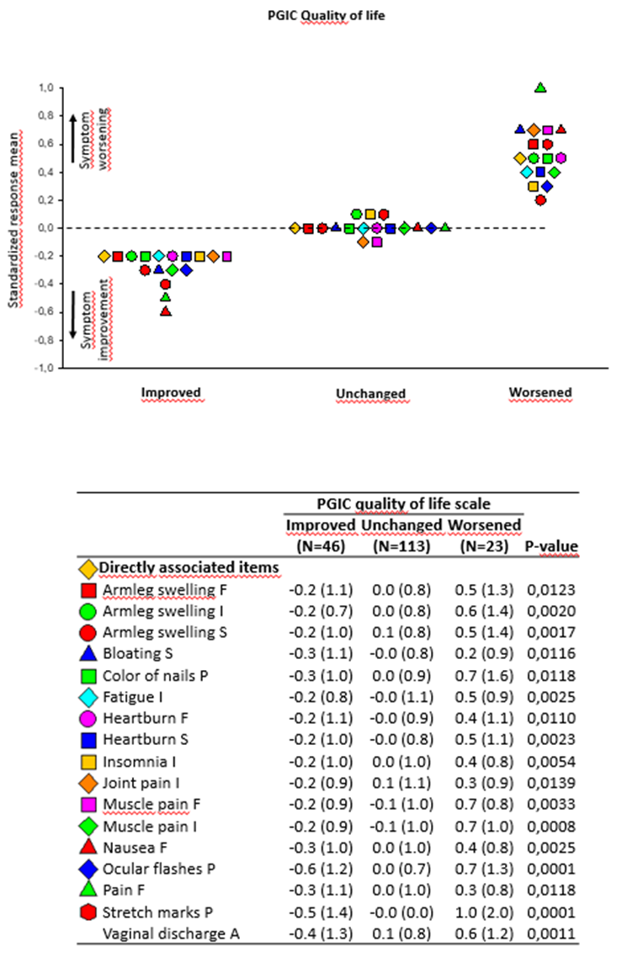

Figure S2. Description of significant associations between PRO-CTCAE items and PGIC physical condition score

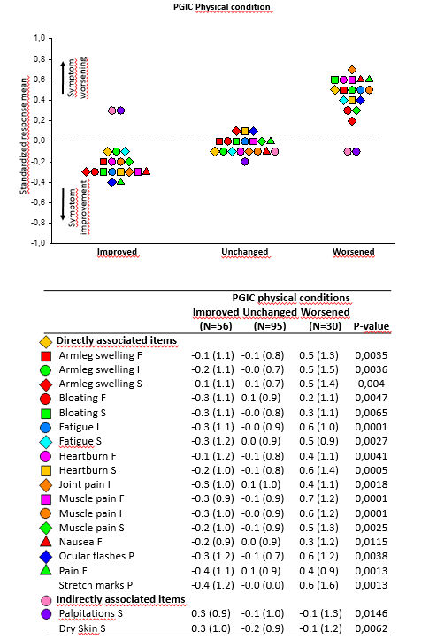

Figure S3. Description of significant associations between PRO-CTCAE items and PGIC emotional status score

