SUPPLEMTARY MATERIAL
Table S1. Search Query Example

Pubmed search strategy:
Variable | Keywords | Mesh terms | Search strategy (Pubmed)
#1 condition | Cystic fibrosis  cystic fibrosis transmembrane conductance regulator  mucoviscidosis  CFTR | Cystic fibrosis  cystic fibrosis transmembrane conductance regulator | "cystic fibrosis"[MeSH Terms] OR "cystic fibrosis transmembrane conductance regulator"[MeSH Terms] OR "cystic fibrosis"[MeSH Terms] OR "cystic fibrosis"[Title/Abstract] OR "cystic fibrosis transmembrane conductance regulator"[Title/Abstract] OR "mucoviscidosis"[Title/Abstract] OR "CFTR"[Title/Abstract]
#2 treatment | CFTR modulator  cystic fibrosis  transmembrane conductance regulator modulator  elexacaftor-tezacaftor-ivacaftor  elexacaftor  tezacaftor  ivacaftor  Trikafta  Kaftrio  Vx445  Vx-445 |  | ("cftr modulator"[All Fields] OR "cystic fibrosis transmembrane conductance regulator modulator"[All Fields] OR "elexacaftor-tezacaftor-ivacaftor"[All Fields] OR "elexacaftor"[All Fields] OR "tezacaftor"[All Fields] OR "ivacaftor"[All Fields] OR "Trikafta"[All Fields] OR "Kaftrio"[All Fields] OR "Vx445"[All Fields]) AND ("cftr modulator"[All Fields] OR "cystic fibrosis transmembrane conductance regulator modulator"[All Fields] OR "elexacaftor-tezacaftor-ivacaftor"[All Fields] OR "elexacaftor"[All Fields] OR "tezacaftor"[All Fields] OR "ivacaftor"[All Fields] OR "Trikafta"[All Fields] OR "Kaftrio"[All Fields] OR "Vx445"[All Fields])
#3 outcome | patient-reported outcomes  self-report  questionnaire  quality of life  QOL  Health-related quality of life  HRQOL  CFQ-R  CFQ-R 14+  CFQ-R-8 dimensions  CFQ  Cystic fibrosis questionnaire OR  CFQoL  CF QOL  Cystic fibrosis quality of life OR  SF-36  The 36-Item Short Form Health Survey  FLZM  Questions on Life Satisfaction OR  UKSIP  United Kingdom Sickness Impact Profile  CRDQ  Chronic Respiratory Disease Questionnaire  PLC  Quality of Life Profile for the Chronically Ill  SGRQ  St. George’s Respiratory Questionnaire  PQLS  The Pulmonary-specific Quality-of-Life Scale  SIG scale  Single Item Global scale  CAT  Chronic Obstructive Pulmonary Disease Assessment Test  AWESCORE  Q-Life | Quality of life  Surveys and Questionnaires | ("patient-reported"[All Fields] AND "outcome*"[All Fields]) OR ("patient reported outcome measures"[MeSH Terms] OR ("patient"[All Fields] AND "reported"[All Fields] AND "outcome"[All Fields] AND "measures"[All Fields]) OR "patient reported outcome measures"[All Fields] OR ("patient"[All Fields] AND "reported"[All Fields] AND "outcome"[All Fields]) OR "patient reported outcome"[All Fields]) OR "self report*"[All Fields] OR ("questionnair"[All Fields] OR "questionnaire s"[All Fields] OR "surveys and questionnaires"[MeSH Terms] OR ("surveys"[All Fields] AND "questionnaires"[All Fields]) OR "surveys and questionnaires"[All Fields] OR "questionnaire"[All Fields] OR "questionnaires"[All Fields]) OR ("quality of life"[MeSH Terms] OR ("quality"[All Fields] AND "life"[All Fields]) OR "quality of life"[All Fields]) OR "QOL"[All Fields] OR ("quality of life"[MeSH Terms] OR ("quality"[All Fields] AND "life"[All Fields]) OR "quality of life"[All Fields] OR ("health"[All Fields] AND "related"[All Fields] AND "quality"[All Fields] AND "life"[All Fields]) OR "health related quality of life"[All Fields]) OR ("hrqols"[All Fields] OR "quality of life"[MeSH Terms] OR ("quality"[All Fields] AND "life"[All Fields]) OR "quality of life"[All Fields] OR "hrqol"[All Fields]) OR "prom*"[All Fields] OR "CFQ-R"[All Fields] OR ("CFQ-R"[All Fields] AND "14"[All Fields]) OR ("CFQ-R-8"[All Fields] AND ("dimension"[All Fields] OR "dimensions"[All Fields])) OR "CFQ"[All Fields] OR (("cystic fibrosis"[MeSH Terms] OR ("cystic"[All Fields] AND "fibrosis"[All Fields]) OR "cystic fibrosis"[All Fields]) AND ("questionnair"[All Fields] OR "questionnaire s"[All Fields] OR "surveys and questionnaires"[MeSH Terms] OR ("surveys"[All Fields] AND "questionnaires"[All Fields]) OR "surveys and questionnaires"[All Fields] OR "questionnaire"[All Fields] OR "questionnaires"[All Fields])) OR "CFQoL"[All Fields] OR (("cerebrospinal fluid"[MeSH Subheading] OR ("cerebrospinal"[All Fields] AND "fluid"[All Fields]) OR "cerebrospinal fluid"[All Fields] OR "cf"[All Fields]) AND "QOL"[All Fields]) OR (("cystic fibrosis"[MeSH Terms] OR ("cystic"[All Fields] AND "fibrosis"[All Fields]) OR "cystic fibrosis"[All Fields]) AND ("quality of life"[MeSH Terms] OR ("quality"[All Fields] AND "life"[All Fields]) OR "quality of life"[All Fields])) OR "SF-36"[All Fields] OR ("36-Item"[All Fields] AND ("short"[All Fields] OR "shorts"[All Fields]) AND "Form"[All Fields] AND ("health surveys"[MeSH Terms] OR ("health"[All Fields] AND "surveys"[All Fields]) OR "health surveys"[All Fields] OR ("health"[All Fields] AND "survey"[All Fields]) OR "health survey"[All Fields])) OR "FLZM"[All Fields] OR (("question"[All Fields] OR "question s"[All Fields] OR "questionable"[All Fields] OR "questionables"[All Fields] OR "questionably"[All Fields] OR "questioned"[All Fields] OR "questioner"[All Fields] OR "questioners"[All Fields] OR "questioning"[All Fields] OR "questionings"[All Fields] OR "questions"[All Fields]) AND ("personal satisfaction"[MeSH Terms] OR ("personal"[All Fields] AND "satisfaction"[All Fields]) OR "personal satisfaction"[All Fields] OR ("life"[All Fields] AND "satisfaction"[All Fields]) OR "life satisfaction"[All Fields])) OR "UKSIP"[All Fields] OR (("united kingdom"[MeSH Terms] OR ("united"[All Fields] AND "kingdom"[All Fields]) OR "united kingdom"[All Fields]) AND ("sickness impact profile"[MeSH Terms] OR ("sickness"[All Fields] AND "impact"[All Fields] AND "profile"[All Fields]) OR "sickness impact profile"[All Fields])) OR "CRDQ"[All Fields] OR (("chron respir dis"[Journal] OR ("chronic"[All Fields] AND "respiratory"[All Fields] AND "disease"[All Fields]) OR "chronic respiratory disease"[All Fields]) AND ("questionnair"[All Fields] OR "questionnaire s"[All Fields] OR "surveys and questionnaires"[MeSH Terms] OR ("surveys"[All Fields] AND "questionnaires"[All Fields]) OR "surveys and questionnaires"[All Fields] OR "questionnaire"[All Fields] OR "questionnaires"[All Fields])) OR "PLC"[All Fields] OR (("quality of life"[MeSH Terms] OR ("quality"[All Fields] AND "life"[All Fields]) OR "quality of life"[All Fields]) AND ("profile"[All Fields] OR "profiled"[All Fields] OR "profiler"[All Fields] OR "profilers"[All Fields] OR "profiles"[All Fields] OR "profiling"[All Fields] OR "profilings"[All Fields]) AND ("chronic disease"[MeSH Terms] OR ("chronic"[All Fields] AND "disease"[All Fields]) OR "chronic disease"[All Fields] OR ("chronically"[All Fields] AND "ill"[All Fields]) OR "chronically ill"[All Fields])) OR "SGRQ"[All Fields] OR ((st george s[Author] OR st george s[Investigator]) AND ("eur med j respir"[Journal] OR "respiratory"[All Fields]) AND ("questionnair"[All Fields] OR "questionnaire s"[All Fields] OR "surveys and questionnaires"[MeSH Terms] OR ("surveys"[All Fields] AND "questionnaires"[All Fields]) OR "surveys and questionnaires"[All Fields] OR "questionnaire"[All Fields] OR "questionnaires"[All Fields])) OR "PQLS"[All Fields] OR ("Pulmonary-specific"[All Fields] AND ("quality of life"[MeSH Terms] OR ("quality"[All Fields] AND "life"[All Fields]) OR "quality of life"[All Fields]) AND ("scale s"[All Fields] OR "scaled"[All Fields] OR "scaling"[All Fields] OR "scalings"[All Fields] OR "weights and measures"[MeSH Terms] OR ("weights"[All Fields] AND "measures"[All Fields]) OR "weights and measures"[All Fields] OR "scale"[All Fields] OR "scales"[All Fields])) OR ("SIG"[All Fields] AND ("scale s"[All Fields] OR "scaled"[All Fields] OR "scaling"[All Fields] OR "scalings"[All Fields] OR "weights and measures"[MeSH Terms] OR ("weights"[All Fields] AND "measures"[All Fields]) OR "weights and measures"[All Fields] OR "scale"[All Fields] OR "scales"[All Fields])) OR (("single person"[MeSH Terms] OR ("single"[All Fields] AND "person"[All Fields]) OR "single person"[All Fields] OR "single"[All Fields] OR "singles"[All Fields]) AND "Item"[All Fields] AND ("global"[All Fields] OR "globalism"[All Fields] OR "globalize"[All Fields] OR "globalized"[All Fields] OR "globalizes"[All Fields] OR "globalizing"[All Fields] OR "globally"[All Fields] OR "globals"[All Fields] OR "internationality"[MeSH Terms] OR "internationality"[All Fields] OR "globalization"[All Fields]) AND ("scale s"[All Fields] OR "scaled"[All Fields] OR "scaling"[All Fields] OR "scalings"[All Fields] OR "weights and measures"[MeSH Terms] OR ("weights"[All Fields] AND "measures"[All Fields]) OR "weights and measures"[All Fields] OR "scale"[All Fields] OR "scales"[All Fields])) OR "CAT"[All Fields] OR (("pulmonary disease, chronic obstructive"[MeSH Terms] OR ("pulmonary"[All Fields] AND "disease"[All Fields] AND "chronic"[All Fields] AND "obstructive"[All Fields]) OR "chronic obstructive pulmonary disease"[All Fields] OR ("chronic"[All Fields] AND "obstructive"[All Fields] AND "pulmonary"[All Fields] AND "disease"[All Fields])) AND ("assess"[All Fields] OR "assessed"[All Fields] OR "assessement"[All Fields] OR "assesses"[All Fields] OR "assessing"[All Fields] OR "assessment"[All Fields] OR "assessment s"[All Fields] OR "assessments"[All Fields]) AND ("research design"[MeSH Terms] OR ("research"[All Fields] AND "design"[All Fields]) OR "research design"[All Fields] OR "test"[All Fields])) OR "AWESCORE"[All Fields] OR "Q-Life"[All Fields]
Results
#4 | #1 and #2 = 2,267 results
#5 | #4 and #3 = 596 results
Filtered results | 2018 to 2025 = 501 results

Embase search strategy:
Variable | Keywords | Emtree | Search strategy (Embase)
#1 condition | Cystic fibrosis  cystic fibrosis transmembrane conductance regulator  mucoviscidosis  CFTR | Cystic fibrosis  cystic fibrosis transmembrane conductance regulator | 'cystic fibrosis'/exp OR 'cystic fibrosis transmembrane conductance regulator'/exp OR 'cystic fibrosis':ti,ab OR 'cftr':ti,ab OR 'mucoviscidosis':ti,ab
#2 treatment | CFTR modulator  cystic fibrosis  transmembrane conductance regulator modulator  elexacaftor-tezacaftor-ivacaftor  elexacaftor  tezacaftor  ivacaftor  Trikafta  Kaftrio  Vx445  Vx-445 |  | 'cftr modulator' OR 'cystic fibrosis transmembrane conductance regulator modulator' OR 'elexacaftor-tezacaftor-ivacaftor' OR 'elexacaftor' OR 'tezacaftor' OR 'ivacaftor' OR 'trikafta' OR 'kaftrio' OR 'vx445' OR 'vx-445'
#3 outcome | patient-reported outcomes  self-report  questionnaire  quality of life  QOL  Health-related quality of life  HRQOL  CFQ-R  CFQ-R 14+  CFQ-R-8 dimensions  CFQ  Cystic fibrosis questionnaire OR  CFQoL  CF QOL  Cystic fibrosis quality of life OR  SF-36  The 36-Item Short Form Health Survey  FLZM  Questions on Life Satisfaction OR  UKSIP  United Kingdom Sickness Impact Profile  CRDQ  Chronic Respiratory Disease Questionnaire  PLC  Quality of Life Profile for the Chronically Ill  SGRQ  St. George’s Respiratory Questionnaire  PQLS  The Pulmonary-specific Quality-of-Life Scale  SIG scale  Single Item Global scale  CAT  Chronic Obstructive Pulmonary Disease Assessment Test  AWESCORE  Q-Life | quality of life  questionnaire | 'quality of life'/exp OR 'questionnaire'/exp OR 'patient-reported outcomes' OR 'self-report' OR 'questionnaire' OR 'quality of life' OR 'qol' OR 'health-related quality of life' OR 'hrqol' OR 'cfq-r' OR 'cfq-r 14+' OR 'cfq-r-8 dimensions' OR 'cfq' OR 'cystic fibrosis questionnaire' OR 'cfqol' OR 'cf qol' OR 'cystic fibrosis quality of life' OR 'sf-36' OR 'the 36-item short form health survey' OR 'flzm' OR 'questions on life satisfaction' OR 'uksip' OR 'united kingdom sickness impact profile' OR 'crdq' OR 'chronic respiratory disease questionnaire' OR 'plc' OR 'quality of life profile for the chronically ill' OR 'sgrq' OR 'st. george* respiratory questionnaire' OR 'pqls' OR 'the pulmonary-specific quality-of-life scale' OR 'sig scale' OR 'single item global scale' OR 'cat' OR 'chronic obstructive pulmonary disease assessment test' OR 'awescore' OR 'q-life'
Results
#4 | #1 and #2 = 7,137 results
#5 | #4 and #3 = 1,295 results
Filtered results | 2018 to 2025 = 1,066 results  #5 AND (2018:py OR 2019:py OR 2020:py OR 2021:py OR 2022:py OR 2023:py OR 2024:py OR 2025:py)

Scopus search strategy:
Variable | Keywords |  | Search strategy (Scopus)
#1 condition | Cystic fibrosis  cystic fibrosis transmembrane conductance regulator  mucoviscidosis  CFTR |  | TITLE-ABS ( "cystic fibrosis" OR "cystic fibrosis transmembrane conductance regulator" OR "mucoviscidosis" OR "CFTR" )
#2 treatment | CFTR modulator  cystic fibrosis  transmembrane conductance regulator modulator  elexacaftor-tezacaftor-ivacaftor  elexacaftor  tezacaftor  ivacaftor  Trikafta  Kaftrio  Vx445  Vx-445 |  | ALL ( ( "CFTR modulator" OR "cystic fibrosis transmembrane conductance regulator modulator" OR "elexacaftor-tezacaftor-ivacaftor" OR "elexacaftor" OR "tezacaftor" OR "ivacaftor" OR "Trikafta" OR "Kaftrio" OR "VX445" OR "VX-445" ) )
#3 outcome | patient-reported outcomes  self-report  questionnaire  quality of life  QOL  Health-related quality of life  HRQOL  CFQ-R  CFQ-R 14+  CFQ-R-8 dimensions  CFQ  Cystic fibrosis questionnaire OR  CFQoL  CF QOL  Cystic fibrosis quality of life OR  SF-36  The 36-Item Short Form Health Survey  FLZM  Questions on Life Satisfaction OR  UKSIP  United Kingdom Sickness Impact Profile  CRDQ  Chronic Respiratory Disease Questionnaire  PLC  Quality of Life Profile for the Chronically Ill  SGRQ  St. George’s Respiratory Questionnaire  PQLS  The Pulmonary-specific Quality-of-Life Scale  SIG scale  Single Item Global scale  CAT  Chronic Obstructive Pulmonary Disease Assessment Test  AWESCORE  Q-Life |  | ALL ( ( "patient-reported outcomes" OR "self-report" OR "questionnaire" OR "quality of life" OR "QOL" OR "health-related quality of life" OR "HRQOL" OR "CFQ-R" OR "CFQ-R 14+" OR "CFQ-R-8 dimensions" OR "CFQ" OR "Cystic fibrosis questionnaire" OR "CFQoL" OR "CF QOL" OR "Cystic fibrosis quality of life" OR "SF-36" OR "The 36-Item Short Form Health Survey" OR "FLZM" OR "Questions on Life Satisfaction" OR "UKSIP" OR "United Kingdom Sickness Impact Profile" OR "CRDQ" OR "Chronic Respiratory Disease Questionnaire" OR "PLC" OR "Quality of Life Profile for the Chronically Ill" OR "SGRQ" OR "St. George’s Respiratory Questionnaire" OR "PQLS" OR "The Pulmonary-specific Quality-of-Life Scale" OR "SIG scale" OR "Single Item Global scale" OR "CAT" OR "Chronic Obstructive Pulmonary Disease Assessment Test" OR "AWESCORE" OR "Q-Life" ) )
Results
#4 | #1 and #2 = 6,723 results
#5 | #4 and #3 = 1,777 results
Filtered results | 2018 to 2025 = 1,497 results  #5 AND PUBYEAR > 2017 AND PUBYEAR < 2026

Cochrane search strategy:
Variable | Keywords | Mesh terms | Search strategy (Cochrane)
#4 condition | Cystic fibrosis  cystic fibrosis transmembrane conductance regulator  mucoviscidosis  CFTR | Cystic fibrosis  cystic fibrosis transmembrane conductance regulator | #1 (cystic fibrosis):ti,ab OR (cystic fibrosis transmembrane conductance regulator):ti,ab OR (mucoviscidosis):ti,ab OR (CFTR):ti,ab  #2 MeSH descriptor: [Cystic Fibrosis] explode all trees  #3 MeSH descriptor: [Cystic Fibrosis Transmembrane Conductance Regulator] explode all trees
#5 treatment | CFTR modulator  cystic fibrosis  transmembrane conductance regulator modulator  elexacaftor-tezacaftor-ivacaftor  elexacaftor  tezacaftor  ivacaftor  Trikafta  Kaftrio  Vx445  Vx-445 |  | #5 (cftr modulator) OR (cystic fibrosis transmembrane conductance regulator modulator) OR (elexacaftor-tezacaftor-ivacaftor) OR (elexacaftor) OR (tezacaftor) OR (ivacaftor) OR (trikafta) OR (kaftrio) OR (vx445) OR (vx-445)
#9 outcome | patient-reported outcomes  self-report  questionnaire  quality of life  QOL  Health-related quality of life  HRQOL  CFQ-R  CFQ-R 14+  CFQ-R-8 dimensions  CFQ  Cystic fibrosis questionnaire OR  CFQoL  CF QOL  Cystic fibrosis quality of life OR  SF-36  The 36-Item Short Form Health Survey  FLZM  Questions on Life Satisfaction OR  UKSIP  United Kingdom Sickness Impact Profile  CRDQ  Chronic Respiratory Disease Questionnaire  PLC  Quality of Life Profile for the Chronically Ill  SGRQ  St. George’s Respiratory Questionnaire  PQLS  The Pulmonary-specific Quality-of-Life Scale  SIG scale  Single Item Global scale  CAT  Chronic Obstructive Pulmonary Disease Assessment Test  AWESCORE  Q-Life | quality of life  Surveys and Questionnaires | #6 (patient-reported outcomes) OR (self-report) OR (questionnaire) OR (quality of life) OR (qol) OR (health-related quality of life) OR (hrqol) OR (cfq-r) OR (cfq-r 14*) OR (cfq-r-8 dimensions) OR (cfq) OR (cystic fibrosis questionnaire) OR (cfqol) OR (cf qol) OR (cystic fibrosis quality of life) OR (sf-36) OR (the 36 item short form health survey) OR (flzm) OR (questions on life satisfaction) OR (uksip) OR (united kingdom sickness impact profile) OR (crdq) OR (chronic respiratory disease questionnaire) OR (plc) OR (quality of life profile for the chronically ill) OR (sgrq) OR (st. george* respiratory questionnaire) OR (pqls) OR (the pulmonary-specific quality-of-life scale) OR (sig scale) OR (single item global scale) OR (cat) OR (chronic obstructive pulmonary disease assessment test) OR (awescore) OR (q-life)  #7 MeSH descriptor: [Quality of Life] explode all trees  #8 MeSH descriptor: [Surveys and Questionnaires] explode all trees
Results
#10 | #4 AND #5 AND #9 = 213 results [28: reviews, 185: trials]  in Cochrane Reviews and Trials
Filtered results | 2018 to 2025 = 176 results [28: reviews, 148: trials]  with Cochrane Library publication date from Jan 2018 to Dec 2025, in Cochrane Reviews and Trials

Clinical trial.gov search strategy:
Condition: Cystic Fibrosis
Other term: Mucoviscidosis
Intervention: CFTR Modulators
Cystic Fibrosis | Other terms: Mucoviscidosis | CFTR Modulators | Study start from 01/01/2018 to 12/31/2025
Results: 51 studies

Health Technology Assessment search strategy:
Variable | Keywords | Mesh terms | Search strategy (HTA)
#1 condition | Cystic fibrosis  cystic fibrosis transmembrane conductance regulator  mucoviscidosis  CFTR | Cystic fibrosis  cystic fibrosis transmembrane conductance regulator | (Cystic Fibrosis)[mh] OR (Cystic Fibrosis Transmembrane Conductance Regulator)[mh] OR (cystic fibrosis)[Title] OR (cystic fibrosis)[Abstract] OR (cystic fibrosis transmembrane conductance regulator)[Title] OR (cystic fibrosis transmembrane conductance regulator)[Abstract] OR (mucoviscidosis)[Title] OR (mucoviscidosis)[Abstract] OR (CFTR)[Title] OR (CFTR)[Abstract]
#2 treatment | CFTR modulator  cystic fibrosis  transmembrane conductance regulator modulator  elexacaftor-tezacaftor-ivacaftor  elexacaftor  tezacaftor  ivacaftor  Trikafta  Kaftrio  Vx445  Vx-445 |  | (cftr modulator) OR (cystic fibrosis transmembrane conductance regulator modulator) OR (elexacaftor-tezacaftor-ivacaftor) OR (elexacaftor) OR (tezacaftor) OR (ivacaftor) OR (trikafta) OR (kaftrio) OR (vx445) OR (vx-445)
#3 outcome | patient-reported outcomes  self-report  questionnaire  quality of life  QOL  Health-related quality of life  HRQOL  CFQ-R  CFQ-R 14+  CFQ-R-8 dimensions  CFQ  Cystic fibrosis questionnaire OR  CFQoL  CF QOL  Cystic fibrosis quality of life OR  SF-36  The 36-Item Short Form Health Survey  FLZM  Questions on Life Satisfaction OR  UKSIP  United Kingdom Sickness Impact Profile  CRDQ  Chronic Respiratory Disease Questionnaire  PLC  Quality of Life Profile for the Chronically Ill  SGRQ  St. George’s Respiratory Questionnaire  PQLS  The Pulmonary-specific Quality-of-Life Scale  SIG scale  Single Item Global scale  CAT  Chronic Obstructive Pulmonary Disease Assessment Test  AWESCORE  Q-Life | quality of life  Surveys and Questionnaires | (Quality of Life)[mh] OR (Surveys and Questionnaires)[mh] OR (patient-reported outcomes) OR (self-report) OR (questionnaire) OR (quality of life) OR (qol) OR (health-related quality of life) OR (hrqol) OR (cfq-r) OR (cfq-r 14*) OR (cfq-r-8 dimensions) OR (cfq) OR (cystic fibrosis questionnaire) OR (cfqol) OR (cf qol) OR (cystic fibrosis quality of life) OR (sf-36) OR (the 36 item short form health survey) OR (flzm) OR (questions on life satisfaction) OR (uksip) OR (united kingdom sickness impact profile) OR (crdq) OR (chronic respiratory disease questionnaire) OR (plc) OR (quality of life profile for the chronically ill) OR (sgrq) OR (st. george* respiratory questionnaire) OR (pqls) OR (the pulmonary-specific quality-of-life scale) OR (sig scale) OR (single item global scale) OR (cat) OR (chronic obstructive pulmonary disease assessment test) OR (awescore) OR (q-life)
Results
F#4 | #1 AND #2 = 72 results
#5 | #3 AND #4 = 6 results
Filtered results | 2018 to 2025 = 6 results

Social Science Citation Index search strategy:
Variable | Keywords |  | Search strategy (SSCI-WoS)
#1 condition | Cystic fibrosis  cystic fibrosis transmembrane conductance regulator  mucoviscidosis  CFTR |  | (TI=(cystic fibrosis OR cystic fibrosis transmembrane conductance regulator OR mucoviscidosis OR CFTR)) OR AB=(cystic fibrosis OR cystic fibrosis transmembrane conductance regulator OR mucoviscidosis OR CFTR)
#2 treatment | CFTR modulator  cystic fibrosis  transmembrane conductance regulator modulator  elexacaftor-tezacaftor-ivacaftor  elexacaftor  tezacaftor  ivacaftor  Trikafta  Kaftrio  Vx445  Vx-445 |  | ALL=(CFTR modulator OR cystic fibrosis transmembrane conductance regulator modulator OR elexacaftor-tezacaftor-ivacaftor OR elexacaftor OR tezacaftor OR ivacaftor OR Trikafta OR Kaftrio OR VX445 OR VX-445)
#3 outcome | patient-reported outcomes  self-report  questionnaire  quality of life  QOL  Health-related quality of life  HRQOL  CFQ-R  CFQ-R 14+  CFQ-R-8 dimensions  CFQ  Cystic fibrosis questionnaire OR  CFQoL  CF QOL  Cystic fibrosis quality of life OR  SF-36  The 36-Item Short Form Health Survey  FLZM  Questions on Life Satisfaction OR  UKSIP  United Kingdom Sickness Impact Profile  CRDQ  Chronic Respiratory Disease Questionnaire  PLC  Quality of Life Profile for the Chronically Ill  SGRQ  St. George’s Respiratory Questionnaire  PQLS  The Pulmonary-specific Quality-of-Life Scale  SIG scale  Single Item Global scale  CAT  Chronic Obstructive Pulmonary Disease Assessment Test  AWESCORE  Q-Life |  | ALL=(patient-reported outcomes OR self-report OR questionnaire OR quality of life OR QOL OR health-related quality of life OR HRQOL OR CFQ-R OR CFQ-R 14+ OR CFQ-R-8 dimensions OR CFQ OR Cystic fibrosis questionnaire OR CFQoL OR CF QOL OR Cystic fibrosis quality of life)  OR  ALL=(SF-36 OR The 36-Item Short Form Health Survey OR FLZM OR Questions on Life Satisfaction OR UKSIP OR United Kingdom Sickness Impact Profile OR CRDQ OR Chronic Respiratory Disease Questionnaire OR PLC OR Quality of Life Profile for the Chronically Ill OR SGRQ)  OR  ALL=(St. George’s Respiratory Questionnaire OR PQLS OR The Pulmonary-specific Quality-of-Life Scale OR SIG scale OR Single Item Global scale OR CAT OR Chronic Obstructive Pulmonary Disease Assessment Test OR AWESCORE OR Q-Life)  This exceeded the maximum number of terms allowed in a single field and could not be executed when combining with the condition and treatment. To address this, I shortened the query by removing abbreviations where the full terms were already included.  ALL=(patient-reported outcomes OR self-report OR questionnaire OR quality of life OR health-related quality of life OR HRQOL OR QOL OR Cystic fibrosis questionnaire OR Cystic fibrosis quality of life OR CFQ*)  OR  ALL=(The 36-Item Short Form Health Survey OR SF-36 OR Questions on Life Satisfaction OR United Kingdom Sickness Impact Profile OR Chronic Respiratory Disease Questionnaire OR Quality of Life Profile for the Chronically Ill OR St. George’s Respiratory Questionnaire OR SGRQ)  OR  ALL=(The Pulmonary-specific Quality-of-Life Scale OR Single Item Global scale OR Chronic Obstructive Pulmonary Disease Assessment Test OR Q-Life)
Results
#4 | #1 and #2 = 63 results
#5 | #4 and #3 = 22 results
Filtered results | 2018 to 2025 = 16 results https://www.webofscience.com/wos/woscc/summary/ef50d3c7-01fe-429b-adf4-e5e41dd2327d-01654be18a/relevance/1

PsycINFO search strategy:
Variable | Keywords | Mesh terms | Search strategy (PsycINFO)
#1 condition | Cystic fibrosis  cystic fibrosis transmembrane conductance regulator  mucoviscidosis  CFTR | Cystic fibrosis | TI (cystic fibrosis OR cystic fibrosis transmembrane conductance regulator OR mucoviscidosis OR CFTR) OR AB (cystic fibrosis OR cystic fibrosis transmembrane conductance regulator OR mucoviscidosis OR CFTR) OR DE "Cystic Fibrosis")
#2 treatment | CFTR modulator  cystic fibrosis  transmembrane conductance regulator modulator  elexacaftor-tezacaftor-ivacaftor  elexacaftor  tezacaftor  ivacaftor  Trikafta  Kaftrio  Vx445  Vx-445 |  | (CFTR modulator OR cystic fibrosis transmembrane conductance regulator modulator OR elexacaftor-tezacaftor-ivacaftor OR elexacaftor OR tezacaftor OR ivacaftor OR Trikafta OR Kaftrio OR VX445 OR VX-445)
#3 outcome | patient-reported outcomes  self-report  questionnaire  quality of life  QOL  Health-related quality of life  HRQOL  CFQ-R  CFQ-R 14+  CFQ-R-8 dimensions  CFQ  Cystic fibrosis questionnaire OR  CFQoL  CF QOL  Cystic fibrosis quality of life OR  SF-36  The 36-Item Short Form Health Survey  FLZM  Questions on Life Satisfaction OR  UKSIP  United Kingdom Sickness Impact Profile  CRDQ  Chronic Respiratory Disease Questionnaire  PLC  Quality of Life Profile for the Chronically Ill  SGRQ  St. George’s Respiratory Questionnaire  PQLS  The Pulmonary-specific Quality-of-Life Scale  SIG scale  Single Item Global scale  CAT  Chronic Obstructive Pulmonary Disease Assessment Test  AWESCORE  Q-Life | quality of life  Surveys  Questionnaires | (((patient-reported outcomes OR self-report OR questionnaire OR quality of life OR qol OR health-related quality of life OR hrqol OR cfq-r OR cfq-r 14* OR cfq-r-8 dimensions OR cfq OR cystic fibrosis questionnaire OR cfqol OR cf qol OR cystic fibrosis quality of life OR sf-36 OR the 36 item short form health survey OR flzm OR questions on life satisfaction OR uksip OR united kingdom sickness impact profile OR crdq OR chronic respiratory disease questionnaire OR plc OR quality of life profile for the chronically ill OR sgrq OR st. george* respiratory questionnaire OR pqls OR the pulmonary-specific quality-of-life scale OR sig scale OR single item global scale OR cat OR chronic obstructive pulmonary disease assessment test OR awescore OR q-life) OR (DE "Quality of Life" OR DE "Health Related Quality of Life" OR DE "Quality of Work Life") OR (DE "Questionnaires" OR DE "Surveys")))
Results
#4 | #1 AND #2 AND #3 = 3 results
Filtered results | 2018 to 2025 = 2 results

CINAHL search strategy:
Variable | Keywords |  | Search strategy (CINAHL)
#1 condition | Cystic fibrosis  cystic fibrosis transmembrane conductance regulator  mucoviscidosis  CFTR |  | XB (cystic fibrosis OR cystic fibrosis transmembrane conductance regulator OR mucoviscidosis OR CFTR)
#2 treatment | CFTR modulator  cystic fibrosis  transmembrane conductance regulator modulator  elexacaftor-tezacaftor-ivacaftor  elexacaftor  tezacaftor  ivacaftor  Trikafta  Kaftrio  Vx445  Vx-445 |  | (CFTR modulator OR cystic fibrosis transmembrane conductance regulator modulator OR elexacaftor-tezacaftor-ivacaftor OR elexacaftor OR tezacaftor OR ivacaftor OR Trikafta OR Kaftrio OR VX445 OR VX-445)
#3 outcome | patient-reported outcomes  self-report  questionnaire  quality of life  QOL  Health-related quality of life  HRQOL  CFQ-R  CFQ-R 14+  CFQ-R-8 dimensions  CFQ  Cystic fibrosis questionnaire OR  CFQoL  CF QOL  Cystic fibrosis quality of life OR  SF-36  The 36-Item Short Form Health Survey  FLZM  Questions on Life Satisfaction OR  UKSIP  United Kingdom Sickness Impact Profile  CRDQ  Chronic Respiratory Disease Questionnaire  PLC  Quality of Life Profile for the Chronically Ill  SGRQ  St. George’s Respiratory Questionnaire  PQLS  The Pulmonary-specific Quality-of-Life Scale  SIG scale  Single Item Global scale  CAT  Chronic Obstructive Pulmonary Disease Assessment Test  AWESCORE  Q-Life |  | (patient-reported outcomes OR self-report OR questionnaire OR quality of life OR qol OR health-related quality of life OR hrqol OR cfq-r OR cfq-r 14* OR cfq-r-8 dimensions OR cfq OR cystic fibrosis questionnaire OR cfqol OR cf qol OR cystic fibrosis quality of life OR sf-36 OR the 36 item short form health survey OR flzm OR questions on life satisfaction OR uksip OR united kingdom sickness impact profile OR crdq OR chronic respiratory disease questionnaire OR plc OR quality of life profile for the chronically ill OR sgrq OR st. george* respiratory questionnaire OR pqls OR the pulmonary-specific quality-of-life scale OR sig scale OR single item global scale OR cat OR chronic obstructive pulmonary disease assessment test OR awescore OR q-life)
Results
#4 | #1 AND #2 AND #3 = 71results
Filtered results | 2018 to 2025 = 51 results

Derivation of Standard deviations
When studies did not report standard deviations (SDs), they were derived from reported standard errors, 95% confidence intervals, or, for paired change scores, using an assumed correlation of 0.5 between baseline and follow-up measurements using recommended methods (1–3). For studies reporting only medians, SDs were estimated from the interquartile range using established methods under the assumption of approximate symmetry (4). All derived SDs are approximations and were used to enable inclusion in the meta-analysis.

Table S2. Characteristics of studies included in the Systematic Review.
Study | Comparator group | N | Mean age in years (SD) | F508del Homo (%) | Mean ppFEV1 (SD) | Follow-up (months) | PRO(s) assessed | PRO outcome
Randomized Clinical Trials (n=5)
Middleton et al (2019)(2)  Fajac et al (2023) (3)* | Placebo | 403 | 26 (11) | 100 | 61 (15) | 6 | CFQ-R | -Respiratory (+)  -Physical (+)  -Vitality (+)  -Emotion (+)  -Eat (+)  -Treat (+)  -Health (+)  -Social (+)  -Body (+)  -Role (+)  -Weight (+)  -Digestive (+)
Heijerman et al (2019)(4)  Fajac et al (2023) (3)* | Tezacaftor/Ivacaftor | 105 | 28 (11) | 100 | 60 (14) | 1 | CFQ-R | -Respiratory (+)  -Physical (+)  -Vitality (+)  -Emotion (+)  -Eat (+)  -Treat (+)  -Health (+)  -Social (+)  -Body (ns)  -Role (+)  -Weight (+)  -Digestive (ns)
Barry et al (2021)(5) | Ivacaftor or Tezacaftor/Ivacaftor | 258 | 38 (15) | 0 | 68 (16) | 2 | CFQ-R | -Respiratory (+)
Sutharson et al (2021)(6) | Tezacaftor/Ivacaftor | 175 | 28 (11) | 100 | 64 (16) | 6 | CFQ-R | -Respiratory (+)
Mall et al (2022)(7) | Placebo | 121 | 9 (2) | 0 | 89 (15) | 6 | CFQ-R | -Respiratory (+)
Observational studies (n=61)
Douglas et al (2020) (8) | None | 25 | 23 (12) | 44 | 72 (23) | 5 | SNOT-22 | -Total score (+)  -Rhinologic (+)  -Extra rhinologic (+)  -Ear/face (+)  -Psychologic (ns)  -Sleep (ns)
Dimango et al (2020)(9) | None | 43 | 34 (12) | 33 | 64 (11) | 3 | SNOT-22  CFQ-R | SNOT-22  -Total score (+)  -Rhinologic (+)  -Extra rhinologic (+)  -Ear/face (+)  -Psychologic (+)  -Sleep (+)  CFQ-R  -Respiratory (+)
Beswick et al (2021)(10) | None | 25 | 34 (9) | 60 | 67 (26) | 6 | QOD | -Total score (+)
Carnovale et al (2021)(11) | None | 26 | 31 (7) | 0 | 31 (8) | 6 | CFQ-R | -Respiratory (+)
Martin et al (2021)(12) | None | 245 | 35 (1) | 39 | Not reported | N/A | Self-designed | -No inferential testing but general improvement in respiratory symptoms, sleep quality, general well-being, and physical self-esteem, and treatment burden
Nichols et al (2021)(13) | None | 487 | 25 (11) | 49 | 81 (23) | 6 | CFQ-R | -Respiratory (+)
Zamanick et al (2021)(14) | None | 66 | 9 (2) | 44 | 89 (18) | 6 | CFQ-R | -Respiratory (+)
Carnovale et al (2022)(15) | None | 47 | 34 (26) | 0 | 30 (9) | 6 | CFQ-R | -Respiratory (+)
Migliorisi et al (2022)(16) | None | 13 | 31 (1) | Not reported | 52 (29) | 12 | CFQ-R | -No inferential testing but descriptive improvement
Sakon et al (2022)(17) | None | 82 | 29 (12) | Not reported | Not reported | N/A | Self-designed | -No inferential testing but descriptive improvement in physical and mental domains
Salvatore et al (2022)(18) | None | 9 | 9 (1) | 44 | 31 (5) | 6 | CFQ-R | -Respiratory (+)
Schwarzenberg et al (2022)(19) | None | 438 | 25 (11) | Not reported | Not reported | 6 | PAGI-SYM  PAC-SYM  PAC-QOL  SSQ | PAGI-SYM  -Total score (+)  -Nausea/vomiting (+)  -Fullness/Early satiety (+)  -Bloating (ns)  -Upper AP (+)  -Lower AP (+)  -Heartburn/Regurgitation (+)  PAC-SYM  -Total (+)  -Abdominal (+)  -Rectal (ns)  -Stool (+)  PAC-QOL  -Total (+)  -Physical (+)  -Psychosocial (+)  -Worries and concerns (+)  Dissatisfaction (+)  SSQ  -Stool type (ns)  -Bowel pattern (ns)  -No. of bowel movements (ns)  -Stool leakage (ns)
Shakir et al (2022)(20) | None | 32 | 33 (8) | 69 | 25 (7) | 6 | RSI  HARQ  SNOT-20  CFQ-R | RSI  -Total score (+)  HARQ  -Total score (+)  SNOT-20  -Total score (+)  CFQ-R  -Respiratory (+)
Zhang et al (2022)(21) | None | 100 | 35 (11) | Not reported | 67 (22) | N/A | PHQ-9  GAD-7 | PHQ-9 (ns)  GAD-7 (ns)
Stapleton et al (2022)(22) | None | 34 | 27 (12) | 71 | 80 (29) | 6 | SNOT-22 | -Total score (+)
Castellanos et al (2022)(23) | None | 35 | 17 (2) | Not reported | Not reported | 17 | SNOT-5  SNOT-22  CFQ-R | SNOT-5 (ns)  SNOT-22 (+)  CFQ-R  -Respiratory (+)
Aalbers et al (2023)(24) | None | 18 | 34 (11) | 50 | 31 (5) | 3 | CFQ-R | -Physical (+)  -Vitality (+)  -Emotion (+)  -Eat (ns)  -Treat (ns)  -Health (+)  -Social (ns)  -Body (ns)  -Role (+)  -Weight (ns)  -Respiratory (+)  -Digestive (ns)
Allgood et al (2023)(25) | None | 22 | 35 (8) | 55 | 78 (24) | Mean 3.5 | PROMIS  FACIT-Fatigue  SNOT-22  PAC-SYM  PHQ-8  GAD-7  PSQI | PROMIS  -Pain intensity (ns)  -Pain interference (+)  FACIT (ns)  SNOT-22 (+)  PAC-SYM (ns)  PHQ-8 (ns)  GAD-7 (ns)  PSQI (+)
Baroud et al (2023)(26) | None | 31 | 36 (13) | Not reported | 63 (28) | 23 | ADHD-RS  PHQ-9  GAD-7 | -No inferential testing but descriptive improvement
Bode et al (2023)(27) | -pwCF not taking any modulators  -Within group comparisons included | 63 | 31 (11) | 54 | 68 (22) | Mean 9.3 | SNOT-22 | SNOT-22  -Total (ns)  -Nasal (+)  -Emotional (ns)  -Otologic (ns)  -Sleep (ns)  -Olfaction (ns)
Carrasco Hernandez et al (2023)(28) | None | 114 | 32 (1) | 25 | 38 (15) | 24 | CFQ-R | -Physical (ns)  -Vitality (ns)  -Emotion (ns)  -Eat (ns)  -Treat (ns)  -Respiratory (ns)  -Digestive (-)
Donaldson et al (2023) | None | 45 | 28 (11) | 61 | 78 (24) | 1 | CFQ-R | -Respiratory (+)
Fainardi et al (2023)(29) | None | 19 | 33 (10) | 63 | 59 (18) | 6 | CFQ-R | -Respiratory (ns)
Gill et al (2023)(30) | Non-ETI treated | 48 | Not reported | Not reported | 32 (4) | 24 | CFQ-R  CRISS | CFQ-R  -Respiratory (+)  CRISS  -Total (+)  Note: No change in trajectory of symptoms over time
Gruber et al (2023)(31) | -Non-ETI treated  -Within group comparisons included | 28 | 26 (8) | 60 | 65 (17) | 8 | CFQ-R | -Physical (ns)  -Vitality (ns)  -Emotion (ns)  -Eat (ns)  -Treat (ns)  -Health (ns)  -Social (ns)  -Body (ns)  -Role (ns)  -Weight (ns)  -Respiratory (ns)  -Digestive (ns)
Meltzer et al (2023)(32) | People aged 18-25 years without CF (healthy controls) | 76 | 23 (2) | Not reported | 92 (22) | N/A | PROMIS | -Sleep disturbance (-)  -Sleep related impairment (ns)  -Depression (ns)  -Anxiety (ns)  -Emotional support (ns)  -Informational support (ns)  -Pain interference (-)  Note: Descriptive changes in sleep reported
Muilwijk et al (2023)(33) | None | 223 | 25 (10) | 69 | 72 (21) | 6 | Q-Life CR  CFQ-R | Q-Life  -Total (+)  CFQ-R  -Total (+)  -Respiratory (+)
Nieto Royo et al (2023)(34) | None | 35 | 36 (13) | 40 | 61 (21) | 6 | CFQ-R  VAS (energy) | CFQ-R  -Physical (+)  -Vitality (+)  -Emotion (+)  -Eat (+)  -Treat (+)  -Respiratory (+)  -Digestive (ns)  VAS  -Total (+)
Piehler et al (2023)(35) | None | 70 | 28 (9) | 46 | 68 (30) | 3 | CFQ-R  PHQ-9  BDI-FS  GAD-7 | CFQ-R  -Physical (+)  -Vitality (+)  -Emotion (ns)  -Eat (ns)  -Treat (+)  -Health (+)  -Social (+)  -Body (+)  -Role (+)  -Weight (ns)  -Respiratory (+)  -Digestive (ns)  PHQ-9 (+)  BDI-FS (+)  GAD-7 (ns)
Salomao et al (2023)(36) | None | 22 | 27 (9) | 45 | 41 (22) | 6 | CFQ-R | CFQ-R  -Respiratory (+)  -Physical (+)
Savi et al (2023)(37) | None | 36 | 37 (25) | 33 | 36 (21) | 24 | CFQ-R | Respiratory (+)
Tagliati et al (2023)(38) | -Non-ETI treated with chronic rhinosinusitis  -Within group comparisons included | 44 | 30 (11) | No reported | 72 (15) | 12 | SNOT-22 | -Total (ns)
Tervo et al (2023)(39) | None | 41 | 35 (SD not reported) | Not reported | Not reported | 3 | CFQ-R  SNOT-22 | SNOT-22  -Total (+)  -Rhinologic (+)  -Extra nasal (+)  -Sense of smell (+)  CFQ-R  -Health (+)  -Body image (ns)  -Eating (ns)
Wainwright et al (2023)(40) | None | 64 | 9 (2) | 44 | 88 (18) | 24 | CFQ-R | -Respiratory (+)
Alicandro et al (2024)(41) | None | 211 | 29 (13) | 38 | 71 (32) | 6 | CFQ-R | -Respiratory: descriptive changes reported
Beswick et al (2024)(42) | None | 25 | 34 (9) | 60 | 67 (26) | 24 | SNOT-22 | -Total score (+)
Fainardi et al (2024)(43) | None | 19 | 30 (13) | 63 | 45 (18) | 2 | CFQ-R | -Total score (+)
Graziano et al (2024)(44) | None | 92 | 25 (9) | Not reported | 75 (22) | 6 | PHQ-9  GAD-7  SDMT  GI symptom tracker  CFQ-R | PHQ-9 (+)  GAD-7 (ns)  SDMT (+)  GI symptom tracker  -Abdominal (ns)  -Stools (+)  -Eating (+)  -Adherence (+)  CFQ-R  -Physical (+)  -Vitality (+)  -Emotion (ns)  -Eat (ns)  -Treat (ns)  -Health (+)  -Social (+)  -Body (ns)  -Role (+)  -Weight (+)  -Respiratory (+)  -Digestive (ns)
Hevilla et al (2024)(45) | None | 31 | 31 (9) | 29 | 51 (22) | 12 | HADS-A  HADS-D  CFQ-R | HADS-A (ns)  HADS-D (ns)  CFQ-R  -Physical (ns)  -Vitality (+)  -Emotion (ns)  -Eat (+)  -Treat (+)  -Health (+)  -Social (ns)  -Body (+)  -Role (ns)  -Weight (+)  -Respiratory (+)  -Digestive (ns)
Minzoni et al (2024)(46) | None | 45 | 38 (13) | 27 | 47 (20) | 12 | SNOT-22 | -Total (+)  -Rhinologic (+)  -Extra nasal (+)  -Sense of smell (+)
Mainz et al (2024)(47) | -Healthy controls  -Within group comparisons also made | 108 | 25 (11) | 66 | 83 (15) | 6 | CFAbd | -Total score (+)  -Pain (+)  -GERD (+)  -DBM (+)  -DA (+)  -QoL (+)
Nguyen et al (2024)(48) | None | 100 | 36 (13) | 56 | 60 (19) | 12 | PHQ-9  GAD-7 | PHQ-9 (+)  GAD-7 (+)
Pasley et al (2024)(49) | None | 81 | 12 (2) | 57 | Not reported | 18 | PHQ-8  GAD-7  PROMIS-D  PROMIS-A | PHQ-8 (ns)  GAD-7 (ns)  PROMIS-D (ns)  PROMIS-A (+)
Pham et al (2024)(50) | None | 52 | 15 (2) | Not reported | 90 (15) | NA | PHQ‐9  GAD‐7  SDSC  PDSS | PHQ‐9 (ns)  GAD‐7 (ns)  SDSC (ns)  PDSS (ns)
Pudukodu et al (2024)(51) | None | 86 | 33 (10) | 58 | 59 (24) | 12 | PHQ‐9  GAD‐7 | PHQ‐9 (ns)  GAD‐7 (ns)
Sermet-Gaudelus (2024)(52) | None | 197 | 4 (1) | Not reported | Not reported | 3 | Self-designed | -No inferential testing but 68 out of 197 children had Sleep difficulties and behavioural issues at 3 months post-ETI
Solomon et al (2024)(53) | None | 20 | 25 (11) | 0 | 76 (20) | 1 | CFQ-R | -Respiratory (+)
Sutering (2024) | -pwCF not on ETI  -Within group comparisons included | 10 | 32 (19) | 10 | Not reported | 7 | CFQ-R  SNOT-22 | CFQ-R  -Physical (ns)  -Vitality (+)  -Emotion (ns)  -Eat (ns)  -Treat (ns)  -Health (ns)  -Social (ns)  -Body (+)  -Role (ns)  -Weight (ns)  -Respiratory (+)  -Digestive (ns)  SNOT-22 (+)
Wollsching-Strobel1 et al (2024)(54) | None | 38 | 37 (12) | 50 | 60 (20) | 4 | CFQ-R | -Physical (+)  -Vitality (+)  -Treat (+)  -Respiratory (+)
Caley et al (2025)(55) | None | 68 | 34 (8) | 69 | 54 (23) | 36 | CFAbd | -Total score (+)  -Pain (ns)  -GERD (+)  -DBM (+)  -DA (ns)  -QoL (ns)
Daines et al (2025)(56) | None | 506 | 27 (11) | 21 | 61 (15) | 40 | CFQ-R | - Respiratory (+)
Garcia et al (2025) | None | 108 | 35 (7) | 45 | 68 (14) | 12 | CFQ-R  GAD-7  PHQ-9 | CFQ-R  -Physical (+)  -Vitality (+)  -Emotion (+)  -Eat (+)  -Treat (ns)  -Respiratory (+)  -Digestive (+)  GAD-7 (+)  PHQ-9 (ns)
Gravelle et al (2025)(57) | None | 61 | 36 (13) | 54 | 70 (20) | 12 | CFQ-R | -Vitality (+)
Lucca et al (2025)(58) | None | 23 | 38 (14) | 0 | 52 (21) | 12 | CFQ-R | -Respiratory (+)
Mall et al (2025)(59) | None | 120 | 9 (2) | 0 | 89 (15) | 24 | CFQ-R | -Respiratory (+)
Perez-Ruiz et al (2025) | None | 28 | 9 (2) | 32 | Not reported | 7 | CFQ-R | -Physical (ns)  -Emotion (+)  -Eat (+)  -Treat (ns)  -Respiratory (+)  -Digestive (ns)  -Social (ns)  -Body (ns)
Perrone et al (2025) | None | 71 | 32 (13) | 51 | 59 (28) | 12 | CFQ-R | -Physical (+)  -Respiratory (+)
Perrotta et al (2025)(60) | None | 139 | 30 (15) | 73 | 64 (26) | 24 | CFQ-R | -Respiratory (+)
Petit et al (2025)(61) | None | 26 | 9 (15) | 86 | Not reported | 12 | SNOT-5  VAS-QoL | SNOT-5  -Total (+)  VAS-QoL (+)
Petitjean et al (2025)(62) | None | 391 | 14 (2) | 58 | 82 (19) | 12 | SNOT-5 | -Total (+)
Salvatore et al (2025)(63) | None | 78 | 36 (15) | 0 | 75 (25) | 6 | CFQ-R | -Respiratory (+)
Stapleton et al (2025)(64) | None | 11 | 8 (2) | 36 | Not reported | 9 | SNOT-5 | -Total (ns)
* Secondary publication reporting non-respiratory CFQ-R domains from same trial population as primary RCT
Abbreviations: ETI = Elexacaftor/Tezacaftor/Ivacaftor;
PRO = Patient-reported outcome;
+ = statistically significant improvement;
ns = not significant
ppfev1 = percent predicted in forced expiratory volume in 1 second
VAS = visual analog scale
F508del homo = F508 delta homozygous
Table S3. Characteristics of included studies
 | N = 67¹
Broad study design
Observational | 62 (93%)
Randomized Clinical Trial | 5 (7%)
Specific observational design (n=62)
Prospective | 49 (79%)
Retrospective | 13 (21%)
More specific obs. Design (n=62)
Comparator | 6 (9.8%)
Cross-sectional | 3 (4.9%)
Pre-post | 53 (85%)
Follow-up (months)
0–6 | 33 (53%)
6–12 | 17 (27%)
12–24 | 10 (16%)
24+ | 2 (3.2%)
Unknown/NA | 5
Countries
Australia | 7 (11%)
Belgium | 2 (2.9%)
Brazil | 1 (1.5%)
Canada | 8 (12%)
Denmark | 2 (2.9%)
Europe | 4 (6.0%)
France | 6 (9.0%)
Germany | 8 (12%)
Ireland | 1 (1.5%)
Israel | 2 (2.9%)
Italy | 15 (22%)
Netherlands | 5 (7.5%)
Spain | 7 (11%)
Switzerland | 2 (2.9%)
UK | 7 (11%)
United States | 25 (37%)
¹n (%)

Table S4. Risk of Bias of individual assessments
Study | First reviewer | Second reviewer | Third reviewer
Aalbers 2023 | Fair | Fair
Alicandro 2024 | Good | Good
Allgood 2023 | Good | Good
Baroud 2023 | Fair | Fair
Barry 2021 | Good | Good
Beswick 2021 | Good | Good
Beswick 2023 | Good | Good
Bode 2023 | Fair | Fair
Caley 2025 | Good | Good
Carnovale 2021 | Good | Good
Carrasco Hernandez 2023 | Fair | Fair
Carnovale 2022 | Good | Fair
Castellanos 2022 | Fair | Fair
Daines 2025 | Good | Good
DiMango 2020 | Good | Poor | Fair
Donaldson 2023 | Good | Good
Douglas 2020 | Good | Fair | Fair
Fainardi 2023 | Good | Good
Fainardi 2024 | Fair | Fair
Garcia 2025 | Good | Good
Gill 2023 | Fair | Fair
Gravelle 2025 | Good | Good
Graziano 2024 | Good | Good
Gruber 2023 | Fair | Fair
Heijerman 2019 | Good | Good
Hevilla 2024 | Good | Good
Lucca 2025 | Fair | Fair
Mainz 2024 | Good | Good
Mall 2022 | Good | Good
Mall 2025 | Fair | Fair
Martin 2021 | Fair | Fair
Meltzer 2023 | Fair | Fair
Middleton 2019 | Good | Good
Migliorisi 2022 | Fair | Fair
Minzoni 2024 | Fair | Fair
Muilwijk 2023 | Good | Good
Nguyen 2024 | Good | Good
Nichols 2021 | Good | Good
Nieto Royo 2023 | Good | Good
Pasley 2024 | Fair | Fair
Perrone 2025 | Fair | Fair
Perrotta 2025 | Fair | Fair
Petit 2025 | Fair | Fair
Petitjean 2025 | Good | Good
Pham 2024 | Fair | Fair
Piehler 2023 | Fair | Fair
Pudukodu 2024 | Fair | Fair
Sakon 2022 | Fair | Fair
Salomao 2023 | Fair | Fair
Salvatore 2022 | Fair | Fair
Salvatore 2025 | Good | Good
Savi 2023 | Fair | Fair
Schwarzenberg 2022 | Good | Good
Sermet-Gaudelus 2024 | Fair | Fair
Shakir 2022 | Good | Good
Solomon 2024 | Fair | Fair
Stapleton 2022 | Good | Good
Stapleton 2025 | Good | Good
Sutharsan 2021 | Good | Good
Sutering 2024 | Fair | Fair
Tagliati 2023 | Good | Good
Tervo 2023 | Fair | Fair
Wainwright 2023 | Good | Good
Wollsching-Strobel 2024 | Good | Good
Zemanick 2021 | Good | Good
Zhang 2022 | Fair | Fair

Overall Agreement: 96%

Table S5. Percentage of F508del homozygous and respiratory improvement (CFQ-R domain) meta-regression results (n=25 studies included)
Variable | Estimate | SE | t-value | df | p-value | 95% CI Lower | 95% CI Upper
Intercept | 20.44 | 5.03 | 4.07 | 23 | 0.0005 | 10.04 | 30.84
pct_F508del_homo_pct | 0.030 | 0.118 | 0.26 | 23 | 0.8002 | -0.21 | 0.28

Table S6. Percentage with prior modulator use and respiratory improvement (CFQ-R domain) meta-regression results (n=20 studies included)
Variable | Estimate | SE | t-value | df | p-value | 95% CI Lower | 95% CI Upper
Intercept | 28.17 | 5.09 | 5.53 | 18 | <0.0001 | 17.47 | 38.87
pct_prior_modulator | -0.10 | 0.10 | -1.01 | 18 | 0.3242 | -0.31 | 0.11

Table S7. Age and respiratory improvement (CFQ-R domain) meta-regression results (n=29 studies included)
Variable | Estimate | SE | t-value | df | p-value | 95% CI Lower | 95% CI Upper
Intercept | 15.34 | 6.56 | 2.34 | 27 | 0.0270 | 1.88 | 28.79
avg_age | 0.25 | 0.23 | 1.06 | 27 | 0.2989 | -0.23 | 0.73

Figure S1. Forest plot of mean change after ETI for respiratory domain of CFQ-R

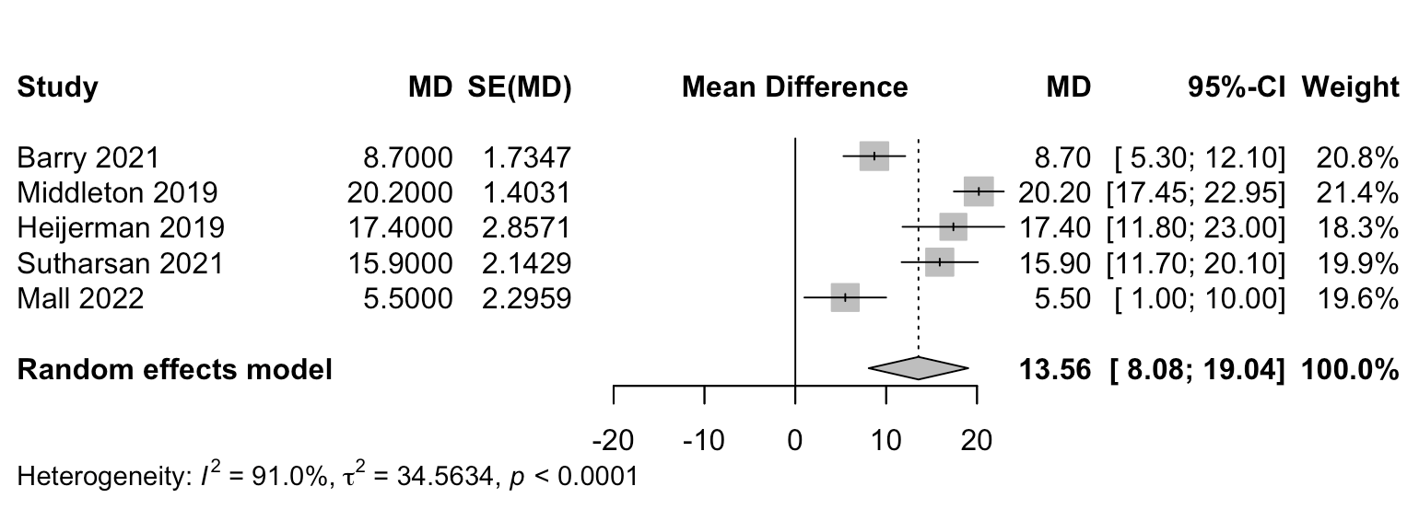

Figure S2. Forest plot of mean change after ETI for physical domain of CFQ-R
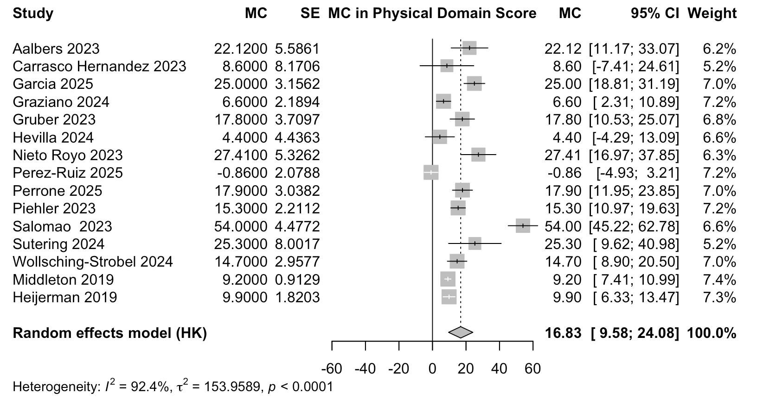

Figure S3. Forest plot of mean change after ETI for emotional functioning domain of CFQ-R
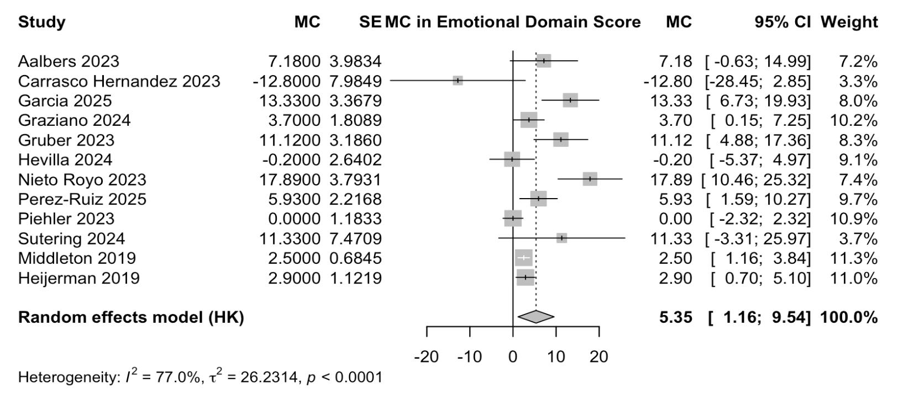

Figure S4. Forest plot of mean change after ETI for eating disturbances domain of CFQ-R
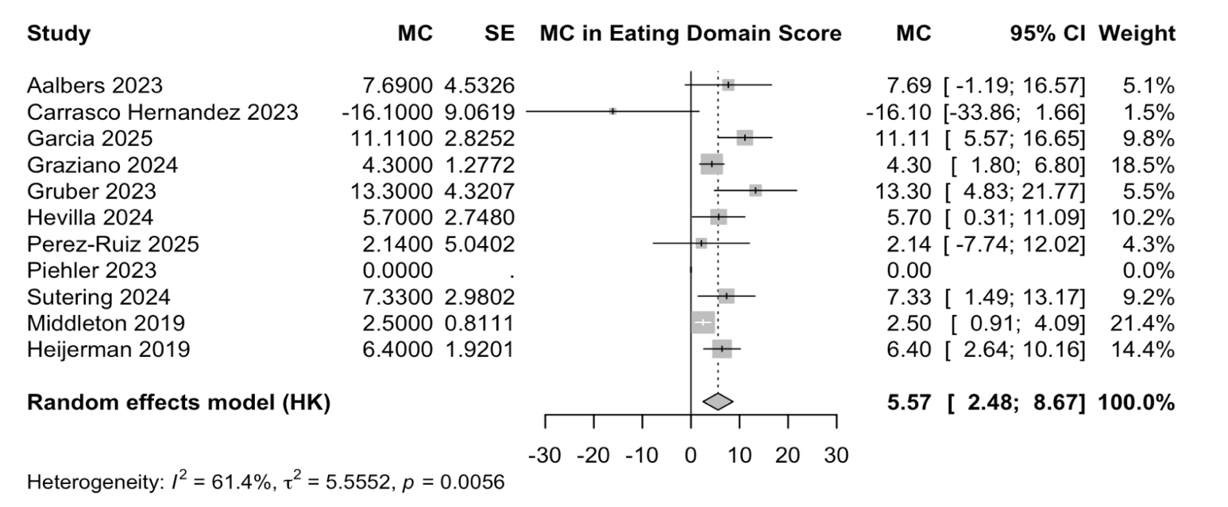

Figure S5. Forest plot of mean change after ETI for treatment burden domain of CFQ-R
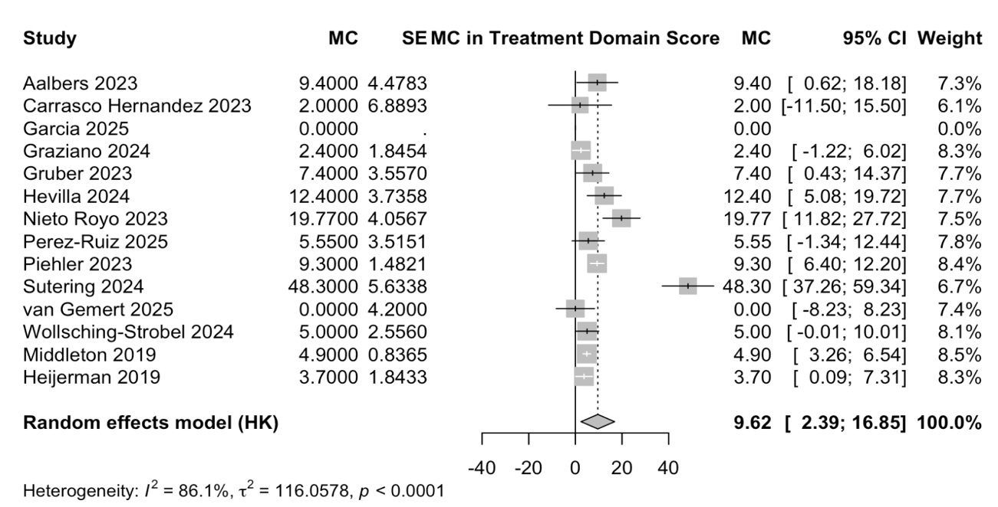

Figure S6. Forest plot of mean change after ETI for health perceptions domain of CFQ-R
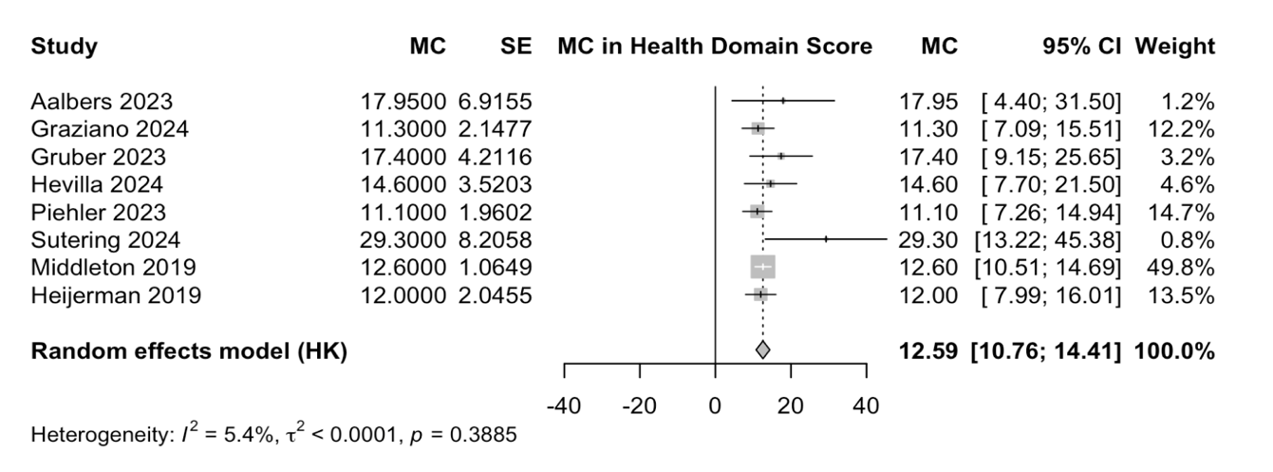
Figure S7. Forest plot of mean change after ETI for vitality domain of CFQ-R
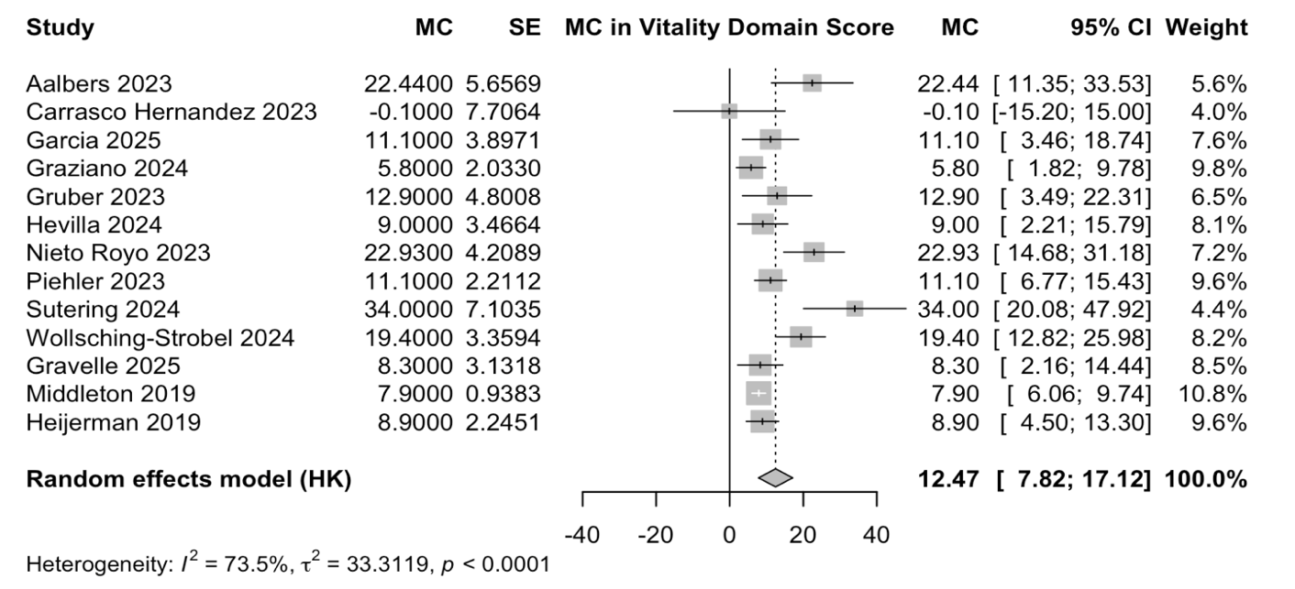

Figure S8. Forest plot of mean change after ETI for social functioning domain of CFQ-R
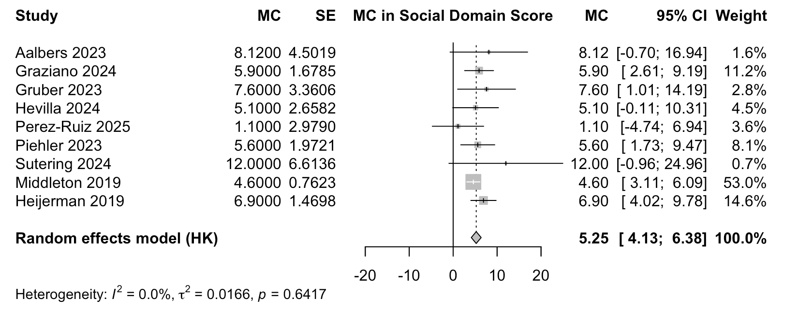
Figure S9. Forest plot of mean change after ETI for body image domain of CFQ-R

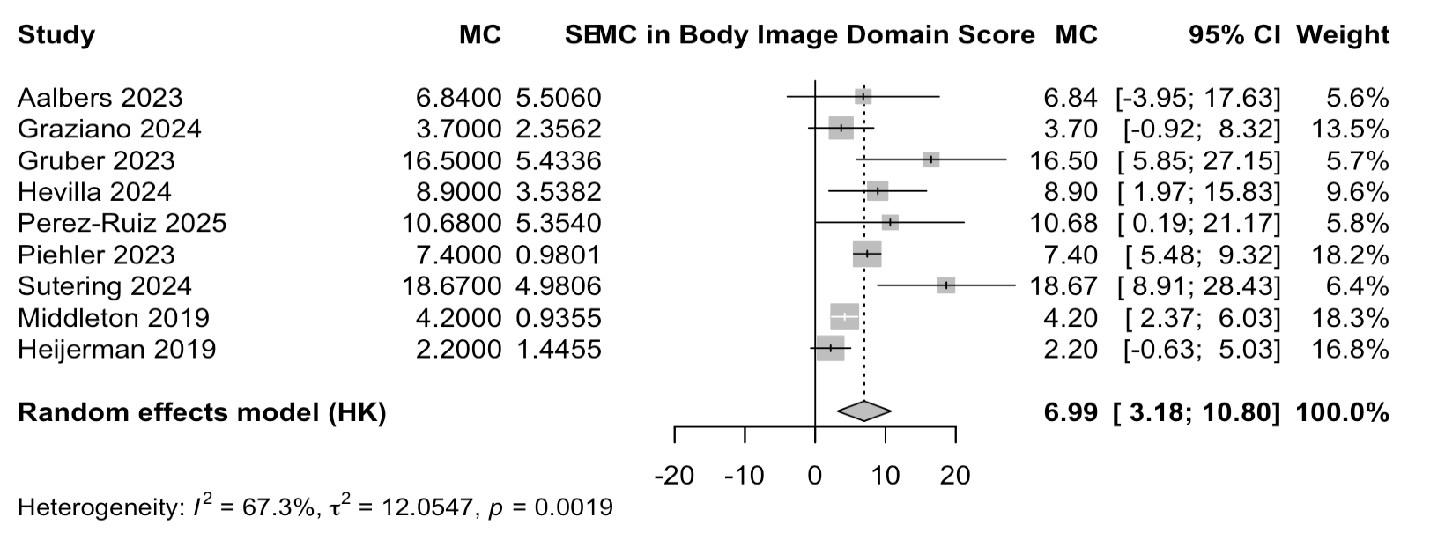
Figure S10. Forest plot of mean change after ETI for role functioning domain of CFQ-R
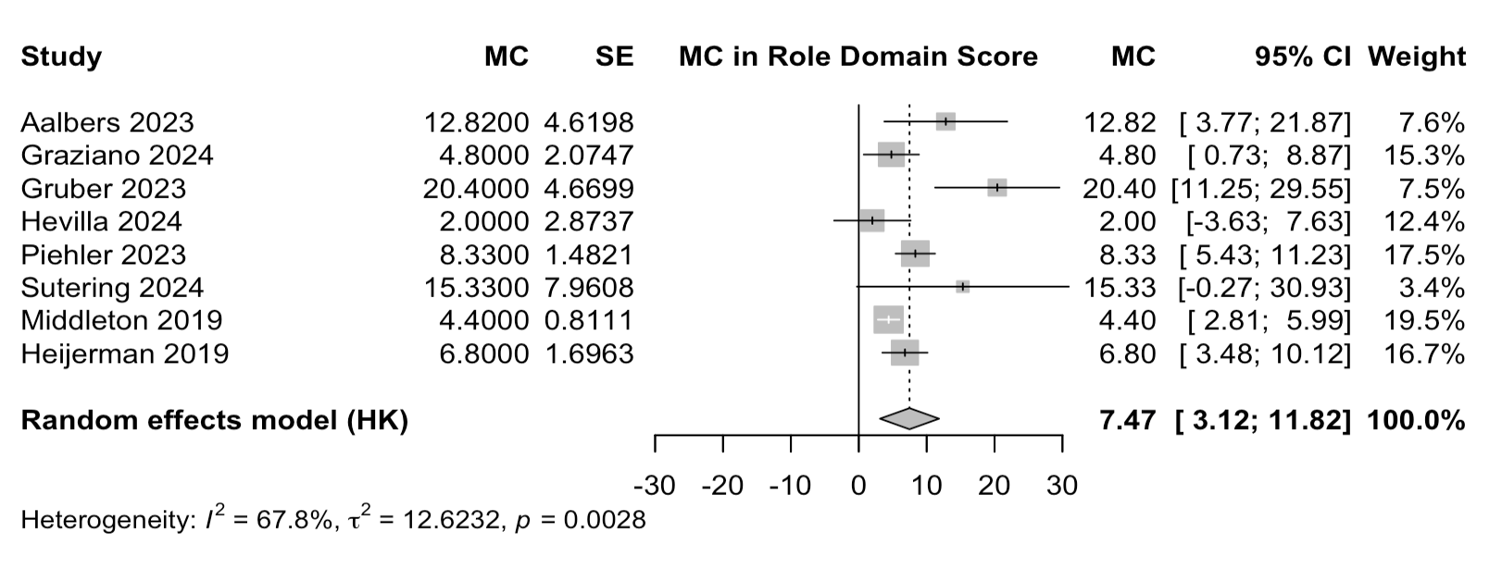

Figure S11. Forest plot of mean change after ETI for weight domain of CFQ-R
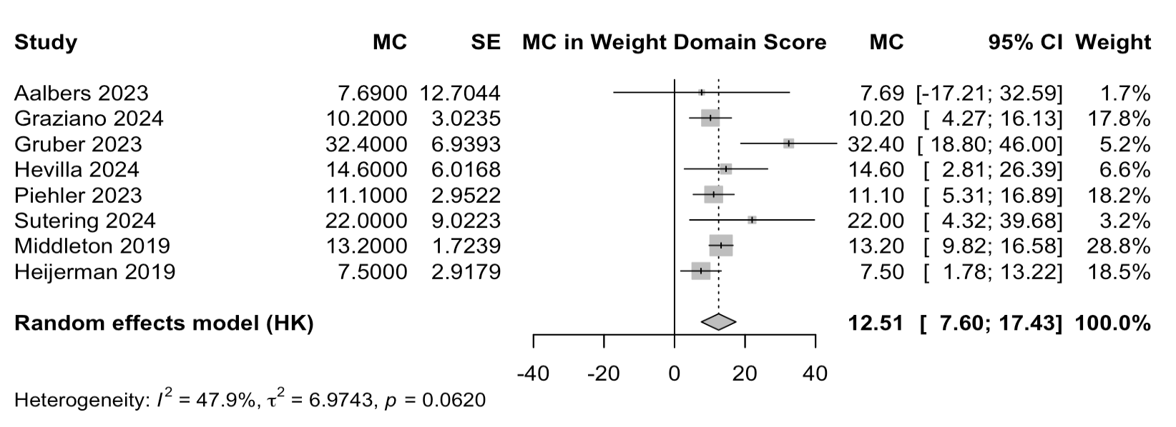

Figure S12. Forest plot of mean change after ETI for digestive domain of CFQ-R

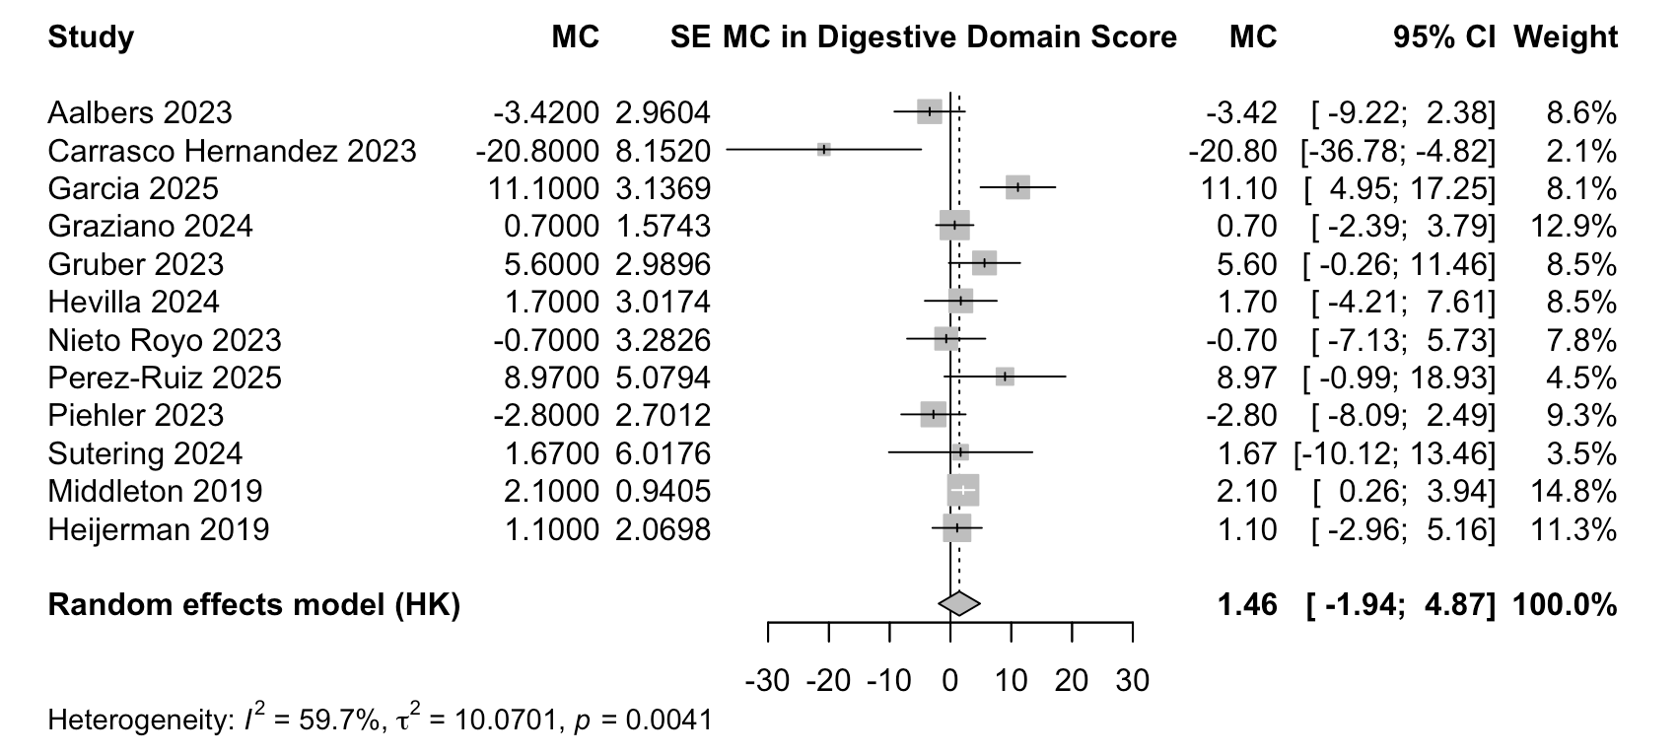

Figure S13. Forest plot of mean change after ETI for SNOT-22 score
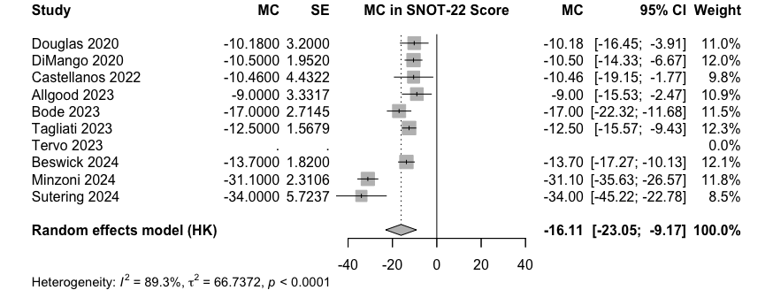

Figure S14. Forest plot of mean change after ETI for PHQ-9 score
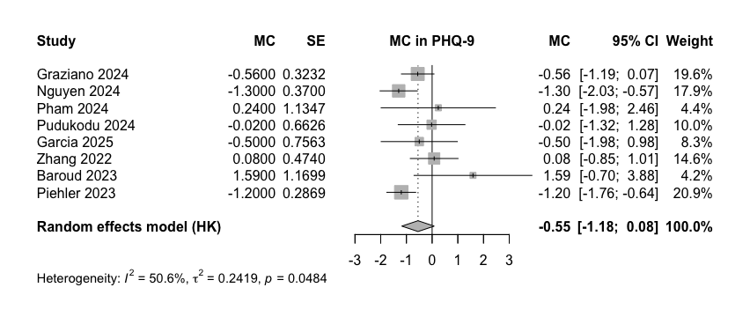

Figure S15. Forest plot of mean change after ETI for GAD-7 score
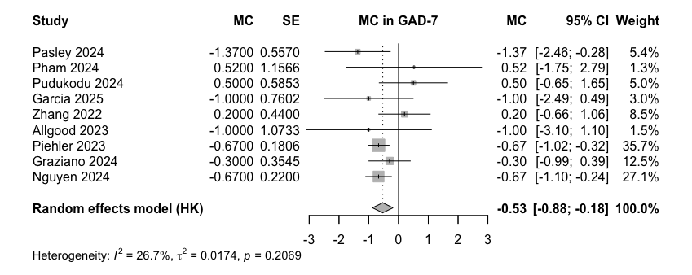
Table S8. Pooled changes after ETI initiation from across CFQ-R domains

CFQ-R domains | No. of studies | Weighted Pre-ETI score | Weighted Post-ETI score | Pooled change* (95% CI) | P-value | I²
Respiratory symptoms | 5 RCTs | 73.0 | 87.4 | 13.6 (8.1 to 19.0) | <0.0001 | 91%
Physical functioning | 15 | 70.9 | 85.2 | 16.8 (9.6 to 24.1) | 0.0002 | 92%
Emotional functioning | 12 | 78.7 | 82.0 | 5.4 (1.2 to 9.5) | 0.0170 | 77%
Eating disturbances | 10 | 88.5 | 92.4 | 5.6 (2.5 to 8.7) | 0.0028 | 61%
Treatment burden | 11 | 58.8 | 65.4 | 9.6 (2.4 to 16.8) | 0.0134 | 86%
Health perceptions | 8 | 61.8 | 74.6 | 12.6 (10.8 to 14.4) | <0.0001 | 5%
Vitality | 13 | 59.1 | 69.3 | 12.5 (7.8 to 17.1) | <0.0001 | 74%
Social functioning | 9 | 70.7 | 75.3 | 5.3 (4.1 to 6.4) | <0.0001 | 0%
Role functioning | 8 | 80.9 | 87.1 | 7.5 (3.1 to 11.8) | 0.0048 | 68%
Body image | 9 | 76.3 | 82.3 | 7.0 (3.2 to 10.8) | 0.0029 | 67%
Weight | 8 | 76.3 | 87.3 | 12.5 (7.6 to 17.4) | 0.005 | 48%
Digestive symptoms | 12 | 81.0 | 82.7 | 1.5 (-1.9 to 4.9) | 0.3645 | 60%
*=Mean difference used for RCTs and Mean change used for observational studies

REFERENCES
1. Higgins JPT, Thomas J, Chandler J, Cumpston M, Li T, Page MJ, et al., editors. Cochrane Handbook for Systematic Reviews of Interventions [Internet]. Version 6.4. London: Cochrane; 2023. Available from: https://www.training.cochrane.org/handbook
2. Wan X, Wang W, Liu J, Tong T. Estimating the sample mean and standard deviation from the sample size, median, range and/or interquartile range. BMC Medical Research Methodology. 2014;14(1):135. doi:10.1186/1471-2288-14-135
3. Fu R, Vandermeer BW, Shamliyan TA, O’Neil ME, Yazdi F, Fox SH, et al. Handling Continuous Outcomes in Quantitative Synthesis [Methods Research Report] [Internet]. Agency for Healthcare Research and Quality; 2012. Available from: https://www.ncbi.nlm.nih.gov/books/NBK154408/
4. Hozo SP, Djulbegovic B, Hozo I. Estimating the mean and variance from the median, range, and the size of a sample. BMC Medical Research Methodology. 2005;5:13. doi:10.1186/1471-2288-5-13

