Table S1. Detailed results and syntax of PubMed “radiomics” search.
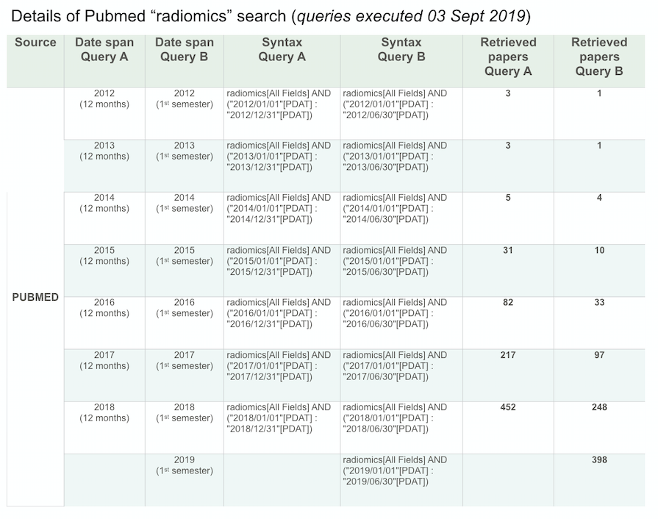

Table S2. Occurrence and category of statistic techniques in radiomics from an arbitrary sample of the 40 first research papers referenced in PubMed in 2019.

