ELECTRONIC SUPPLEMENTARY MATERIAL

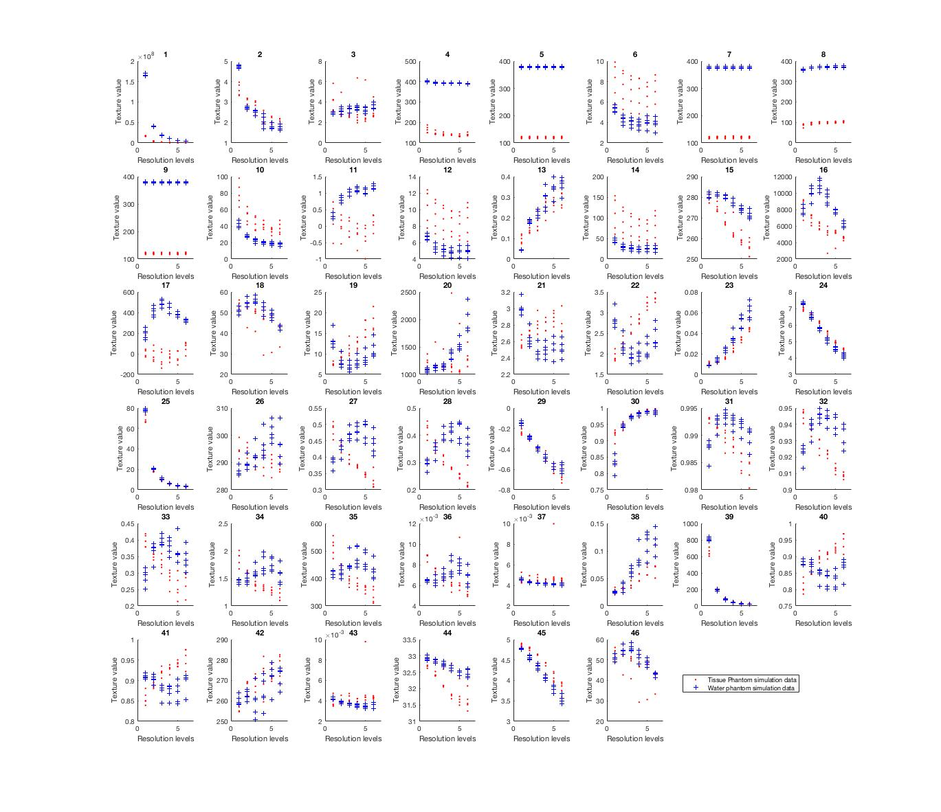
Supplementary Fig. S1. Resolution response data 1 for tissue phantom (red dots) and water phantom (blue cross) for 46 features. x-axis is resolution level. Feature numbering is described in Table 2.

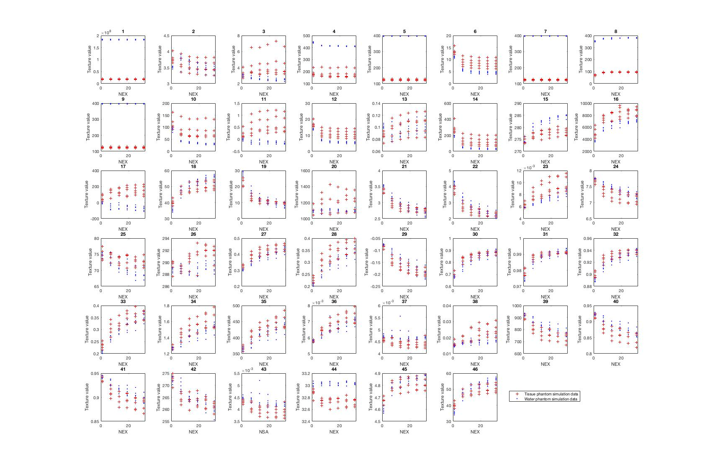
Supplementary Fig. S2. Noise response data for tissue (red cross) and water phantom (blue dot) for 46 features. NEX Number of excitations. Feature numbering is described in Table 2.

