SUPPLEMENT (S1-S5)
S1. Inclusion and exclusion criteria of the CAIRO5 trial^{[1]}
Inclusion criteria: histological proof of colorectal cancer, previously untreated and unresectable metastases confined to the liver (as assessed by the central panel) according to CT scan obtained less than 2 weeks prior to registration, adequate tumour tissue available for assessment of RAS and BRAF mutation status, WHO performance status 0-1 (Karnofsky performance status ≥ 70), age ≥ 18 years, no contraindications for liver surgery, resectable primary tumour if still in situ, adequate organ functions, life expectancy over 12 weeks, expected adequacy of follow-up, and written informed consent.
Exclusion criteria: previous systemic treatment for metastatic disease, extrahepatic metastases, with the exception of small (≤1 cm) extrahepatic lesions that are not suspicious of metastases, unresectable primary tumour, serious comorbidity or any other condition preventing the safe administration of study treatment (including both systemic treatment and surgery), major cardiovascular event within 12 months before randomisation, uncontrolled hypertension, or unsatisfactory blood pressure control with ≥3 antihypertensive drugs, previous adjuvant treatment unless completed ≥ 6 months prior to randomisation, previous surgery for metastatic disease, previous intolerance of study drugs in the adjuvant setting, pregnant or lactating women, second primary malignancy within the past 5 years with the exception of adequately treated in situ carcinoma of any organ or basal cell carcinoma of the skin, any concomitant experimental treatment.
1. Huiskens J, van Gulik TM, van Lienden KP, Engelbrecht MR, Meijer GA, van Grieken NC, et al. Treatment strategies in colorectal cancer patients with initially unresectable liver-only metastases, a study protocol of the randomised phase 3 CAIRO5 study of the Dutch Colorectal Cancer Group (DCCG). BMC Cancer. 2015;15:365. doi: 10.1186/s12885-015-1323-9.
S2. CT parameters
Development cohort (CAIRO5)
Slice thickness (mm) | 5.0 [3.0 – 5.0]
Pixel spacing (mm) | 0.73 [0.68 – 0.78]
Tube voltage (kvP) | 120 [100 – 120]
Total collimation width (mm) | 40 [40 – 40]
Exposure (mAs) | 50 – 293
CT dose index (mGy) | 2 – 15
Note – Values are displayed as median with [interquartile range] or as range.

External validation cohort
Slice thickness (mm) | 3.0 [3.0 – 5.0]
Pixel spacing (mm) | 0.74 [0.68 – 0.78]
Tube voltage (kvP) | 120 [120 – 120]
Tube current (mA) | 239 [143 – 325]
Note – Values are displayed as median with [interquartile range].
S3. Model details
Model
Architecture | U-net ^{[2]}
Input resolution | 512x512
Output resolution | 512x512
Number of convolutional layers | 23
Solver
Solver type | Adam
Loss function | Entropy
Learning rate | 0.0001
Minimum gradient value | -100
Maximum gradient value | 100
Optimizer
L1 | 0
L2 | 0.0001
Mini batch size | 1
Dropout | 0

2. Ronneberger O, Fischer P, Brox T. U-Net: Convolutional Networks for Biomedical Image Segmentation. In: Navab N, Hornegger J, Wells WM, Frangi AF, editors. Medical Image Computing and Computer-Assisted Intervention – MICCAI 2015. Cham: Springer International Publishing; 2015. p. 234-41.
S4. Scans in training, validation and test set
Patient | Number of training scans | Number of validation scans | Number of test scans
001 | 2
004 | 2
007 | 2
010 | 2
011 | 3
012 | 2
014 | 2
015 | 2
017 | 2
018 | 3
021 | 2
022 | 3
026 | 2
027 | 2
028 | 2
029 | 2
030 | 2
032 | 2
033 | 3
034 | 2
036 | 2
037 | 2
038 | 2
041 | 2
043 | 2
044 | 2
045 | 2
046 |  |  | 2
047 |  |  | 3
048 |  |  | 2
049 |  |  | 2
050 | 2
051 | 2
052 | 1
053 | 2
054 | 2
055 | 2
057 | 2
058 | 2
061 | 1
062 | 2
063 | 2
065 | 3
066 | 2
067 | 2
068 | 2
070 | 3
072 | 2
074 | 2
075 | 3
076 | 2
077 |  |  | 3
078 |  |  | 3
079 |  |  | 2
082 | 2
083 | 3
084 | 1 | 1
085 | 2
086 | 2
087 | 3
088 | 2
089 | 2
092 | 2
093 | 2
095 | 2
096 | 1
097 | 2
101 | 2
102 | 3
105 | 2
107 | 3
111 | 3
112 | 2
116 | 2
117 | 2
118 | 4
121 | 2
122 | 3
123 | 2
124 | 2
125 |  |  | 2
126 |  |  | 2
127 |  |  | 2
128 |  |  | 2
129 |  |  | 2
130 | 1 | 1
131 |  |  | 4
132 |  |  | 2
133 |  |  | 3
134 |  |  | 2
135 | 2
136 |  | 2
137 |  | 2
138 |  | 2
139 | 2
140 | 2
141 | 2
143 |  | 2
144 | 2
148 |  | 2
151 | 2
152 | 4
153 | 2
154 | 4
155 | 2
157 | 3
158 | 2
159 | 2
161 | 2
162 | 2
165 | 3
166 | 3
167 | 2
168 | 2
169 | 2
174 | 2
175 | 2
176 | 2
177 | 2
178 | 3
180 | 2
182 | 2
185 | 3
186 | 3
188 | 2
189 | 2
191 | 2
194 | 3
195 | 2
197 | 2
198 | 2
200 | 3
202 | 2
204 | 2
205 | 2
207 | 2
208 | 3
210 | 2
211 | 3
215 | 2
216 |  |  | 2
218 | 3
220 |  |  | 2
221 |  |  | 2
222 |  |  | 3
223 |  |  | 2
224 |  |  | 2
225 |  |  | 2
226 | 4
227 |  |  | 2
229 |  |  | 2
230 | 2
231 |  |  | 2
232 |  |  | 4
235 | 1 | 2
236 |  | 3
237 |  | 2
240 | 2
241 | 2
242 | 4
245 | 2
247 | 3
248 | 2
252 | 2
253 | 3
255 | 3
256 | 2
257 | 3
259 | 2
261 | 2
262 | 3
265 | 2
266 | 2
267 | 3
269 | 3
270 | 3
272 | 2
273 | 2
274 | 2
277 | 1
282 | 2
283 | 2
284 | 2
286 | 2
287 |  |  | 2
291 | 3
292 | 2
293 | 2
295 | 2
296 | 2
297 |  |  | 3
298 | 2
299 | 4
300 | 3
302 |  |  | 2
303 |  |  | 2
304 | 2
305 | 2
306 |  |  | 4
307 |  |  | 2
308 | 3
309 | 2
310 | 3
311 | 2
312 | 3
314 | 2
315 | 2
318 | 3
323 | 2
324 | 4
325 | 4
326 | 2
327 | 2
330 | 2
331 |  |  | 2
332 |  |  | 4
334 | 2
335 |  |  | 2
336 |  |  | 2
337 |  |  | 2
338 |  |  | 2
339 |  |  | 2
340 |  |  | 2
342 |  |  | 2
344 |  |  | 3
346 |  |  | 2
347 |  |  | 2
348 |  |  | 3
349 |  |  | 3
350 |  | 2
351 |  | 4
352 |  | 2
353 | 2
354 | 2
355 | 2
358 | 3
359 | 2
362 | 3
364 | 2
365 | 2
367 | 3
368 | 2
369 | 2
370 |  |  | 3
372 | 3
374 | 2
375 | 2
378 | 2
379 | 2
383 |  | 2
384 |  | 3
386 | 1 | 1
388 |  | 2
389 |  |  | 2
390 |  |  | 2
396 |  |  | 2
400 |  |  | 2
406 |  | 2
407 |  | 2

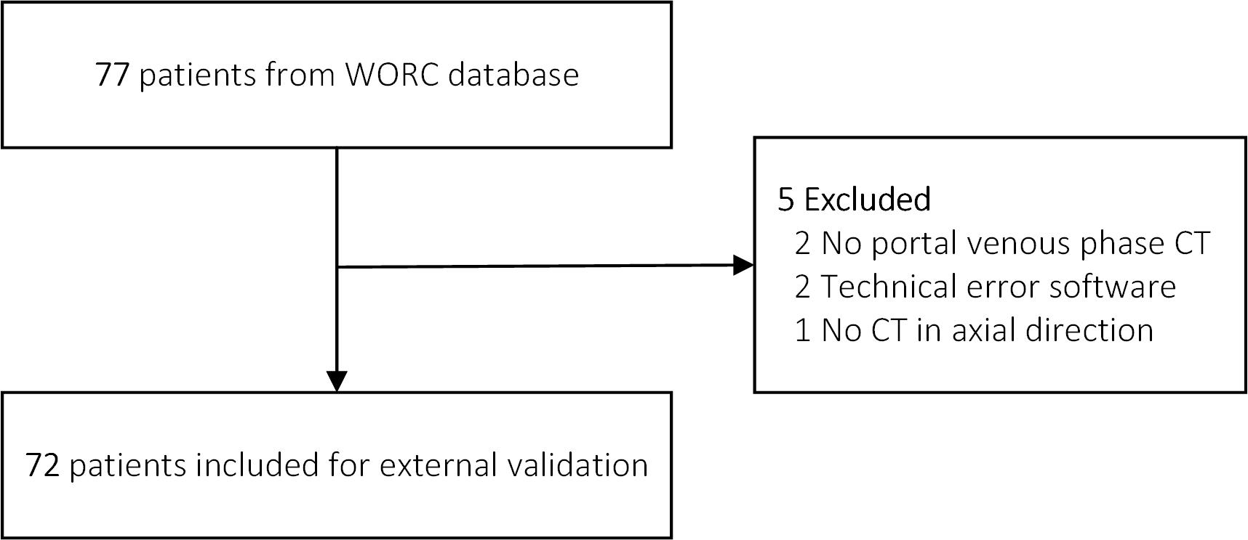
S5. Flow diagram patient selection external validation cohort

Abbreviations: CT, computed tomography; WORC, Workflow for Optimal Radiomics Classification.

