Evaluation of MR-safe bioptomes for MR-guided endomyocardial biopsy in minipigs: a potential radiation-free clinical approach

ELECTRONIC SUPPLEMENTARY MATERIAL

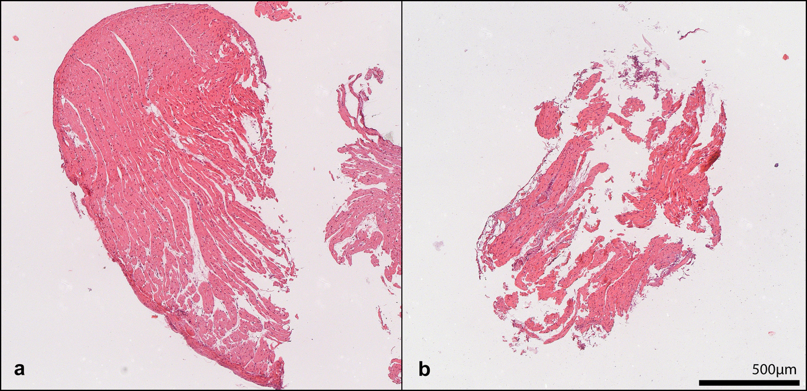
Figure S1. Histological H&E sections from ex vivo obtained biopsies. (A) shows a large tissue fragment featuring non-lacerated, non-deformed myocardium judged of sufficient diagnostic value. (B) example section of a non-diagnostically valuable sample with significant rupture and deformation.

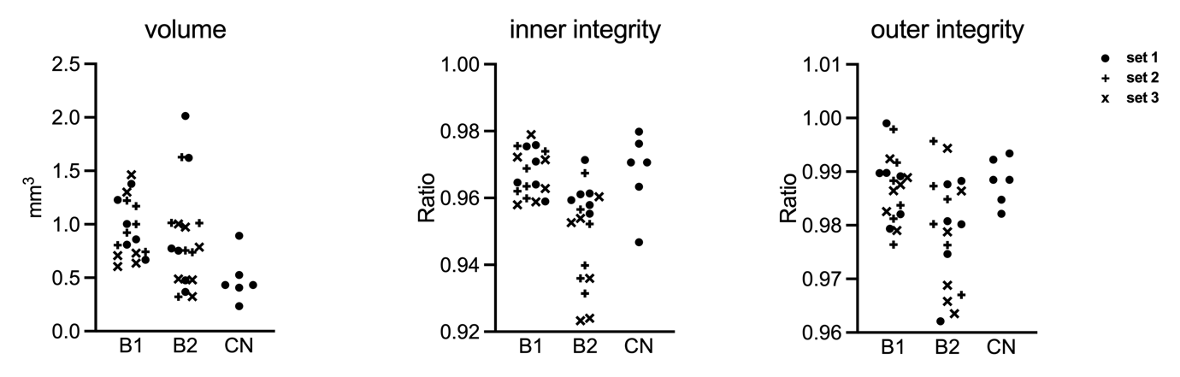
Figure S2. Distributions of SRµCT quantified values between the 3 consecutive sampling sets in B1 and B2.

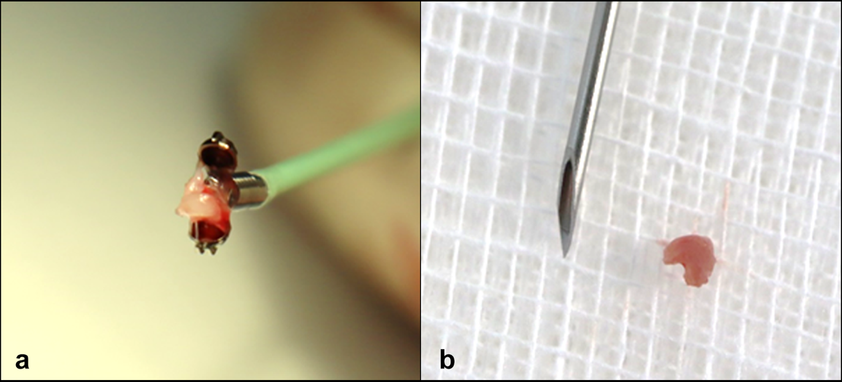
Figure S3. Bioptome B2 with typical myocardial specimen rated as “normal”. (A) specimen in the open forceps; (B) specimen in comparison to a beveled 18 Gauge (1.27 mm) Intradyn® introducer needle (Braun Melsungen, Germany).

