Oxygen-enhanced MRI assessment of tumour hypoxia in head and neck cancer is feasible and well tolerated in the clinical setting
ELECTRONIC SUPPLEMENTARY MATERIAL

Appendix 1
PRIMARY TUMOUR |  |  |  | T1 time: median (ms) |  |  |  | R₂* rate: median (Hz)
Participant | p16 | HPV DNA | Volume (cm³) | Baseline  (IQR) | ΔT1 (%)  (IQR) | p-value | Hypoxic fraction (%) | Baseline  (IQR) | ΔR₂*  (IQR) | p-value
1 | - | N/A | 31.15 | 1417  (294) | -0.7  (4.8) | <0.0001 | 78.6 | 26.1  (27.6) | 0.9  (16.9) | 0.0004
3 | N/A | N/A | 4.35 | 1170  (197) | -2.6  (4.7) | <0.0001 | 73.5 | 43.6  (35.2) | 0.0  (37.0) | 0.6852
5 | + | + | 3.98 | 1239  (198) | -5.4  (4.2) | <0.0001 | 30.7 | 27.8  (39.1) | 10.7  (38.8) | <0.0001
6 | N/A | N/A | 8.83 | 1400  (178) | -0.6  (2.5) | <0.0001 | 70.4 | 20.6  (26.9) | 3.4  (14.7) | <0.0001
7 | + | N/A | 33.70 | 1206  (239) | -3.4  (4.9) | <0.0001 | 50.0 | 47.3  (66.6) | -8.6  (55.5) | <0.0001
9 | + | + | 0.61 | 716  (152) | -3.5  (2.7) | <0.0001 | 44.0 | 51.4  (39.2) | 4.8  (18.1) | 0.0392
10 (i) | + | + | 5.04 | 1034  (190) | -7.0  (3.8) | <0.0001 | 13.3 | 68.8  (57.7) | 0.4  (27.6) | 0.5291
10 (ii) | + | + | 17.69 | 997  (196) | -2.6  (2.3) | <0.0001 | 27.1 | 26.1  (23.3) | 0.0  (8.1) | 0.0115
11 | N/A | N/A | 33.11 | 1211  (223) | -5.4  (4.4) | <0.0001 | 19.3 | 25.1  (25.4) | 0.2  (25.4) | 0.2705
13 | - | - | 0.54 | 817  (372) | -5.5  (6.0) | <0.0001 | 26.1 | 144.8  (73.1) | -29.1  (49.7) | <0.0001
14 | + | - | 21.60 | 1066  (146) | -0.3  (4.3) | <0.0001 | 70.2 | 29.6  (17.7) | 0.0  (17.7) | 0.5403
15 | + | + | 2.35 | 1206  (173) | -6.5  (3.6) | <0.0001 | 6.5 | 21.7  (27.0) | -0.5  (15.2) | 0.4338
16 | + | N/A | 3.75 | 1200  (194) | -4.6  (2.3) | <0.0001 | 9.8 | 33.6  (20.5) | 9.7  (17.4) | <0.0001
19 | + | + | 4.55 | 1256  (164) | -3.6  (3.0) | <0.0001 | 24.1 | 20.1  (22.2) | 4.1  (18.0) | <0.0001
20 | N/A | N/A | 7.20 | 1179  (224) | -3.1  (6.4) | <0.0001 | 53.4 | 43.5  (40.5) | 3.6  (45.8) | <0.0001
MALIGNANT NODES |  |  |  | T1 time: median (ms) |  |  |  | R₂* rate: median (Hz)
Participant | p16 | HPV DNA | Volume (cm³) | Baseline  (IQR) | ΔT1 (%)  (IQR) | p-value | Hypoxic fraction (%) | Baseline  (IQR) | ΔR₂*  (IQR) | p-value
1 (i) | - | N/A | 2.50 | 1353  (296) | -1.8  (5.6) | <0.0001 | 64.6 | 29.6  (12.7) | -1.3  (13.5) | 0.1550
1 (ii) | - | N/A | 1.31 | 1087  (216) | 1.2  (4.1) | 0.0008 | 82.8 | 11.2  (32.2) | 18.5  (31.9) | <0.0001
3 (i) | N/A | N/A | 4.27 | 1262  (429) | -3.0  (6.0) | <0.0001 | 63.3 | 21.3  (10.1) | 0.1  (10.9) | 0.6329
3(ii) | N/A | N/A | 9.81 | 1327  (302) | -3.0  (4.5) | <0.0001 | 60.2 | 17.5  (15.1) | 5.6  (14.9) | <0.0001
4 (i) | + | + | 10.71 | 1339  (629) | -1.0  (4.6) | <0.0001 | 60.5 | 15.2  (18.1) | 4.3  (17.3) | <0.0001
5 (i) | + | + | 10.88 | 1343  (194) | -2.2  (3.1) | <0.0001 | 59.9 | 14.3  (8.8) | 5.9  (9.8) | <0.0001
5(ii) | + | + | 1.64 | 1177  (197) | -2.3  (3.2) | <0.0001 | 51.7 | 30.9  (19.9) | -2.8  (19.7) | 0.0684
6 (i) | N/A | N/A | 7.23 | 1547  (244) | -1.7  (2.4) | <0.0001 | 60.3 | 20.1  (14.3) | 2.0  (10.5) | <0.0001
6 (ii) | N/A | N/A | 3.50 | 1426  (146) | -1.5  (2.9) | <0.0001 | 56.1 | 20.0  (13.2) | 2.1  (11.3) | <0.0001
6 (iii) | N/A | N/A | 20.56 | 1674  (619) | -1.8  (3.7) | <0.0001 | 67.9 | 15.2  (15.8) | -1.3  (7.8) | <0.0001
(iv) | N/A | N/A | 1.01 | 847  (654) | -2.6  (7.8) | <0.0001 | 63.9 | 28.1  (28.7) | -4.4  (8.7) | <0.0001
6 (v) | N/A | N/A | 1.16 | 1324  (433) | -0.2  (3.1) | 0.5021 | 77.4 | 20.8  (12.4) | -0.4  (6.3) | 0.4582
(vi) | N/A | N/A | 8.41 | 1345  (198) | -4.0  (3.2) | <0.0001 | 37.3 | 17.0  (7.7) | -1.0  (12.5) | <0.0001
6 (vii) | N/A | N/A | 1.19 | 1402  (203) | -2.2  (2.1) | <0.0001 | 43.1 | 16.5  (8.4) | -2.8  (7.6) | <0.0001
6 (viii) | N/A | N/A | 1.70 | 1455  (101) | -2.7  (2.7) | <0.0001 | 31.9 | 15.2  (11.2) | -4.2  (7.7) | <0.0001
6 (ix) | N/A | N/A | 6.32 | 1424  (142) | -1.9  (2.3) | <0.0001 | 51.5 | 18.2  (7.8) | -2.0  (8.4) | <0.0001
6 (x) | N/A | N/A | 1.54 | 1327  (363) | -1.2  (3.4) | <0.0001 | 73.4 | 24.5  (14.1) | 1.7  (7.0) | <0.0001
7 (i) | + | N/A | 0.37 | 1333  (392) | -1.6  (4.2) | 0.0045 | 80.0 | 20.6  (12.3) | 1.2  (7.5) | 0.0827
7 (ii) | + | N/A | 3.13 | 1371  (220) | -5.3  (3.8) | <0.0001 | 34.6 | 16.4  (15.0) | 11.3  (19.5) | <0.0001
7 (iii) | + | N/A | 6.44 | 1232  (288) | -0.4  (5.1) | <0.0001 | 84.4 | 29.8  (14.5) | -3.0  (21.3) | <0.0001
7 (iv) | + | N/A | 0.54 | 903  (383) | -1.9  (6.8) | 0.0059 | 74.2 | 17.5  (22.4) | -2.7  (22.1) | 0.0080
9 (i) | + | + | 11.98 | 1258  (269) | -4.7  (3.7) | <0.0001 | 14.5 | 18.9  (12.8) | 0.2  (7.6) | 0.0314
10 (i) | + | + | 5.55 | 1019  (254) | -4.6  (3.6) | <0.0001 | 21.7 | 18.1  (10.6) | 0.5  (7.1) | 0.0104
10 (ii) | + | + | 0.26 | 577  (187) | -6.5  (12.5) | 0.0001 | 28.6 | 23.8  (12.5) | -0.4  (4.6) | 0.4074
11 (i) | N/A | N/A | 0.46 | 957  (231) | -3.9  (5.9) | <0.0001 | 36.0 | 27.7  (17.5) | -7.1  (7.6) | <0.0001
13 (i) | - | - | 9.94 | 1567  (252) | -1.1  (3.4) | <0.0001 | 69.0 | 12.7  (12.2) | -1.4  (10.8) | <0.0001
14 (i) | + | - | 8.40 | 1246  (177) | -3.3  (3.7) | <0.0001 | 35.7 | 16.4  (13.1) | 2.1  (13.7) | <0.0001
14 (ii) | + | - | 0.48 | 1205  (365) | -2.4  (4.8) | <0.0001 | 59.5 | 20.2  (11.6) | -0.2  (12.4) | 0.6045
14 (iii) | + | - | 1.10 | 1202  (211) | -0.6  (4.4) | 0.1290 | 89.5 | 23.0  (17.5) | -12.7  (29.4) | <0.0001
15 (i) | + | + | 5.93 | 1454  (303) | -2.8  (4.1) | <0.0001 | 58.0 | 16.6  (11.7) | -6.0  (13.8) | <0.0001
15 (ii) | + | + | 0.54 | 1546  (330) | -4.8  (3.5) | <0.0001 | 21.6 | 9.1  (7.5) | -4.5  (6.7) | 0.0002
15 (iii) | + | + | 2.62 | 1590  (289) | -2.1  (3.5) | <0.0001 | 55.9 | 6.9  (7.3) | 10.6  (8.0) | <0.0001
15 (iv) | + | + | 0.62 | 1521  (267) | -2.0  (2.7) | <0.0001 | 64.4 | 15.2  (12.3) | 9.0  (7.4) | <0.0001
15 (v) | + | + | 3.40 | 1656  (384) | -3.3  (3.4) | <0.0001 | 30.7 | 18.4  (11.0) | 2.3  (7.4) | <0.0001
15 (vi) | + | + | 0.93 | 1664  (320) | -0.6  (3.1) | 0.0012 | 71.7 | 20.2  (6.4) | 5.2  (4.0) | <0.0001
15 (vii) | + | + | 7.19 | 1577  (318) | -1.0  (2.7) | <0.0001 | 72.0 | 18.4  (11.0) | -2.8  (6.4) | <0.0001
16 (i) | + | N/A | 0.93 | 1187  (351) | -5.2  (5.0) | <0.0001 | 21.7 | 27.1  (12.0) | -6.1  (5.8) | <0.0001
16 (ii) | + | N/A | 11.07 | 1249  (148) | -4.4  (2.6) | <0.0001 | 11.6 | 24.1  (9.7) | 1.7  (10.6) | <0.0001
19 (i) | + | + | 8.35 | 1448  (585) | -2.3  (6.6) | <0.0001 | 57.5 | 14.4  (18.7) | 2.8  (11.7) | <0.0001
20 (i) | N/A | N/A | 1.87 | 1359  (257) | -0.4  (6.3) | 0.8391 | 75.6 | 17.3  (19.9) | 24.7  (16.3) | <0.0001
20 (ii) | N/A | N/A | 1.17 | 1285  (240) | 0.0  (6.2) | 0.6378 | 82.3 | 10.8  (25.2) | 10.7  (45.2) | 0.0004

Supplementary Figures

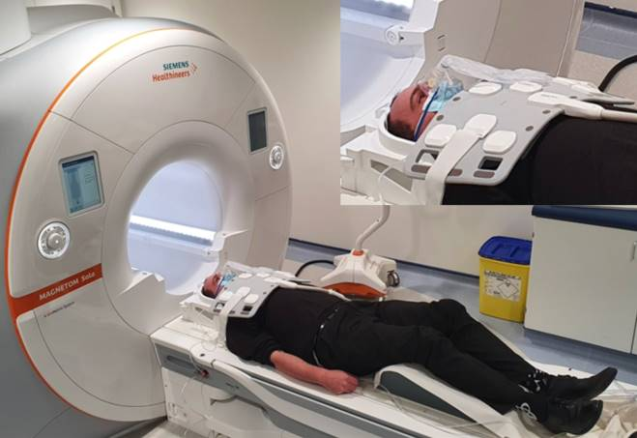
Fig. S1. A member of the research team modelling the participant setup. The posterior component of the head coil was used together with an ultraflex large 18-channel coil positioned over the neck region allowing ready placement of the non-rebreather oxygen mask. The non-rebreather bag was positioned on top of the ultraflex coil. Study participants wore ear plugs and ear defenders and did not wear a surgical face mask during the scan.

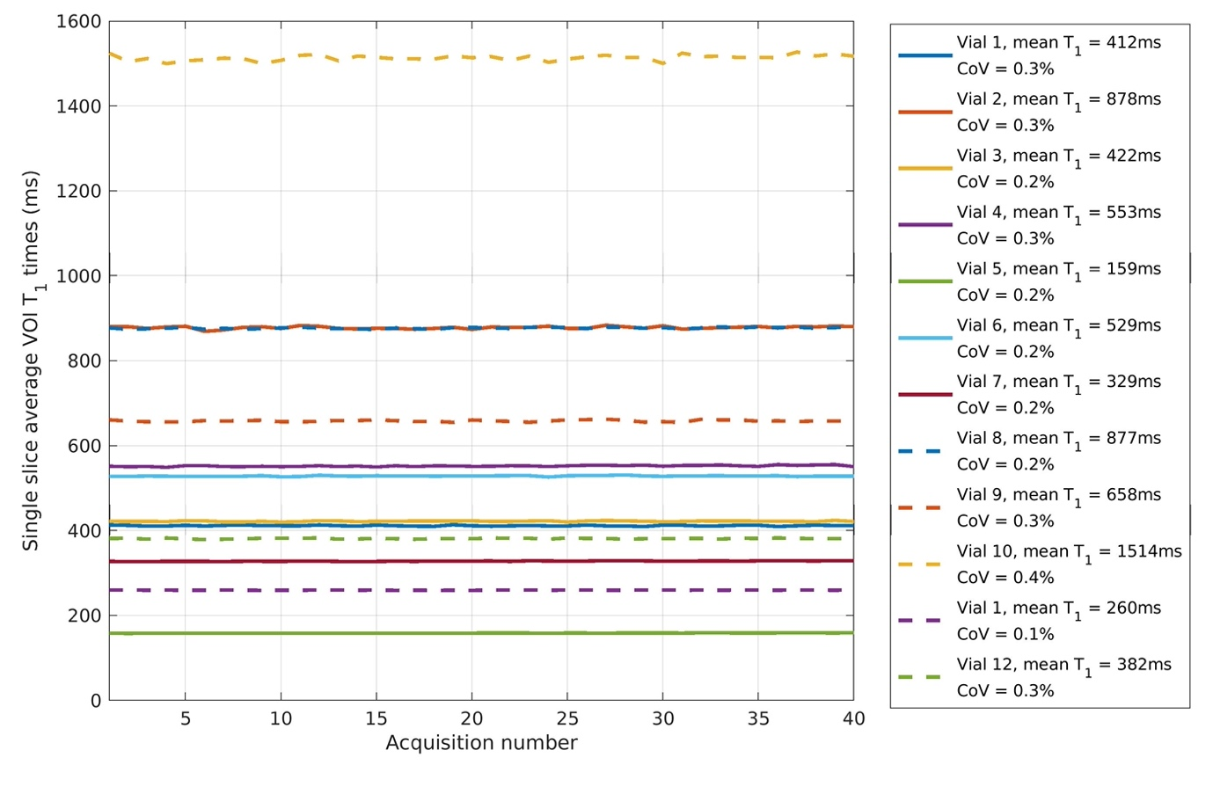
Fig. S2. T1 values for 12 tubes in a Eurospin TO5 phantom measured using the study dynamic vibe sequence. T1 values quoted are mean values over all 40 acquisitions. Coefficient of variations quoted for each tube have a median value of 0.2%.

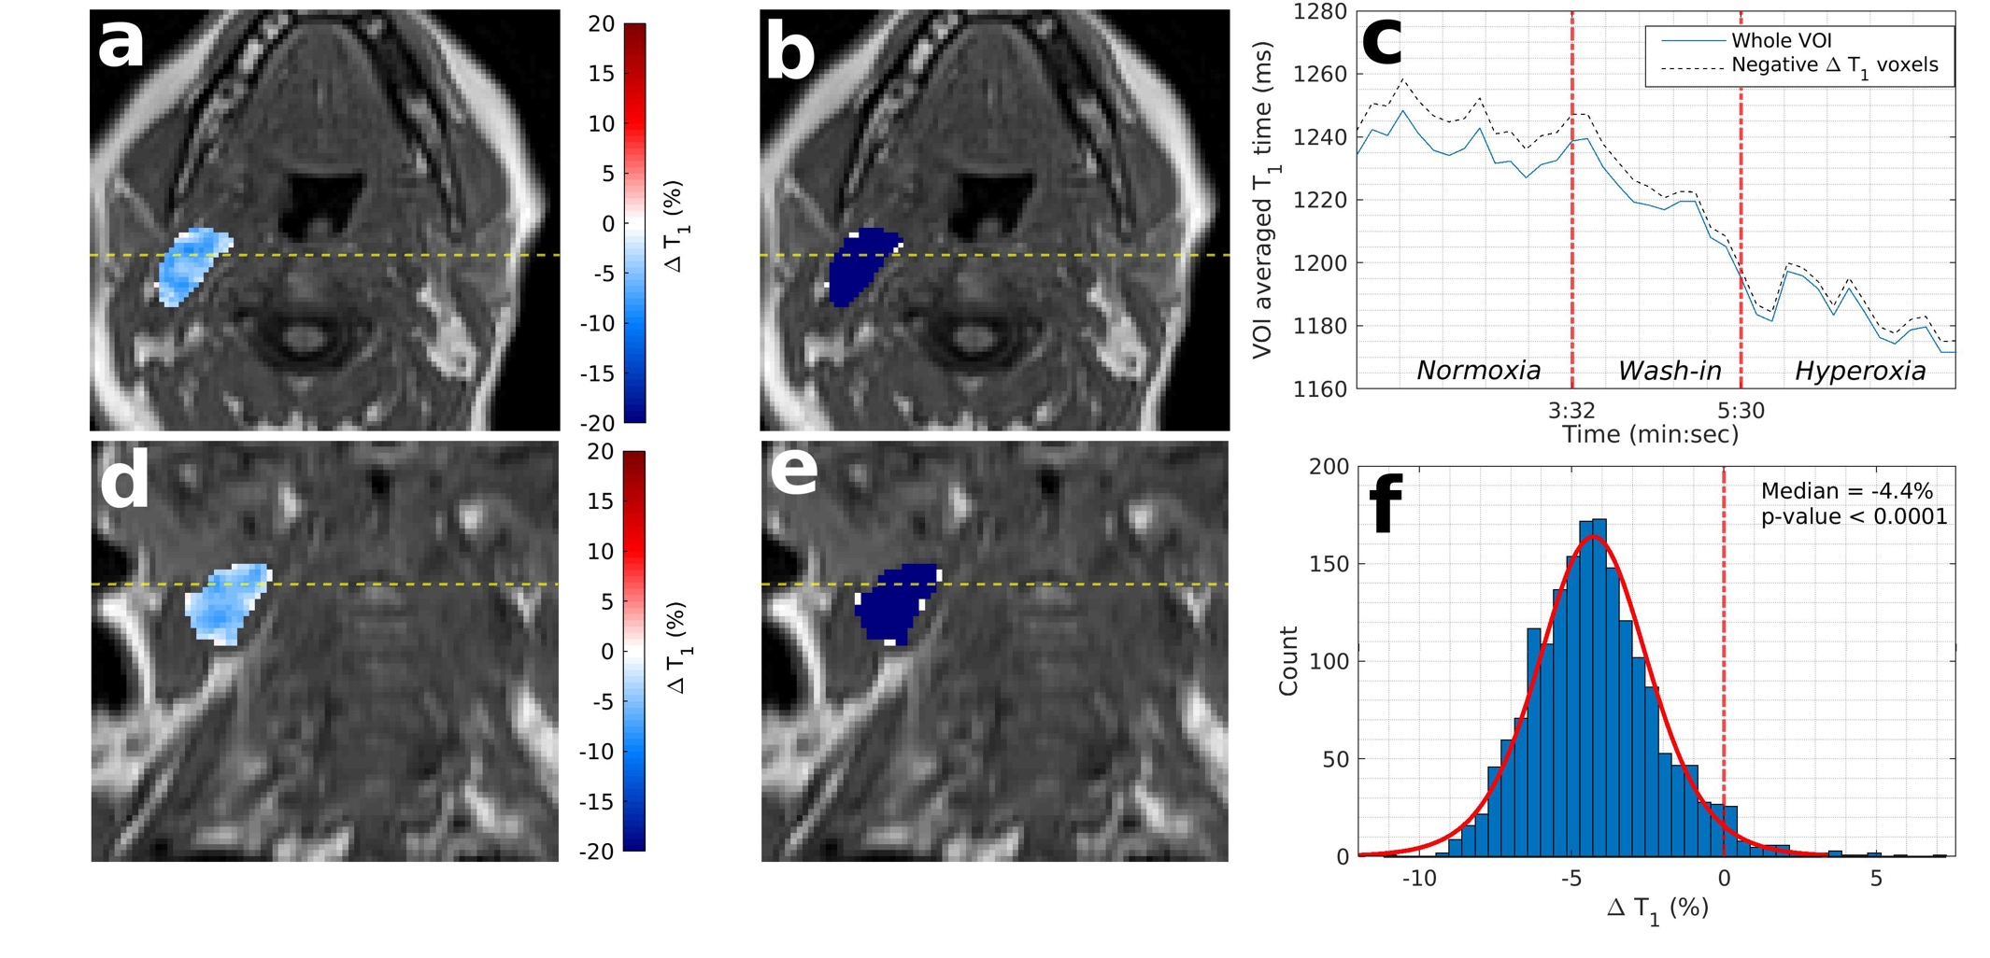
Fig. S3. Example OE-MRI parametrical maps in a patient with a suspected malignant nodal mass (patient no: 16 Lymph Node no: 2). Low estimated hypoxic fraction (11.6%) is shown on a T1 weighted vibe image with overlaid parametric ΔT1 map of the malignant mass (a, d, axial and coronal plane respectively) and overlaid statistical map of ΔT1 times (b, e). Blue colour indicates statistically significant decrease in T1 times, white indicating no statistically significant change and red indicating statistically significant increasing T1 times. c Time series of T1 times averaged over the entire malignant node VOI and over those voxels with significantly decreasing T1 times only. f Histogram of ΔT1 times for the entire malignant nodal VOI. OE-MRI Oxygen-enhanced magnetic resonance imaging, VIBE Volumetric interpolated breath-hold examination, VOI Volume of interest.
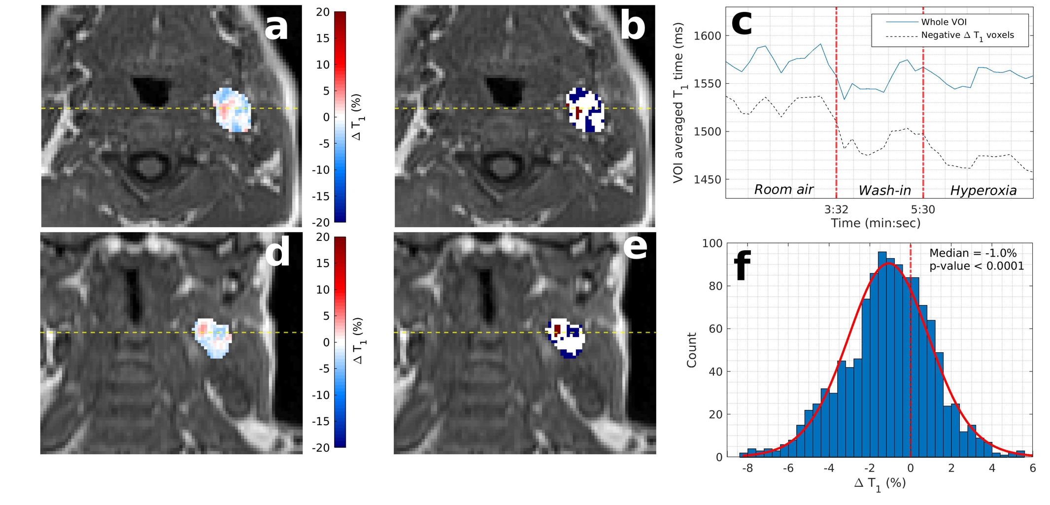
Fig. S4. Example OE-MRI parametrical maps in a patient with a suspected malignant nodal mass (patient no: 15 Lymph Node no: 7). High estimated hypoxic fraction (72.0%) is shown on a T1 weighted vibe image with overlaid parametric ΔT1 map of the malignant mass (a, d, axial and coronal plane respectively) and overlaid statistical map of ΔT1 times (b, e). Blue colour indicates statistically significant decrease in T1 times, white indicating no statistically significant change and red indicating statistically significant increasing T1 times. c Time series of T1 times averaged over the entire malignant node VOI and over those voxels with significantly decreasing T1 times only. f Histogram of ΔT1 times for the entire malignant nodal VOI. OE-MRI Oxygen-enhanced magnetic resonance imaging, VIBE Volumetric interpolated breath-hold examination, VOI Volume of interest.

Supplementary Table

Supplementary Table S1 Summed scores from all patient participants for each of the 15 domains assessed in the MRI specific anxiety questionnaire.
 | Total score for 20 patient participants
Statement | Mask on | No mask | Difference
1. I felt that I controlled the situation | 27 (73) | 24 (76) | -3
2. I had palpitations (heart feeling unusual) | 24 | 22 | -2
3. I found it hard to breathe | 22 | 23 | 1
4. I was afraid | 32 | 27 | -5
5. I wanted to come out | 26 | 27 | 1
6. I panicked | 22 | 22 | 0
7. I felt relaxed | 36 (64) | 29 (71) | -7
8. I felt safe | 25 (75) | 24 (76) | -1
9. I worried in advance | 35 | 28 | -7
10. I felt calm | 31 (69) | 27 (73) | -4
11. I had to force myself to manage the situation | 31 | 30 | -1
12. Self-control was required when going through the examination | 38 | 35 | -3
13. I needed support and encouragement | 25 | 25 | 0
14. I wished to have someone with me | 26 | 26 | 0
15. I needed more detailed information | 20 | 21 | 1

Lowest potential summed score is 20 (lowest anxiety) to 80 (maximum anxiety). The scores for domains 1, 7, 8 and 10 have been inverted to allow ease of comparison (original scores stated in brackets).

