Thin-slice reverse encoding distortion correction DWI facilitates visualization of non-functioning pituitary neuroendocrine tumor (PitNET)/pituitary adenoma and surrounding normal structures

ELECTRONIC SUPPLEMENTARY MATERIAL

Supplementary Table S1
Interrater reliability of qualitative evaluations
 | κ
Frontal artifact | 0.59
Temporal artifact | 0.66
Right optic nerve | 0.61
Left optic nerve | 0.64
Right oculomotor nerve | 0.78
Left oculomotor nerve | 0.71
Right trigeminal nerve | 0.66
Left trigeminal nerve | 0.74
Cavernous sinus invasion | 0.69
Overall tumor visualization | 0.76
The calculated κ statistic is interpreted as follows: ≤ 0.20, slight agreement; 0.21–0.40, fair agreement; 0.41–0.60, moderate agreement; 0.61–0.80, substantial agreement; and 0.81–1.00, almost perfect agreement.

Supplementary Figure S1
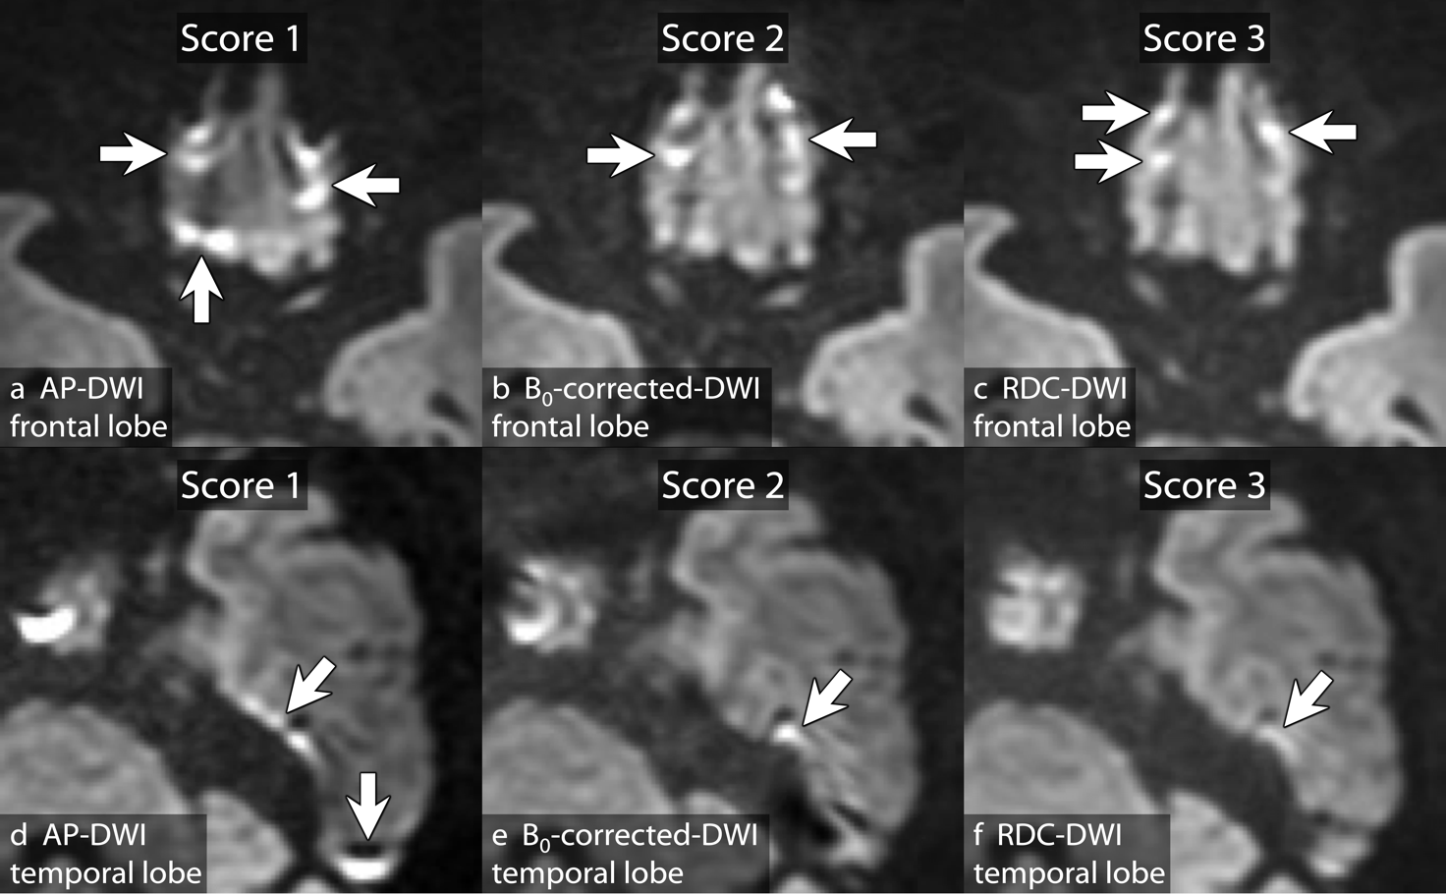
Image assessment criteria for susceptibility artifacts. Arrows indicate susceptibility artifacts. The slice with the strongest artifacts is evaluated. Score 0 (very poor), artifacts at almost all edges of the frontal or temporal lobe. Score 1 (poor), many linear artifacts (a and d). Score 2 (fair), some linear artifacts (b and e). Score 3 (good), spotty artifacts or artifacts with lower signal intensity compared with typical signal pileup artifacts (c and f). Score 4 (excellent), no artifacts.

Supplementary Figure S2
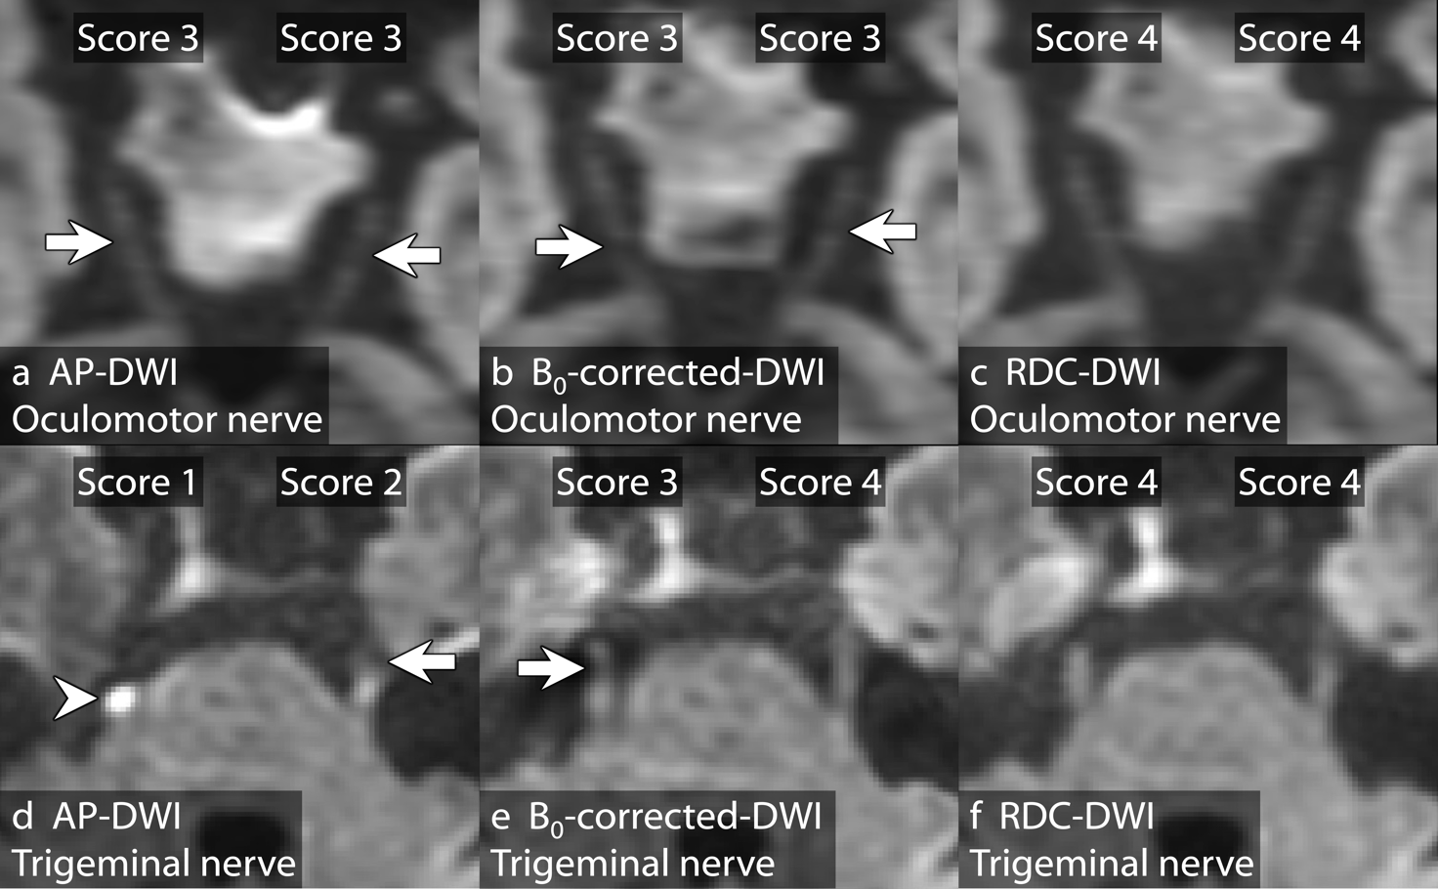
Criteria for image assessment of cranial nerves. Arrows indicate signal loss along the cranial nerves. Score 0 (very poor), no anatomical visualization of the nerve. Score 1 (poor), only a small portion of the nerve is seen (d, right arrowhead). Score 2 (fair), part of the course of the nerve is seen (d, left). Score 3 (good), most of the course of the nerve is seen (a, bilateral; b, bilateral; e, right). Score 4 (excellent), the whole course of the nerve is clearly delineated (c, bilateral; e, left; f, bilateral).

Supplementary Figure S3
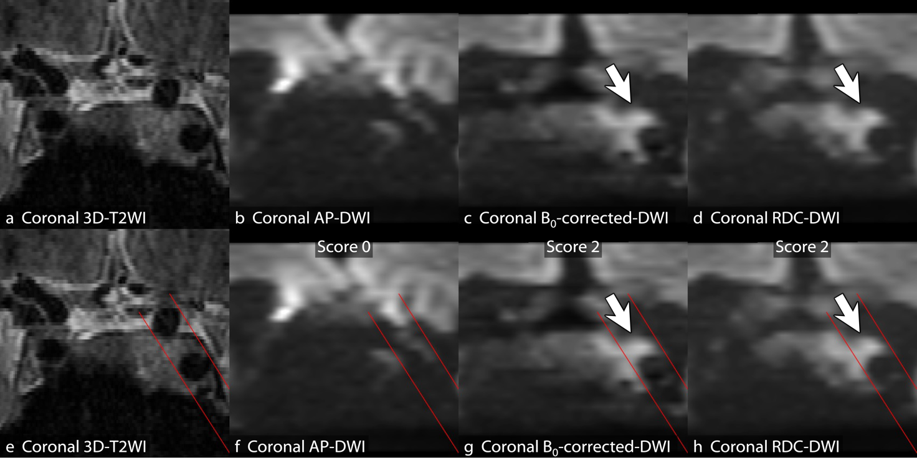
Image assessment criteria for visualization of cavernous sinus invasion. Coronal reconstructed b = 1,000 s/mm² images of AP-DWI (b and f), B₀-corrected-DWI (c and g), and RDC-DWI (d and h) are evaluated in comparison with the corresponding coronal reconstructed three-dimensional T2-weighted imaging (3D-T2WI) (a and e). Red lines indicate the medial and lateral walls of the internal carotid arteries. Score 0 (poor), PitNET/pituitary adenoma is not well visualized in the cavernous sinus (b and f). Score 1 (fair), PitNET/pituitary adenoma is seen in the cavernous sinus, but the diagnosis of cavernous sinus invasion differs between DWI and 3D-T2WI. Score 2 (good), PitNET/pituitary adenoma is seen clearly in the cavernous sinus on DWI and the diagnosis of cavernous sinus invasion is the same on DWI and 3D-T2WI (c, d, g, and h, arrows).

Supplementary Figure S4
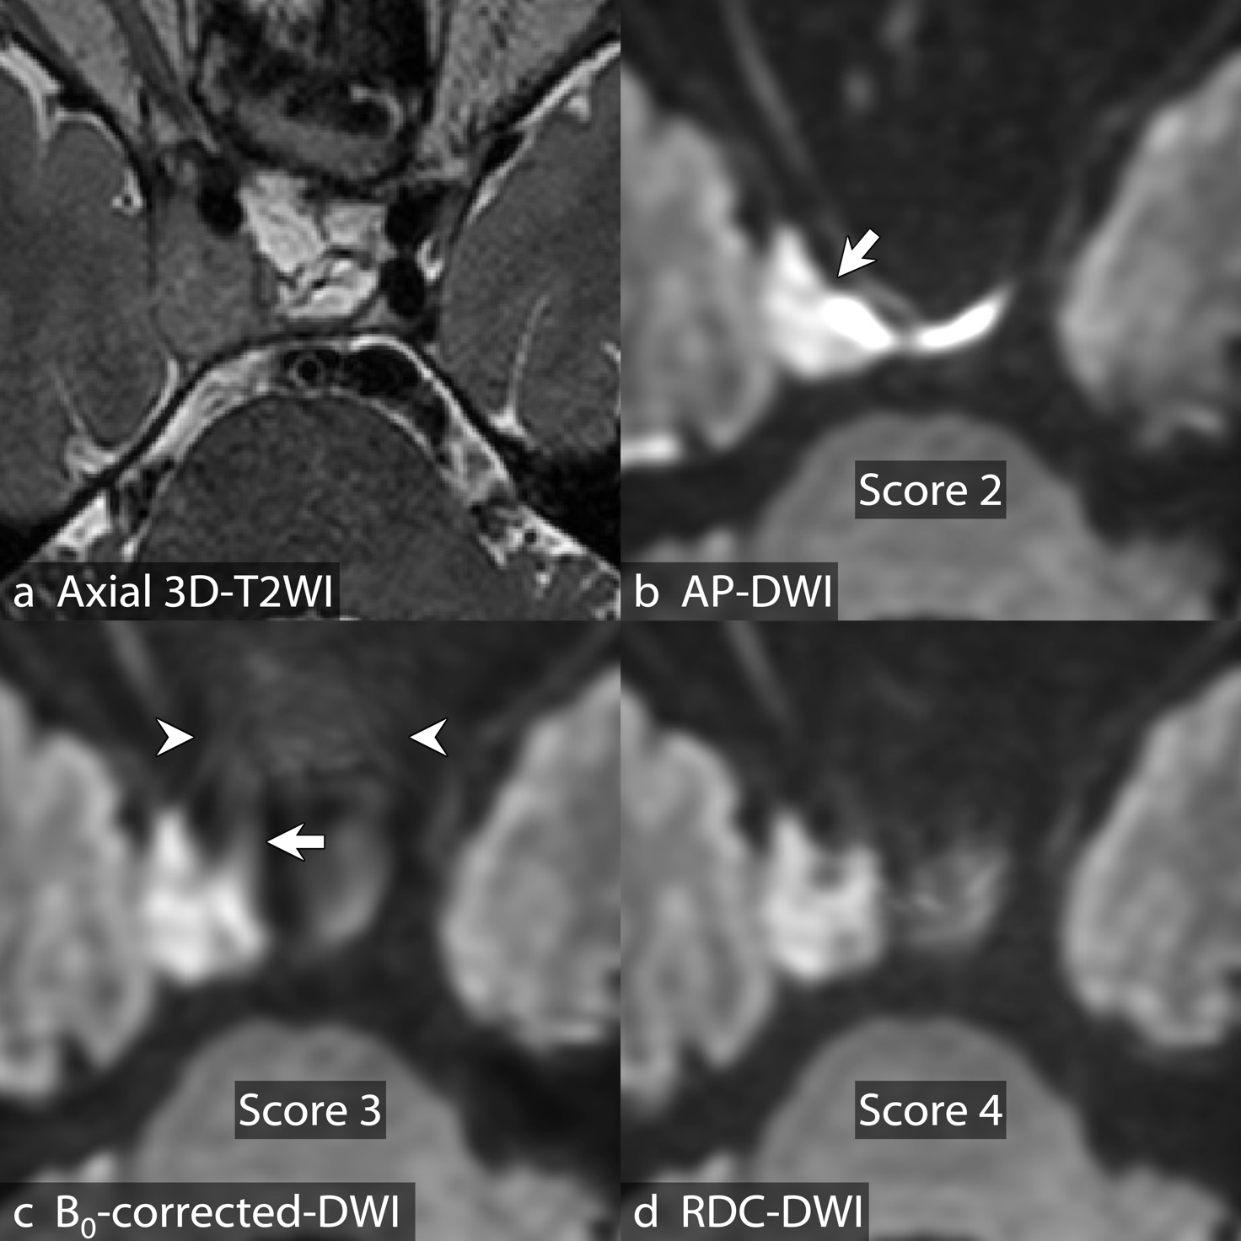
Image assessment criteria for overall tumor visualization. Axial b = 1,000 s/mm² images of AP-DWI (b), B₀-corrected-DWI (c), and RDC-DWI (d) are evaluated in comparison with the corresponding axial reconstructed 3D-T2WI (a). Score 0 (very poor), tumor is not seen. Score 1 (poor), only a portion of the PitNET/pituitary adenoma is seen. Score 2 (fair), the PitNET/pituitary adenoma is seen, but its shape is distorted (b, arrow). Score 3 (good), most of the PitNET/pituitary adenoma is clearly seen, but the image is degraded by distortion (arrow) and blurring around the sphenoid sinus (arrowheads) (c). Score 4 (excellent), the PitNET/pituitary adenoma is clearly seen (d).

Supplementary Figure S5
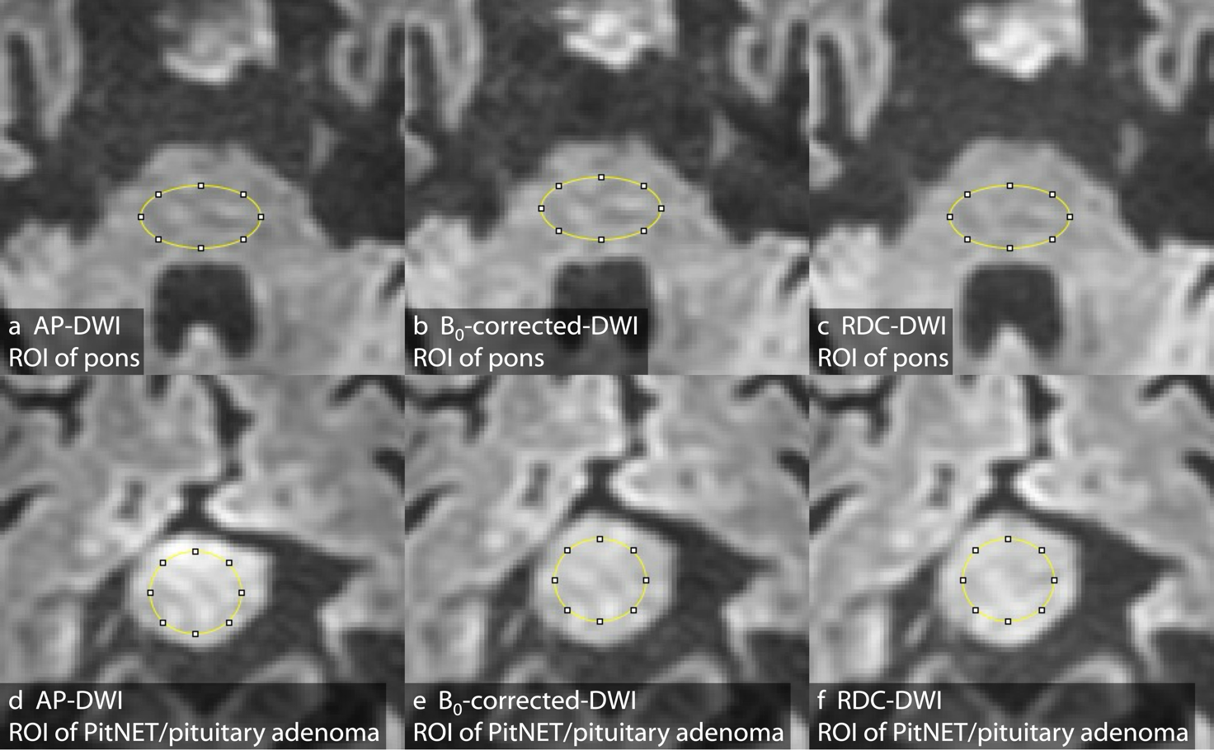
Example showing regions of interest (ROIs) placement. A ROI (yellow oval) is placed on the pons on AP-DWI (a), B₀-corrected-DWI (b), and RDC-DWI (c); and also on the solid portion of the PitNET/pituitary adenoma on AP-DWI (d), B₀-corrected-DWI (e), and RDC-DWI (f).

Supplementary Figure S6
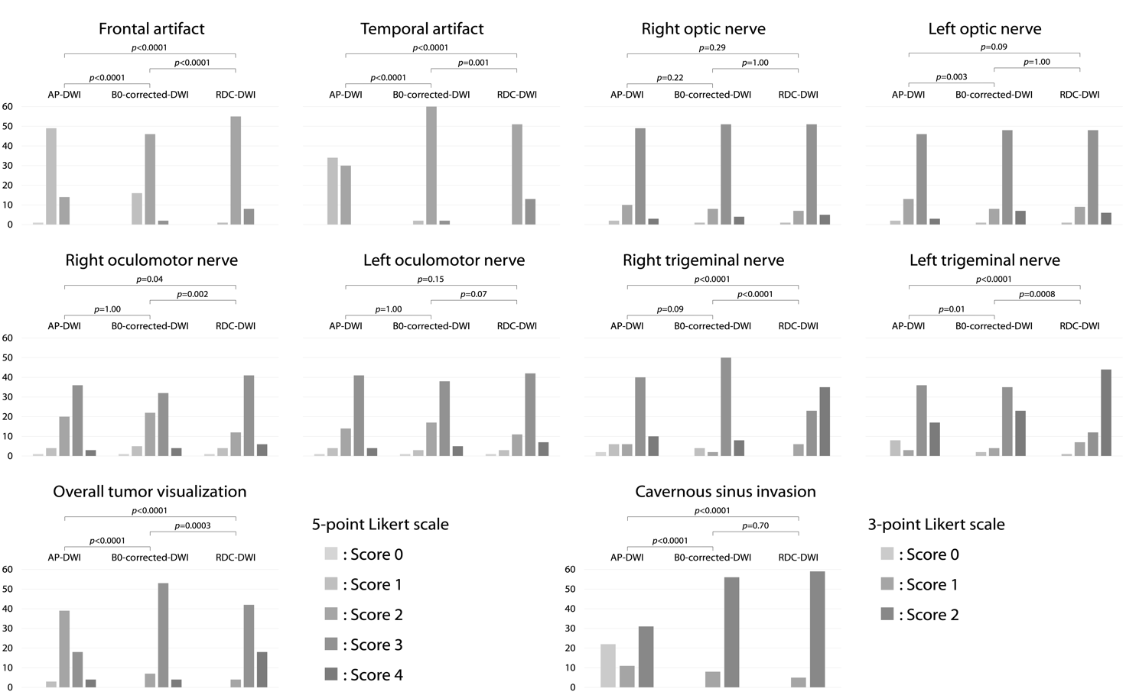
Histograms of qualitative evaluations. Susceptibility artifacts in the frontal and temporal lobes, anatomical visualization of cranial nerves, and overall tumor visualization are assessed using a 5-point Likert scale. Visualization of cavernous sinus invasion is assessed using a 3-point Likert scale. Image quality scores are compared among the three DWIs (AP-DWI, B₀-corrected-DWI, and RDC-DWI) using the Friedman test followed by pairwise comparisons with Bonferroni correction.

Supplementary Figure S7
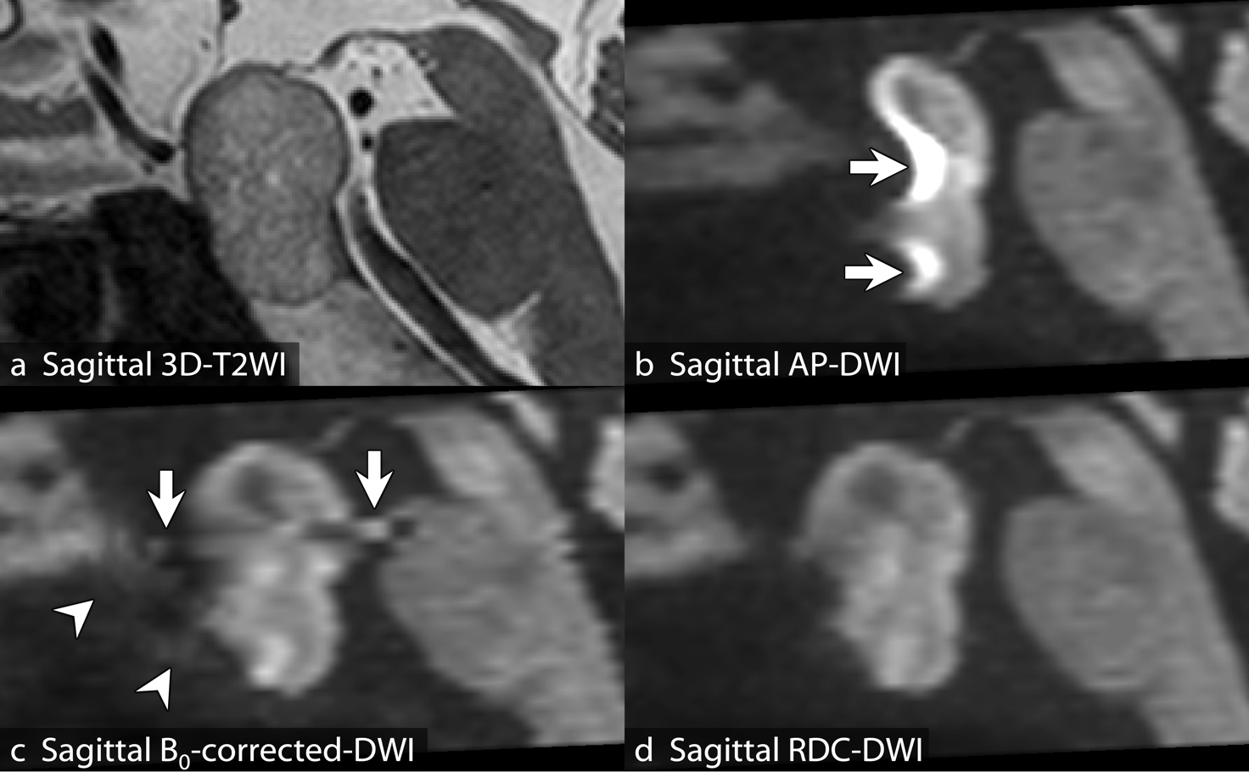
A 79-year-old woman with unoperated clinically non-functioning PitNET/pituitary adenoma. Sagittal three-dimensional T2-weighted imaging (3D-T2WI) (a) and the corresponding reconstructed sagittal b = 1,000 s/mm² images of AP-DWI (b), B₀-corrected-DWI (c), and RDC-DWI (d) are shown. The 3D-T2WI shows the typical appearance of PitNET/pituitary adenoma (a). Severe geometric distortion, susceptibility artifacts, and signal pileup near the sphenoid sinus are seen on AP-DWI (b, arrows). There is less distortion on the B₀-corrected-DWI; however, abnormal signal remains (c, arrows), along with blurring near the sphenoid sinus (c, arrowheads). Among the three DWIs, image quality is the best for RDC-DWI, which has the least geometric distortion and fewest susceptibility artifacts (d).

