Supplemental Material

Supplementary Table 1: Bias between early-frame ¹⁸F-florbetapir and ¹⁸F-FDG PET. Calculated as ((early-frame ¹⁸F-florbetapir - ¹⁸F-FDG) / ¹⁸F-FDG) x 100.

 | Left | Right |  | Left | Right
ROI | Bias (%) | Bias (%) | ROI | Bias (%) | Bias (%)
Temporal Lobe |  |  | Insula and Cingulate
Hippocampus | -4.47 | -4.97 | Posterior long gyrus (insula) | -6.49 | -6.26
Amygdala | -2.88 | -3.26 | Anterior long gyrus (insula) | -9.34 | -9.38
Anterior Temporal (M) | -8.78 | -8.62 | Anterior short gyrus (insula) | -11.80 | -11.40
Anterior Temporal (L) | -11.04 | -10.73 | Middle short gyrus (insula) | -9.09 | -8.14
Parahippocampal | -9.69 | -10.34 | Posterior short gyrus (insula) | -8.96 | -8.98
Middle/Inferior Temp | -13.22 | -12.76 | Anterior inferior cortex (insula) | -7.64 | -7.20
Fusiform | -10.76 | -11.40 | ACC | -10.40 | -10.71
Posterior Temp | -12.67 | -12.04 | PCC | -15.18 | -15.66
Superior Temp (A) | -11.14 | -10.50 | Occipital Lobe
Superior Temp (P) | -12.91 | -12.71 | Lingual gyrus | -16.00 | -16.10
Frontal Lobe |  |  | Cuneus | -17.29 | -17.17
Middle Frontal | -17.46 | -16.99 | Lateral occipital | -16.83 | -16.21
Precentral gyrus | -14.79 | -14.66 | Parietal Lobe
Straight | -14.98 | -14.24 | Postcentral gyrus | -14.96 | -14.98
Anterior Orbital | -16.59 | -17.32 | Superior Parietal | -17.13 | -16.53
Inferior Frontal | -16.62 | -15.65 | Inferolateral Remainder | -17.10 | -16.15
Superior Frontal | -16.00 | -15.75 | Central Structures
Medial Orbital | -16.65 | -16.58 | Caudate | -16.10 | -16.96
Lateral Orbital | -18.20 | -17.57 | Nucleus Accumbens | -7.20 | -7.01
Posterior Orbital | -13.45 | -12.85 | Putamen | -11.10 | -11.47
Subgenual Frontal | -7.64 | -7.60 | Thalamus | 0.29 | 0.69
Subcallosal | -7.72 | -7.35 | Pallidum | -6.72 | -10.08
Pre-subgenual | -8.81 | -8.05 | Composite ROI | -14.84 | -15.38

Supplementary Table 2: Partial Correlations for Early-frame Amyloid and F-FDG Comparison

 | Left |  |  | Right
ROI | AV-45 ± SD | FDG ± SD | R | AV-45 ± SD | FDG ± SD | R
Temporal Lobe
Hippocampus | 0.94 ± 0.11 | 0.98 ± 0.1 | 0.81*** | 0.94 ± 0.1 | 0.99 ± 0.1 | 0.80***
Amygdala | 0.91 ± 0.12 | 0.94 ± 0.1 | 0.80*** | 0.89 ± 0.1 | 0.92 ± 0.1 | 0.79***
Anterior Temporal (M) | 0.83 ± 0.12 | 0.91 ± 0.12 | 0.85*** | 0.83 ± 0.11 | 0.91 ± 0.11 | 0.85***
Anterior Temporal (L) | 1.08 ± 0.13 | 0.96 ± 0.13 | 0.83*** | 0.97 ± 0.12 | 1.08 ± 0.13 | 0.80***
Parahippocampal | 0.85 ± 0.1 | 0.94 ± 0.1 | 0.80*** | 0.84 ± 0.09 | 0.94 ± 0.1 | 0.80***
Middle/Inferior Temp | 0.99 ± 0.11 | 1.14 ± 0.13 | 0.81*** | 1.01 ± 0.11 | 1.16 ± 0.13 | 0.78***
Fusiform | 0.90 ± 0.12 | 1.01 ± 0.13 | 0.84*** | 0.88 ± 0.12 | 0.99 ± 0.13 | 0.83***
Posterior Temp | 1.06 ± 0.09 | 1.21 ± 0.11 | 0.78*** | 1.08 ± 0.09 | 1.23 ± 0.1 | 0.69**
Superior Temp (A) | 0.89 ± 0.1 | 1.00 ± 0.1 | 0.82*** | 0.91 ± 0.1 | 1.02 ± 0.11 | 0.80***
Superior Temp (P) | 1.11 ± 0.09 | 1.27 ± 0.1 | 0.71** | 1.11 ± 0.09 | 1.28 ± 0.1 | 0.68**
Insula and Cingulate
PLG (insula) | 1.07 ± 0.1 | 1.14 ± 0.09 | 0.75** | 1.08 ± 0.09 | 1.15 ± 0.09 | 0.76**
ALG (insula) | 1.11 ± 0.1 | 1.22 ± 0.09 | 0.76*** | 1.11 ± 0.1 | 1.23 ± 0.09 | 0.71**
ASG (insula) | 1.17 ± 0.12 | 1.32 ± 0.12 | 0.72** | 1.17 ± 0.11 | 1.33 ± 0.12 | 0.75***
MSG (insula) | 1.20 ± 0.11 | 1.32 ± 0.1 | 0.68** | 1.22 ± 0.11 | 1.33 ± 0.1 | 0.69**
PSG (insula) | 1.15 ± 0.1 | 1.26 ± 0.1 | 0.73** | 1.16 ± 0.1 | 1.27 ± 0.1 | 0.70**
AIC (insula) | 1.03 ± 0.11 | 1.11 ± 0.1 | 0.75*** | 1.06 ± 0.11 | 1.14 ± 0.11 | 0.81***
ACC | 1.03 ± 0.1 | 1.15 ± 0.11 | 0.77*** | 1.03 ± 0.1 | 1.16 ± 0.11 | 0.79***
PCC | 1.18 ± 0.11 | 1.19 ± 0.1 | 0.70** | 1.19 ± 0.1 | 1.41 ± 0.14 | 0.70**
Frontal Lobe
Middle Frontal | 1.18 ± 0.1 | 1.43 ± 0.13 | 0.61** | 1.19 ± 0.1 | 1.44 ± 0.14 | 0.64**
Precentral gyrus | 1.13 ± 0.09 | 1.33 ± 0.09 | 0.66** | 1.13 ± 0.09 | 1.32 ± 0.10 | 0.69**
Straight | 0.96 ± 0.11 | 1.13 ± 0.12 | 0.77*** | 1.17 ± 0.11 | 1.17 ± 0.12 | 0.78***
Anterior Orbital | 1.12 ± 0.11 | 1.34 ± 0.13 | 0.65** | 1.12 ± 0.1 | 1.35 ± 0.13 | 0.71**
Inferior Frontal | 1.13 ± 0.1 | 1.36 ± 0.11 | 0.62** | 1.16 ± 0.09 | 1.38 ± 0.11 | 0.63**
Superior Frontal | 1.09 ± 0.1 | 1.29 ± 0.1 | 0.66** | 1.09 ± 0.1 | 1.30 ± 0.11 | 0.72***
Medial Orbital | 1.01 ± 0.1 | 1.21 ± 0.11 | 0.73*** | 0.99 ± 0.1 | 1.19 ± 0.12 | 0.77***
Lateral Orbital | 1.06 ± 0.12 | 1.29 ± 0.15 | 0.74*** | 1.09 ± 0.12 | 1.33 ± 0.15 | 0.72**
Posterior Orbital | 1.04 ± 0.11 | 1.20 ± 0.12 | 0.77*** | 1.04 ± 0.12 | 1.19 ± 0.13 | 0.81***
Subgenual Frontal | 1.03 ± 0.11 | 1.11 ± 0.11 | 0.79*** | 1.00 ± 0.12 | 1.08 ± 0.12 | 0.85***
Subcallosal | 0.91 ± 0.12 | 0.98 ± 0.12 | 0.82*** | 0.88 ± 0.13 | 0.95 ± 0.13 | 0.89***
Pre-subgenual | 1.12 ± 0.14 | 1.23 ± 0.13 | 0.80*** | 1.09 ± 0.14 | 1.18 ± 0.14 | 0.84***
Occipital Lobe
Lingual gyrus | 1.22 ± 0.1 | 1.46 ± 0.12 | 0.67** | 1.23 ± 0.11 | 1.46 ± 0.12 | 0.69**
Cuneus | 1.26 ± 0.11 | 1.52 ± 0.13 | 0.64** | 1.30 ± 0.11 | 1.57 ± 0.12 | 0.62**
Lateral occipital | 1.08 ± 0.12 | 1.30 ± 0.13 | 0.79*** | 1.10 ± 0.11 | 1.31 ± 0.13 | 0.72***
Parietal Lobe
Postcentral gyrus | 1.09 ± 0.09 | 1.28 ± 0.09 | 0.64** | 1.10 ± 0.08 | 1.30 ± 0.1 | 0.66**
Superior Parietal | 1.15 + 0.1 | 1.39 ± 0.12 | 0.69** | 1.15 ± 0.1 | 1.37 ± 0.12 | 0.71**
Inferolateral Remainder | 1.09 ± 0.1 | 1.32 ± 0.17 | 0.77*** | 1.11 ± 0.11 | 1.33 ± 0.16 | 0.75***
Central Structures
Caudate | 0.86 ± 0.17 | 1.03 ± 0.17 | 0.90*** | 0.84 ± 0.17 | 1.01 ± 0.19 | 0.92***
Nucleus Accumbens | 1.07 ± 0.12 | 1.15 ± 0.13 | 0.76*** | 1.02 ± 0.12 | 1.10 ± 0.13 | 0.85***
Putamen | 1.38 ± 0.13 | 1.55 ± 0.13 | 0.65** | 1.36 ± 0.12 | 1.53 ± 0.12 | 0.63**
Thalamus | 1.03 ± 0.15 | 1.03 ± 0.14 | 0.93*** | 1.02 ± 0.17 | 1.02 ± 0.16 | 0.94***
Pallidum | 1.28 ± 0.14 | 1.37 ± 0.15 | 0.66** | 1.31 ± 0.13 | 1.46 ± 0.17 | 0.69**
Composite ROI | 1.09 ± 0.09 | 1.28 ± 0.13 | 0.74** | 1.10 ± 0.09 | 1.30 ± 0.13 | 0.74**
** p-value < 0.001, *** p-value < 2e-16
Supplementary Table 3: Bland-Altman Plot Statistics (EF and FDG)
 | Left |  |  | Right
ROI | Avg. of differences | SD of differences | Lower CI, Upper CI | Avg. of differences | SD of differences | Lower CI,  Upper CI
Temporal Lobe
Hippocampus | 0.045 | 0.063 | -0.08, 0.17 | 0.049 | 0.061 | -0.07, 0.17
Amygdala | 0.026 | 0.069 | -0.11, 0.16 | 0.031 | 0.063 | -0.09, 0.15
Anterior Temporal (M) | 0.081 | 0.063 | -0.04, 0.21 | 0.078 | 0.057 | -0.03, 0.19
Anterior Temporal (L) | 0.119 | 0.072 | -0.02, 0.26 | 0.115 | 0.078 | -0.04, 0.27
Parahippocampal | 0.091 | 0.059 | -0.03, 0.21 | 0.097 | 0.059 | -0.02, 0.21
Middle/Inferior Temp | 0.15 | 0.08 | 0.00, 0.31 | 0.15 | 0.08 | -0.02, 0.31
Fusiform | 0.11 | 0.07 | -0.03, 0.24 | 0.11 | 0.07 | -0.03, 0.26
Posterior Temp | 0.15 | 0.07 | 0.02, 0.29 | 0.15 | 0.08 | 0.00, 0.30
Superior Temp (A) | 0.11 | 0.06 | 0.00, 0.23 | 0.11 | 0.07 | -0.02, 0.24
Superior Temp (P) | 0.16 | 0.07 | 0.03, 0.30 | 0.16 | 0.08 | 0.01, 0.31
Insula and Cingulate
PLG (insula) | 0.07 | 0.07 | -0.06, 0.20 | 0.07 | 0.06 | -0.05, 0.20
ALG (insula) | 0.11 | 0.07 | -0.02, 0.24 | 0.12 | 0.07 | -0.03, 0.26
ASG (insula) | 0.16 | 0.09 | -0.02, 0.33 | 0.15 | 0.08 | -0.01, 0.31
MSG (insula) | 0.12 | 0.08 | -0.04, 0.28 | 0.11 | 0.08 | -0.05, 0.27
PSG (insula) | 0.11 | 0.07 | -0.03, 0.26 | 0.11 | 0.08 | -0.04, 0.27
AIC (insula) | 0.09 | 0.07 | -0.06, 0.23 | 0.08 | 0.07 | -0.05, 0.21
ACC | 0.12 | 0.07 | -0.02, 0.26 | 0.12 | 0.07 | -0.01, 0.26
PCC | 0.21 | 0.1 | 0.02, 0.40 | 0.22 | 0.10 | 0.03, 0.41
Frontal Lobe
Middle Frontal | 0.25 | 0.11 | 0.04, 0.46 | 0.24 | 0.10 | 0.04, 0.45
Precentral gyrus | 0.20 | 0.08 | 0.05, 0.35 | 0.19 | 0.08 | 0.05, 0.34
Straight | 0.17 | 0.08 | 0.02, 0.32 | 0.17 | 0.08 | 0.01, 0.32
Anterior Orbital | 0.22 | 0.10 | 0.03, 0.42 | 0.23 | 0.09 | 0.06, 0.41
Inferior Frontal | 0.23 | 0.09 | 0.05, 0.41 | 0.22 | 0.09 | 0.04, 0.39
Superior Frontal | 0.21 | 0.08 | 0.05, 0.37 | 0.20 | 0.08 | 0.05, 0.36
Medial Orbital | 0.20 | 0.08 | 0.05, 0.36 | 0.20 | 0.08 | 0.05, 0.35
Lateral Orbital | 0.23 | 0.10 | 0.04, 0.43 | 0.23 | 0.10 | 0.03, 0.43
Posterior Orbital | 0.16 | 0.08 | 0.12, 0.31 | 0.15 | 0.07 | 0.01, 0.30
Subgenual Frontal | 0.09 | 0.07 | -0.06, 0.23 | 0.08 | 0.07 | -0.05, 0.21
Subcallosal | 0.08 | 0.07 | -0.06, 0.22 | 0.07 | 0.06 | -0.06, 0.20
Pre-subgenual | 0.11 | 0.08 | -0.05, 0.27 | 0.10 | 0.08 | -0.06, 0.25
Occipital Lobe
Lingual gyrus | 0.23 | 0.09 | 0.05, 0.41 | 0.24 | 0.10 | 0.06, 0.41
Cuneus | 0.26 | 0.10 | 0.07, 0.46 | 0.27 | 0.10 | 0.07, 0.47
Lateral occipital | 0.22 | 0.08 | 0.05, 0.38 | 0.21 | 0.09 | 0.04, 0.39
Parietal Lobe
Postcentral gyrus | 0.19 | 0.08 | 0.05, 0.34 | 0.19 | 0.08 | 0.04, 0.35
Superior Parietal | 0.24 | 0.09 | 0.07, 0.41 | 0.23 | 0.09 | 0.06, 0.40
Inferolateral Remainder | 0.23 | 0.11 | 0.01, 0.44 | 0.21 | 0.10 | 0.01, 0.41
Central Structures
Caudate | 0.16 | 0.08 | 0.01, 0.31 | 0.17 | 0.07 | 0.03, 0.31
Nucleus Accumbens | 0.08 | 0.08 | -0.08, 0.25 | 0.08 | 0.07 | -0.06, 0.22
Putamen | 0.17 | 0.10 | -0.03, 0.38 | 0.18 | 0.10 | -0.02, 0.37
Thalamus | 0.00 | 0.06 | -0.11, 0.11 | 0.00 | 0.06 | -0.12, 0.11
Pallidum | 0.09 | 0.12 | -0.14, 0.33 | 0.15 | 0.13 | -0.10, 0.40
Composite ROI | 0.20 | 0.09 | 0.03, 0.36 | 0.19 | 0.09 | 0.02, 0.37

Supplementary Table 4: Interactions of Disease State and FDG in Explaining early-frame Amyloid
 | Left |  | Right
ROI | Dementia x FDG | MCI x FDG | Dementia x FDG | MCI x FDG
Temporal Lobe
Hippocampus | -0.02 | 0.15 | -0.14 | 0.35*
Amygdala | 0.07 | 0.29 | 0.19 | 0.42
Anterior Temporal (M) | 0.01 | 0.14 | -0.07 | 0.16
Anterior Temporal (L) | -0.14 | 0.14 | -0.25 | 0.001
Parahippocampal | -0.26 | 0.06 | -0.02 | 0.09
Middle/Inferior Temp | -0.22 | 0.08 | -0.07 | -0.04
Fusiform | -0.24 | 0.12 | -0.22 | -0.11
Posterior Temp | -0.09 | 0.01 | 0.05 | -0.16
Superior Temp (A) | -0.13 | 0.29 | 0.11 | 0.15
Superior Temp (P) | 0.03 | 0.21 | 0.30 | 0.23
Insula and Cingulate
PLG (insula) | -0.14 | 0.12 | -0.07 | 0.25
ALG (insula) | -0.10 | 0.12 | -0.34 | 0.31
ASG (insula) | -0.15 | 0.17 | -0.05 | 0.29
MSG (insula) | -0.04 | 0.14 | -0.18 | 0.40
PSG (insula) | -0.03 | 0.16 | -0.19 | 0.16
AIC (insula) | -0.29 | -0.03 | 0.11 | 0.12
ACC | -0.02 | 0.24 | 0.28 | 0.29
PCC | 0.06 | 0.03 | -0.04 | 0.04
Frontal Lobe
Middle Frontal | 0.002 | 0.16 | 0.04 | 0.14
Precentral gyrus | -0.04 | 0.36 | 0.04 | 0.22
Straight | 0.04 | 0.10 | -0.03 | 0.02
Anterior Orbital | -0.12 | 0.07 | -0.02 | -0.01
Inferior Frontal | -0.13 | 0.18 | -0.08 | 0.10
Superior Frontal | 0.01 | 0.33 | -0.04 | 0.23
Medial Orbital | -0.21 | 0.03 | -0.15 | 0.02
Lateral Orbital | -0.08 | 0.08 | -0.14 | -0.19
Posterior Orbital | 0.001 | 0.05 | -0.01 | -0.17
Subgenual Frontal | 0.15 | 0.39 | 0.12 | 0.39
Subcallosal | 0.31 | 0.24 | 0.05 | 0.13
Pre-subgenual | 0.33 | 0.37 | 0.15 | 0.24
Occipital Lobe
Lingual gyrus | 0.07 | 0.12 | 0.04 | -0.01
Cuneus | -0.13 | -0.10 | -0.04 | 0.13
Lateral occipital | -0.08 | -0.05 | -0.08 | -0.15
Parietal Lobe
Postcentral gyrus | -0.003 | 0.31 | 0.11 | 0.23
Superior Parietal | 0.06 | 0.07 | 0.10 | 0.06
Inferolateral Remainder | 0.04 | 0.05 | 0.10 | -0.05
Central Structures
Caudate | 0.15 | 0.15 | 0.31 | 0.20
Nucleus Accumbens | 0.24 | 0.11 | 0.02 | 0.08
Putamen | -0.12 | 0.23 | -0.25 | 0.18
Thalamus | 0.25 | 0.21 | 0.37* | 0.37*
Pallidum | -0.01 | 0.06 | 0.23 | 0.31
Composite ROI | -0.01 | 0.05 | -0.09 | -0.01
* denotes a significant adjusted p-value (p<0.05)

Supplementary Table 5: Linear Regression for Early-frame Florbetapir and Early-frame Florbetaben Comparison Covariates include age, diagnostic group (CU vs MCI), and CDR sum of boxes score, FDR corrected; Estimate of tracer: Florbetaben compared to Florbetapir
 | Left |  |  |  | Right
ROI | FBP  Mean (SD) | FBB  Mean (SD) | Estimate of tracer | Adjusted P-value | FBP  Mean (SD) | FBB  Mean (SD) | Estimate of tracer | Adjusted P-value
Temporal Lobe
Hippocampus | 0.97 (0.09) | 0.94 (0.09) | -0.04 | 0.24 | 0.97 (0.09) | 0.91 (0.10) | -0.06 | 0.10
Amygdala | 0.94 (0.10) | 0.90 (0.11) | -0.05 | 0.24 | 0.92 (0.10) | 0.86 (0.11) | -0.06 | 0.11
Anterior Temporal (M) | 0.86 (0.10) | 0.85 (0.09) | -0.001 | 0.96 | 0.86 (0.10) | 0.85 (0.10) | -0.01 | 0.89
Anterior Temporal (L) | 0.98 (0.12) | 0.96 (0.13) | -0.02 | 0.64 | 0.99 (0.12) | 0.97 (0.10) | -0.02 | 0.73
Parahippocampal | 1.00 (0.09) | 0.89 (0.09) | 0.01 | 0.89 | 0.88 (0.10) | 0.88 (0.08) | -0.003 | 0.96
Middle/Inferior Temp | 1.03 (0.11) | 1.05 (0.11) | 0.01 | 0.74 | 1.05 (0.11) | 1.06 (0.08) | 0.01 | 0.88
Fusiform | 0.95 (0.12) | 0.97 (0.12) | 0.02 | 0.70 | 0.93 (0.11) | 0.94 (0.11) | 0.01 | 0.74
Posterior Temp | 1.08 (0.09) | 1.12 (0.08) | 0.04 | 0.26 | 1.10 (0.09) | 1.13 (0.08) | 0.02 | 0.44
Superior Temp (A) | 0.90 (0.09) | 0.87 (0.09) | -0.03 | 0.36 | 0.94 (0.09) | 0.90 (0.10) | -0.03 | 0.43
Superior Temp (P) | 1.13 (0.09) | 1.15 (0.09) | 0.02 | 0.57 | 1.14 (0.08) | 1.15 (0.09) | 0.001 | 0.96
Insula and Cingulate
PLG (insula) | 1.08 (0.10) | 1.09 (0.09) | -0.001 | 0.96 | 1.10 (0.09) | 1.09 (0.09) | -0.02 | 0.63
ALG (insula) | 1.12 (0.10) | 1.13 (0.10) | -0.003 | 0.96 | 1.13 (0.10) | 1.14 (0.11) | -0.0003 | 0.96
ASG (insula) | 1.19 (0.11) | 1.15 (0.12) | -0.05 | 0.24 | 1.20 (0.10) | 1.15 (0.13) | -0.06 | 0.19
MSG (insula) | 1.21 (0.11) | 1.20 (0.11) | -0.02 | 0.67 | 1.23 (0.10) | 1.19 (0.11) | -0.04 | 0.27
PSG (insula) | 1.16 (0.10) | 1.16 (0.10) | -0.003 | 0.96 | 1.17 (0.10) | 1.17 (0.10) | -0.01 | 0.74
AIC (insula) | 1.04 (0.11) | 1.07 (0.12) | 0.02 | 0.63 | 1.08 (0.11) | 1.06 (0.14) | -0.02 | 0.64
ACC | 1.06 (0.11) | 1.06 (0.14) | -0.002 | 0.96 | 1.06 (0.10) | 1.08 (0.13) | 0.01 | 0.74
PCC | 1.21 (0.12) | 1.26 (0.02) | 0.04 | 0.37 | 1.22 (0.11) | 1.27 (0.15) | 0.04 | 0.37
Frontal Lobe
Middle Frontal | 1.18 (0.11) | 1.21 (0.10) | 0.03 | 0.43 | 1.20 (0.10) | 1.22 (0.12) | 0.02 | 0.63
Precentral gyrus | 1.13 (0.10) | 1.16 (0.12) | 0.03 | 0.37 | 1.13 (0.10) | 1.17 (0.12) | 0.04 | 0.36
Straight | 0.98 (0.12) | 1.02 (0.10) | 0.03 | 0.43 | 1.02 (0.12) | 1.05 (0.10) | 0.03 | 0.43
Anterior Orbital | 1.11 (0.12) | 1.14 (0.11) | 0.03 | 0.57 | 1.11 (0.12) | 1.14 (0.13) | 0.03 | 0.50
Inferior Frontal | 1.15 (0.11) | 1.19 (0.12) | 0.04 | 0.36 | 1.18 (0.10) | 1.20 (0.12) | 0.02 | 0.63
Superior Frontal | 1.09 (0.10) | 1.11 (0.10) | 0.02 | 0.63 | 1.09 (0.11) | 1.13 (0.10) | 0.03 | 0.37
Medial Orbital | 1.10 (0.11) | 1.06 (0.10) | 0.05 | 0.24 | 1.00 (0.12) | 1.05 (0.11) | 0.06 | 0.19
Lateral Orbital | 1.06 (0.13) | 1.13 (0.14) | 0.07 | 0.20 | 1.10 (0.12) | 1.15 (0.13) | 0.05 | 0.24
Posterior Orbital | 1.04 (0.11) | 1.06 (0.10) | 0.03 | 0.49 | 1.04 (0.12) | 1.07 (0.12) | 0.03 | 0.50
Subgenual Frontal | 1.04 (0.11) | 0.96 (0.20) | -0.08 | 0.11 | 1.00 (0.11) | 0.92 (0.21) | -0.09 | 0.10
Subcallosal | 0.94 (0.11) | 0.86 (0.14) | -0.08 | 0.10 | 1.00 (0.11) | 0.83 (0.16) | -0.08 | 0.10
Pre-subgenual | 1.12 (0.13) | 1.05 (0.13) | -0.08 | 0.11 | 1.08 (0.13) | 1.02 (0.16) | -0.07 | 0.19
Occipital Lobe
Lingual gyrus | 1.23 (0.10) | 1.31 (0.11) | 0.08 | 0.10 | 1.24 (0.11) | 1.29 (0.13) | 0.05 | 0.24
Cuneus | 1.27 (0.12) | 1.36 (0.10) | 0.08 | 0.10 | 1.31 (0.12) | 1.38 (0.11) | 0.07 | 0.11
Lateral occipital | 1.08 (0.12) | 1.19 (0.11) | 0.103 | 0.04 | 1.11 (0.12) | 1.21 (0.12) | 0.09 | 0.08
Parietal Lobe
Postcentral gyrus | 1.10 (0.09) | 1.14 (0.12) | 0.04 | 0.24 | 1.11 (0.09) | 1.14 (0.12) | 0.03 | 0.37
Superior Parietal | 1.17 (0.11) | 1.22 (0.11) | 0.05 | 0.24 | 1.16 (0.10) | 1.21 (0.11) | 0.05 | 0.24
Inferolateral Remainder | 1.12 (0.10) | 1.18 (0.10) | 0.06 | 0.11 | 1.14 (0.10) | 1.18 (0.10) | 0.04 | 0.30
Central Structures
Caudate | 0.91 (0.16) | 0.83 (0.21) | -0.09 | 0.19 | 0.89 (0.15) | 0.83 (0.20) | -0.07 | 0.24
Nucleus Accumbens | 1.08 (0.12) | 1.04 (0.10) | -0.04 | 0.32 | 1.05 (0.12) | 1.00 (0.10) | -0.05 | 0.24
Putamen | 1.38 (0.13) | 1.37 (0.10) | -0.01 | 0.85 | 1.36 (0.12) | 1.35 (0.10) | -0.01 | 0.84
Thalamus | 1.07 (0.14) | 1.01 (0.18) | -0.07 | 0.20 | 1.07 (0.13) | 1.04 (0.17) | -0.04 | 0.40
Pallidum | 1.27 (0.13) | 1.19 (0.10) | -0.09 | 0.10 | 1.31 (0.14) | 1.26 (0.11) | -0.01 | 0.26
Composite ROI | 1.12 (0.09) | 1.16 (0.10) | 0.04 | 0.27 | 1.14 (0.09) | 1.17 (0.09) | 0.03 | 0.39

Supplementary Table 6: Anatomical Regions Corresponding to Figure 6
Number | ROI | Number | ROI
1 | Right Hippocampus | 43 | Left Straight Gyrus
2 | Left Hippocampus | 44 | Right Straight Gyrus
3 | Right Amygdala | 45 | Left Anterior Orbital Gyrus
4 | Left Amygdala | 46 | Right Anterior Orbital Gyrus
5 | Right Anterior Temporal (medial) | 47 | Left Inferior Frontal Gyrus
6 | Left Anterior Temporal (medial) | 48 | Right Inferior Frontal Gyrus
7 | Right Anterior Temporal (lateral) | 49 | Left Superior Frontal Gyrus
8 | Left Anterior Temporal (lateral) | 50 | Right Superior Frontal Gyrus
9 | Right Parahippocampal | 51 | Left Postcentral Gyrus
10 | Left Parahippocampal | 52 | Right Postcentral Gyrus
11 | Right Superior Temporal (posterior) | 53 | Left Superior Parietal Gyrus
12 | Left Superior Temporal (posterior) | 54 | Right Superior Parietal Gyrus
13 | Right Middle/Inferior Temporal | 55 | Left Lingual Gyrus
14 | Left Middle/Inferior Temporal | 56 | Right Lingual Gyrus
15 | Right Fusiform Gyrus | 57 | Left Cuneus
16 | Left Fusiform Gyrus | 58 | Right Cuneus
17 | Left Posterior Long Gyrus (insula) | 59 | Left Medial Orbital Gyrus
18 | Right Posterior Long Gyrus (insula) | 60 | Right Medial Orbital Gyrus
19 | Left Lateral Occipital Lobe | 61 | Left Lateral Orbital Gyrus
20 | Right Lateral Occipital Lobe | 62 | Right Lateral Orbital Gyrus
21 | Left Anterior Cingulate | 63 | Left Posterior Orbital Gyrus
22 | Right Anterior Cingulate | 64 | Right Posterior Orbital Gyrus
23 | Left Posterior Cingulate | 65 | Left Subgenual Frontal Cortex
24 | Right Posterior Cingulate | 66 | Right Subgenual Frontal Cortex
25 | Left Middle Frontal Gyrus | 67 | Left Subcallosal Area
26 | Right Middle Frontal Gyrus | 68 | Right Subcallosal Area
27 | Left Posterior Temporal | 69 | Left Pre-subgenual Frontal Cortex
28 | Right Posterior Temporal | 70 | Right Pre-subgenual Frontal Cortex
29 | Left Inferiolateral Remainder of Parietal Lobe | 71 | Left Superior Temporal (anterior)
30 | Right Inferiolateral Remainder of Parietal Lobe | 72 | Right Superior Temporal (anterior)
31 | Left Caudate | 73 | Left Anterior Short Gyrus (insula)
32 | Right Caudate | 74 | Right Anterior Short Gyrus (insula)
33 | Left Nucleus Accumbens | 75 | Left Middle Short Gyrus (insula)
34 | Right Nucleus Accumbens | 76 | Right Middle Short Gyrus (insula)
35 | Left Putamen | 77 | Left Posterior Short Gyrus (insula)
36 | Right Putamen | 78 | Right Posterior Short Gyrus (insula)
37 | Left Thalamus | 79 | Left Anterior Inferior Cortex (insula)
38 | Right Thalamus | 80 | Right Anterior Inferior Cortex (insula)
39 | Left Pallidum | 81 | Left Anterior Long Gyrus (insula)
40 | Right Pallidum | 82 | Right Anterior Long Gyrus (insula)
41 | Left Precentral Gyrus | 83 | Left Composite Region
42 | Right Precentral Gyrus | 84 | Right Composite Region

Supplementary Figure 1: Bland-Altman Plots
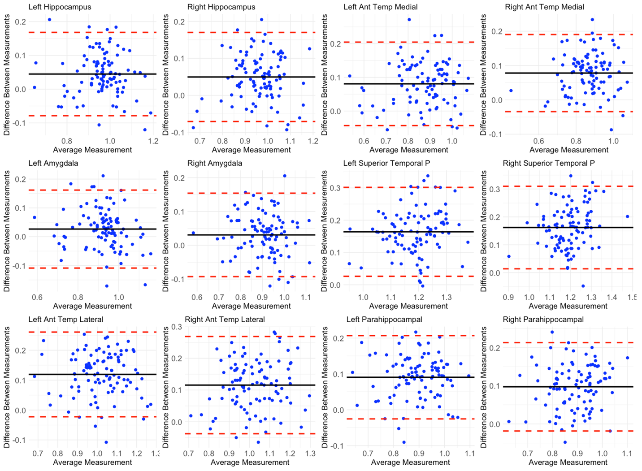
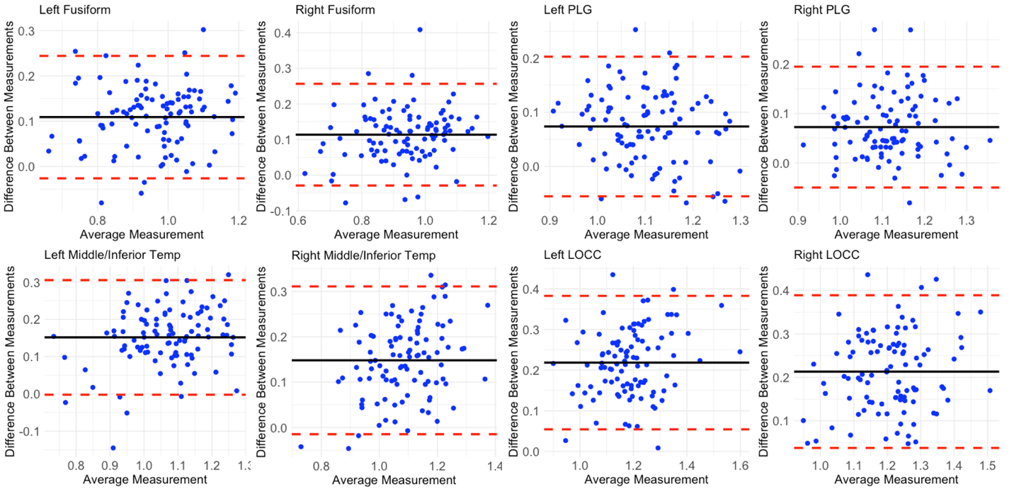

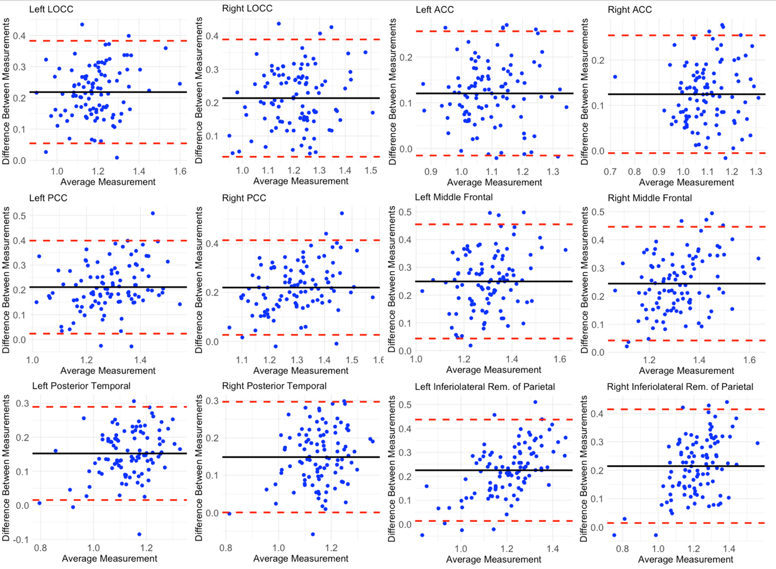
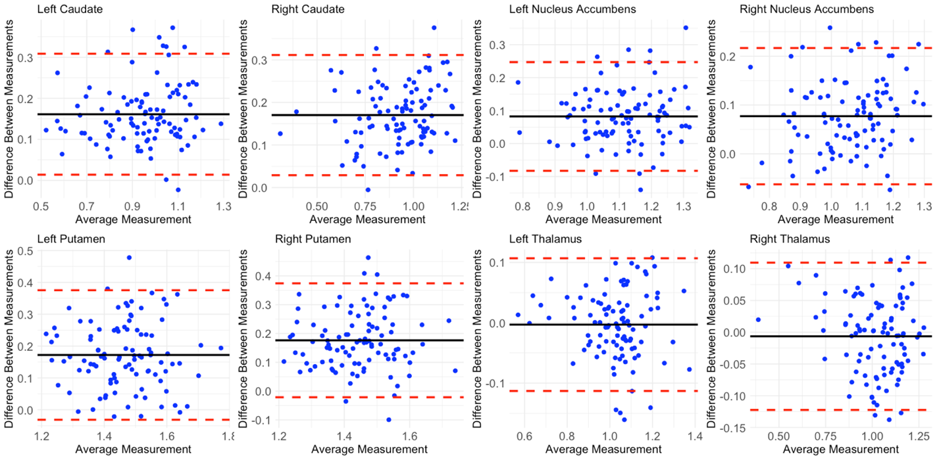

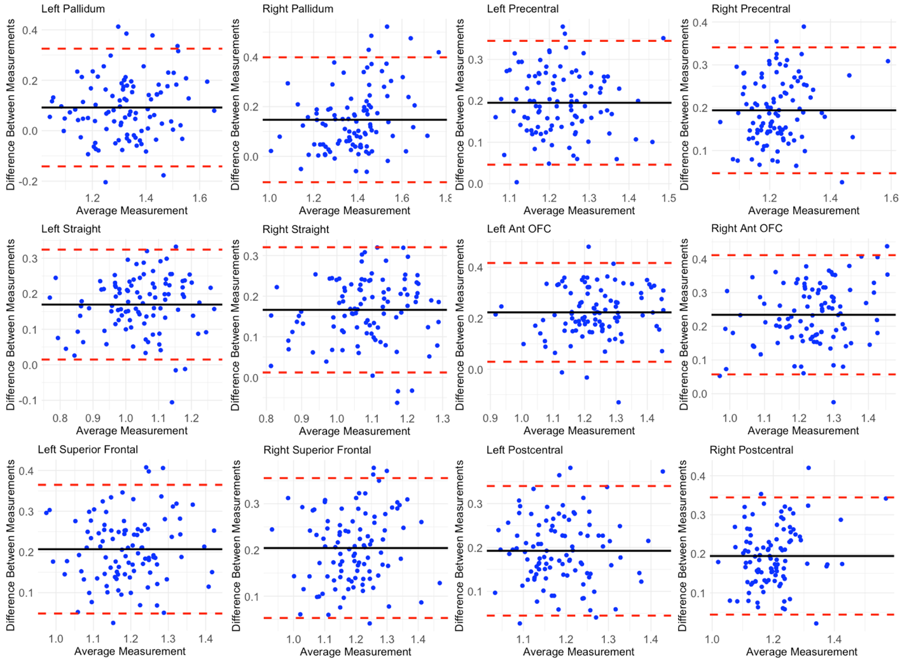
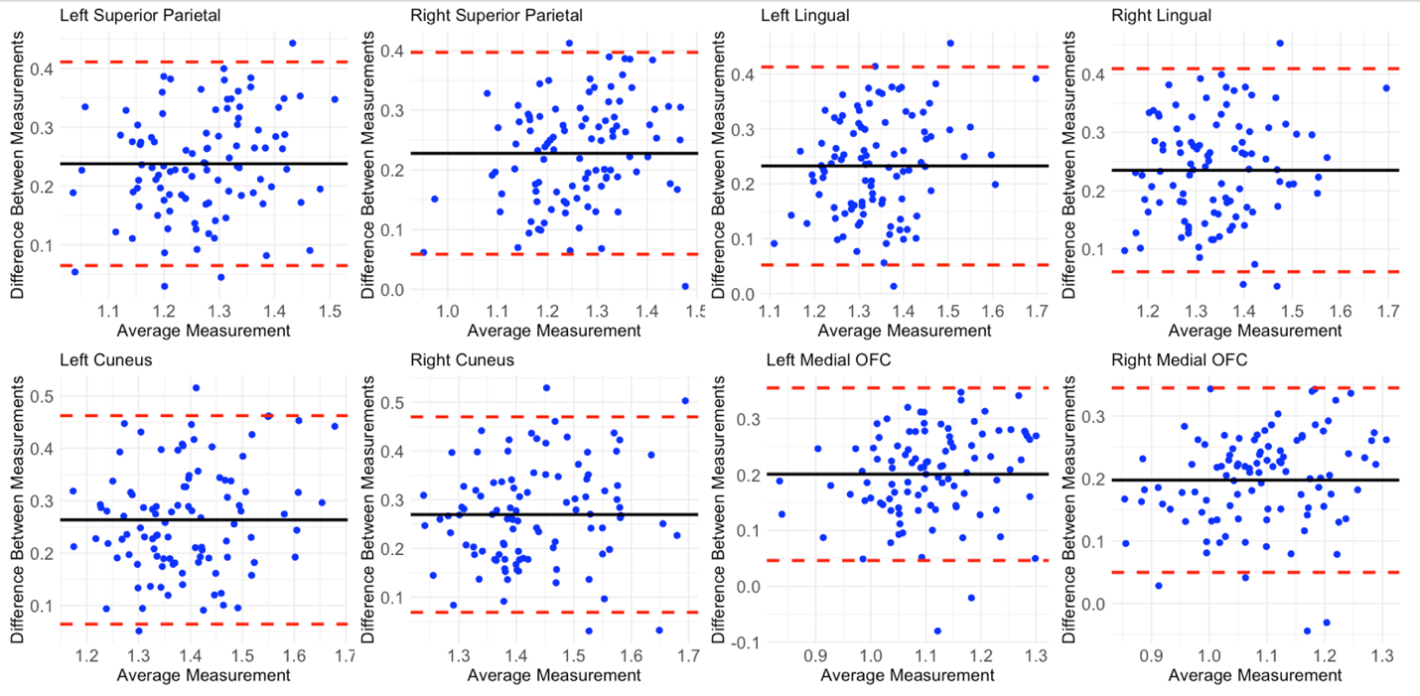

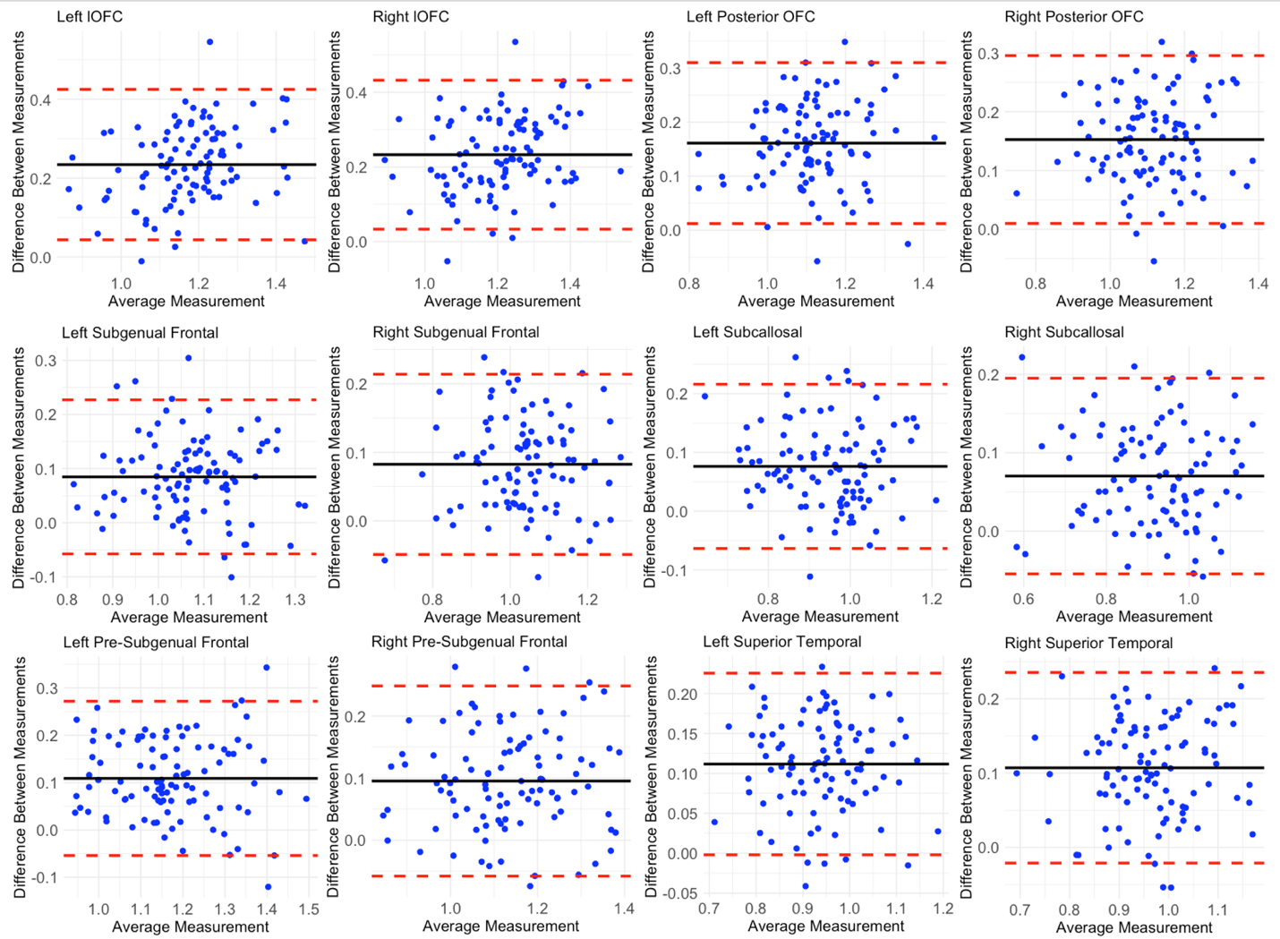
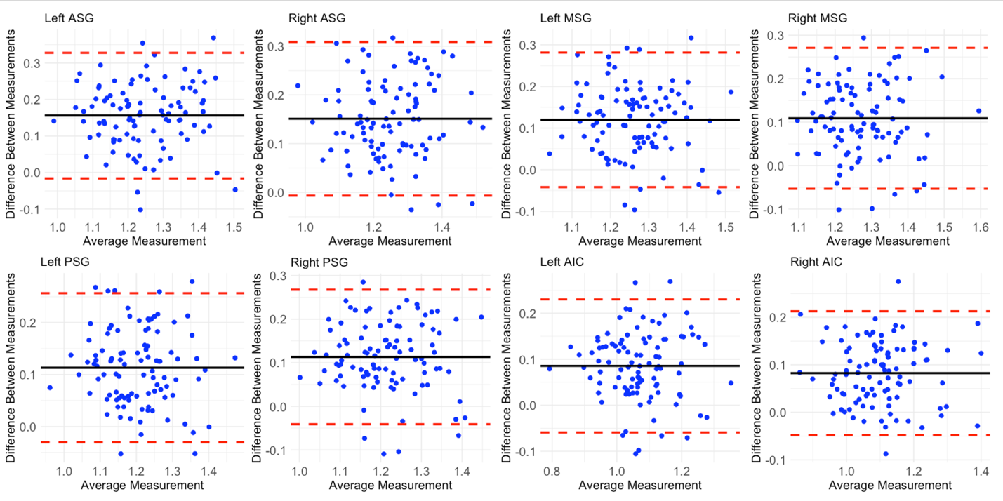

Supplementary Figure 2: Histogram of Cosine Similarity Distribution
