Supplementary Table 1: Univariable analysis of the patient subgroup without induction therapy regarding progression-free and overall survival

Patient subgroup without Induction  therapy |  | Univariable analysis  (p-value)
 | No. of Patients  (%) | OS | PFS
Age, y  ≥70  <70 | 18 (69)  8 (31) | .833 | .928
Sex  Male  Female | 15 (58)  11 (42) | .528 | .498
T category  Tx- T2  T3- T4 | 13 (50)  13 (50) | .287 | .368
N category  N1  N2  N3 | 6 (23)  13 (50)  7 (27) | .034 | .535
Stage IIIC/recurrent  Yes  No | 12 (46)  14 (54) | .852 | .349
ECOG- PS  1  2- 3 | 15 (58)  11 (42) | .112 | .753
CCI  4- 6  ≥7 | 12 (46)  14 (54) | .153 | .472
Histology  SCC  Non-SCC | 13 (50)  13 (50) | .028 | .367
Salvage systemic therapy  Yes  No | 5 (19)  21 (81) | .515 | .148

Supplementary Table 2: Univariable analysis of primary/nodal PET metrics in the patient subgroup without induction therapy regarding progression-free and overall survival

Subgroup without Induction therapy | Median  value | Univariable Analysis:  (p-value)
 |  | OS | PFS
tMTV (ml) | 26.2 | .012 | <.001
pMTV (ml) | 28 | .061 | .003
nMTV (ml) | 10.6 | .492 | .398
SUVmax | 12 | .096 | .009
pSUVmax | 13 | .527 | .269
nSUVmax | 8.2 | .071 | .155
TLG | 175.4 | .091 | <.001
pSUVmean | 5.3 | .205 | .027
nSUVmean | 4 | .048 | .068
pSUVpeak | 11 | .184 | .031
nSUVpeak | 7.6 | .022 | .095

Supplementary Figure 1: Kaplan-Meier estimate of the patient subgroup without induction therapy regarding progression-free survival: high tMTV was associated with a median PFS of 5.3 months [95% CI: 2.7-10.4] vs. 31.8 months [95% CI: 15.2-not reached] in the low tMTV subgroup.
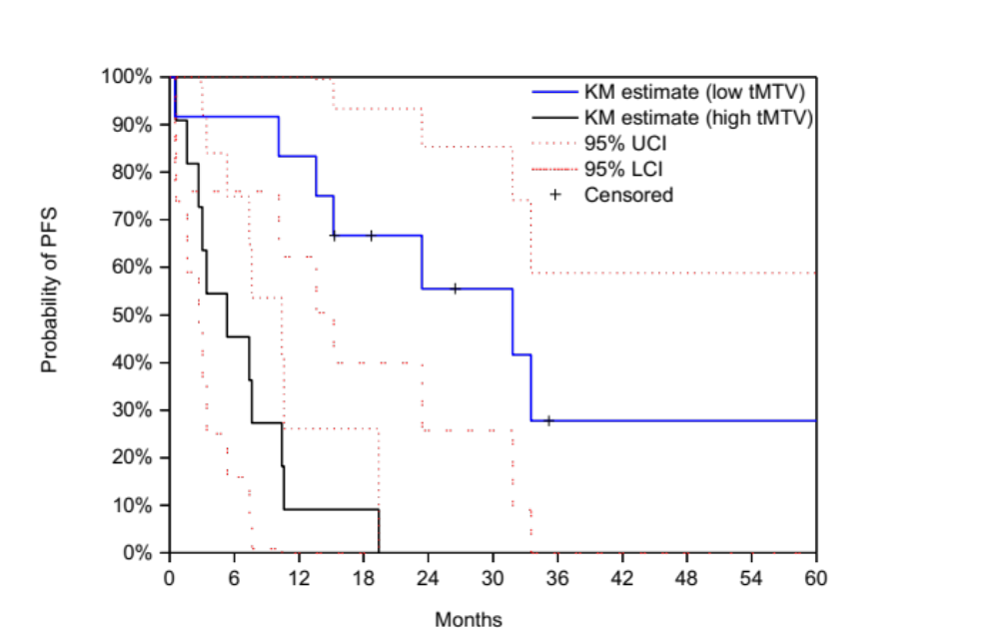

Supplementary Figure 2: Kaplan-Meier estimate of the patient subgroup without induction therapy regarding overall survival: high tMTV was associated with a median OS of 15.2 months [95% CI: 8.8-27.2] vs. 33.5 months [95% CI: 27.9-not reached] in the low tMTV group.

