Supplemental data
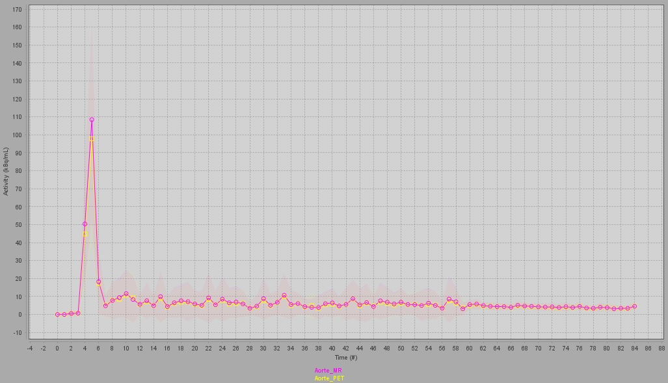
Figure S1: An example of TAC for the arterial input function when the ROIs are drawn on the MRI aorta (light red) and on the PET (yellow) using fused images.

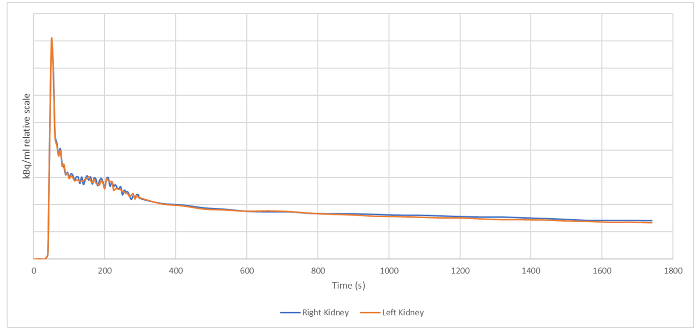
Figure S2: PET TACs from a patient with a high BKG pv SF_{MAG3} of 61 %. The value of the SF_{FDG} for BKG was 55.5 % and was 50 % using our integral method over the 1-2 minute or 1-3 minute interval.

