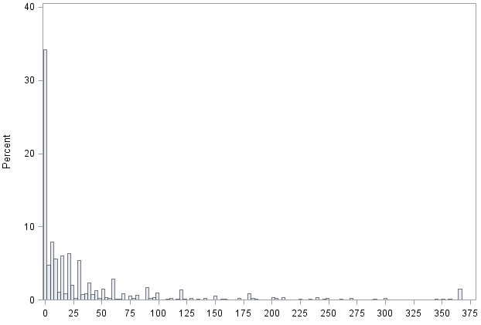
Days

Histogram of the number of days of sick leave in the studied sample

