COVID-19 as a putative trigger of anti-MDA5-associated dermatomyositis with acute respiratory distress syndrome (ARDS) requiring lung transplantation, A case report

Supplementary material

Fig. S1: Event summary on a timeline axis

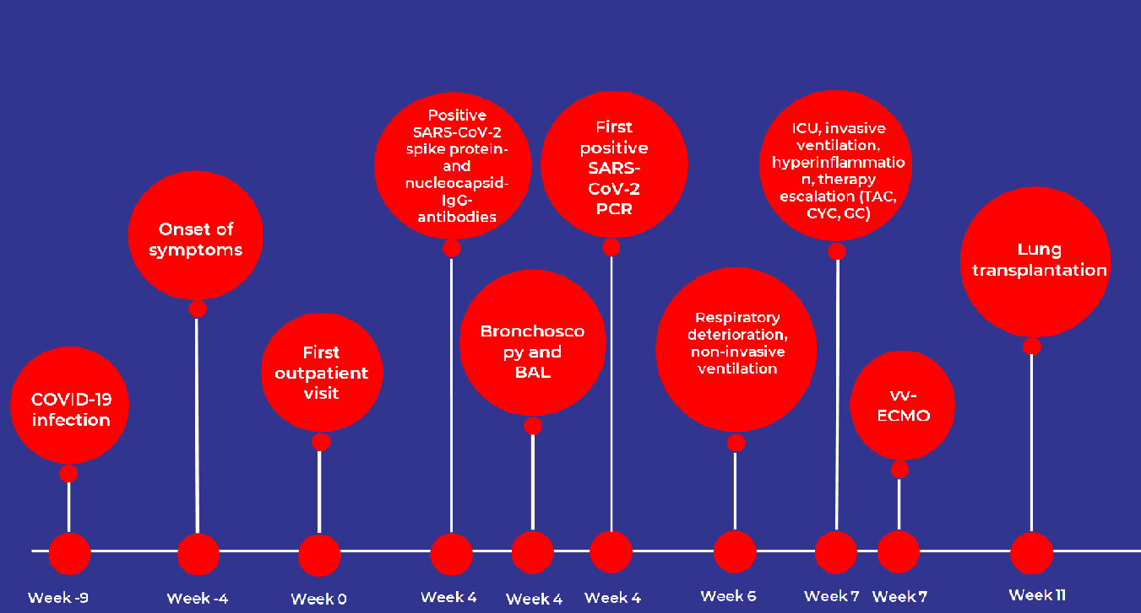

Fig. S2: Development of laboratory values during the inpatient and outpatient treatment: Creatine kinase (CK), C-reactive protein (CRP), Interleukin-6 and ferritin

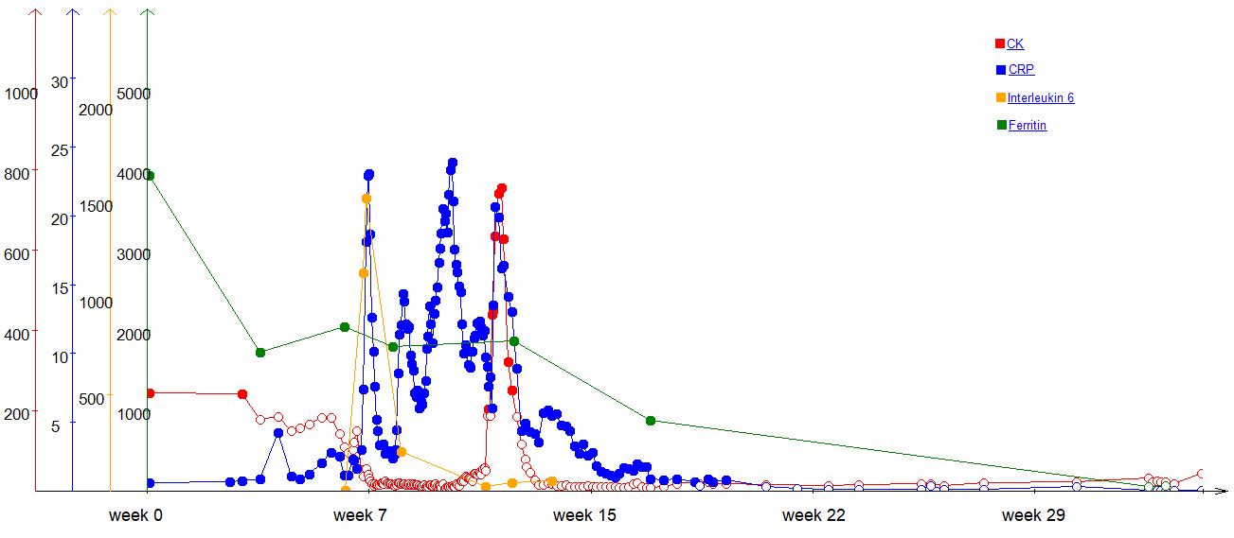

Supplement 3: List of the analysed genes in association with myositis:
ADAR, C4A, CAPN3, CCR1, ERAP1, FAS, FOXP3, HLA-B, HNRNPA2B1, IFIH1, IL10, IL12A, IL12A-AS1, IL23R, IRAK1, KLRC4, LAMA2, MEFV, PSMB4, PSMB9, PSTPIP1, RNASEH2A, RNASEH2B, RNASEH2C, SAMHD1, SPP1, STAT4, STING1, TLR4, TNFRSF1A, TREX1, UBAC2, NAB1, TYK2, YDJC, PTPN22, FAM167A, DGKQ

