Suppliment1.Comparison of disease activity indices by biologic use among employed and unemployed patients
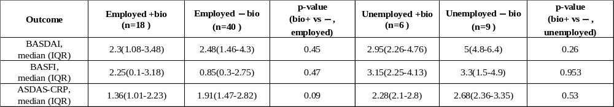
Values are expressed median (interquartile range),
BASDAI: Bath Ankylosing Spondylitis Disease Activity Index; BASFI: Bath Ankylosing Spondylitis Functional Index; ASDAS-CRP: Ankylosing Spondylitis Disease Activity Score (CRP).

