Supplemental Figure1. Subgroup analysis of the relationship of hydroxychloroquine dose with risk of systemic lupus erythematosus flares. They were adjusted for age, sex, baseline SLEDAI, infection, other autoimmune diseases, prednisone initial dose at the baseline, immunosuppressant, biologics, and HCQ duration.

Supplementary Table 1. Association of Hydroxychloroquine Dose（≤5mg/kg/d vs＞5mg/kg/d）with Risk of Systemic Lupus Erythematosus Flares
 |  | HCQ Groups
 |  | ≤5mg/kg/d | ＞5mg/kg/d
 | Total | 118 | 585
 | Flare, n,% | 63 (53.4) | 257 (43.9)
 | Follow-up Time(Person-months) | 1438.766667 | 7201.7
Model 1 | HR (95%CI) | 1(Ref) | 0.77 (0.58~1.01)
 | P value |  | 0.057
Model 2 | HR (95%CI) | 1(Ref) | 0.75 (0.57~0.99)
 | P value |  | 0.043
Model 3 | HR (95%CI) | 1(Ref) | 0.68 (0.51~0.9)
 | P value |  | 0.007
Model 1, unadjusted;
Model 2, adjusted for age, sex, baseline SLEDAI-2K.
Model 3, adjusted for age, sex, baseline SLEDAI-2K, infection, other autoimmune diseases, prednisone starting dose, immunosuppressant, biologics, and HCQ duration.
HR Hazards ratio; CI confidence index; Ref: reference. *, P<0.05

Supplementary table 2 Association of Hydroxychloroquine cumulative Dose with Risk of Systemic Lupus Erythematosus Flares
 | Variables | Log (HCQ cumulative dose) | Low dose group | High dose group
 | Total | 703 | 351 | 352
 | Flare, n, % | 320 (45.5) | 164 (46.7) | 156 (44.3)
 | Follow-up Time(Person-months) | 8640.467 | 3802.63 | 4837.83
Model 1 | HR (95%CI) | 0.64 (0.54~0.77) | 1(Ref) | 0.32 (0.25~0.4)
 | P value | <0.001 | <0.001
Model 2 | HR (95%CI) | 0.66 (0.55~0.79) | 1(Ref) | 0.29 (0.23~0.37)
 | P value | <0.001 | <0.001
Model 3 | HR (95%CI) | 0.65 (0.54~0.78) | 1(Ref) | 0.3 (0.24~0.38)
 | P value | <0.001 | <0.001
Model 1, unadjusted;
Model 2, adjusted for age, sex, baseline SLEDAI-2K.
Model 3, adjusted for age, sex, baseline SLEDAI-2K, infection, other autoimmune diseases, prednisone starting dose, immunosuppressant, biologics, and HCQ duration.
HR Hazards ratio; CI confidence index; Ref: reference. *, P<0.05

Supplementary table S3. Sensitivity analysis of the association between hydroxychloroquine dosage and risk of SLE flares after excluding patients with neuropsychiatric involvement
 |  | HCQ Groups
 | Variable | ≤6.5mg/kg/d | >6.5mg/kg/d
 | Total | 274 | 352
 | Flare, n,% | 142 (51.8) | 141 (40.1)
 | Follow-up Time(Person-months) | 3364.33 | 4339.133333
Model 1 | HR (95%CI) | 1(Ref) | 0.75 (0.59~0.95)
 | P value |  | 0.016*
Model 2 | HR (95%CI) | 1(Ref) | 0.77 (0.6~0.98)
 | P value |  | 0.032*
Model 3 | HR (95%CI) | 1(Ref) | 0.77 (0.61~0.98)
 | P value |  | 0.037*
Model 1, unadjusted;
Model 2, adjusted for age, sex, and baseline SLEDAI-2K.
Model 3, adjusted for age, sex, baseline SLEDAI-2K, infection, other autoimmune diseases, prednisone starting dose, immunosuppressant, biologics, and HCQ duration.
HR Hazards ratio; CI confidence index; Ref: reference. *, P<0.05

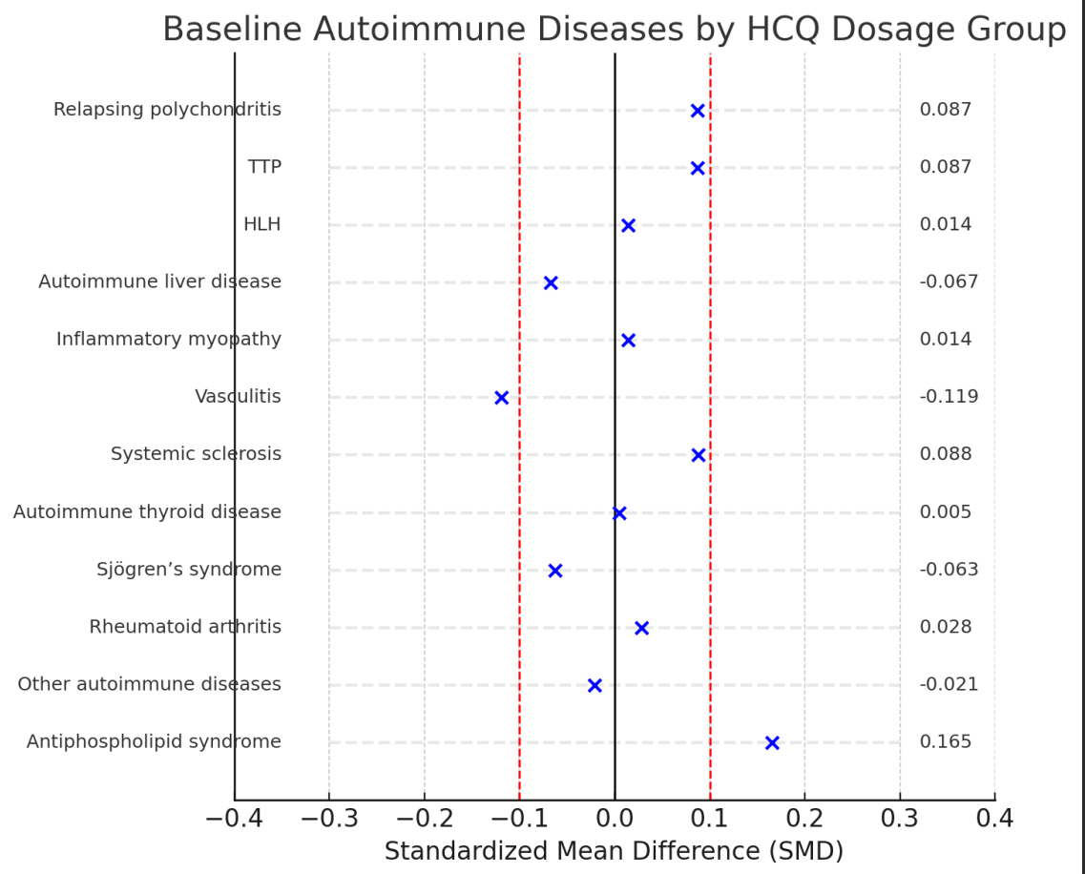
Supplemental Figure 2. Standardized mean differences (SMDs) for baseline autoimmune diseases between hydroxychloroquine dosage groups (≤6.5 mg/kg/day vs. >6.5 mg/kg/day).
Each point represents the standardized mean difference (SMD) in the prevalence of autoimmune diseases between the two HCQ dosage groups. The vertical dashed red lines at ±0.10 indicate the conventional threshold for potential imbalance. Most conditions showed SMDs within this range, suggesting good balance, except for antiphospholipid syndrome (APS), which demonstrated a modest imbalance (SMD = 0.165).

Supplementary Table 4 Impact of Antiphospholipid Syndrome on the Association Between HCQ Dose and Flare Risk
 |  | HCQ Groups
 |  | ≤6.5mg/kg/d | >6.5mg/kg/d
 | Total | 305 | 398
 | Flare, n,% | 157 (51.5) | 163 (41)
 | Follow-up Time(Person-months) | 3731.833333 | 4908.633333
Model 1 | HR (95%CI) | 1(Ref) | 0.77 (0.61~0.95)
 | P value |  | 0.017*
Model 2 | HR (95%CI) | 1(Ref) | 0.77 (0.61~0.96)
 | P value |  | 0.023*
Model 1, unadjusted;
Model 2, adjusted for age, sex, baseline SLEDAI-2K, infection, antiphospholipid syndrome, other autoimmune diseases, prednisone starting dose, immunosuppressant, biologics, and HCQ duration.
HR Hazards ratio; CI confidence index; Ref: reference. *, P<0.05

