Supplementary data

Efficacy and Safety of Non-Conventional Synthetic Disease-Modifying Antirheumatic Drugs in Early Active Rheumatoid Arthritis: A Network Meta-Analysis
Supplementary data 1: Search strategy 1
Supplementary data 2: PICOS 2
Supplementary data 3: Characteristics of included studies 3
Supplementary data 4: Evaluation of Inconsistency 6
Supplementary data 5: SUCRA and cumulative probability plots 9
Supplementary data 6: league figures 10
Supplementary data 7: Other outcomes 12
Supplementary data 8: Risk of bias of included studies according to the Cochrane risk of bias tool 1 14
Supplementary data 9: Funnel plots 16
Supplementary data 10: Sensitivity analyses of primary outcomes 18
Supplementary data 11: References 23

Supplementary data 1: Search strategy
Table S1 Search strategy of PubMed
# | Searches | Results
1 | (("Arthritis, Rheumatoid"[Mesh]) OR (RA[Title/Abstract])) OR ((Rheumatoid[Title/Abstract]) OR (rheumatism[Title/Abstract])) | 237,607
2 | (((((((((((((((((((((((((((((biologic disease modifying antirheumatic drugs[Title/Abstract]) OR (bDMARD[Title/Abstract])) OR (bDMARDs[Title/Abstract])) OR (TNF inhibitors[Title/Abstract])) OR (tumor necrosis factor inhibitors[Title/Abstract])) OR (interleukin receptor antagonists[Title/Abstract])) OR (Rituximab[Title/Abstract])) OR (Abatacept[Title/Abstract])) OR (Adalimumab[Title/Abstract])) OR (Infliximab[Title/Abstract])) OR (Etanercept[Title/Abstract])) OR (Golimumab[Title/Abstract])) OR (Certolizumab[Title/Abstract])) OR (Anakinra[Title/Abstract])) OR (Tocilizumab[Title/Abstract])) OR (Secukinumab[Title/Abstract])) OR (Ixekizumab[Title/Abstract])) OR (Ustekinumab[Title/Abstract])) OR (Sarilumab[Title/Abstract])) OR (Sirukumab[Title/Abstract])) OR (levilimab[Title/Abstract])) OR (Olokizumab[Title/Abstract])) OR (Mavrilimumab[Title/Abstract])) OR (otilimab[Title/Abstract])) OR (ozoralizumab[Title/Abstract])) OR (LZM001[Title/Abstract])) OR (Ziltivekimab[Title/Abstract])) OR (Genakumab[Title/Abstract])) OR (VDJ1001[Title/Abstract])) OR (HL2351[Title/Abstract]) | 72,961
3 | ((((((((((((((((((((targeted synthetic disease modifying antirheumatic drugs[Title/Abstract]) OR (bDMARDs[Title/Abstract])) OR (bDMARD[Title/Abstract])) OR (JAKi[Title/Abstract])) OR (janus kinase inhibitor[Title/Abstract])) OR (Tofacitinib[Title/Abstract])) OR (Baricitinib[Title/Abstract])) OR (Upadacitinib[Title/Abstract])) OR (Filgotinib[Title/Abstract])) OR (Olumiant[Title/Abstract])) OR (peficitinib[Title/Abstract])) OR (telitacicept[Title/Abstract])) OR (Decernotinib[Title/Abstract])) OR (SHR0302[Title/Abstract])) OR (Tasocitinb[Title/Abstract])) OR (VC005[Title/Abstract])) OR (Zemprocitinib[Title/Abstract])) OR (WXFL10203614[Title/Abstract])) OR (EQ121[Title/Abstract])) OR (LW402[Title/Abstract])) OR (TUL01101[Title/Abstract]) | 8,298
4 | "csDMARDs"[Title/Abstract] OR "conventional synthetic disease modifying anti rheumatic drugs"[Title/Abstract] OR "Methotrexate"[Title/Abstract] OR "Leflunomide"[Title/Abstract] OR "Hydroxychloroquine"[Title/Abstract] OR "Sulfasalazine"[Title/Abstract] OR "Azathioprine"[Title/Abstract] | 80,008
5 | (((((((((((((((((((((((((((((((((((((((((((((((((((((((Zuberitamab[Title/Abstract]) OR (Telitacicept[Title/Abstract])) OR (Isomyosamine[Title/Abstract])) OR (Hemay007[Title/Abstract])) OR (edralbrutinib[Title/Abstract])) OR (AC0058TA[Title/Abstract])) OR (Civorebrutinb[Title/Abstract])) OR (IMG004[Title/Abstract])) OR (BTKMax[Title/Abstract])) OR (YZJ3058[Title/Abstract])) OR (Gerilimzumab[Title/Abstract])) OR (MEDI5117[Title/Abstract])) OR (KYV101[Title/Abstract])) OR (Eclitasertib[Title/Abstract])) OR (Ocadusertib[Title/Abstract])) OR (AC003[Title/Abstract])) OR (CUG252[Title/Abstract])) OR (KT474[Title/Abstract])) OR (Nacresertib[Title/Abstract])) OR (ZL82[Title/Abstract])) OR (Peresolimab[Title/Abstract])) OR (Rosnilimab[Title/Abstract])) OR (JNJ67484703[Title/Abstract])) OR (Turenkibart[Title/Abstract])) OR (zuberitamab[Title/Abstract])) OR (ozoralizumab[Title/Abstract])) OR (Deucravacitinib[Title/Abstract])) OR (Abiprubart[Title/Abstract])) OR (Namilumab[Title/Abstract])) OR (Pegantiangitide[Title/Abstract])) OR (KIO101[Title/Abstract])) OR (Balinatunfib[Title/Abstract])) OR (cenerimod[Title/Abstract])) OR (suciraslimab[Title/Abstract])) OR (JNJ63823539[Title/Abstract])) OR (lguratimod[Title/Abstract])) OR (DTRMHS07[Title/Abstract])) OR (Belimumab[Title/Abstract])) OR (IMD2560[Title/Abstract])) OR (FR104[Title/Abstract])) OR (Emapalumab[Title/Abstract])) OR (Tacrolimus[Title/Abstract])) OR (Cyclosporine[Title/Abstract])) OR (Repibresib[Title/Abstract])) OR (VYN202[Title/Abstract])) OR (NIM1324[Title/Abstract])) OR (IPG11406[Title/Abstract])) OR (EVT401[Title/Abstract])) OR (GB-261[Title/Abstract])) OR (XMAB13676[Title/Abstract])) OR (QY201[Title/Abstract])) OR (Girocitinib[Title/Abstract])) OR (SDC1801[Title/Abstract])) OR (KL130008[Title/Abstract])) OR (Luminol[Title/Abstract])) OR (Mizoribine[Title/Abstract]) | 57,552
6 | randomized controlled trial[Publication Type] OR (randomized[Title/Abstract] AND controlled[Title/Abstract] AND trial[Title/Abstract]) | 717,386
7 | #2 OR #3 OR #4 OR #5 | 196,875
8 | #1 AND #6 AND #7 | 2,207
The search strategies for other databases follow the same approach.

Supplementary data 2: PICOS
Table S2 PICOS of the meta-analysis
PICOS | Criteria
P（Population） | Adults (≥18 years) with early RA, defined as disease duration <2 years, diagnosed according to ACR or EULAR classification criteria;
I（Intervention） | Currently approved non-conventional Synthetic Disease-Modifying Antirheumatic Drugs for RA treatment, primarily including biologics and JAK inhibitors, with a minimum treatment duration of 24 weeks;
C（Comparison） | Conventional synthetic DMARDs
O（Outcome） | DAS28 remission(≤2.6), ACR70, adverse events, serious adverse events;
S(Study Design） | Randomized controlled trials;

Supplementary data 3: Characteristics of included studies
Table S3 Baseline characteristics of included studies
Author (year) | Country | Group, N | Intervention(N) | Comparator(N) | Age(yr)  Intervention | Gender Female (%) | Duration of RA | Follow-up Time | RCT
Atsumi  (2016)[1] | Japan | 316 | CZP+MTX(n=159) | MTX+PBO(n=157) | 49.4±10.6 | 81% | 4.0±2.9m | 52w | NCT01451203
Bejarano  (2008)[2] | UK | 148 | ADA+MTX(n=75) | MTX+PBO(n=73) | 47±9 | 41% | 9.5±6.0m | 56w | NA
Bertrand  (2024)[3] | Belgium | 112 | MTX+ETN(n=55) | MTX+LEF(n=55) | 52.5±12.9 | 69% | 4(2-6)m | 28w | NCT03649061
Bijlsma  (2016)[4] | Netherlands | 317 | TCZ+MTX(n=106)  TCZ+PBO(n=103) | MTX+PBO(n=108) | 53(46–60)  55 (47–63) | 61%  76% | 24.5(16-41.5)d  25.5(18–45)d | 52w | NCT01034137
Burmester  (2016)[5] | Multi-country | 896 | TCZ+MTX(n=290)  TCZ+PBO(n=292) | MTX+PBO(n=287) | 49.5±13.70  49.9±13.22 | 79%  75% | 0.4±0.48y | 52w | NCT01007435
Conaghan  (2016)[6] | Multi-country | 109 | TOFA+ MTX(n=36)  TOFA+ PBO(n=36) | MTX+PBO(n=37) | 47.8±12.3  50.8±12.8 | 86%  83% | 0.8(0.1-2.2）y  0.8(0.1-8.5)y | 52w | NCT01164579
Detert  (2013)[7] | Germany | 172 | ADA+MTX(n=87) | MTX+PBO(n=85) | 47.2±12.12 | 77% | 1.8±2.1m | 24w | NA
Emery  (2008)[8] | Multi-country | 542 | ETN+MTX(n=265) | MTX+PBO(n=263) | 50.5±0.9 | 74% | 8.8±0.4m | 52w | NCT00195494
Emery  (2015)[9] | Multi-country | 351 | ABA+MTX(n=119)  ABA+PBO(n=116) | MTX+PBO(n=116) | 46.4±13.2  45.4±11.9 | 80% | 0.58±0.50y  0.59±0.52y | 52w | NCT01142726
Emery  (2017)[10] | Multi-country | 868 | MTX+CZP(n=655) | MTX+PBO(n=213) | 50.4±13.6 | 76% | 2.9±4.6m | 52w | NCT01519791
Emery  (2020)[11] | UK | 120 | ETN+MTX(n=60) | MTX(n=60) | 49.6±12.5 | 65% | 19.2(12.5-28.1)w | 48w | NCT02433184
Emery  (2023)[12] | Multi-country | 752 | ABA+MTX(n=451) | MTX+PBO(n=301) | 49±13 | 67% | 1.2±1.4m | 52w | NCT02504268
Hørslev-Petersen  (2014)[13] | Denmark | 180 | ADA+MTX(n=89) | MTX+PBO(n=91) | 56.2(25.8-77.6) | 71% | 88(42-162)d | 52w | NCT00660647
Kavanaugh(2013)[14] | Multi-country | 1032 | ADA+MTX(n=515) | MTX+PBO(n=517) | 50.7±14.5 | 74% | 4.0±3.6m | 26w | NCT00420927
Leirisalo-Repo  (2013)[15][15] | Finland | 99 | MTX+SSZ+HCQ+Pred+IFX(n=50) | MTX+SSZ+HCQ+Pred+PBO(n=49) | 47±10 | 70% | 4(2-6)m | 104w | NCT00908089
Nam  (2014)[16] | UK | 112 | MTX+IFX(n=55) | MTX+Steroid(n=57) | 52.9±12.8 | 75% | 1.2(0.7-1.7)m | 26w | NA
Nam*  (2014)[17] | UK | 110 | ETN+MTX(n=55) | MTX+PBO(n=55) | 47.9±13.6 | 73% | 6(4-9)m | 52w | ISRCTN 55428162
Østergaard(2023)[18] | Multi-country | 795 | CZP+MTX(n=203)  ABA+MTX(n=204)  TCZ+MTX(n=188) | MTX+pred/SSZ+HCQ(n=200) | 55±15  55±14  52±15 | 69%  69%  69% | 203±166d  212±168d  208±155d | 48w | NCT01491815
Takeuchi  (2014)[19] | Japan | 334 | ADA+MTX(n=171) | MTX+PBO(n=163) | 54±13.1 | 84% | 0.3±0.4y | 104w | NCT00870467
Vollenhoven(2012)[20] | Sweden | 487 | MTX+IFX(n=128) | MTX+SSZ+HCQ(n=130) | 51.1±13.3 | 76% | 6.2±3.5m | 52w | NCT00764725
Westhovens(2009)[21] | Multi-country | 509 | ABA+MTX(n=256) | MTX+PBO(n=253) | 50.1±12.4 | 77% | 6.2±7.5m | 52w | NCT00122382

Abbreviations: m,moths;w,week;y,year;MTX, Methotrexate;TCZ,Tocilizumab; ABA,Abatacept; ADA,Adalimumab; CZP,Certolizumab pegol; ETN, Etanercept; IFX, Infliximab; TOFA,Tofacitinib;SSZ,Sulfasalazine; HCQ,Hydroxychloroquine;Pred,Prednisone;LEF, Leflunomide;

Supplementary data 4: Evaluation of Inconsistency
Table S4: Global consistency
Clinical outcome | Chi square | P value
DAS28 remission | 0.73 | 0.9481
ACR70 | 1.58 | 0.2090
AE | 0.15 | 0.9270
SAE | 1.39 | 0.7090
ΔmTSS | 2.51 | 0.1133
infections | 2.22 | 0.5274
Serious infections | 0.39 | 0.5340
Discontinuation due to AEs | 0.57 | 0.4484
Abbreviations: DAS28 remission, Disease Activity Score in 28 joints (DAS28) remission; ACR70, American College of Rheumatology 70% improvement criteria; AE, Adverse Event; SAE, Serious Adverse Event； ΔmTSS: Change from baseline in the van der Heijde-Sharp score;

Table S5：Side-splitting of DAS28 remission
Comparison | Direct |  | Indirect |  | Difference
Comparison | Coef. | Std. Err. | Coef. | Std. Err. | Coef. | Std. Err. | P>|z| | tau2
MTX vs  TCZ+MTX | 1.075 | 0.347 | 0.671 | 0.348 | 0.404 | 0.491 | 0.411 | 0.302
MTX vs ABA+MTX | 0.707 | 0.218 | 0.996 | 0.359 | -0.288 | 0.420 | 0.492 | 0.299
MTX vs CZP+MTX | 0.763 | 0.268 | 0.645 | 0.369 | 0.117 | 0.457 | 0.797 | 0.321
MTX vs. ETN+MTX | 0.518 | 0.310 | 0.731 | 0.493 | -0.213 | 0.582 | 0.714 | 0.318
MTX vs. TCZ | 0.986 | 0.357 | 0.178 | 0.907 | 0.808 | 0.983 | 0.411 | 0.302
MTX vs. ABA | -0.105 | 0.407 | 0.277 | 0.828 | -0.382 | 0.923 | 0.679 | 0.310
TCZ+MTX vs. ABA+MTX | 0.141 | 0.364 | -0.353 | 0.389 | 0.494 | 0.533 | 0.354 | 0.290
TCZ+MTX vs. CZP+MTX | -0.075 | 0.385 | -0.246 | 0.444 | 0.171 | 0.587 | 0.770 | 0.318
TCZ+MTX vs. TCZ | -0.089 | 0.335 | 0.719 | 0.931 | -0.808 | 0.983 | 0.411 | 0.302
TCZ+MTX vs. csDMARDs | -0.619 | 0.373 | -1.144 | 0.569 | 0.525 | 0.681 | 0.441 | 0.308
ABA+MTX vs. CZP+MTX | -0.213 | 0.378 | 0.064 | 0.344 | -0.277 | 0.511 | 0.588 | 0.311
ABA+MTX vs. ABA | -0.739 | 0.408 | -1.121 | 0.827 | 0.382 | 0.923 | 0.679 | 0.310
ABA+MTX vs csDMARDs | -0.755 | 0.374 | -0.590 | 0.480 | -0.165 | 0.609 | 0.787 | 0.310
CZP+MTX vs. csDMARDs | -0.545 | 0.380 | -0.788 | 0.513 | 0.243 | 0.639 | 0.704 | 0.319
ETN+MTX vs. csDMARDs | -0.564 | 0.349 | -0.350 | 0.465 | -0.213 | 0.582 | 0.714 | 0.318
IFX+MTX vs. csDMARDs | -0.222 | 0.349 | 0.240 | 882.536 | -0.462 | 882.536 | 1.000 | 0.286

Table S6：Ring consistency of DAS28 remission
Loop | ROR | 95%CI | P value | tau2
MTX vs. TCZ+MTX vs. ETN+MTX vs. csDMARDs | 1.858 | (1.00,17.07) | 0.584 | 0.363
MTX vs. TCZ+MTX vs. ABA+MTX | 1.638 | (1.00,2.99) | 0.108 | 0.000
MTX vs. CZP+MTX vs. ETN+MTX vs. csDMARDs | 1.337 | (1.00,6.08) | 0.707 | 0.131
MTX vs. ABA+MTX vs. ETN+MTX vs. csDMARDs | 1.286 | (1.00,2.35) | 0.415 | 0.000

Table S7：Side-splitting of ACR70
Comparison | Direct |  | Indirect |  | Difference
Comparison | Coef. | Std. Err. | Coef. | Std. Err. | Coef. | Std. Err. | P>|z| | tau2
MTX vs. ETN+MTX | 0.862 | 0.189 | 0.391 | 364.909 | 0.472 | 364.909 | 0.999 | 0.000
ETN+MTX vs. csDMARDs | -0.592 | 0.388 | -1.075 | 413.604 | 0.484 | 413.604 | 0.999 | 0.000
IFX+MTX vs. csDMARDs | -0.295 | 0.235 | 0.554 | 899.080 | -0.850 | 899.080 | 0.999 | 0.000

Table S8: Side-splitting of AE
Comparison | Direct |  | Indirect |  | Difference
Comparison | Coef. | Std. Err. | Coef. | Std. Err. | Coef. | Std. Err. | P>|z| | tau2
MTX vs ABA+MTX | 0.031 | 0.133 | 0.082 | 0.620 | -0.051 | 0.634 | 0.936 | 0.000
MTX vs CZP+MTX | 0.438 | 0.540 | 0.387 | 0.333 | 0.051 | 0.634 | 0.936 | 0.000
MTX vs. ABA | -0.172 | 0.339 | -0.456 | 0.675 | 0.284 | 0.763 | 0.709 | 0.000
TCZ+MTX vs. ABA+MTX | -1.593 | 0.461 | -1.695 | 1.289 | 0.103 | 1.268 | 0.936 | 0.000
TCZ+MTX vs. CZP+MTX | -1.236 | 0.475 | -1.133 | 1.273 | -0.103 | 1.268 | 0.936 | 0.000
TCZ+MTX vs. csDMARDs | -1.366 | 0.471 | -1.589 | 1159.243 | 0.222 | 1159.243 | 1.000 | 0.000
ABA+MTX vs. CZP+MTX | 0.356 | 0.306 | 0.408 | 0.556 | -0.051 | 0.634 | 0.936 | 0.000
ABA+MTX vs. ABA | -0.328 | 0.346 | -0.043 | 0.663 | -0.284 | 0.763 | 0.709 | 0.000
ABA+MTX vs. csDMARDs | 0.226 | 0.299 | 0.329 | 1.240 | -0.103 | 1.268 | 0.936 | 0.000
CZP+MTX vs. csDMARDs | -0.130 | 0.320 | -0.233 | 1.224 | 0.103 | 1.268 | 0.936 | 0.000
IFX+MTX vs. csDMARDs | 0.317 | 0.243 | 0.594 | 1187.198 | -0.277 | 1187.198 | 1.000 | 0.000

Table S9: Ring consistency of AE
Loop | ROR | 95%CI | P value | tau2
MTX vs.  ABA+MTX vs. ABA | 1.157 | (1.00,3.11) | 0.773 | 0.000
MTX vs. ABA+MTX vs. CZP+MTX | 1.053 | (1.00,3.65) | 0.936 | 0.000

Table S10: Side-splitting of SAE
Comparison | Direct |  | Indirect |  | Difference
Comparison | Coef. | Std. Err. | Coef. | Std. Err. | Coef. | Std. Err. | P>|z| | tau2
MTX vs  TCZ+MTX | 0.217 | 0.468 | 0.061 | 0.518 | 0.156 | 0.698 | 0.823 | 0.394
MTX vs ABA+MTX | 0.275 | 0.313 | -0.182 | 0.513 | 0.458 | 0.601 | 0.446 | 0.359
MTX vs CZP+MTX | 0.056 | 0.333 | 0.645 | 0.477 | -0.588 | 0.582 | 0.312 | 0.337
MTX vs. TCZ | 0.007 | 0.494 | -0.306 | 1.305 | 0.312 | 1.397 | 0.823 | 0.394
MTX vs. ABA | 0.490 | 0.578 | 1.241 | 1.222 | -0.752 | 1.381 | 0.586 | 0.365

Table S11: Ring consistency of SAE
Loop | ROR | 95%CI | P value | tau2
MTX vs. ABA+MTX vs. CZP+MTX | 1.923 | (1.00,6.35) | 0.283 | 0.078
MTX vs. ABA+MTX vs.ABA | 1.697 | (1.00,6.62) | 0.447 | 0.000
MTX vs. TCZ+MTX vs. CZP+MTX | 1.591 | (1.00,4.02) | 0.327 | 0.000
MTX vs. TCZ+MTX vs. ABA+MTX | 1.186 | (1.00,6.12) | 0.838 | 0.194

Table S12 Transitivity Assessment

 | Baseline variable (Mean ± SD)
intervention | Age(year) | DAS28（ESR）
ABA+MTX | 49.5 ± 13.1 | 4.8 ± 1.9
ABA+PBO | 45.4 ± 11.9 | 5.5 ± 1.1
ADA+MTX | 50.3 ± 16.4 | 5.8 ± 1.5
CZP+MTX | 51.2 ± 11.7 | 5.4 ± 1.1
ETN+MTX | 51.7 ± 12.5 | 5.5 ± 1.3
IFX+MTX | 48.25 ± 11.88 | 5.71 ± 0.97
MTX+CZP | 50.4 ± 13.6 | 6.7 ± 0.9
MTX+ETN | 52.5 ± 12.9 | 5.6 ± 1.4
TCZ+MTX | 51.6 ± 12.8 | 5.4 ± 1.3
TCZ+PBO | 52.5 ± 12.6 | 6.0 ± 1
TOFA+MTX | 47.8 ± 12.3 | 6.3 ± 0.9
TOFA+PBO | 50.8 ± 12.8 | 6.5 ± 0.8

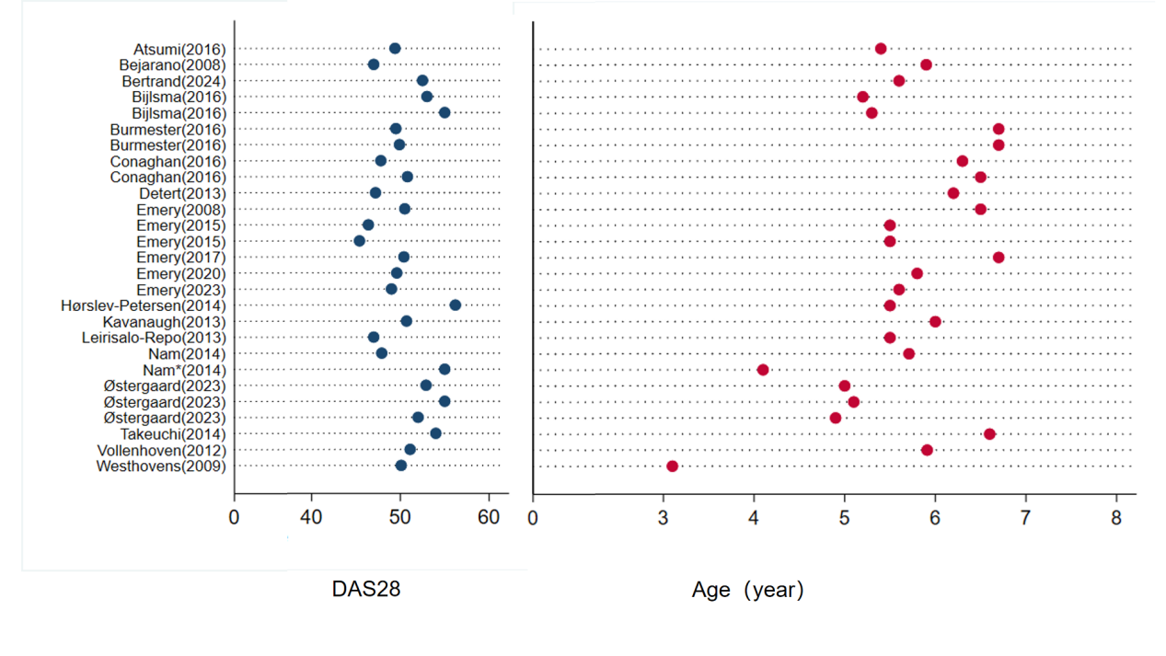
Figure S1: Mean age and DAS28 plots for each intervention group

Supplementary data 5: SUCRA and cumulative probability plots
Table S13: SUCRA of the effects of various interventions for DAS28 remission.
Treatment | SUCRA | PrBest | MeanRank
MTX | 13 | 0 | 10.6
ABA | 14.4 | 0 | 10.4
csDMARDs | 18 | 0 | 10
IFX+MTX | 34.1 | 1.5 | 8.2
TOFA | 42.5 | 4.5 | 7.3
ETN+MTX | 49.5 | 0.6 | 6.6
CZP+MTX | 58.7 | 1.2 | 5.5
ABA+MTX | 64.1 | 1.6 | 4.9
TCZ | 69.6 | 10.6 | 4.3
TCZ+MTX | 71.1 | 6.1 | 4.2
TOFA+MTX | 81.3 | 51.3 | 3.1
ADA+MTX | 83.7 | 22.6 | 2.8

Table S14: SUCRA of the effects of various interventions for ACR70.
Treatment | SUCRA | PrBest | MeanRank
MTX | 9.3 | 0 | 10.1
csDMARDS | 22.2 | 0 | 8.8
TOFA+MTX | 23.5 | 1.2 | 8.6
TOFA | 34.9 | 2.2 | 7.5
IFX+MTX | 42.7 | 2.9 | 6.7
ABA+MTX | 48 | 0 | 6.2
ETN+MTX | 61 | 1.2 | 4.9
CZP+MTX | 65.6 | 5.7 | 4.4
ADA+MTX | 66 | 1.2 | 4.4
TCZ | 81.7 | 14.8 | 2.8
TCZ+MTX | 95.1 | 70.8 | 1.5

Supplementary data 6: league figures
These figures present comparisons between the drug categories listed in the rows versus those in the columns. The effect estimates are expressed as odds ratios (OR) with 95% confidence intervals. An OR < 1 favors the column drug. An OR > 1 favors the row drug. Comparisons marked with an asterisk (*) indicate that the 95% CI does not include 1 (statistically significant).
Figure S2: league table for DAS28 remission compared to methotrexate

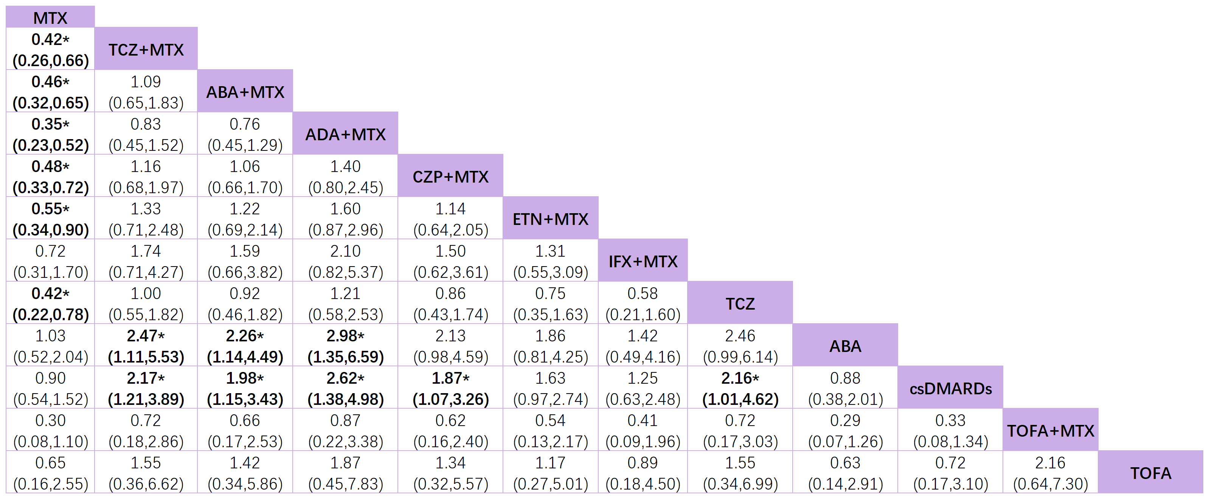
Figure S3 league table for ACR70 response compared to methotrexate.

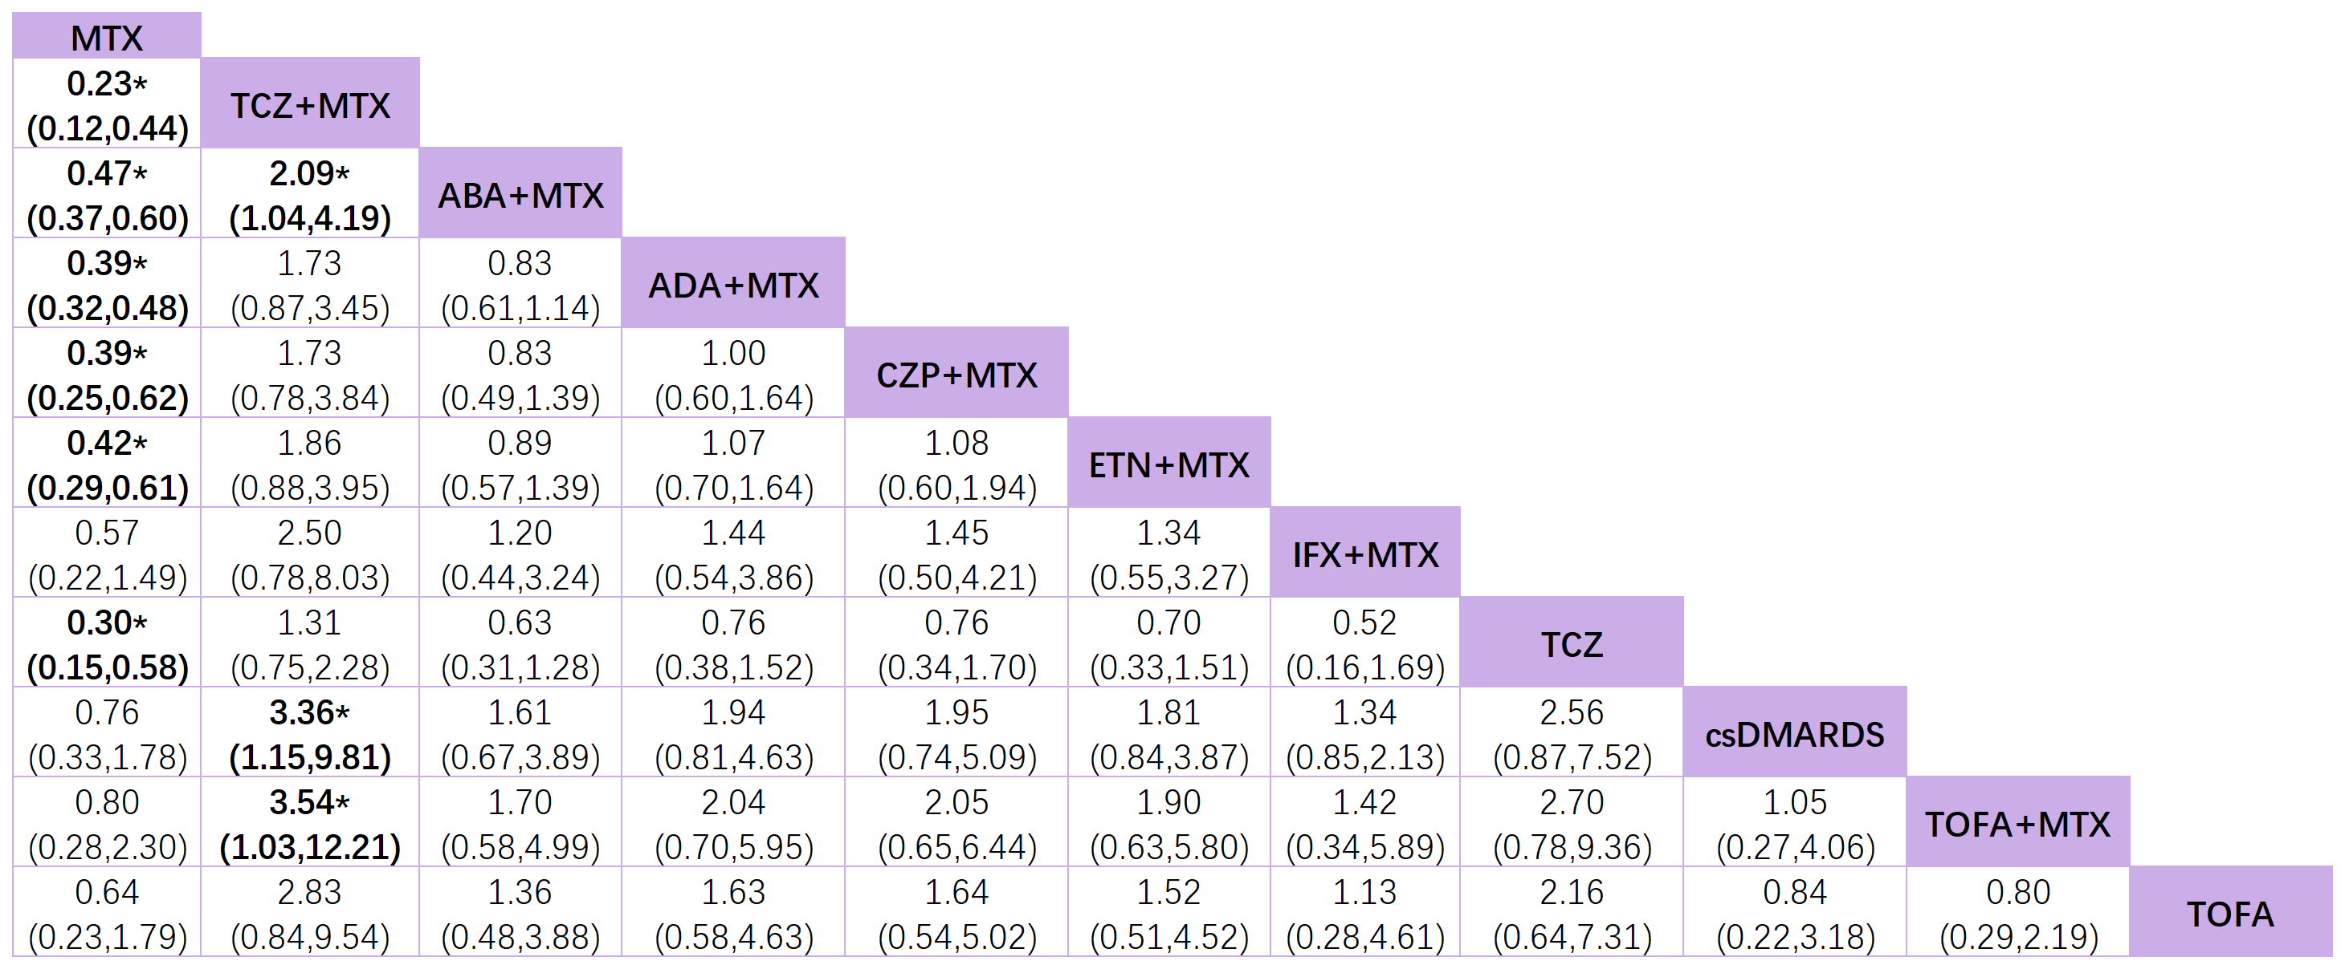

Figure S4 league table for AE compared to methotrexate.

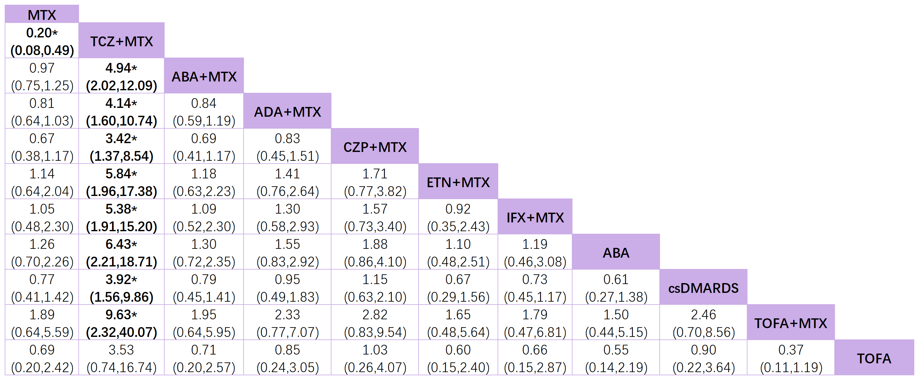

Figure S5 league table for SAE compared to methotrexate.
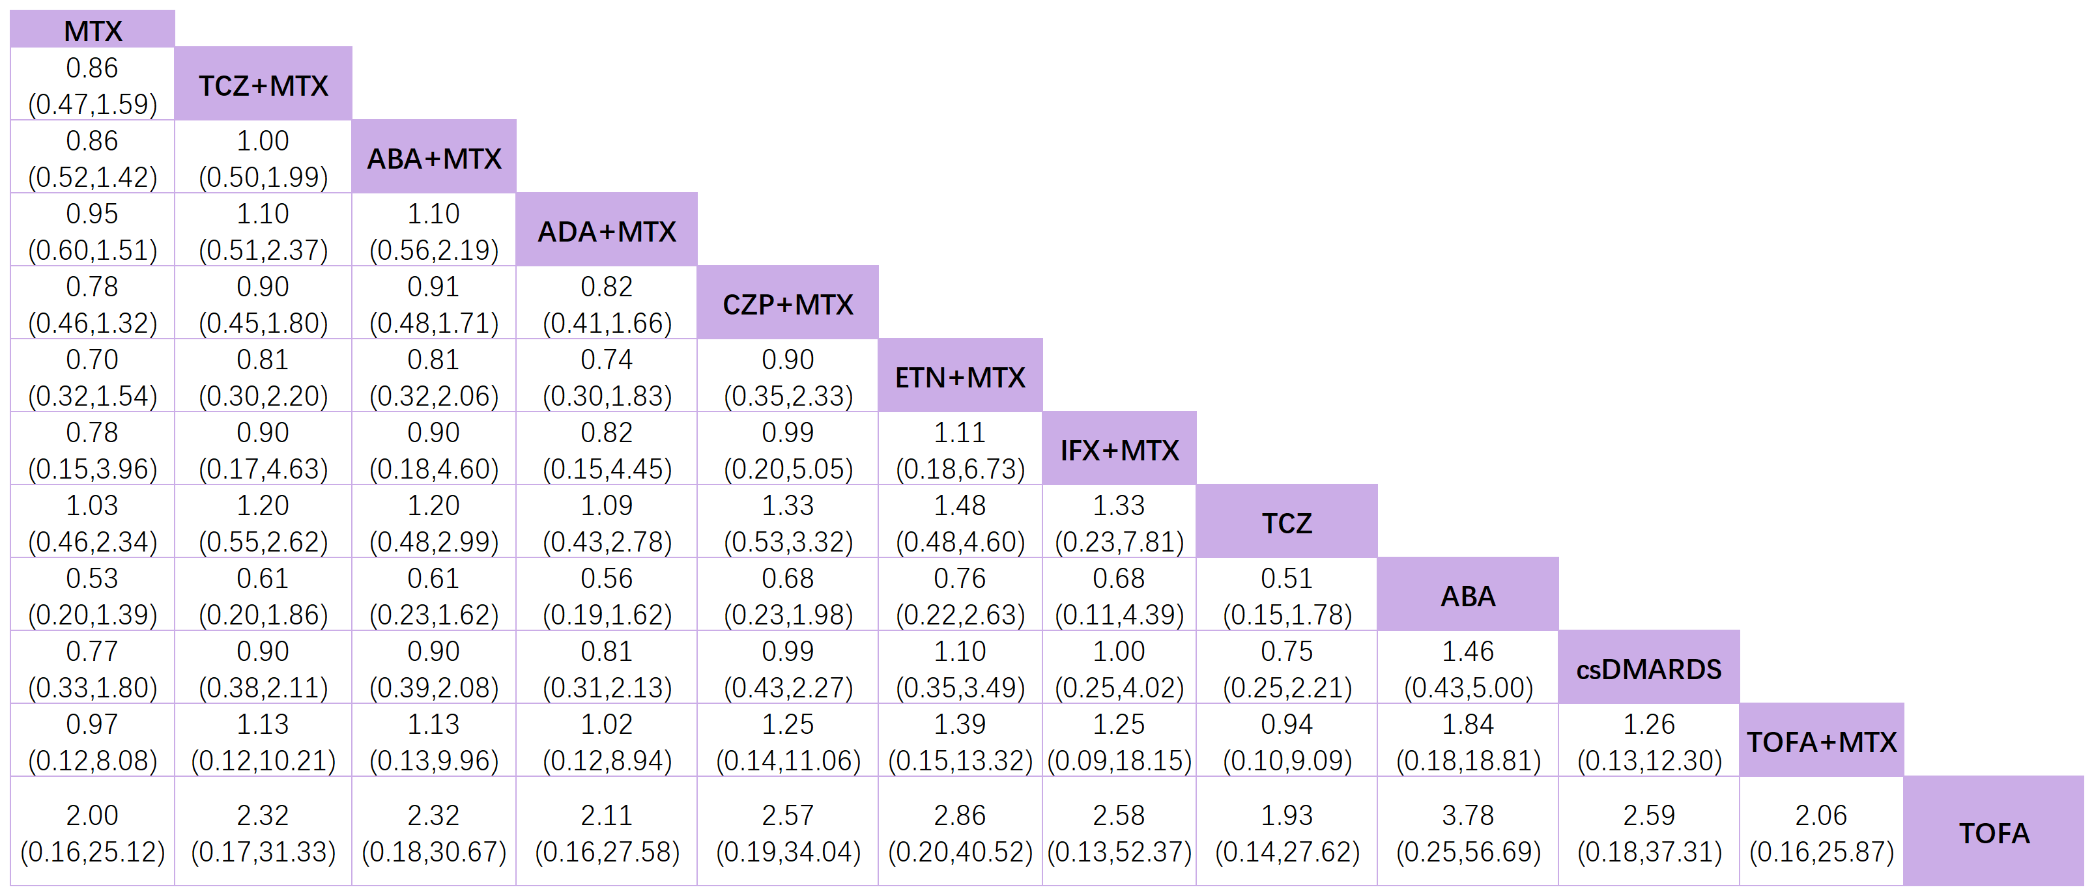

Supplementary data 7: Other outcomes
Figure S6: Forest plot for the change in mTSS.

Table S15: SUCRA of the effects of various interventions for ΔmTSS.

Treatment | SUCRA | PrBest | MeanRank
MTX | 0.700 | 0.000 | 9.900
TOFA+MTX | 14.600 | 0.000 | 8.700
ADA+MTX | 27.200 | 0.300 | 7.500
TOFA | 51.800 | 1.000 | 5.300
ABA+MTX | 57.400 | 0.300 | 4.800
CZP+MTX | 60.000 | 0.600 | 4.600
ETN+MTX | 61.000 | 0.800 | 4.500
TCZ+MTX | 61.700 | 0.900 | 4.400
csDMARDS | 66.300 | 0.100 | 4.000
IFX+MTX | 99.100 | 96.000 | 1.100
Figure S7: Forest plot for infections.
Figure S8: Forest plot for serious infections.
Figure S9: Forest plot for discontinuation due to AEs.

Supplementary data 8: Risk of bias of included studies according to the Cochrane risk of bias tool 1.
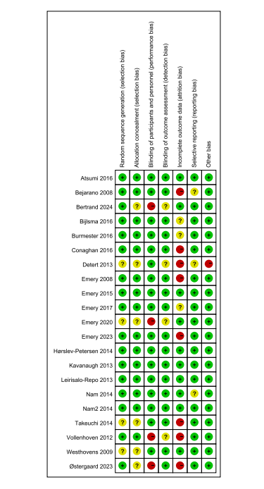
Figure S10: level risk of bias assessment using the Cochrane risk of bias tool 1.0 for assessing risk of bias of a randomized clinical trial

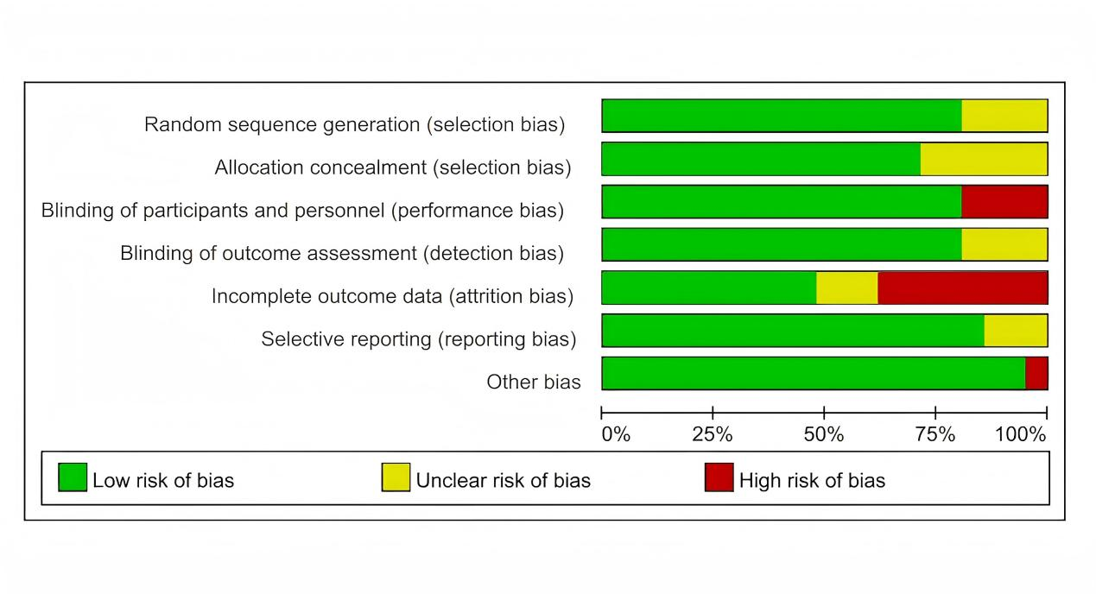
Figure S11: Overall risk of bias presented as a percentage of each risk of bias item across all included studies. Green = Low risk, Red = High risk, Yellow = Some concerns.

Supplementary data 9: Funnel plots
The figures show the assessment of small study effect bias in studies on the effects of various interventions for RA. We also used Egger's test to assess the symmetry of the funnel plot; if P > 0.05, the funnel plot is proven to be symmetrical and may not have publication bias.
Figure S12: Funnel plot of ACR70
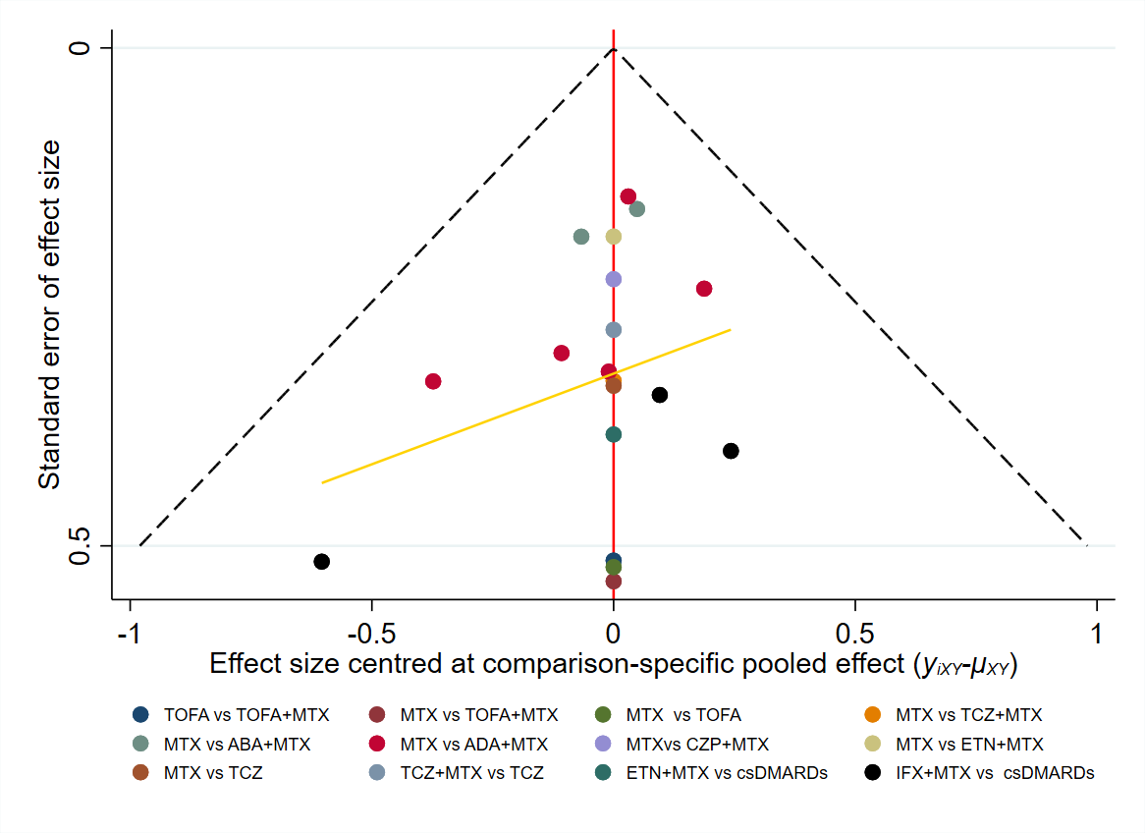
Egger's test t=2.47, P=0.024

Figure S13: Funnel plot of DAS28 remission
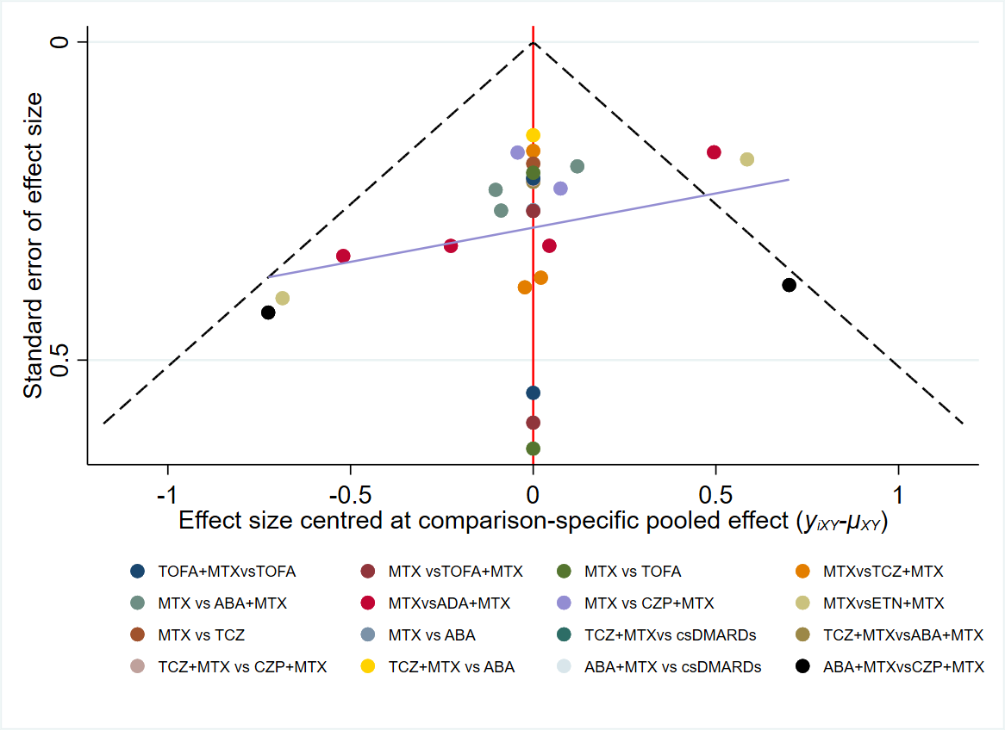
Egger's test t=1.22, P=0.232

Figure S14: Funnel plot of AE
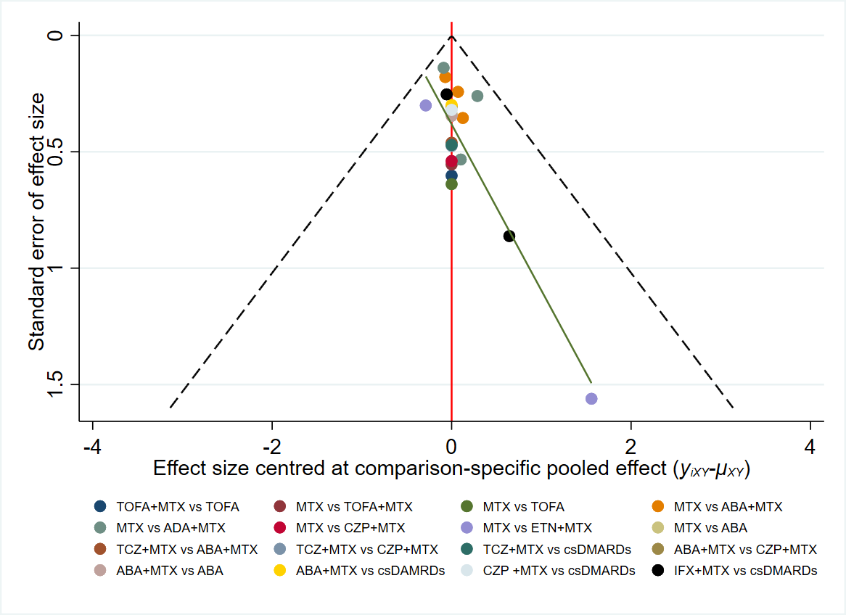
Egger's test t=-0.59, P=0.56

Figure S15: Funnel plot of SAE
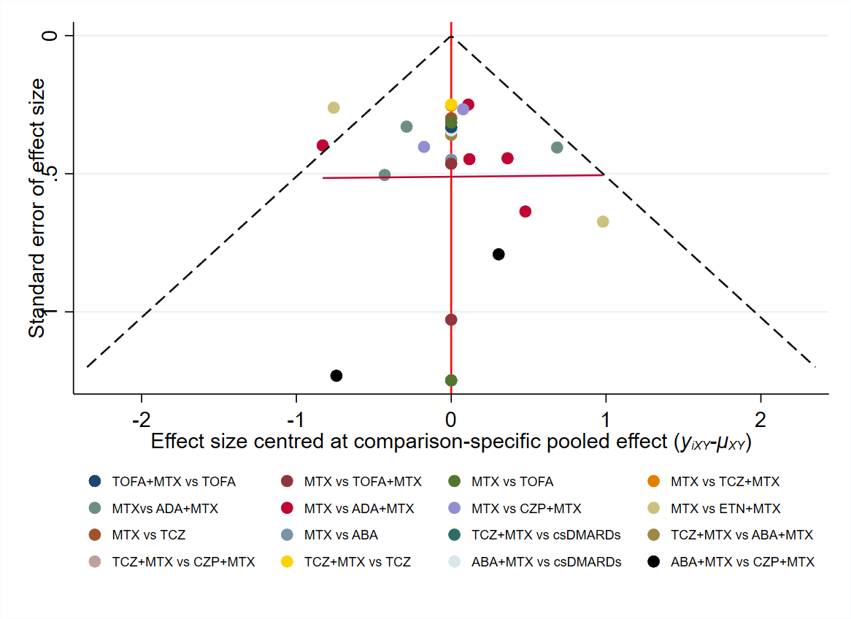
Egger's test t=-0.54, P= 0.591

Supplementary data 10: Sensitivity analyses of primary outcomes
Sensitivity analysis was performed after excluding studies with a high risk of bias.
Figure S16 DAS28 remission
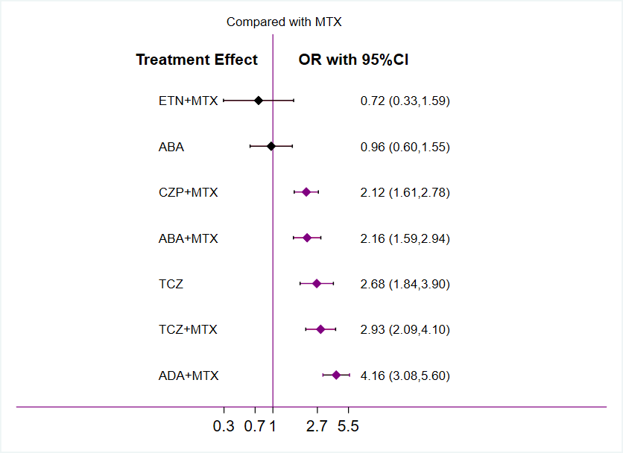

Figure S17 ACR70
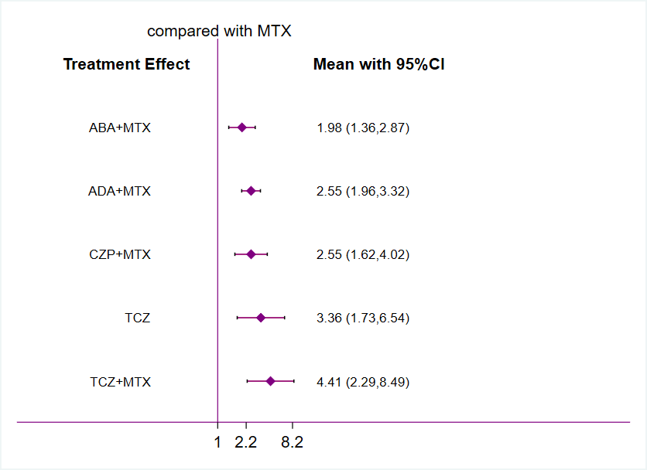
Figure S18 AE
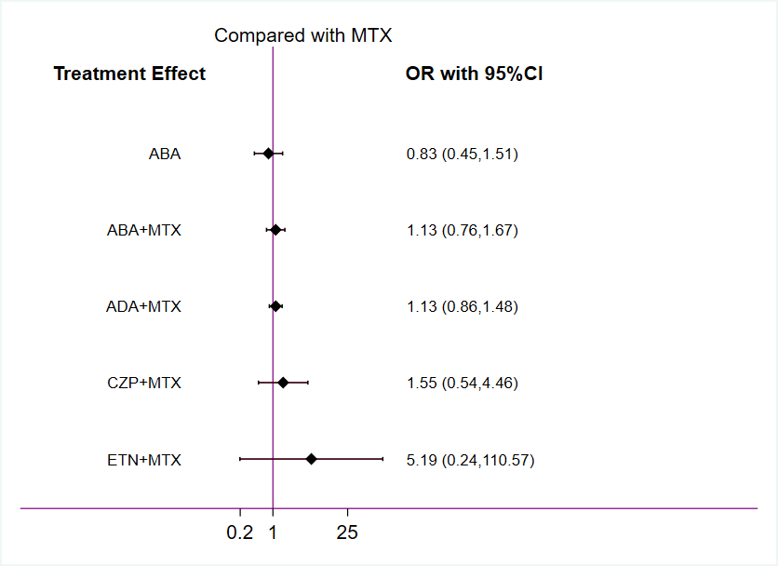
Figure S19 SAE
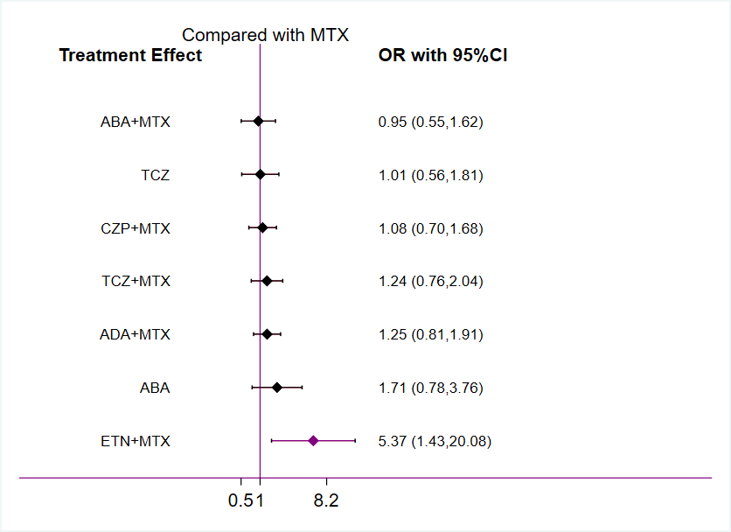

Sensitivity analysis was performed after excluding studies with a small sample size(n<50).
Figure S20 DAS28 remission
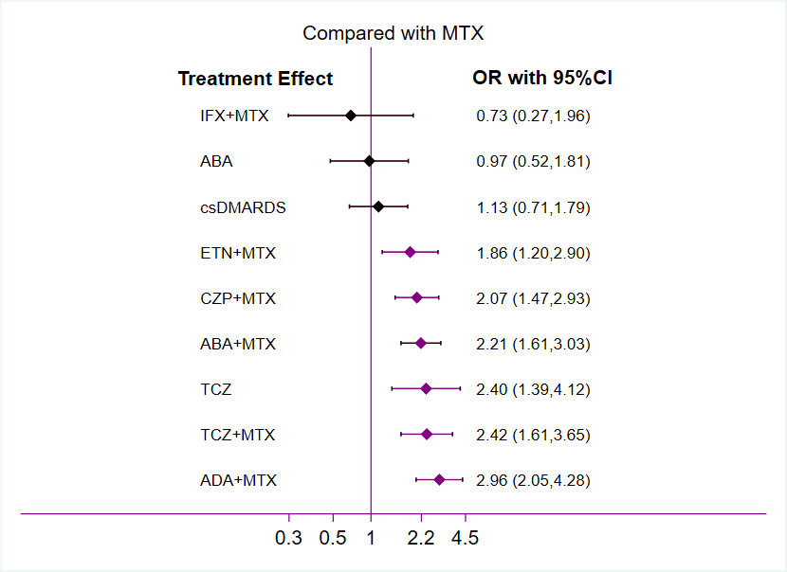
Figure S21 ACR70
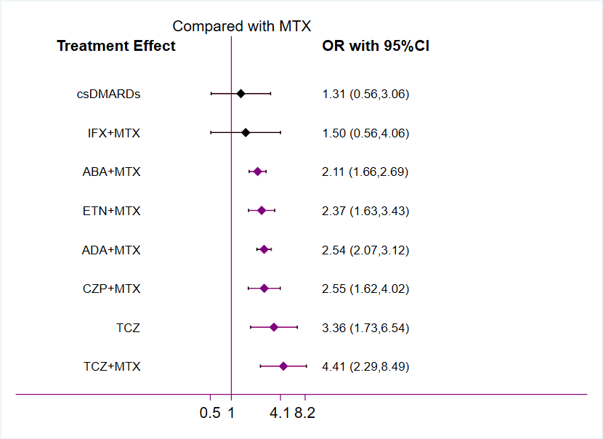
Figure S22 AE
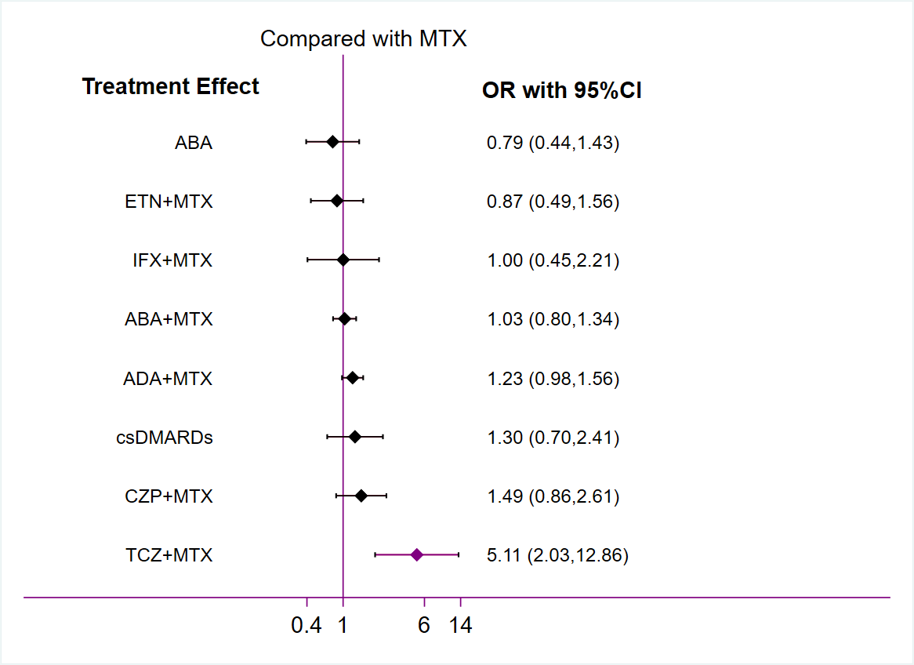
Figure S23 SAE
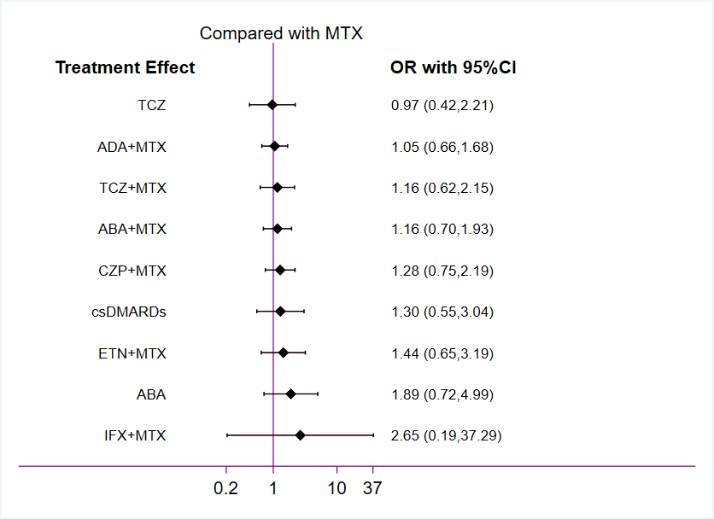

Supplementary data 11: References

1. Atsumi T, Yamamoto K, Takeuchi T, et al. (2016) The first double-blind, randomised, parallel-group certolizumab pegol study in methotrexate-naive early rheumatoid arthritis patients with poor prognostic factors, C-OPERA, shows inhibition of radiographic progression. Ann Rheum Dis 75 (1):75‐83,https://doi.org/10.1136/annrheumdis-2015-207511.

2. Bejarano V, Quinn M, Conaghan PG, et al. (2008) Effect of the early use of the anti-tumor necrosis factor adalimumab on the prevention of job loss in patients with early rheumatoid arthritis. Arthritis and Rheumatism 59 (10):1467-74,https://doi.org/10.1002/art.24106.

3. Bertrand D, Joly J, Neerinckx B, et al. (2024) Effectiveness of methotrexate and bridging glucocorticoids with or without early introduction of a 6-month course of etanercept in early RA: results of the 2-year, pragmatic, randomised CareRA2020 trial. RMD Open 10 (3)https://doi.org/10.1136/rmdopen-2024-004535.

4. Bijlsma JWJ, Welsing PMJ, Woodworth TG, et al. (2016) Early rheumatoid arthritis treated with tocilizumab, methotrexate, or their combination (U-act-early): a multicentre, randomised, double-blind, double-dummy, strategy trial. Lancet 388 (10042):343‐55,https://doi.org/10.1016/S0140-6736(16)30363-4.

5. Burmester GR, Rigby WF, van Vollenhoven RF, et al. (2016) Tocilizumab in early progressive rheumatoid arthritis: FUNCTION, a randomised controlled trial. Annals of the Rheumatic Diseases 75 (6):1081-91,https://doi.org/10.1136/annrheumdis-2015-207628.

6. Conaghan PG, Østergaard M, Bowes MA, et al. (2016) Comparing the effects of tofacitinib, methotrexate and the combination, on bone marrow oedema, synovitis and bone erosion in methotrexate-naive, early active rheumatoid arthritis: results of an exploratory randomised MRI study incorporating semiquantitative and quantitative techniques. Annals of the Rheumatic Diseases 75 (6):1024-33,https://doi.org/10.1136/annrheumdis-2015-208267.

7. Detert J, Bastian H, Listing J, et al. (2013) Induction therapy with adalimumab plus methotrexate for 24 weeks followed by methotrexate monotherapy up to week 48 versus methotrexate therapy alone for DMARD-naive patients with early rheumatoid arthritis: HIT HARD, an investigator-initiated study. Ann Rheum Dis 72 (6):844-50,https://doi.org/10.1136/annrheumdis-2012-201612.

8. Emery P, Breedveld FC, Hall S, et al. (2008) Comparison of methotrexate monotherapy with a combination of methotrexate and etanercept in active, early, moderate to severe rheumatoid arthritis (COMET): a randomised, double-blind, parallel treatment trial. Lancet 372 (9636):375-82,https://doi.org/10.1016/s0140-6736(08)61000-4.

9. Emery P, Burmester GR, Bykerk VP, et al. (2015) Evaluating drug-free remission with abatacept in early rheumatoid arthritis: results from the phase 3b, multicentre, randomised, active-controlled AVERT study of 24 months, with a 12-month, double-blind treatment period. Ann Rheum Dis 74 (1):19‐26,https://doi.org/10.1136/annrheumdis-2014-206106.

10. Emery P, Bingham CO, Burmester GR, et al. (2017) Certolizumab pegol in combination with dose-optimised methotrexate in DMARD-naïve patients with early, active rheumatoid arthritis with poor prognostic factors: 1-year results from C-EARLY, a randomised, double-blind, placebo-controlled phase III study. Ann Rheum Dis 76 (1):96‐104,https://doi.org/10.1136/annrheumdis-2015-209057.

11. Emery P, Horton S, Dumitru RB, et al. (2020) Pragmatic randomised controlled trial of very early etanercept and MTX versus MTX with delayed etanercept in RA: the VEDERA trial. Ann Rheum Dis 79 (4):464‐71,https://doi.org/10.1136/annrheumdis-2019-216539.

12. Emery P, Tanaka Y, Bykerk VP, et al. (2023) Sustained remission and outcomes with abatacept plus methotrexate following stepwise dose de-escalation in patients with early rheumatoid arthritis. Rheumatology and Therapy 10 (3):707-27,https://doi.org/10.1007/s40744-022-00519-9.

13. Hørslev-Petersen K, Hetland ML, Junker P, et al. (2014) Adalimumab added to a treat-to-target strategy with methotrexate and intra-articular triamcinolone in early rheumatoid arthritis increased remission rates, function and quality of life. The OPERA study: an investigator-initiated, randomised, double-blind, parallel-group, placebo-controlled trial. Ann Rheum Dis 73 (4):654‐61,https://doi.org/10.1136/annrheumdis-2012-202735.

14. Kavanaugh A, Fleischmann RM, Emery P, et al. (2013) Clinical, functional and radiographic consequences of achieving stable low disease activity and remission with adalimumab plus methotrexate or methotrexate alone in early rheumatoid arthritis: 26-week results from the randomised, controlled OPTIMA study. Ann Rheum Dis 72 (1):64-71,https://doi.org/10.1136/annrheumdis-2011-201247.

15. Leirisalo-Repo M, Kautiainen H, Laasonen L, et al. (2013) Infliximab for 6 months added on combination therapy in early rheumatoid arthritis: 2-year results from an investigator-initiated, randomised, double-blind, placebo-controlled study (the NEO-RACo Study). Ann Rheum Dis 72 (6):851‐7,https://doi.org/10.1136/annrheumdis-2012-201365.

16. Nam JL, Villeneuve E, Hensor EM, et al. (2014) Remission induction comparing infliximab and high-dose intravenous steroid, followed by treat-to-target: a double-blind, randomised, controlled trial in new-onset, treatment-naive, rheumatoid arthritis (the IDEA study). Ann Rheum Dis 73 (1):75‐85,https://doi.org/10.1136/annrheumdis-2013-203440.

17. Nam JL, Villeneuve E, Hensor EM, et al. (2014) A randomised controlled trial of etanercept and methotrexate to induce remission in early inflammatory arthritis: the EMPIRE trial. Ann Rheum Dis 73 (6):1027‐36,https://doi.org/10.1136/annrheumdis-2013-204882.

18. Østergaard M, van Vollenhoven RF, Rudin A, et al. (2023) Certolizumab pegol, abatacept, tocilizumab or active conventional treatment in early rheumatoid arthritis: 48-week clinical and radiographic results of the investigator-initiated randomised controlled NORD-STAR trial. Ann Rheum Dis 82 (10):1286‐95,https://doi.org/10.1136/ard-2023-224116.

19. Takeuchi T, Yamanaka H, Ishiguro N, et al. (2014) Adalimumab, a human anti-TNF monoclonal antibody, outcome study for the prevention of joint damage in japanese patients with early rheumatoid arthritis: the HOPEFUL 1 study. Ann Rheum Dis 73 (3):536‐43,https://doi.org/10.1136/annrheumdis-2012-202433.

20. van Vollenhoven RF, Geborek P, Forslind K, et al. (2012) Conventional combination treatment versus biological treatment in methotrexate-refractory early rheumatoid arthritis: 2 year follow-up of the randomised, non-blinded, parallel-group swefot trial. Lancet 379 (9827):1712-20,https://doi.org/10.1016/S0140-6736(12)60027-0.

21. Westhovens R, Robles M, Ximenes AC, et al. (2009) Clinical efficacy and safety of abatacept in methotrexate-naive patients with early rheumatoid arthritis and poor prognostic factors. Ann Rheum Dis 68 (12):1870-7,https://doi.org/10.1136/ard.2008.101121.

