Table (S1): Variance Inflation Factors (VIFs) for predictors in the sex prediction model.
Measurement | VIF | 95% CI
Measurement | VIF | Lower | Upper
Inferior-superior distance | 1.27 | 1.14 | 1.51
Anteroposterior distance | 1.19 | 1.08 | 1.43
Latero-lateral distance | 1.46 | 1.29 | 1.74
CI: Confidence interval.

Table (S2): Variance Inflation Factors (VIFs) for predictors in the age prediction model.

Measurement | VIF | 95% CI
Measurement | VIF | Lower | Upper
Inferior-superior distance | 1.35 | 1.21 | 1.61
Anteroposterior distance | 1.13 | 1.04 | 1.39
Latero-lateral distance | 1.49 | 1.31 | 1.77
CI: Confidence interval.

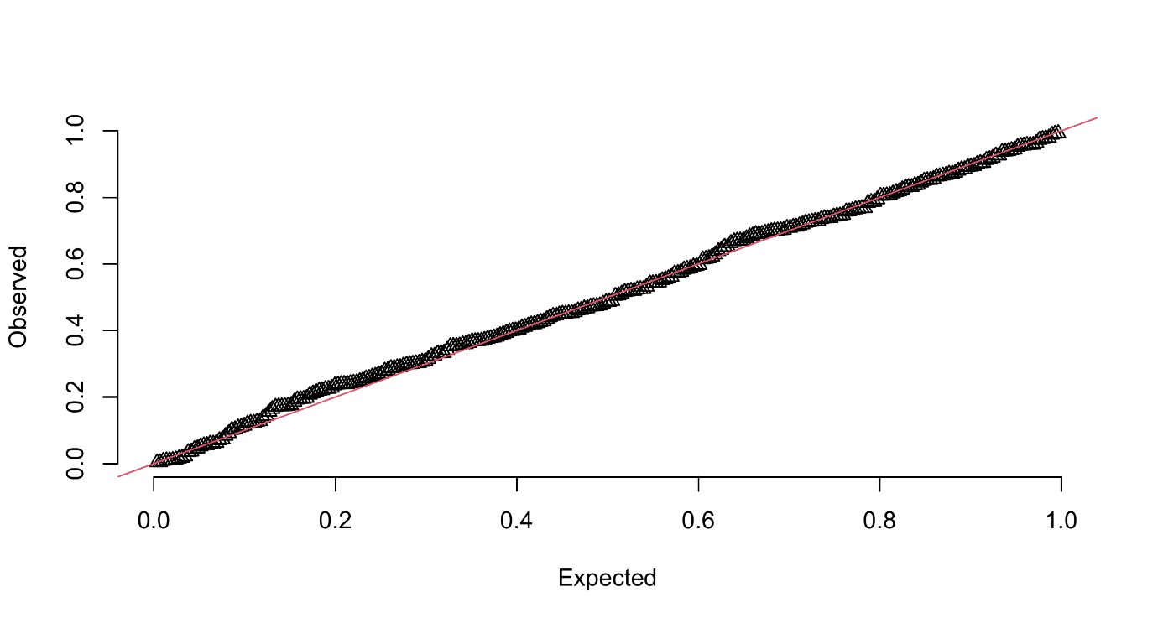Figure (S1): Q–Q plot of simulation-based residuals for the sex classification model.

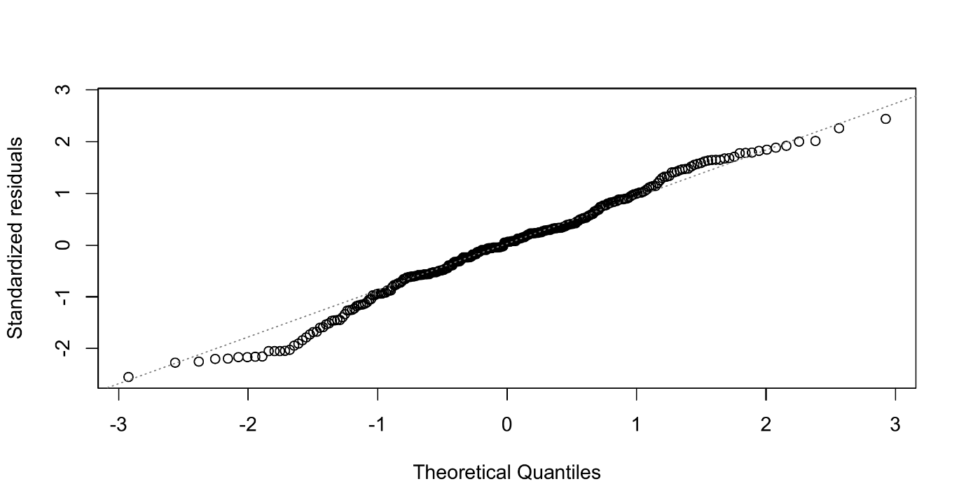Figure (S2): Q–Q plot of standardized residuals for the age prediction model.

