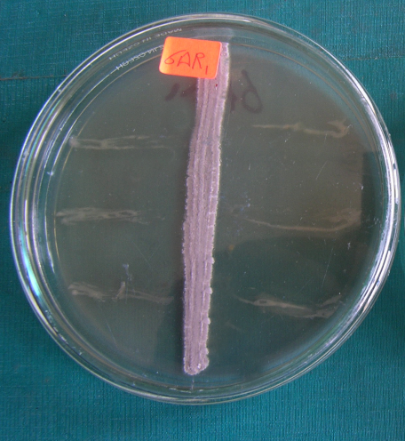
Streptomyces intermedius (99%)
6A1R: Similar to Streptomyces intermedius (99%)
An antagonistic strain isolated from the rhizosphere of corn planted in Wardan

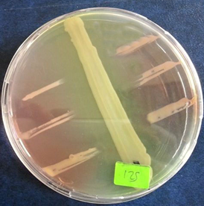
Pseudomonas putida
125: Similar to Pseudomonas putida group (99%)
An antagonistic strain isolated from the soil of onion planted in Wardan
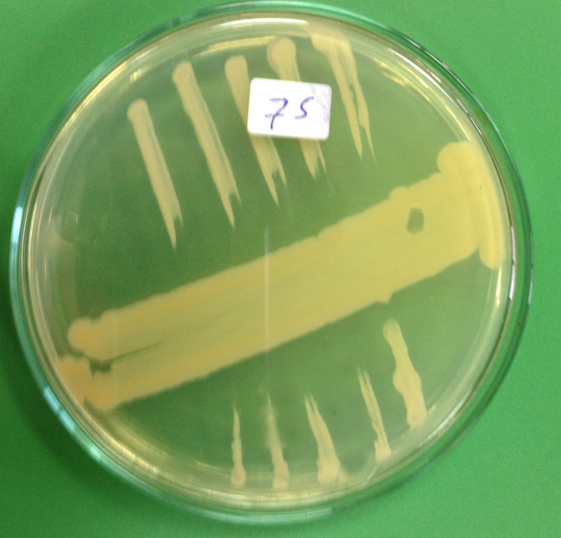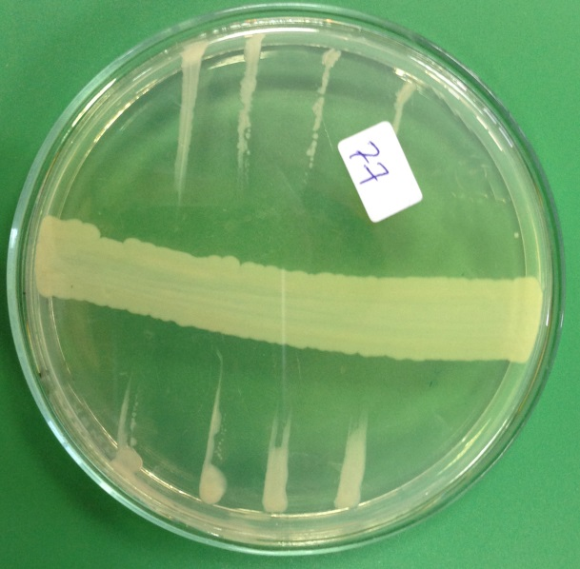
Pseudomonas plecoglossicida
Pseudomonas putida

75: Similar to Pseudomonas putida group (99%)
77: Similar to Pseudomonas plecoglossicida Pseudomonas putida group (95%)
An antagonistic strain isolated from the soil of onion planted in Ganoub El-Tahrir

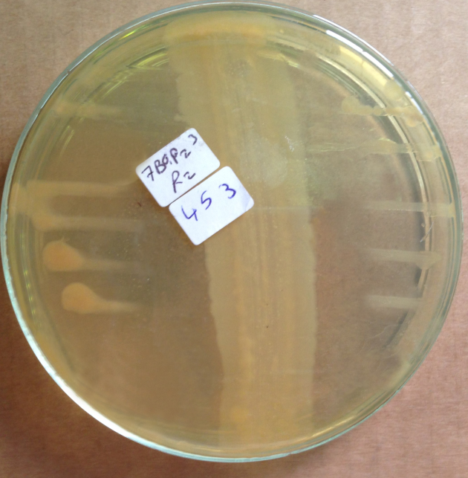
Pseudomonas aeruginosa

453: Similar to Pseudomonas aeruginosa group (97%)
An antagonistic strain isolated from the rhizosphere of potato planted in Ganoub El-Tahrir

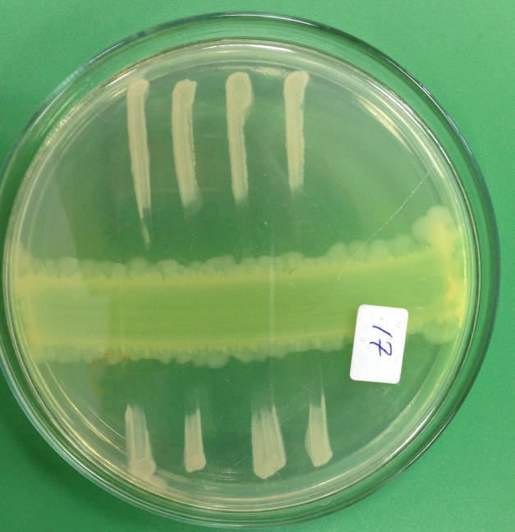
Perlucidibaca aquatic/P. wandonensis
17: Similar to Perlucidibaca aquatic/P. wandonensis (82%)
An antagonistic strain isolated from the rhizosphere of cabbage planted in Talia

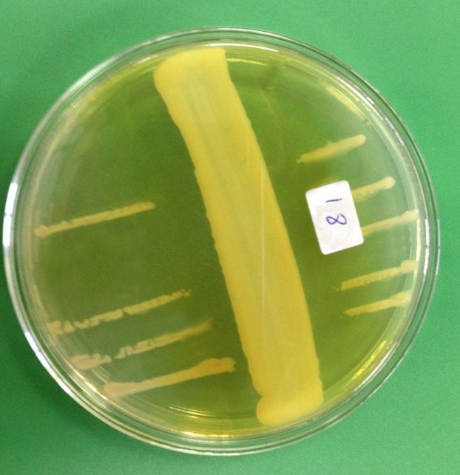
Citrobacter murliniae
18: Similar to Citrobacter murliniae (Citrobacter braakii)
An antagonistic strain isolated from the rhizosphere of potato planted in Talia

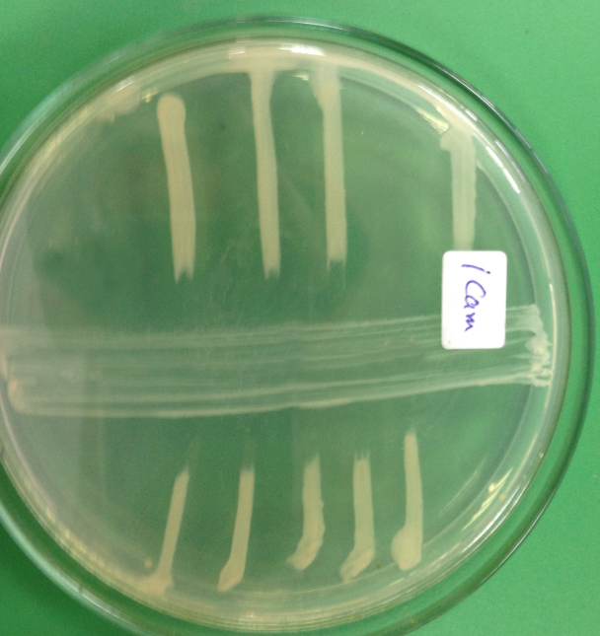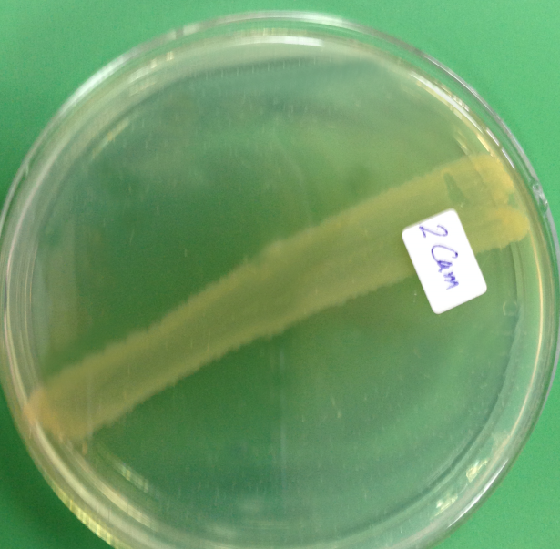
409
408
Stenotrophomonas pavanii
Providencia sneebia
408: Providencia sneebia (99%)
409: Stenotrophomonas pavanii/ Stenotrophomonas maltophilia/[Pseudomonas] geniculate/ S. humi/ S. acidaminiphila (99%)
Two antagonistic strains isolated from the soil of the corn (2) planted in Talia

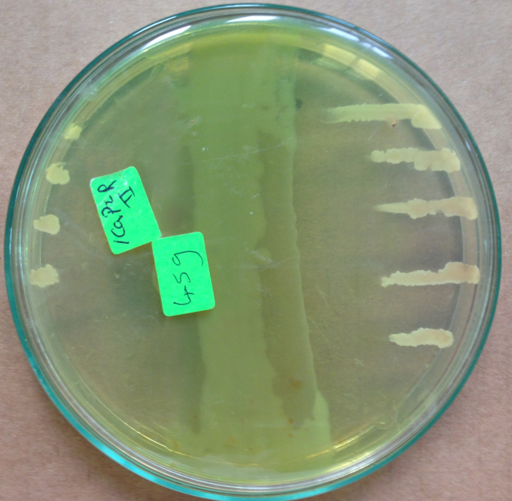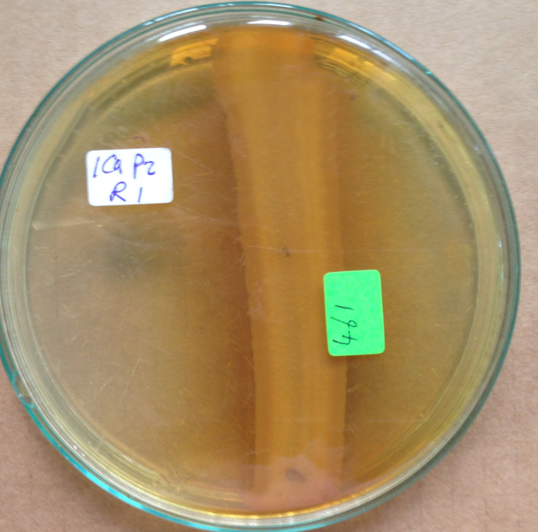
459:Similar to Pseudomonas aeruginosa/ P. mendocina /P. guguanensis/ (99%)
461: Similar to Stenotrophomonas pavanii/ Stenotrophomonas maltophilia/[Pseudomonas] geniculate/ S. humi/ S. acidaminiphila (99%)
Two antagonistic strains isolated from the rhizosphere of the potato (2) planted in Talia

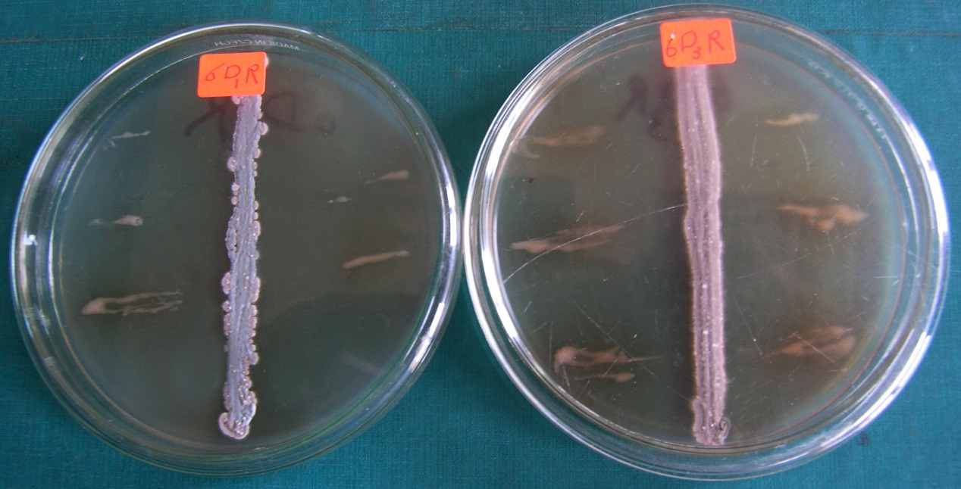
S. griseorubens

R. solanacearum
Streptomyces thermocarboxydus
6D1R: Similar to Streptomyces spp (S. coeruleorubidus group) (99%)
6D3R: Similar to Streptomyces spp (100%)
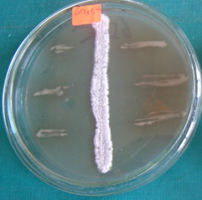
S. griseorubens

6D3R4: Similar to S. griseorubens (S. chartreusis/ S. matensis/ / S. variabilis/ S. coelicolor)
Three antagonistic strains isolated from the rhizosphere of corn planted in Sids

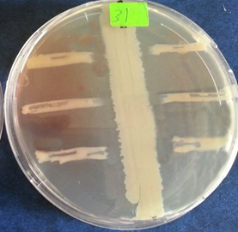
Bacillus marcorestinctum
31: Similar to Bacillus marcorestinctum (98%)
An antagonistic strain isolated from the soil of cabbage planted in Sids

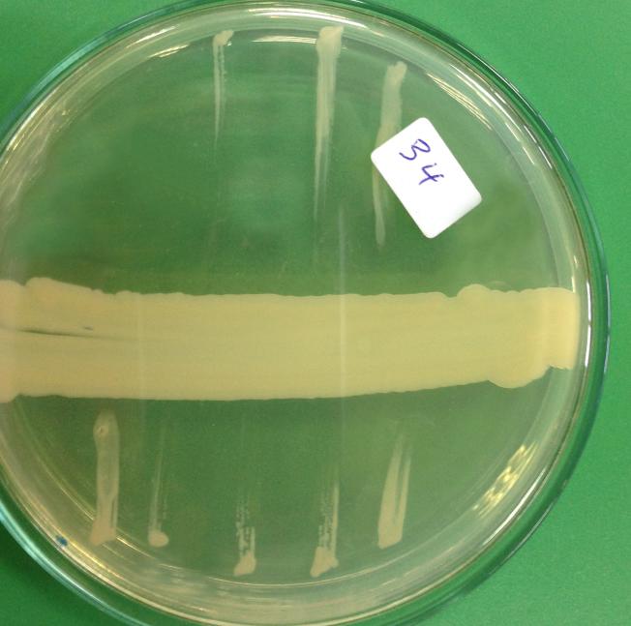
Serratia quinivorans
34: Similar to Serratia quinivorans (99%)
An antagonistic strain isolated from the soil of potato planted in Sids

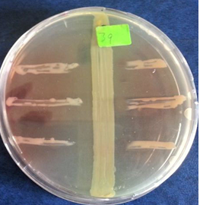
Pseudomonas putida

39: Similar to Pseudomonas putida
An antagonistic strain isolated from the rhizosphere of cabbage planted in Sids

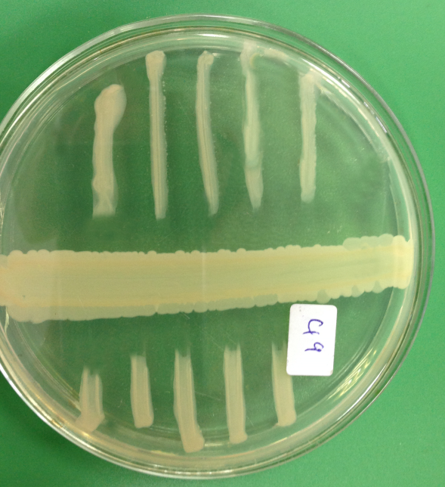
Pseudomonas putida
49: Similar to Pseudomonas putida group (99%)
An antagonistic strain isolated from the rhizosphere of potato planted in Sids
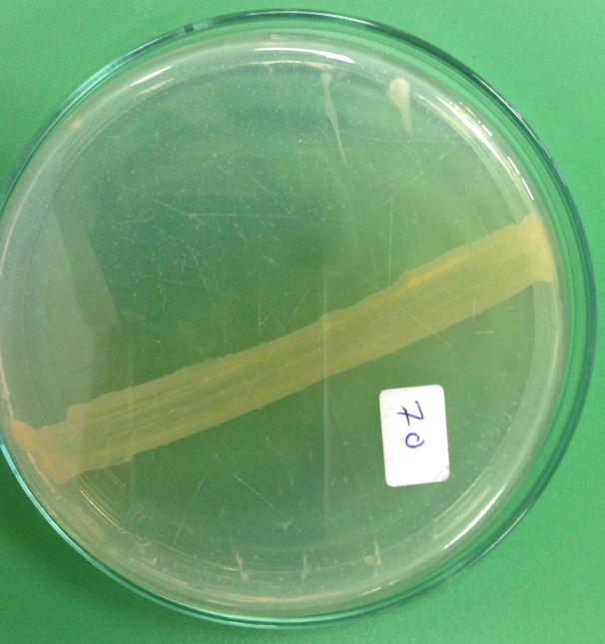
Stenotrophomonas pavanii
70: Similar to Pseudomonas hibiscicola/ Stenotrophomonas pavanii (99%)
An antagonistic strain isolated from the soil of onion planted in Sids
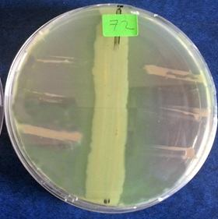
Pseudomonas aeruginosa
72: Similar to Pseudomonas aeruginosa/ P. mendocina /P. guguanensis/ (99%)
An antagonistic strain isolated from the from the rhizosphere of onion planted in Sids area

Supp. 1 In vitro antagonistic potential against R. solanacearum for strains isolated from soil and rhizosphere of different crops isolated from 4 different locations
Wardan and Ganoub El-Tahrir, sandy soil
Talia and Sids, clay soil

