First report of three species of Trichoderma isolated from the rhizosphere in Algeria and the high antagonistic effect of Trichoderma brevicompactum to control grey mould disease of tomato

Supplementary data 03

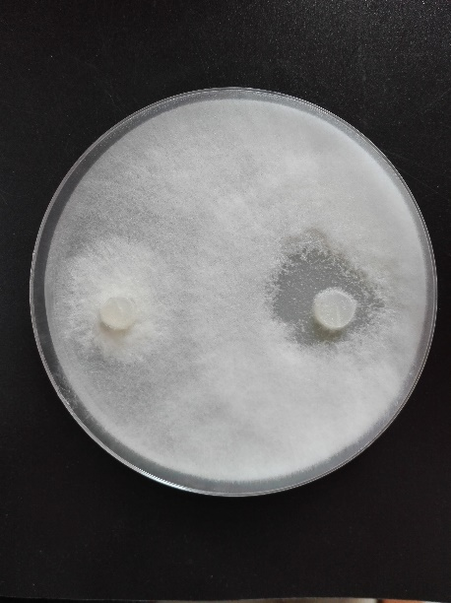
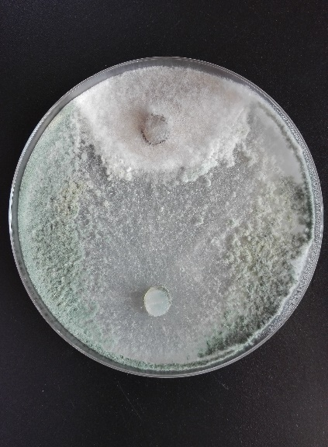
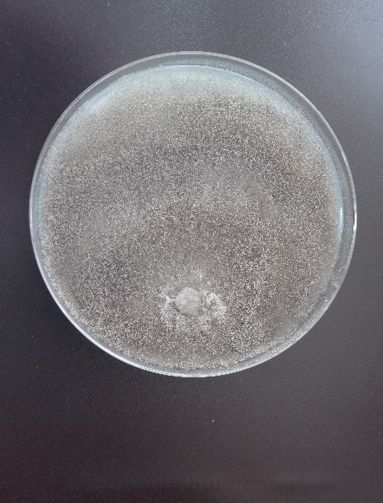
TGS7
TAtC11
Control

Fig. S4: Mycelial growth inhibition of B. cinerea (BCT04) caused by TGS7 and TAtC11 isolates of Trichoderma spp. revealed by the dual-culture test. Mycelial discs of B. cinerea were placed on the right side of the Petri dish.

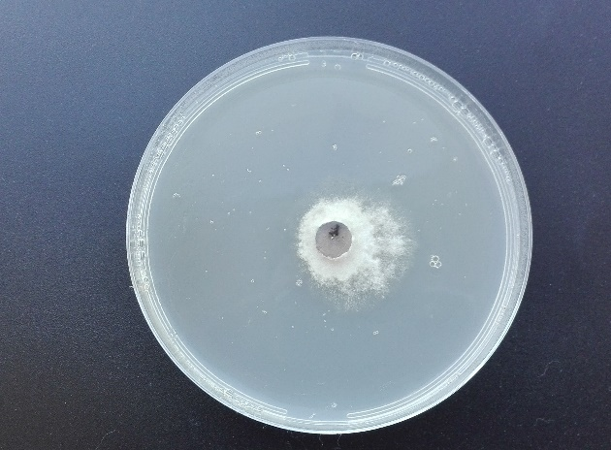
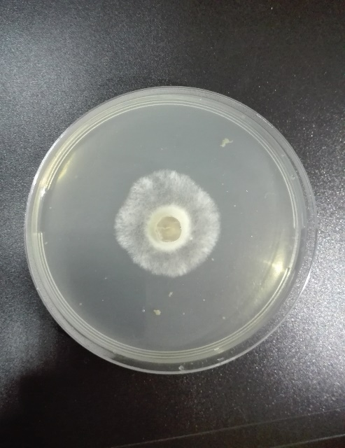
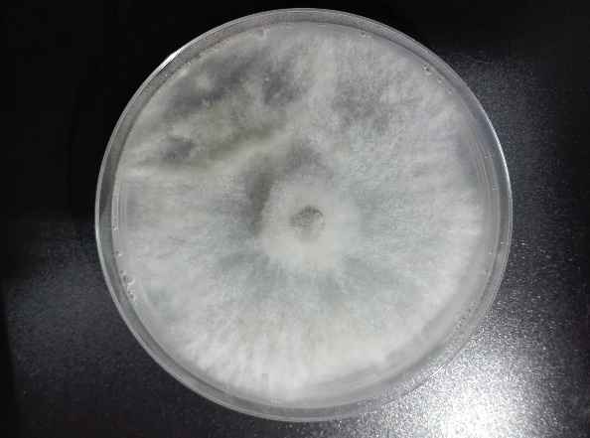
TGS7
Control
TAtC11

Fig. S5: Mycelial growth inhibition of B. cinerea (BCT04) caused by volatile compounds produced by TGS7 and TAtC11 isolates.

