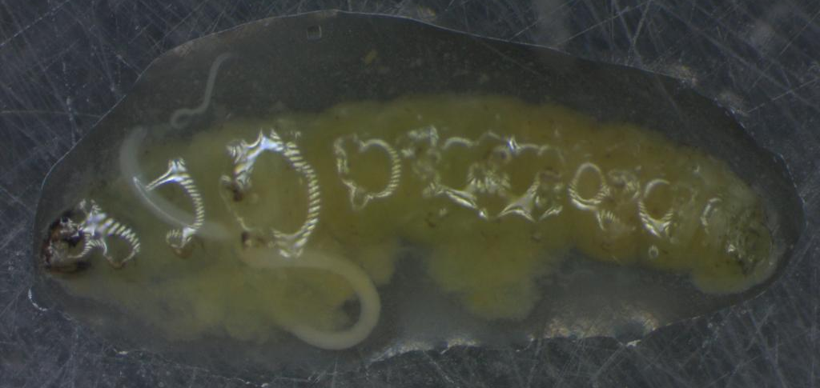
Figure 1. Dissection of Tuta absoluta larvae after exposed to IJs of Steinernema feltiae MCB-8

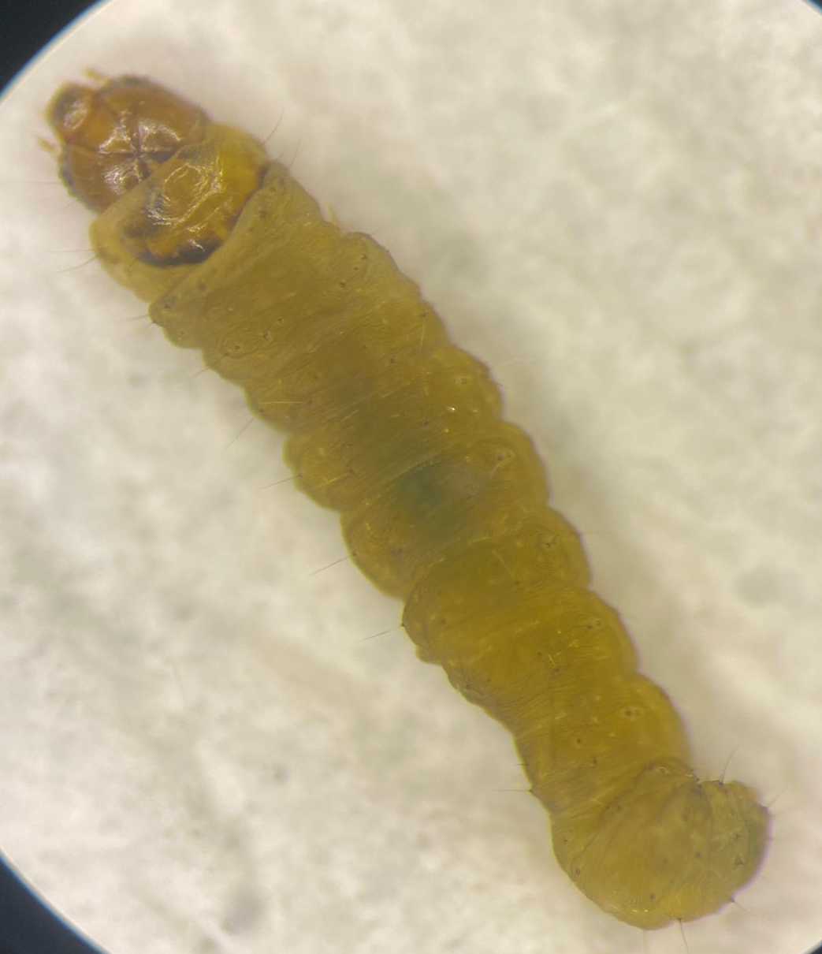
Figure 2. Dead larvae of Tuta absoluta after exposure to Photorhabdus luminescens subsp. kayaii AVB-15 strain
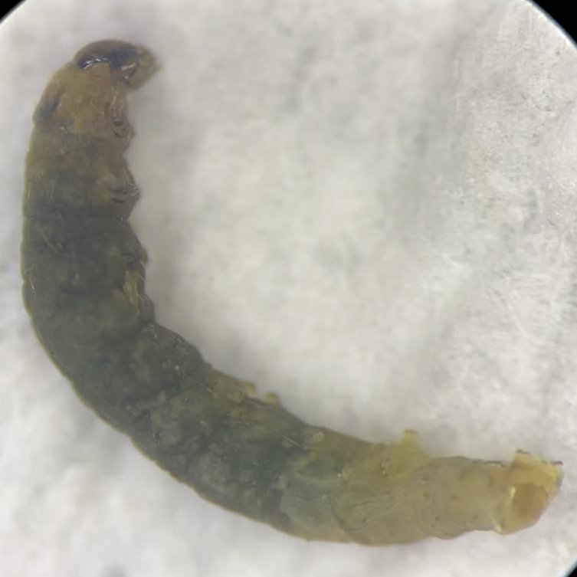
Figure 3. Dead larvae of Tuta absoluta after exposure to Xenorhabdus bovienii MCB-8 strain

