Computerized dynamic posturography (CDP)
The examined subject stands on a movable, dual force plate with rotation (toes up-down) and translation (forward-backward) capabilities to measure the vertical forces exerted by the patient’s feet under the precise control of a computer. The subject is asked to maintain a normal standing balance during varying conditions by altering the visual field of the subject and/or the support surface on which the subject is standing. CDP can impose varying conditions one might encounter in the environment and record the resulting postural responses. The computer processes signal from the force-sensing support surface to quantify the subject’s postural stability under modified sensory conditions and the motor reactions to unexpected perturbations. The software objectively identifies problems with postural control by assessing the patient’s ability to make effective use of (or suppress inappropriately) visual, vestibular, and proprioceptive information.)
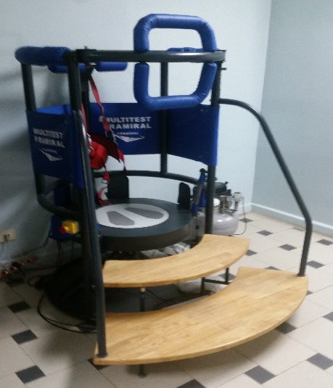 | 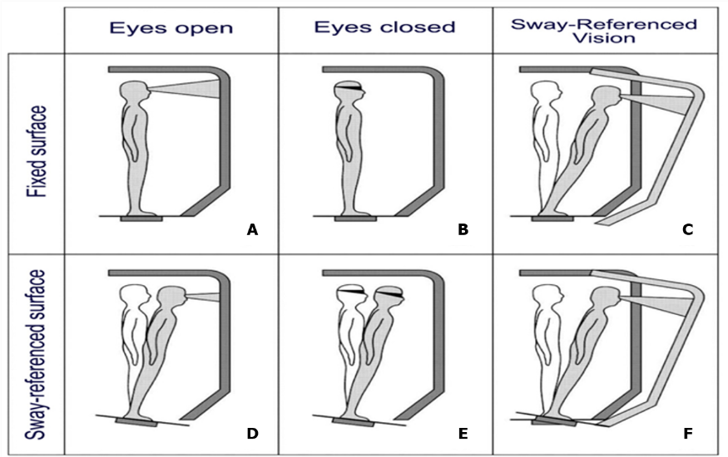
Figure (*). The different conditions performed in the sensory organization test; (A) eyes open, surround and platform stable, (B) eyes closed, surround and platform stable, (C) eyes open, sway- referenced surround, (D) eyes open sway-referenced platform, (E) eyes closed, sway-referenced platform and (F) eyes open sway referenced surround and platform (Quoted from Massukawa Oda and Ganança, 2015).

For each of the six recording conditions, spatial orientation and temporal analysis were determined as follow:
- Spatial orientation:
1– Percentage stability (u) for each condition was computed using this formula: u = [(100–sx)/100] – [ (100–sy)/100] where x, y represents the subjects’ deviations in anterior, posterior, and lateral direction and sx, sy vary from 0 to 100. The results were expressed as percentages, with 0 indicating sway exceeding the limit of stability (fall) and 100% indicating perfect stability.
2– The average speed of center of pressure (COP) sway (mm/s).
3– The surface area of the COP displacement (cm2).
4– The sensory analysis (SA) ratios were used to identify possible impairments of individual sensory systems and it includes somatosensory (SOM), visual (VIS) and vestibular (VEST) ratios which measures ability to use somatosensory, visual, and vestibular information. It also, measures the preference (PREF) ratio which measures reliance of visual input to control balance, even when visual information is incorrect. The SOM ratio = (condition2 / condition1) × 100, the VIS ratio = (condition4/ condition1) × 100 and the VEST ratio = (condition5/ condition1) × 100
4– Frequency (temporal) analysis:
A wavelet analysis was applied to study the frequency of CoM displacements. The spectral power index was calculated as the decimal logarithm for the frequency bands 0.05–0.5 Hz, 0.5–1.5 Hz, and higher than 1.5 Hz on the mediolateral (PIx) as well as anteroposterior (PIy) directions.
The spectral power index in the higher band is minimal in healthy subjects during quiet standing, but it can be observed with aging, in postural pathology, or dynamic postural conditions. The hypothetical physiological significance of the different bands is as follows: 0–0.5 Hz visual-vestibular, 0.5–1.5 Hz cerebellar and 1.5 Hz reflexive loops.
The canceling time (CT) is the total time required to cancel the spectral power within a given frequency range by the posture control mechanisms and was calculated for each frequency band in the mediolateral (CTx) and the anteroposterior (CTy) directions. The shorter the CT for a frequency band, the better is the posture control as it reflects higher subjects use of their sensory information (visual, vestibular, and somatosensory inputs). Reduced CT to zero at a certain frequency indicates a successful action of the postural control system since the overall entropy of the sway has been reduced. While most healthy participants exhibit these zero power instances in their postural sway spectrum, pathological participants cannot. How the canceled frequencies are chosen by the postural control system is not known yet, but it is assumed that the choice criterion is the minimization of muscular effort required to control the sway.
References:
- Massukawa Oda DT, Ganança CF. Computerized dynamic posturography in the assessment of body balance in individuals with vestibular dysfunction. Audiol Commun Res. 2015;20(2):89–95. DOI: 10.1590/S2317-64312015000200001469
- Visser JE, Carpenter MG, der Kooij Hv, Bloem BR. The clinical utility of posturography. Clinical Neurophysiology. 2008; 119:2424–36. DOI: 10.1016/j.clinph.2008.07.220

