Fig. S1a. A forest plot of the change in monthly MHDs (Months 1-3) before sensitivity analysis.
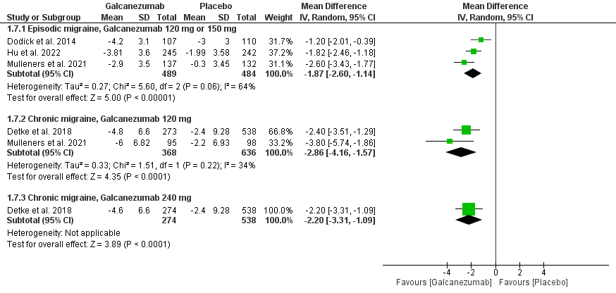

Fig. S1b. A forest plot of the change in monthly MHDs (Months 1-3) after sensitivity analysis.
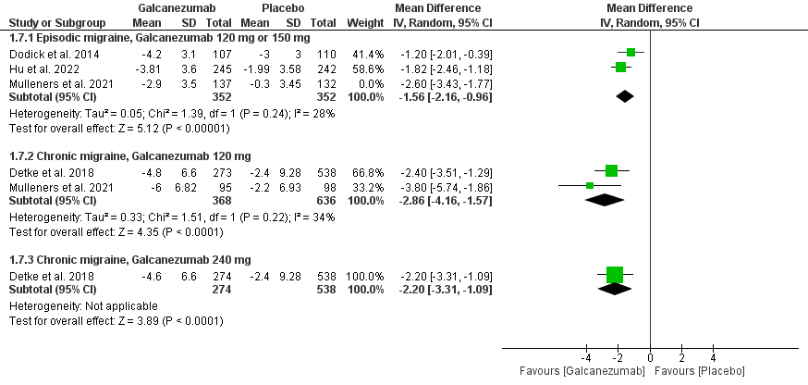

Fig. S2. A forest plot of the change in monthly MHDs with acute medication use.

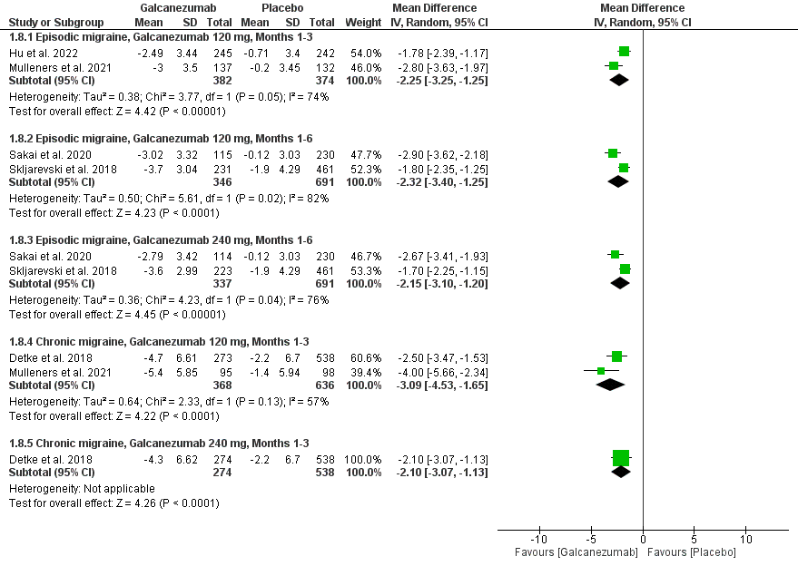

Fig. S3a. A forest plot of the ≥50% response rate outcome before sensitivity analysis.

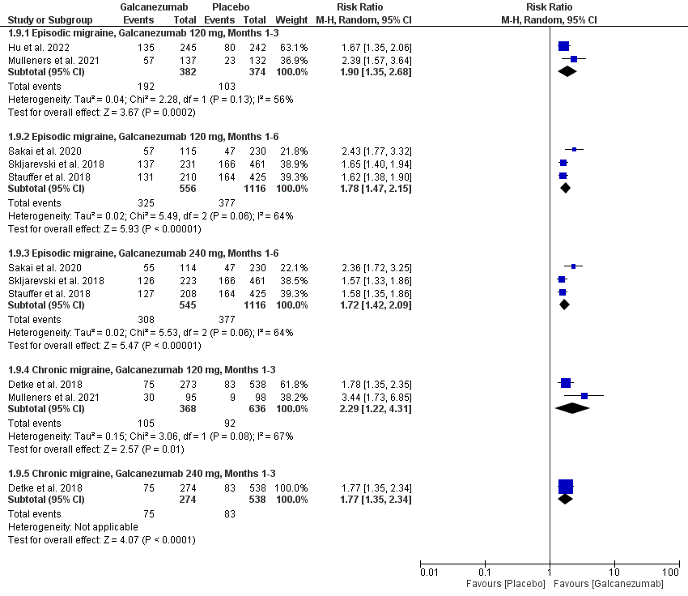

Fig. S3b. A forest plot of the ≥50% response rate outcome after sensitivity analysis.

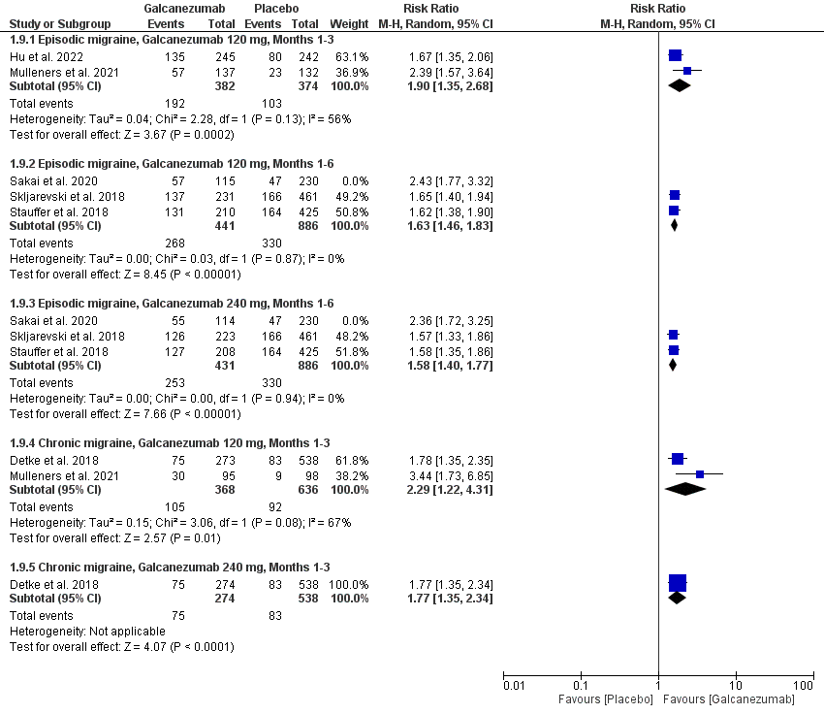

Fig. S4. A forest plot of the ≥75% response rate outcome.

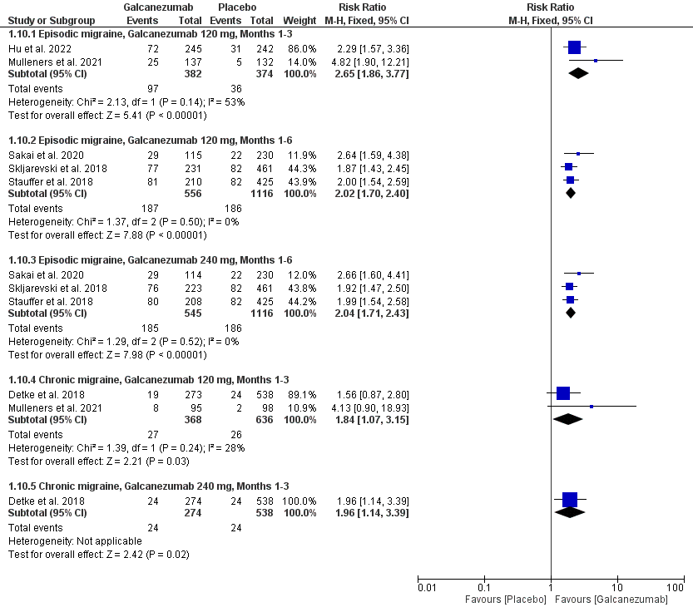

Fig. S5. A forest plot of the 100% response rate outcome.

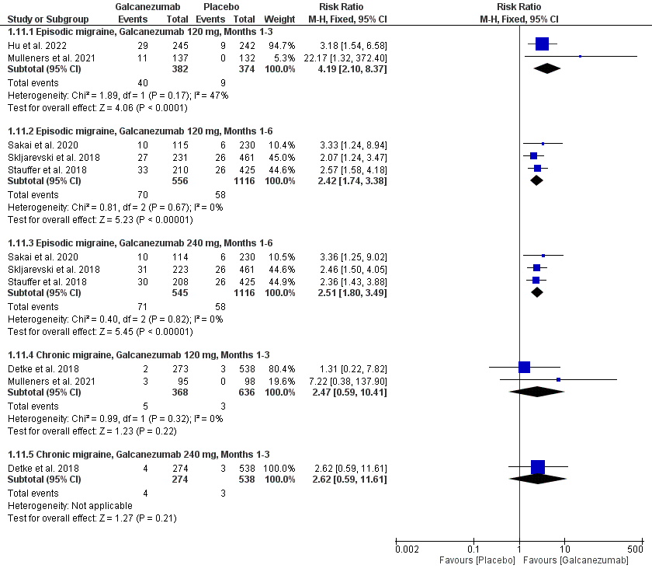

Fig. S6a. A forest plot of the patients with ≥1 adverse events outcome before sensitivity analysis.

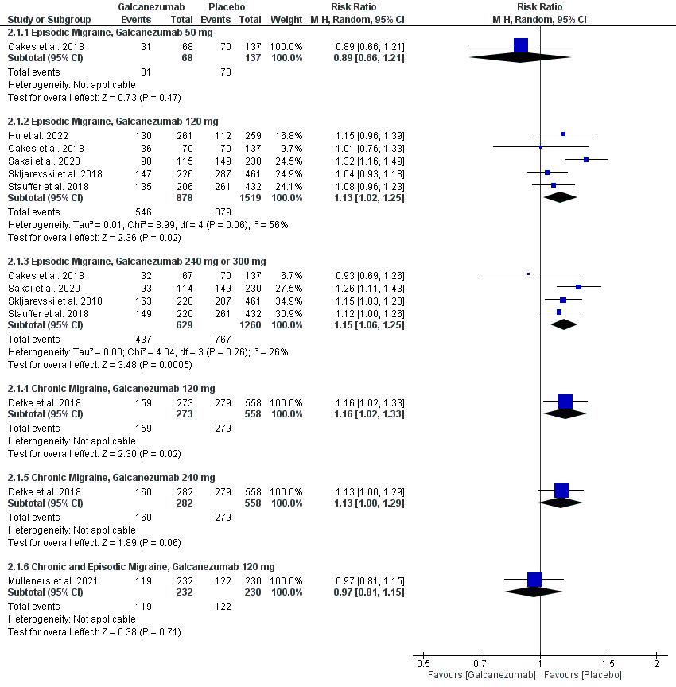

Fig. S6b. A forest plot of the patients with ≥1 adverse events outcome after sensitivity analysis.

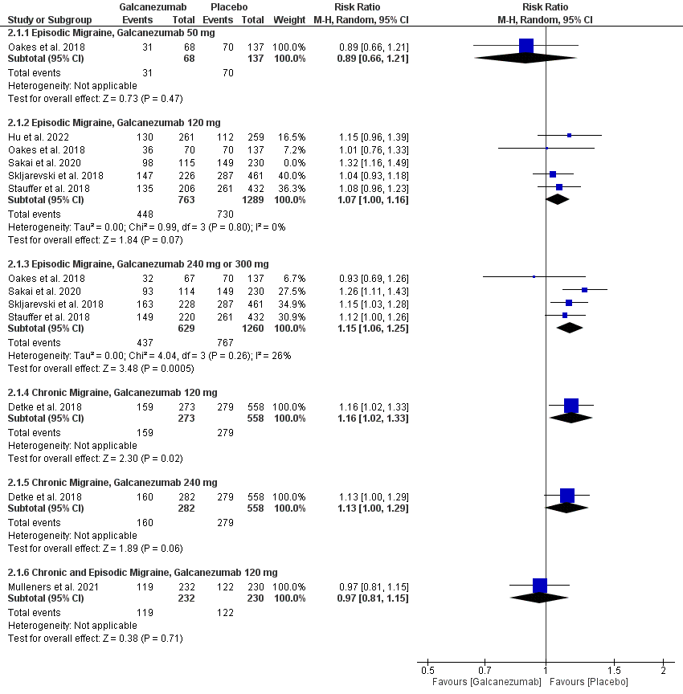

Fig. S7. A forest plot of the patients with ≥1 serious adverse events outcome.
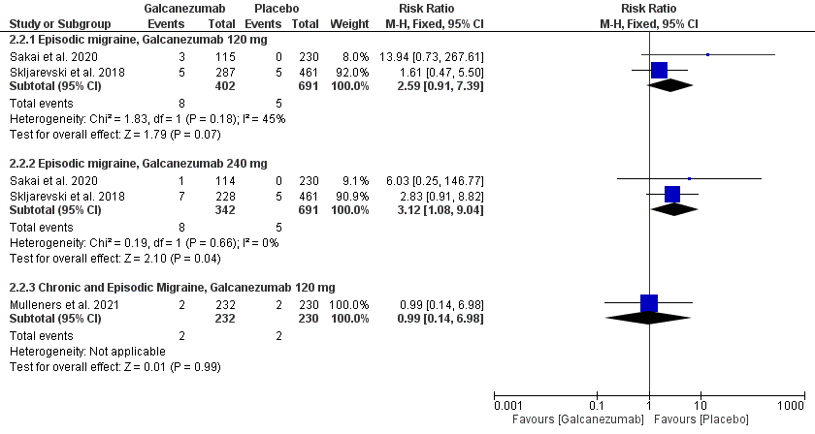

Fig. S8. A forest plot of the patients with adverse events leading to discontinuation outcome.
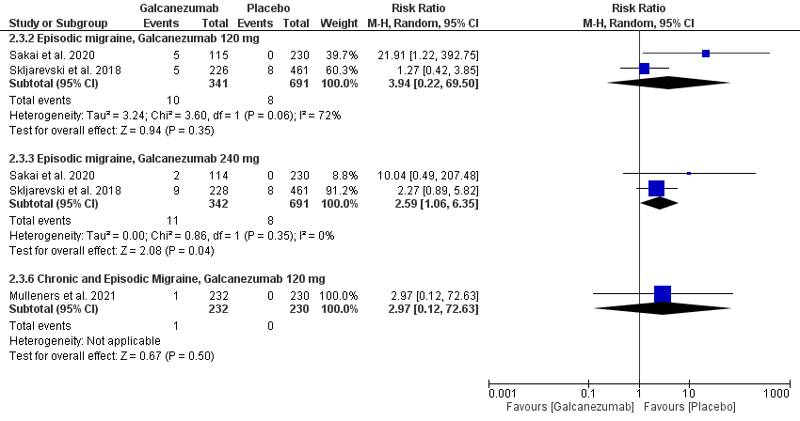

Fig. S9. A forest plot of the injection site pain outcome.

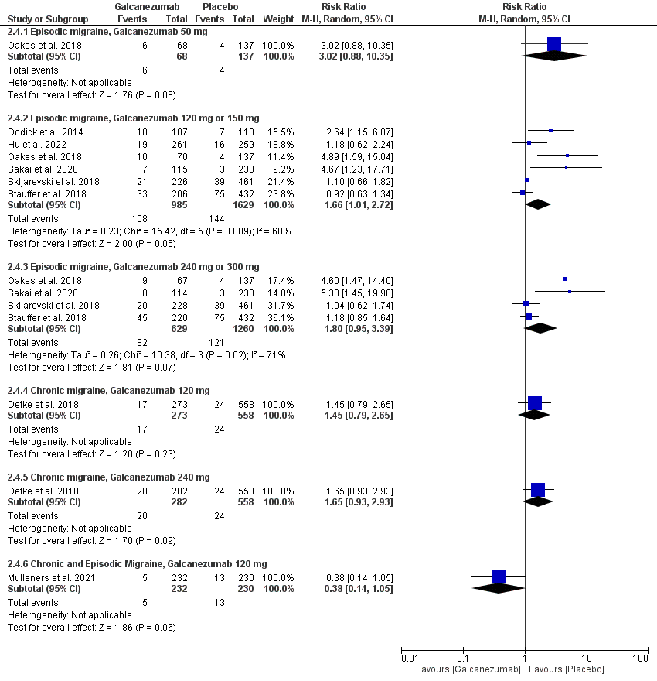

Fig. S10a. A forest plot of the injection site erythema outcome before sensitivity analysis.

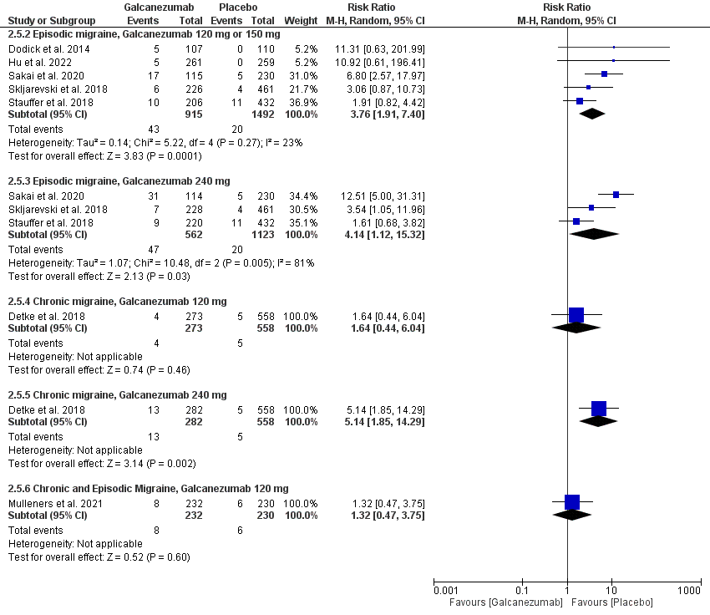

Fig. S10b. A forest plot of the injection site erythema outcome after sensitivity analysis.

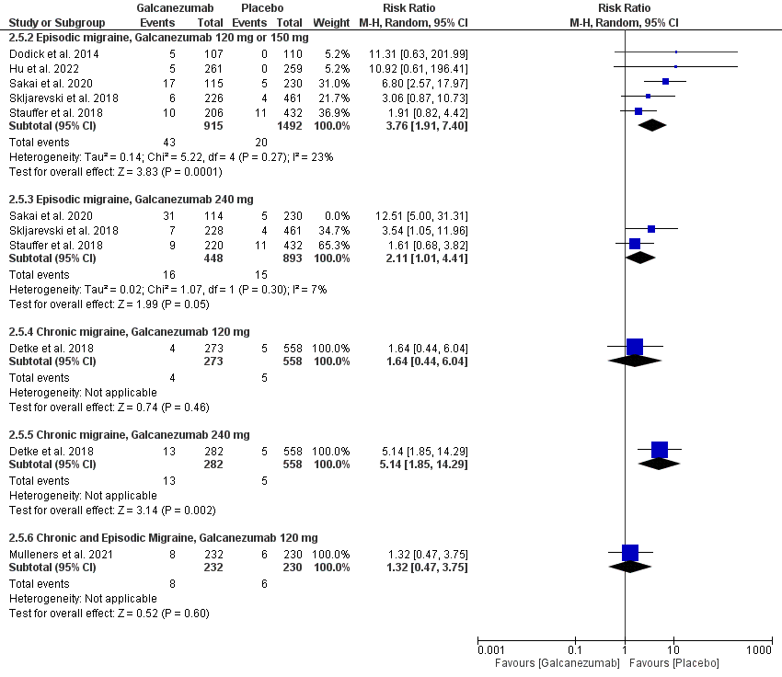

Fig. S11. A forest plot of the injection site reaction outcome.

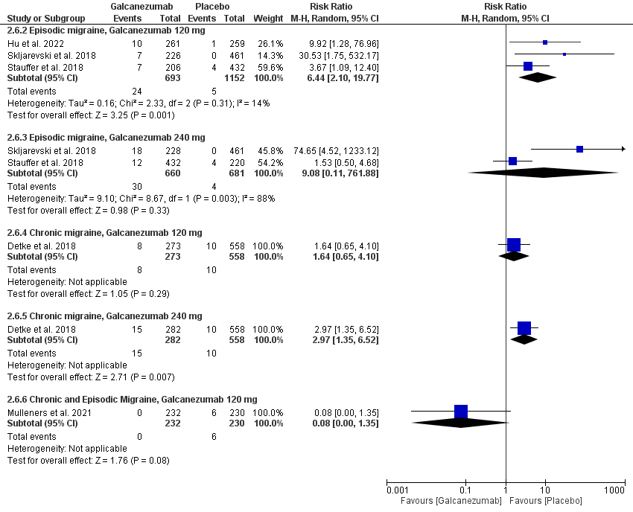

Fig. S12. A forest plot of the injection site pruritis outcome.

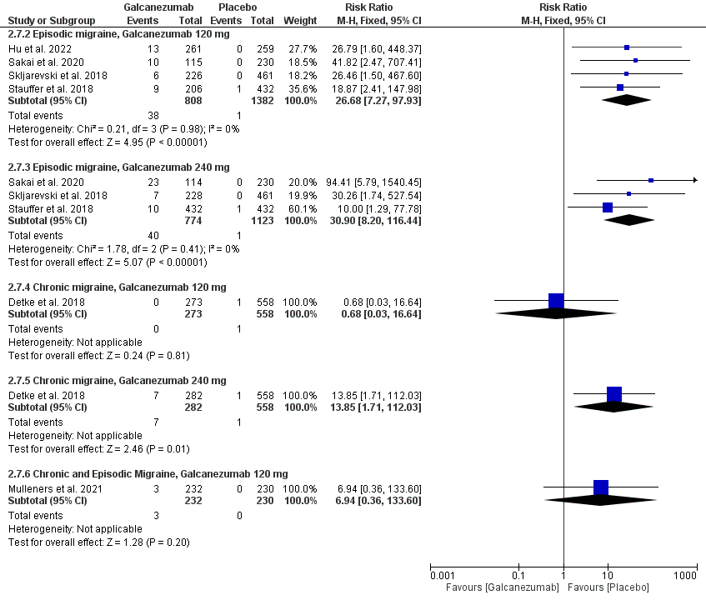

Fig. S13. A forest plot of the injection site swelling outcome.

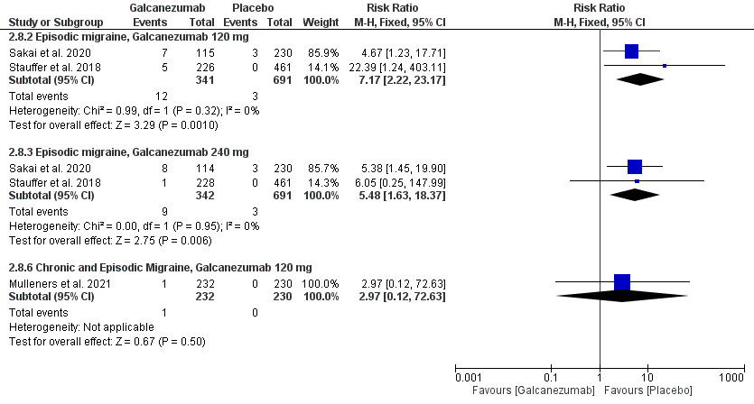

Fig. S14. A forest plot of the nasopharyngitis outcome.

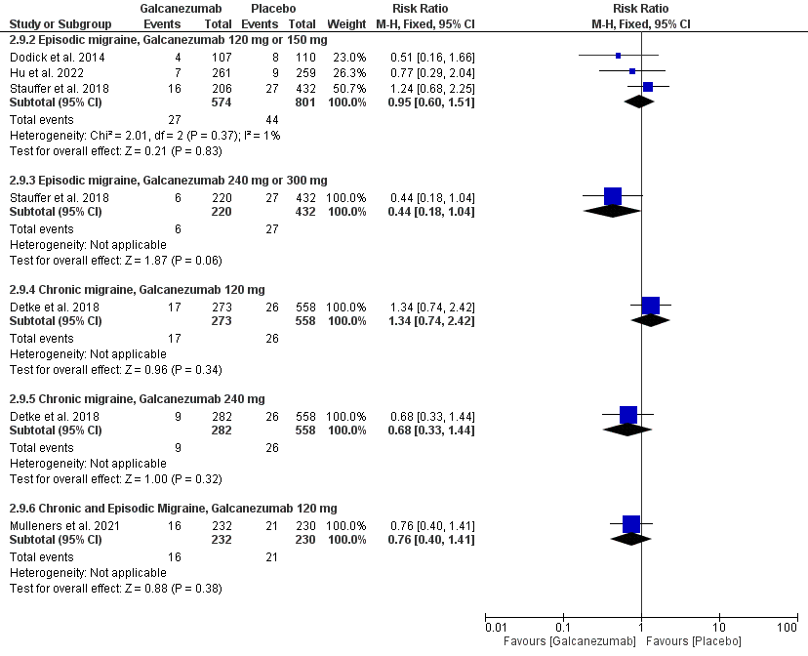

Fig. S15. A forest plot of the sinusitis outcome.

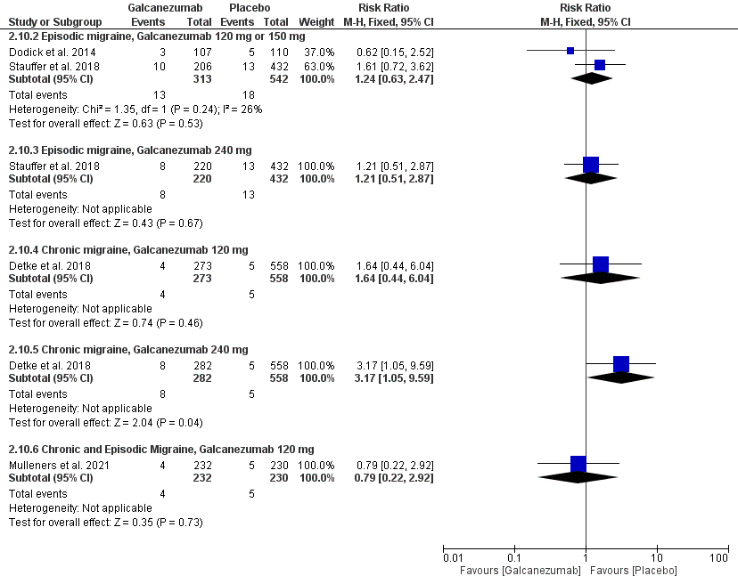

Fig. S16. A forest plot of the upper respiratory tract infection outcome.

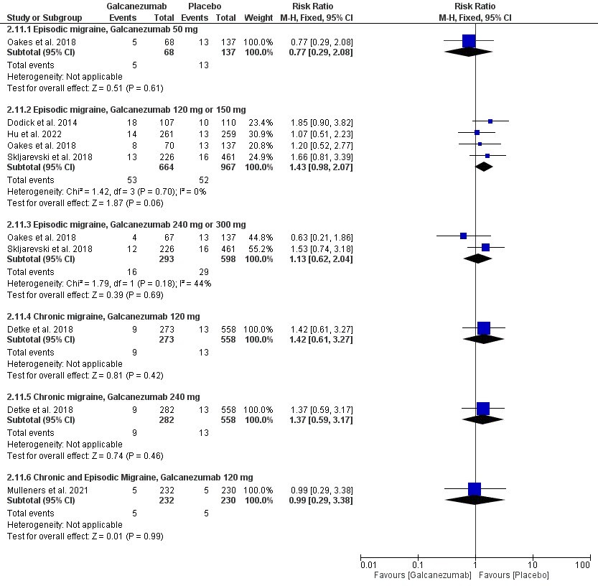

Fig. S117. A forest plot of the neck pain outcome.

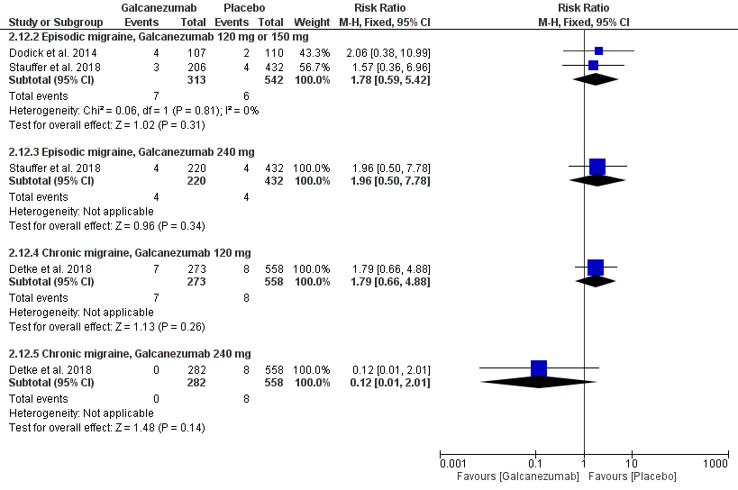

Fig. S18. A forest plot of the back pain outcome.

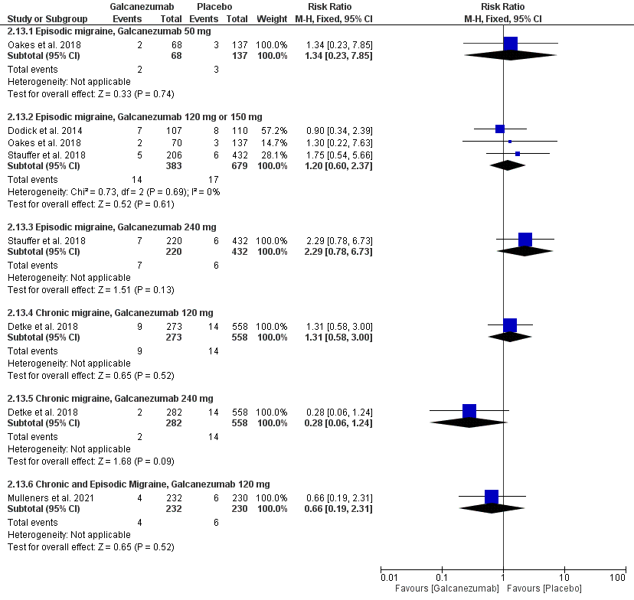

Fig. S19. A forest plot of the diarrhea outcome.

