Supplementary material
table S1 Compared between 3 groups of demographic data and clinical characteristics in male samples (n = 92)
 |  | NSSI+D | D | HC | p | p’ | p’’ | p’’’
Age |  | 16(4) | 13.52±2.502 | 13(2) | 0.005 | 0.073 | 0.221 | 0.007
Type | FE | 9 | 20 | - | 0.777 | - | - | -
Type | RE | 8 | 15
During |  | 16(23) | 16(13) | - | 0.984 | - | - | -
Father-Tr |  | 27(5) | 10(21) | 32(5) | 0.000 | 0.005 | 0.000 | 0.039
Father-Co |  | 22.18±4.305 | 25.69±8.941 | 22.82±3.127 | 0.311 | 0.150 | 0.288 | 0.531
Father-Al |  | 11.47±2.672 | 15.66±6.382 | 12(3) | 0.007 | 0.001 | 0.001 | 0.800
Mother-Tr |  | 28(8) | 40(15) | 31.47±4.025 | 0.003 | 0.003 | 0.001 | 0.086
Mother-Co |  | 22.24±2.412 | 35(11) | 24.24±4.090 | 0.000 | 0.000 | 0.000 | 0.052
Mother-Al |  | 10.12±2.571 | 16(9) | 8(3) | 0.000 | 0.003 | 0.000 | 0.074
Peer-Tr |  | 32.00±5.820 | 35.52±6.156 | 35.53±5.421 | 0.106 | 0.077 | 0.741 | 0.039
Peer -Co |  | 25.53±4.584 | 29(11) | 27.45±4.464 | 0.117 | 0.044 | 0.284 | 0.557
Peer-Al |  | 15.12±2.315 | 16.07±3.161 | 15(3) | 0.064 | 0.444 | 0.169 | 0.507
Depression |  | 29.24±3.784 | 21.38±5.053 | 0(1) | 0.000 | 0.000 | 0.000 | 0.000
Internet_addiction |  | 43.65±14.217 | 34.00±8.876 | 37.45±8.598 | 0.060 | 0.018 | 0.421 | 0.074
Self_harming |  | 35.94±13.222 | - | - | -
Notes p’: group “NSSI+MDD” and “MDD”; p’’: group “MDD” and “HC”; p’’’: group “NSSI+D” and “HC”; IA: Internet addiction; IA-CU: compulsive use subscale of CIAS-R; IA-WS: withdrawal symptoms of CIAS-R; IA-TS: tolerance symptoms of CIAS-R; IA-IHP: interpersonal and health‐related problems of CIAS-R; IA-TM: time management problems of CIAS-R

table S2 Compared between 3 groups of demographic data and clinical characteristics in female samples (n = 172)
 |  | NSSI+D | D | HC | p | p’ | p’’ | p’’’
Age |  | 15(2) | 14.5(3) | 14(2) | 0.000 | 0.229 | 0.015 | 0.000
Type | FE | 39 | 26 | - | 0.644 | - | - | -
Type | RE | 25 | 20
During |  | 14(20) | 14(14) | - | 0.915 | - | - | -
Father-Tr |  | 29(10) | 18.5(28) | 31.30±4.436 | 0.000 | 0.001 | 0.000 | 0.000
Father-Co |  | 22(5) | 23.00±7.510 | 23.63±3.575 | 0.000 | 0.222 | 0.020 | 0.001
Father-Al |  | 12(6) | 12(9) | 14(4) | 0.000 | 0.110 | 0.001 | 0.000
Mother-Tr |  | 30.95±6.741 | 32.80±8.532 | 31.30±4.195 | 0.002 | 0.192 | 0.055 | 0.001
Mother-Co |  | 23.5(5) | 26(12) | 23.22±3.423 | 0.001 | 0.033 | 0.187 | 0.001
Mother-Al |  | 9(5) | 12(8) | 9(3) | 0.000 | 0.000 | 0.574 | 0.000
Peer-Tr |  | 33(10) | 35(13) | 34.96±5.680 | 0.004 | 0.047 | 0.105 | 0.028
Peer -Co |  | 25.11±6.657 | 28.28±7.464 | 26.67±3.721 | 0.001 | 0.012 | 0.434 | 0.000
Peer-Al |  | 15(4) | 14.85±4.628 | 14.19±3.211 | 0.000 | 0.438 | 0.020 | 0.001
Depression |  | 30(9) | 22.37±6.631 | 0(0) | 0.000 | 0.000 | 0.000 | 0.000
Internet_addiction |  | 41(22) | 40.76±12.822 | 26(19) | 0.009 | 0.766 | 0.011 | 0.010
Self_harming |  | 37.3±13.645 | - | - | -
Notes p’: group “NSSI+MDD” and “MDD”; p’’: group “MDD” and “HC”; p’’’: group “NSSI+D” and “HC”; IA: Internet addiction; IA-CU: compulsive use subscale of CIAS-R; IA-WS: withdrawal symptoms of CIAS-R; IA-TS: tolerance symptoms of CIAS-R; IA-IHP: interpersonal and health‐related problems of CIAS-R; IA-TM: time management problems of CIAS-R

Table S3 The correlation matrices for the CIAS‐R, IPPA subscales and PHQ-9
 | CU | WD | TS | IP | TM | Dep | Fa | Mo | Per
CU | 0 | 0.095334 | 0.453229 | 0.318152 | 0.281439 | -0.09037 | -0.00255 | 0.089213 | -0.02228
WD | 0.095334 | 0 | 0.386812 | 0.307307 | 0.057849 | -0.00605 | -0.06458 | 0.126532 | -0.11089
TS | 0.453229 | 0.386812 | 0 | -0.09395 | 0.059611 | 0.166046 | -0.01382 | -0.07516 | 0.020384
IP | 0.318152 | 0.307307 | -0.09395 | 0 | 0.16962 | 0.071077 | 0.062726 | -0.10543 | -0.04341
TM | 0.281439 | 0.057849 | 0.059611 | 0.16962 | 0 | 0.135367 | 0.100056 | -0.16236 | 0.101712
Dep | -0.09037 | -0.00605 | 0.166046 | 0.071077 | 0.135367 | 0 | -0.24895 | 0.172957 | -0.14697
Fa | -0.00255 | -0.06458 | -0.01382 | 0.062726 | 0.100056 | -0.24895 | 0 | 0.509558 | 0.097866
Mo | 0.089213 | 0.126532 | -0.07516 | -0.10543 | -0.16236 | 0.172957 | 0.509558 | 0 | 0.271318
Per | -0.02228 | -0.11089 | 0.020384 | -0.04341 | 0.101712 | -0.14697 | 0.097866 | 0.271318 | 0
Notes: WD: withdrawal symptoms; TS: tolerance symptoms; TM: time management problem; Peer: peer attachment; Mo: mother attachment; IP: interpersonal and health-related problems; Fa: father attachment; Dep: depressive symptoms; CU: compulsive use

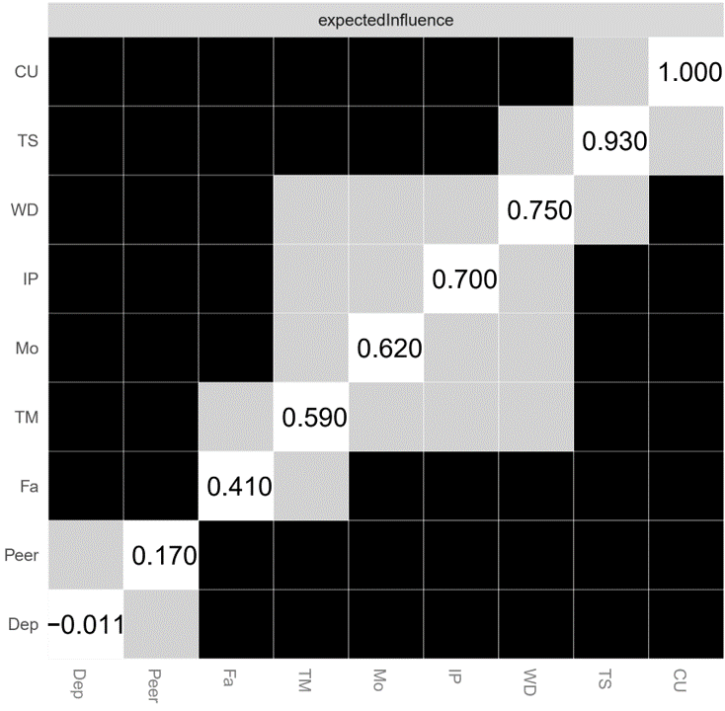
Fig. S1 centrality difference test
Notes: WD: withdrawal symptoms; TS: tolerance symptoms; TM: time management problem; Peer: peer attachment; Mo: mother attachment; IP: interpersonal and health-related problems; Fa: father attachment; Dep: depressive symptoms; CU: compulsive use

Fig. S2 bootstrapped difference test for node bridge strength
Notes: WD: withdrawal symptoms; TS: tolerance symptoms; TM: time management problem; Peer: peer attachment; Mo: mother attachment; IP: interpersonal and health-related problems; Fa: father attachment; Dep: depressive symptoms; CU: compulsive use

Fig. S3 CS-C tests

