Search Strategy: Table S1.

Database | Search Strategy | Results
PubMed | (stroke* OR ischemic stroke* OR ischaemic stroke* OR acute ischemic stroke* OR acute ischaemic stroke* OR cerebral infarct* OR brain infarct* OR cerebral infarction* OR brain infarction* OR AIS) AND (edaravone dexborneol OR edaravone-dexborneol OR "edaravone and dexborneol" OR (edaravone AND dexborneol) OR edaravone OR dexborneol OR EDB) | 722
Embase | (stroke* OR ischemic stroke* OR ischaemic stroke* OR acute ischemic stroke* OR acute ischaemic stroke* OR cerebral infarct* OR brain infarct* OR cerebral infarction* OR brain infarction* OR AIS) AND (edaravone dexborneol OR edaravone-dexborneol OR "edaravone and dexborneol" OR (edaravone AND dexborneol) OR edaravone OR dexborneol OR EDB) | 1105
Cochrane  Scopus  Clinical trials.gov | (stroke OR ischemic stroke* OR ischaemic stroke* OR acute ischemic stroke* OR acute ischaemic stroke* OR cerebral infarct* OR brain infarct* OR cerebral infarction* OR brain infarction* OR AIS) AND (edaravone dexborneol OR edaravone-dexborneol OR "edaravone and dexborneol" OR (edaravone AND dexborneol) OR edaravone OR dexborneol OR EDB)  (stroke* OR ischemic stroke* OR ischaemic stroke* OR acute ischemic stroke* OR acute ischaemic stroke* OR cerebral infarct* OR brain infarct* OR cerebral infarction* OR brain infarction* OR AIS) AND (edaravone dexborneol OR edaravone-dexborneol OR "edaravone and dexborneol" OR (edaravone AND dexborneol) OR edaravone OR dexborneol OR EDB)  (stroke* OR ischemic stroke* OR ischaemic stroke* OR acute ischemic stroke* OR acute ischaemic stroke* OR cerebral infarct* OR brain infarct* OR cerebral infarction* OR brain infarction* OR AIS) AND (edaravone dexborneol OR edaravone-dexborneol OR "edaravone and dexborneol" OR (edaravone AND dexborneol) OR edaravone OR dexborneol OR EDB) | 213  272  113

Supplementary Table S2: Grade Assessment Table:

Outcomes | Sample size | Effect estimate | Quality Assessment | Inconsistency | Indirectness | Imprecision | Publication bias | Overall quality
NIHSS AT 14 DAYS
RCT | 3,761 | −0.23 [−0.58, 0.12] | Not serious | Serious | Not serious | Serious | NA | LOW
Cohort |  |  | Not serious | Not serious | Not serious | Not serious | NA | LOW
MRS(0–2)
RCT | 4,089 | 1.08 [1.03, 1.13] | Not serious | Not serious | Not serious | Not serious | NA | HIGH
Cohort |  |  | Not serious | Not serious | Not serious | Not serious | NA | LOW
MRS(0–1) at 90 days
RCT | 4,474 | 1.14 [1.08, 1.20] | Not serious | Not serious | Not serious | Not serious | NA | HIGH
Cohort | 162 | 1.34 [1.03, 1.75] | Not serious | Not serious (I²=16%) | Not serious | Not serious | NA | LOW
Mean MRS at 90 days (primary analysis, 5 studies)
RCT | 3,698 | −0.35 [−0.72, 0.02] | Not serious | Serious | Not serious | Serious | NA | LOW
Cohort |  |  | Not serious | Not serious | Not serious | Not serious | NA | LOW
MOCA at 90 days
RCT | 1,550 | 0.02 [−0.93, 0.97] | Not serious | Serious | Not serious | Serious | NA | LOW
BARTHEL INDEX ≥95 at 90 days
RCT | 1,550 | OR 1.06 [0.85, 1.31] | Not serious | Not serious | Not serious | Serious | NA | MODERATE
90 DAYS MORTALITY
RCT | 2,754 | 0.87 [0.67, 1.13] | Not serious | Not serious | Not serious | Serious | NA | MODERATE
Cohort |  |  | Not serious | Not serious | Not serious | Not serious | NA | LOW
NIHSS at 30 days
RCT | 235 | 0.51 [−2.84, 3.86] | Not serious | Serious | Not serious | Serious | NA | LOW
ANY ADVERSE EVENT
RCT | 3,013 | 1.01 [0.97, 1.05] | Not serious | Not serious | Not serious | Not serious | NA | HIGH
Cohort |  |  | Not serious | Not serious | Not serious | Not serious | NA | LOW
SERIOUS ADVERSE EVENT (primary analysis, 5 studies)
RCT | 2,962 | 0.83 [0.60, 1.14] | Not serious | Serious | Not serious | Serious | NA | LOW
Cohort |  |  | Not serious | Not serious | Not serious | Not serious | NA | LOW
SYMPTOMATIC INTRA CRANIAL HEMORRHAGE
RCT | 1,672 | 0.73 [0.49, 1.07] | Not serious | Not serious | Not serious | Serious | NA | MODERATE
Cohort |  |  | Not serious | Not serious | Not serious | Not serious | NA | LOW

Supplementary Figure S1-2: Risk OF Bias Assessment:

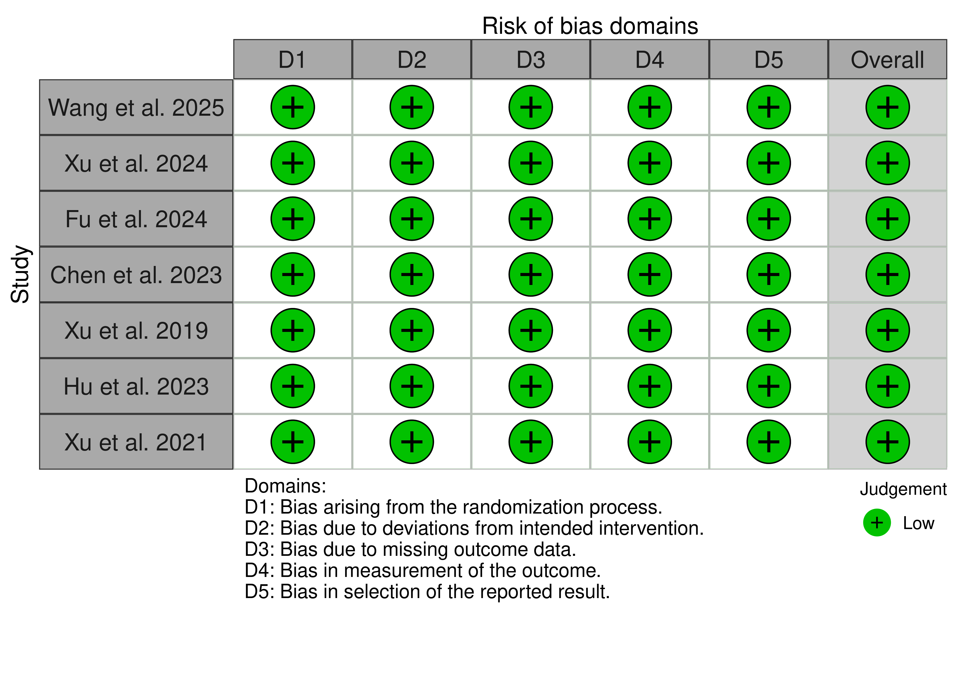

Supplementary figures: S1.

Study ID | Selection |  |  |  | Comparability |  | Outcomes |  |  | Total
Study ID | S1 | S2 | S3 | S4 | C1 | C2 | 01 | 02 | 03
Chen et al.2024 | * | * | * | * | _ | _ | * | * | * | 7*
Ma et al.2026 | * | * | * | * | * | * | * | * | _ | 8*
Luo et al.2025 | * | * | * | * | * | * | * | * | * | 9*
Li et al.2024 | * | * | * | * | _ | _ | * | * | * | 7*

Supplementary figure: S2.
Supplementary Figures: Forest plots of Secondary outcomes.

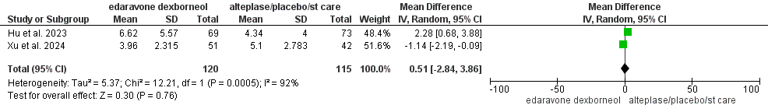
Supplementary Figure S3: Forest plot for NIHSS at 30 Days

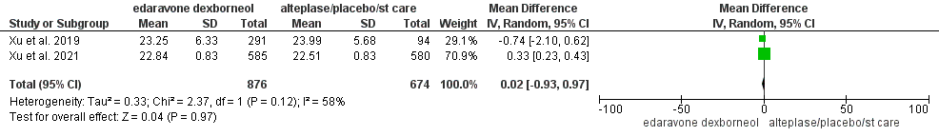
Supplementary Figure S4: Forest plot for MoCA at 90 Days

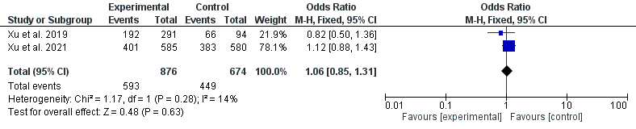
Supplementary Figure S5: Forest plot for Barthel Index ≥ 95 at 90 Days
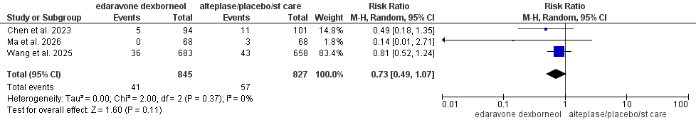
Supplementary Figure S6: Forest plot for Symptomatic Intracranial Hemorrhage

Supplementary Figures: Sensitivity Analysis.

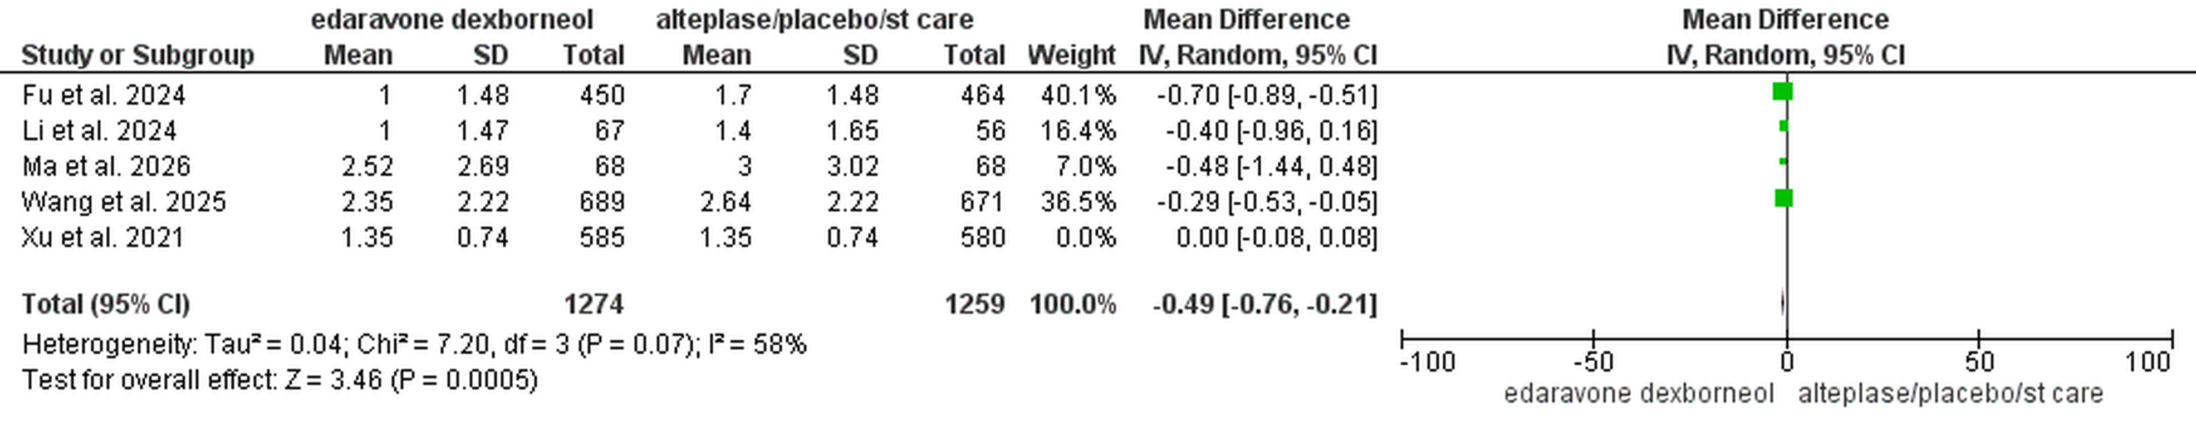
Supplementary Figure S7: post-sensitivity mean MRS at 90 days

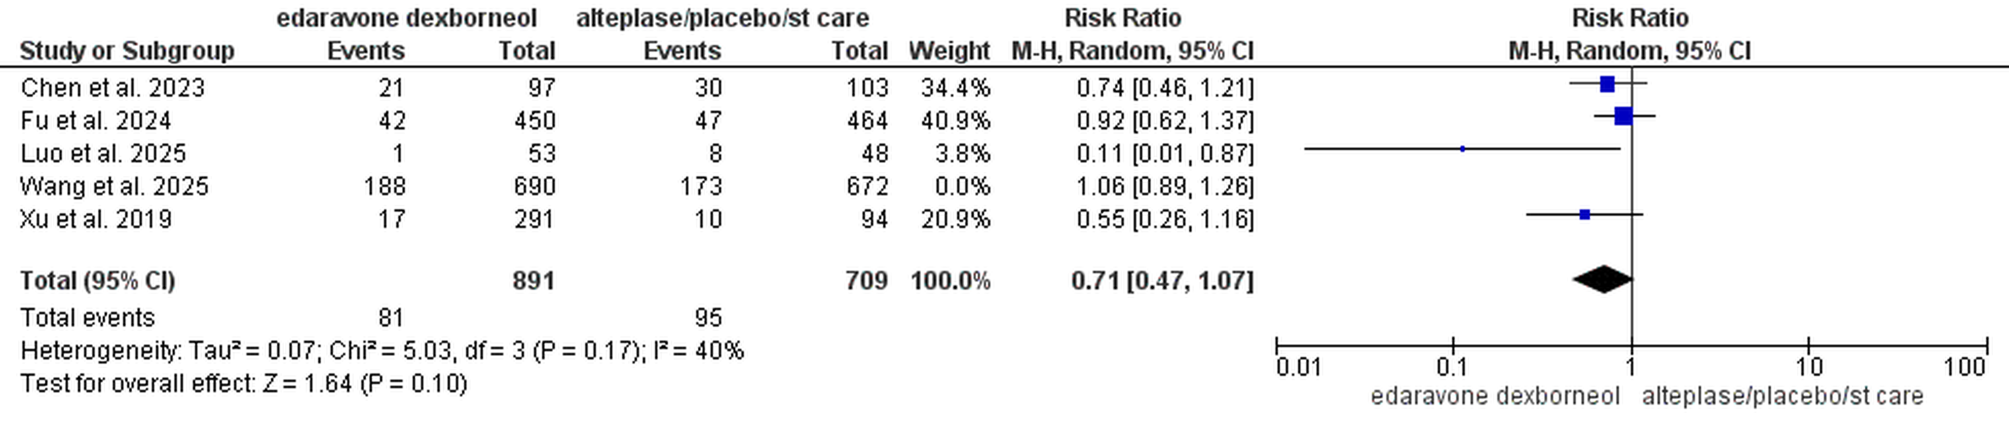

Supplementary Figure S8: post-sensitivity serious adverse event.

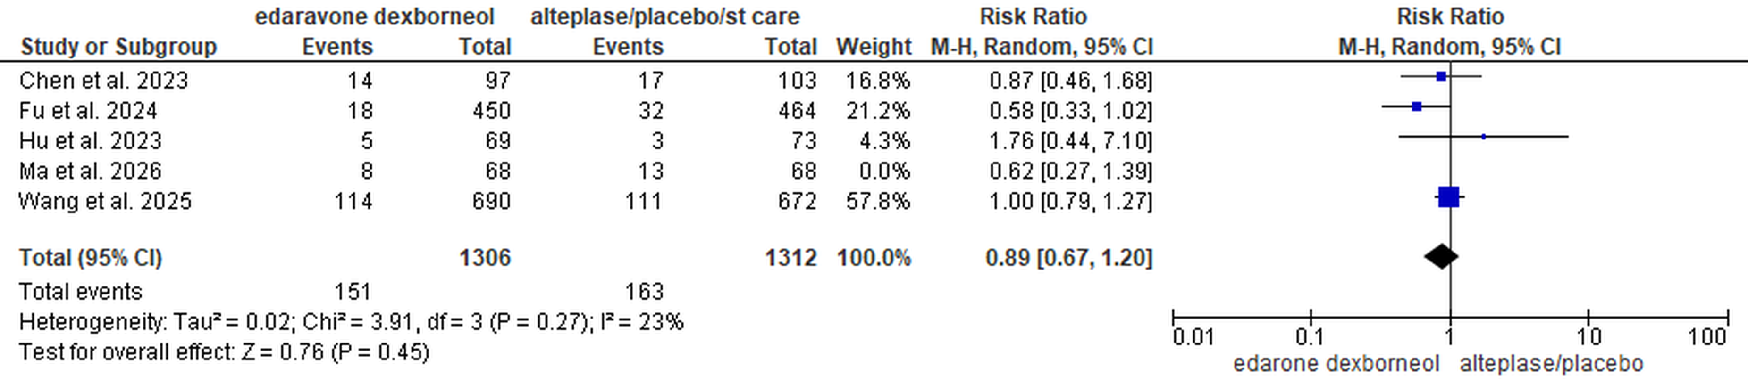

Supplementary Figure S9: post-sensitivity 90-Day All-Cause Mortality.

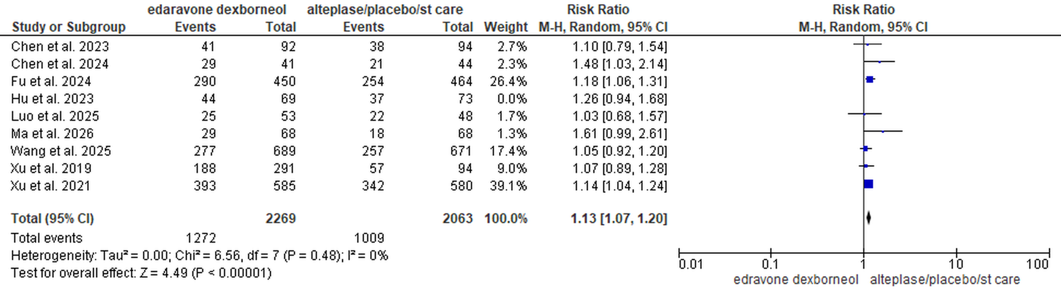

Supplementary Figure S10: post-sensitivity MRS(0-1)at 90 days.
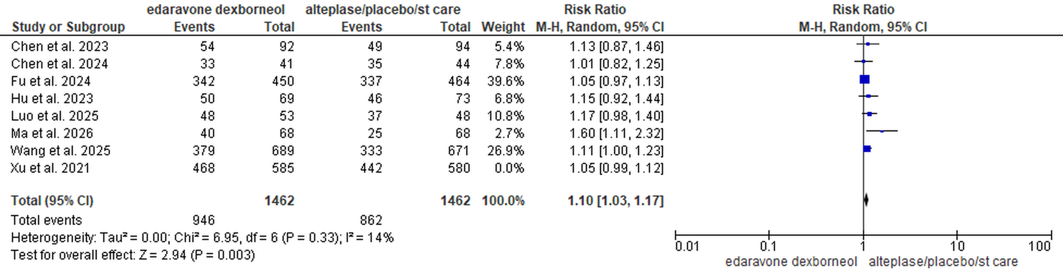
Supplementary Figure S11: post-sensitivity mRS 0–2 at 90 Days excluding Xu et al. 2021
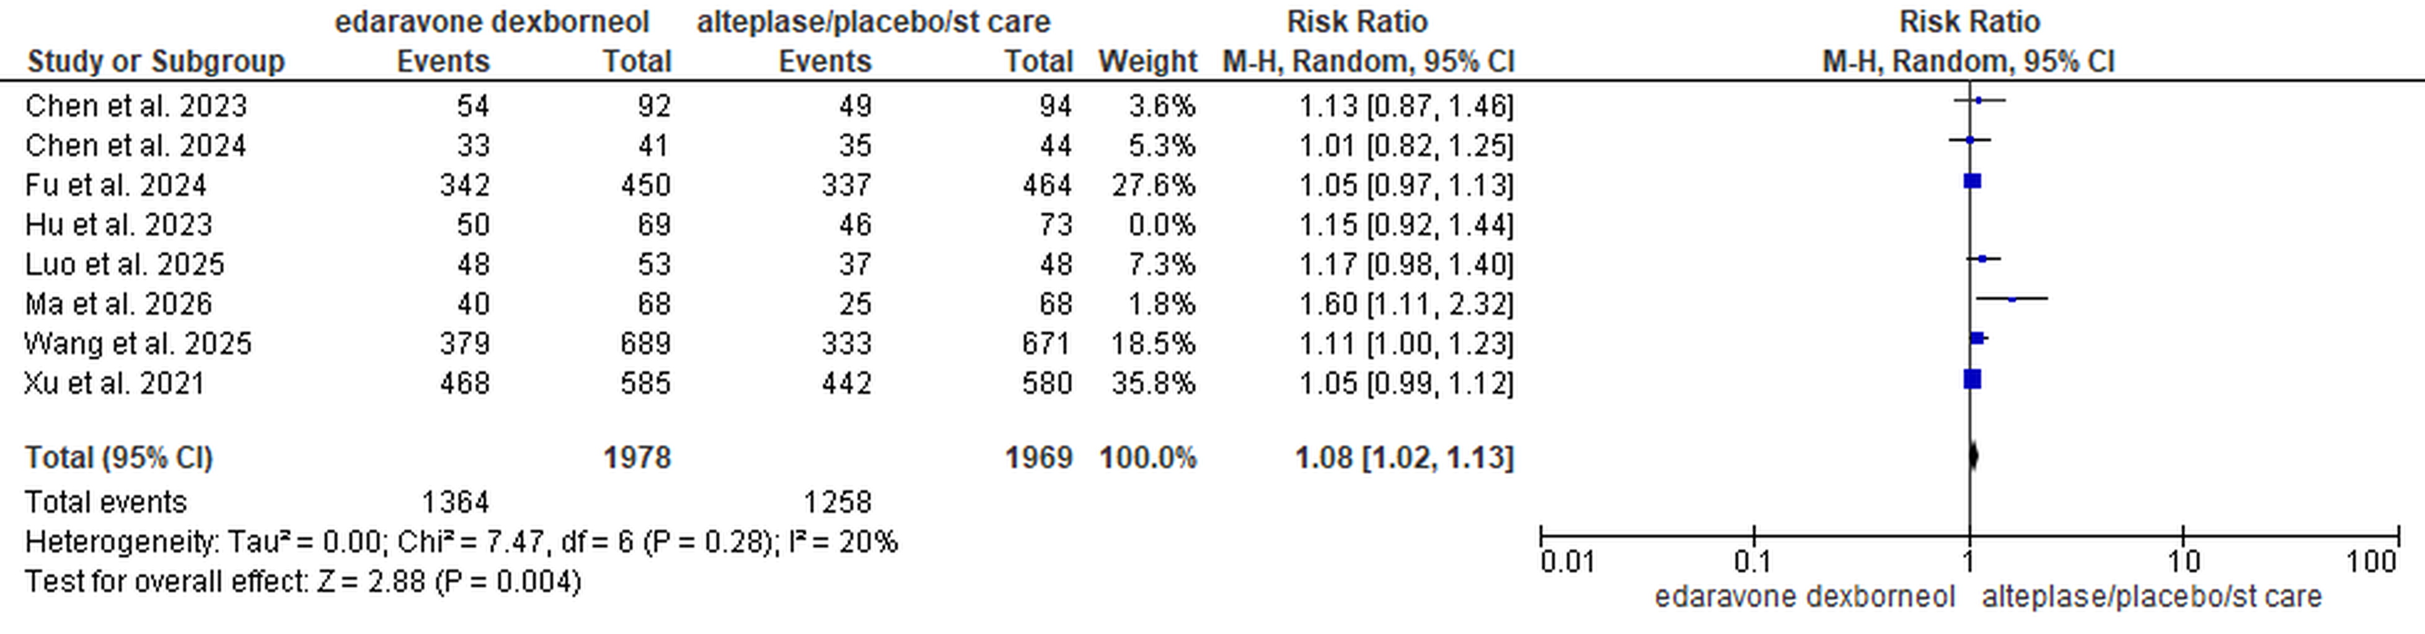
Supplementary Figure S12: post-sensitivity mRS 0–2 at 90 Days excluding Hu et al 2023.

Supplementary Figures: Trial sequential analysis.

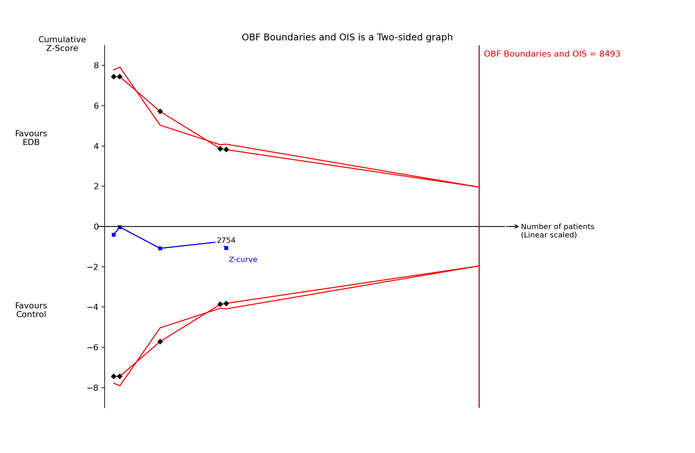

Supplementary Figure S13: 90-Day All-Cause Mortality

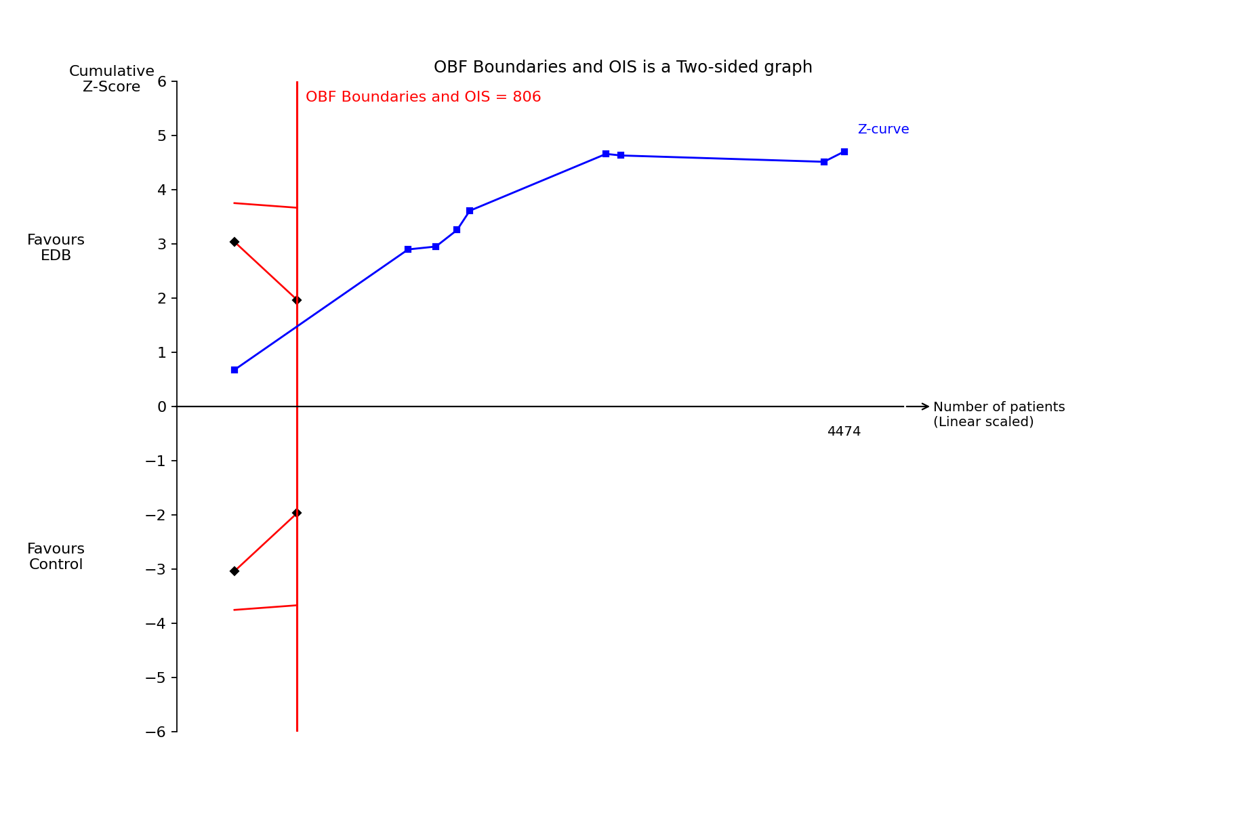

Supplementary Figures S14: MRS(0-1)at 90 days

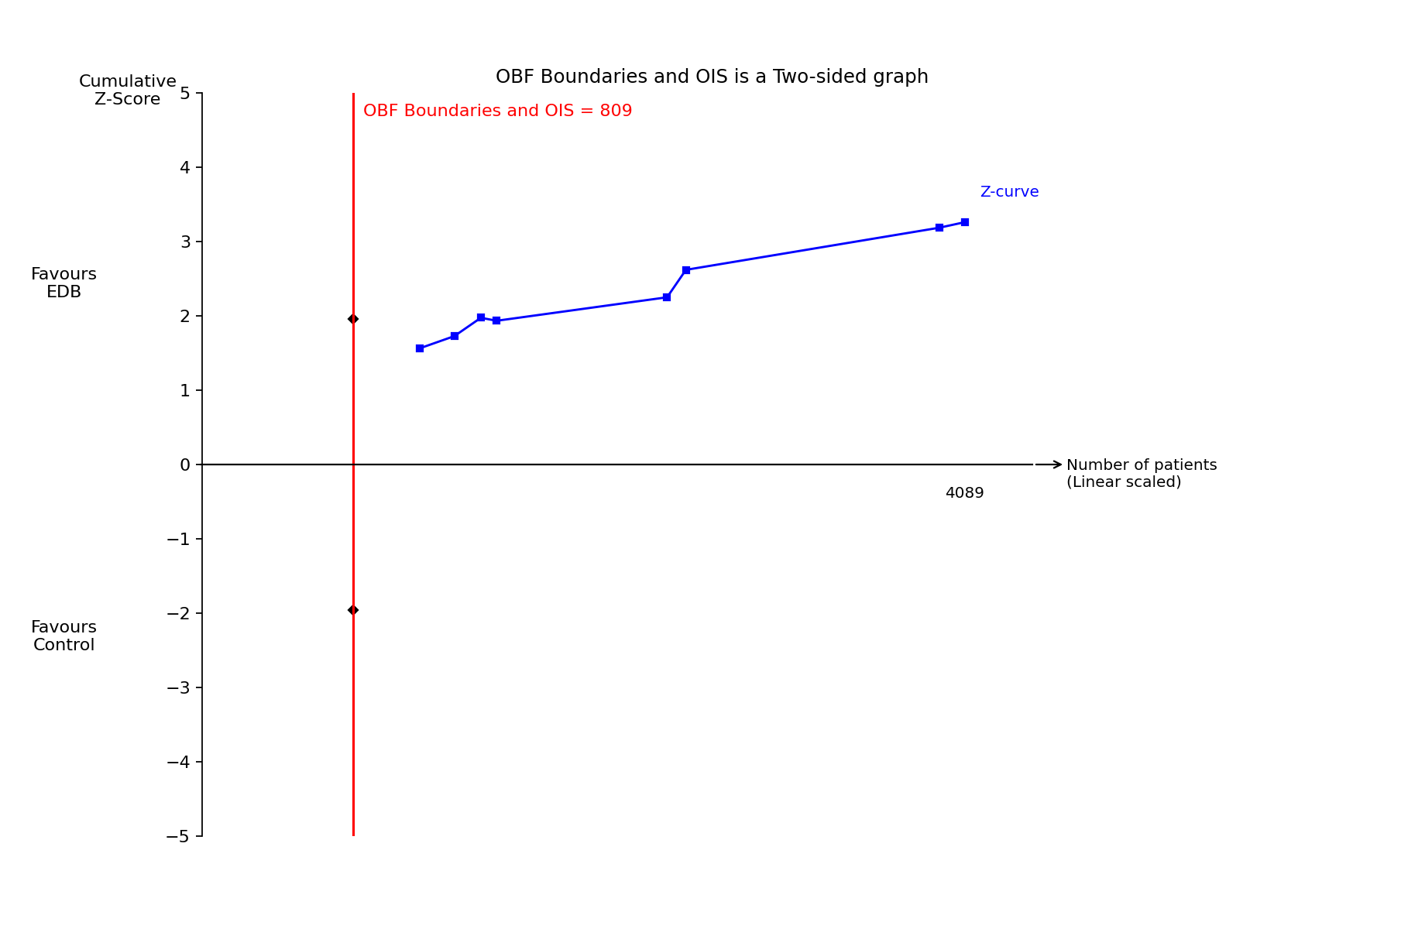

Supplementary Figure S15: mRS 0–2 at 90 Days.

Supplementary Figures: Subgroup Analysis.

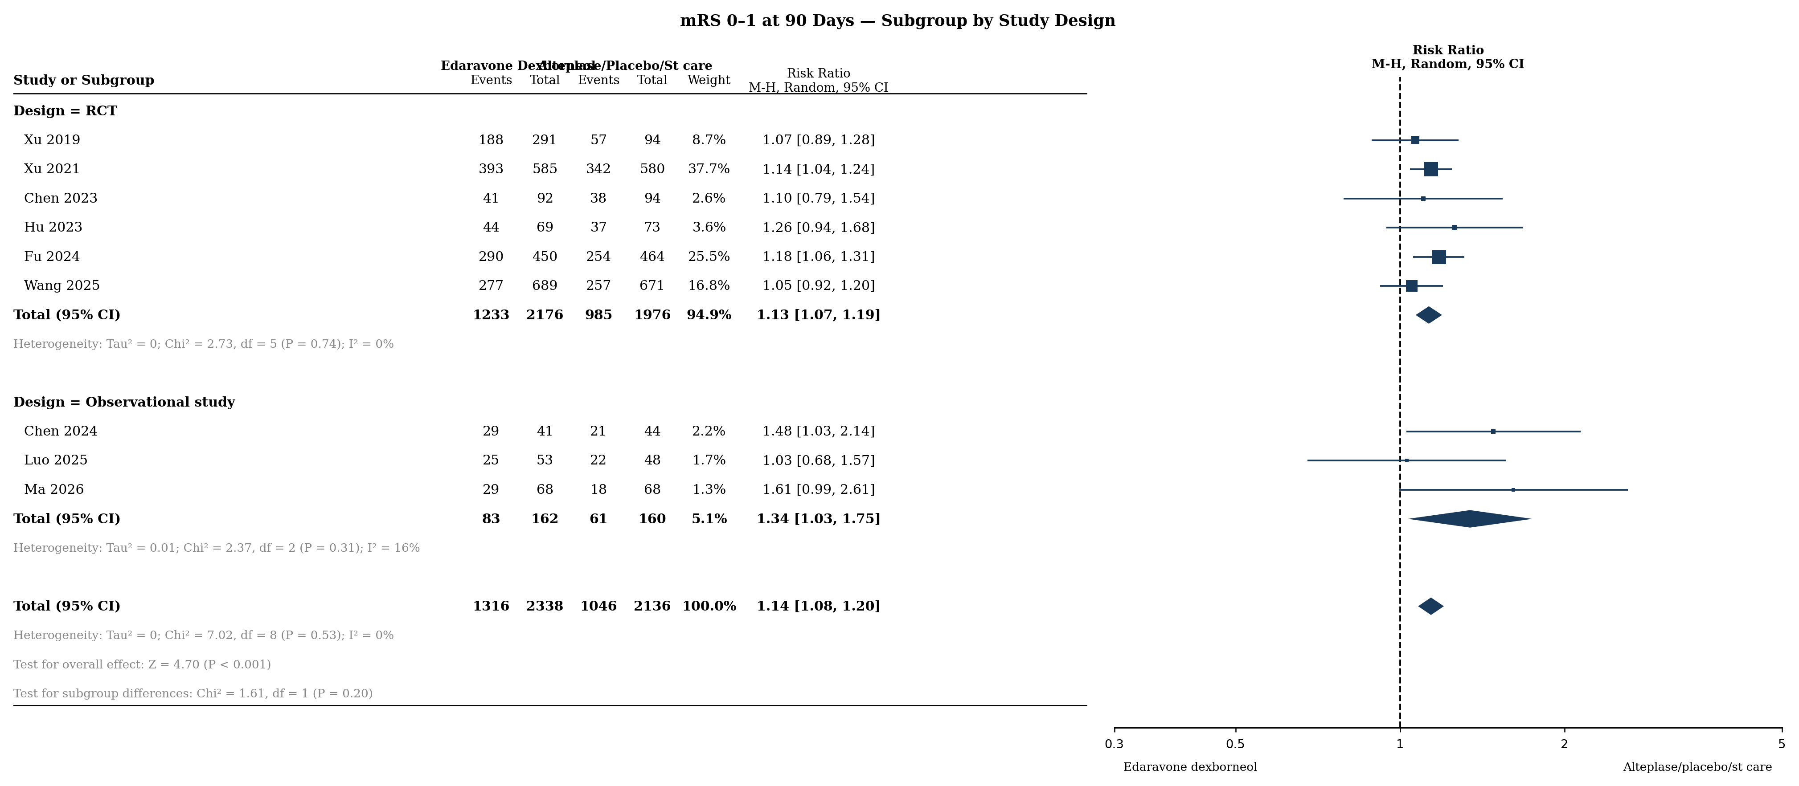
Supplementary Figure S16. Subgroup analysis by study design: mRS 0–1 at 90 days. RCT: 6 studies; Observational: 3 studies. Test for subgroup differences: Chi² = 1.61, df = 1 (P = 0.20).

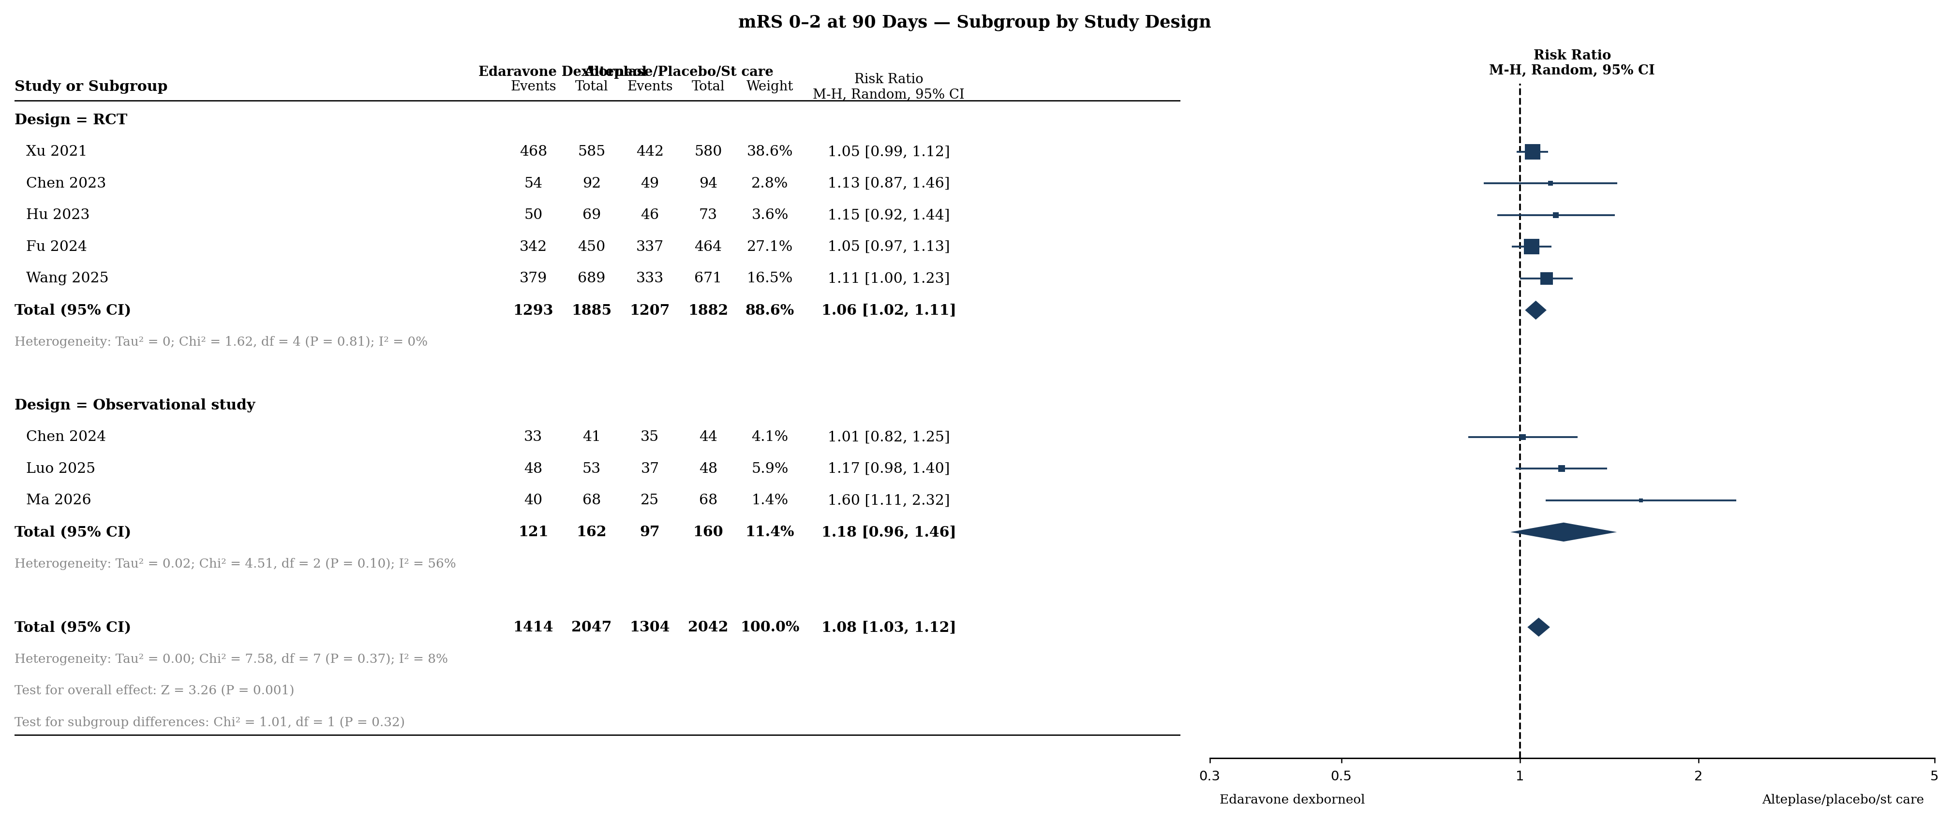

Supplementary Figure S17. Subgroup analysis by study design — mRS 0–2 at 90 days. RCT: 5 studies; Observational: 3 studies.

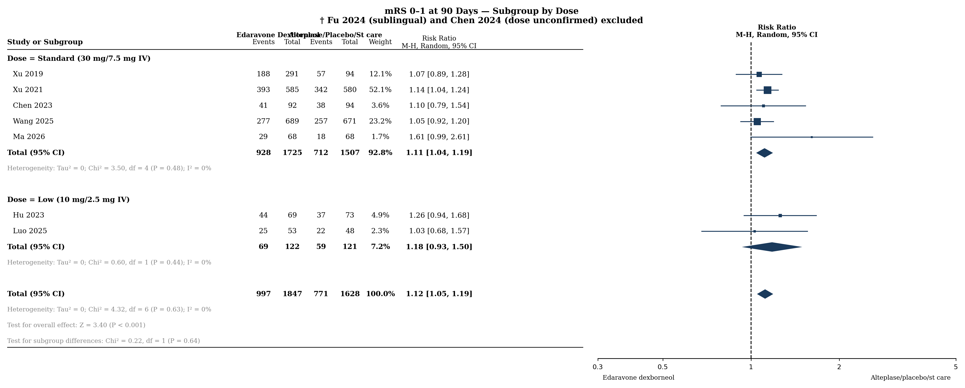
Supplementary Figure S18. Subgroup analysis by dose — mRS 0–1 at 90 days. Standard dose (30/7.5 mg IV): 5 studies; Low dose (10/2.5 mg IV): 2 studies. Fu 2024 (sublingual) and Chen 2024 (dose unconfirmed) excluded. Test for subgroup differences: Chi² = 0.22, df = 1 (P = 0.64).

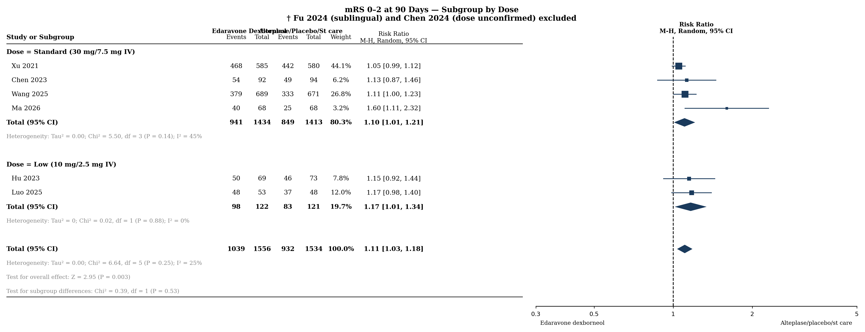
Supplementary Figure S19. Subgroup analysis by dose — mRS 0–2 at 90 days. Standard dose: 4 studies; Low dose: 2 studies.

