SUPPLEMENTARY APPENDIX

Table of Contents

Supplementary Table E1. Investigators list
Supplementary Figure E1. Schematic diagram of AVF lesion treatment and definitions

Supplementary Table E1. List of investigators

Clinical Site | Location | Principal Investigator | Sub-Investigator
United States
Cleveland Clinic | Cleveland, OH | Levester Kirksey | Federico Parod  David Hardy  Sean Lyden
Mayo Clinic | Rochester, MN | Sanjay Misra | Haraldur Bjarnason  Andrew Stockland  Newton Neider  Emily Bendel  Christopher  Reisenauer  Melissa Neisen  Erica Knavel
Sanford University of South Dakota (USD) Medical Center | Sioux Falls, SD | Angelo Santos  Chad Laurich | Patrick Kelly
King's Daughters Medical Center | Ashland, KY | Omran Abul-Khoudoud | Alexander Hou  Paul Lewis
The Mount Sinai Hospital | New York, NY | Adie Friedman | Michael Dudkiewicz  Ronald Dreifuss
Holy Name Medical Center | Teaneck, NJ | John Rundback | Kevin Herman
University of Alabama at Birmingham (UAB) Hospital | Birmingham, AL | Husameddin El Khudari  Ahmed Kamel Abdel Aal | Nathan Ertel  Rachel Oser  Andrew Gunn
University of Iowa Hospitals and Clinics | Iowa City, IA | Mel Sharafuddin | Sandeep Laroia  Shiliang Sun  Brendan O'Shea  Brian Miller  Timothy Kresowik  William Sharp  Shengfu Wang
Rush University Medical Center | Chicago, IL | Sreekumar Madassery
Sentara Vascular Specialists | Norfolk, VA | David Dexter | Samuel Steerman  Animesh Rathore  Richard DeMasi  Gordon Stokes  Scott McEnroe
University Surgical Associates | Chattanooga, TN | Charles Joels | Mark Fugate  Michael Greer  Larry Richard Sprouse  Jeff Horn
Christie Clinic Vein and Vascular Center | Champaign, IL | Syed Hussain  Nikolaos Karagiorgos | Jennifer Ash
Vascular Institute of Virginia | Woodbridge, VA | Sandeep Bagla  Rachel Piechowiak
Richmond Vascular Center | North Chesterfield, VA | Jeffrey Hull
Dialysis Access Institute | Orangeburg, SC | Mark London  John Ross | Jackson Ewart  Jalal Hakmei  Mohamed Sheta
North Carolina Nephrology | Raleigh, NC | Jeffrey Hoggard | Karn Gupta  Sejan Patel
Florida Research Network | Gainesville, FL | Bret Wiechmann | Wesley Mann
Capital Nephrology Medical Group | Sacramento, CA | Naveen Atray | Rohit Kashyap  Karthik Ramani
SKI Vascular Center | Tempe, AZ | Randy Cooper | Aslam Pervez  Umar Waheed
Dallas Nephrology Associates | Plano, TX | Neghae Mawla | Steven Beathard
Coastal Vascular and Interventional | Pensacola, FL | Fernando Kafie | Huey McDaniel
Japan
Kansai Rosai Hospital | Amagasaki | Kotaro Suemitsu | Yuki Matsuoka  Naomi Ota  Kanako Oka  Saho Kawanishi
Shonan Kamakura  General Hospital | Kamakura | Naoko Isogai  Hidemitsu Ogino | Hidemitsu Ogino  Katsunori Miyake  Rai Shimoyama  Naoko Isogai  Jun Kawachi  Takaaki Murata  Nao Kum  Yuto Igarashi  Yuma Sunou  Sumi Hidaka  Kunihiro Ishioka
Kishiwada  Tokushukai Hospital | Kishiwada | Masahiko Fujihara | Yoshiaki Yokoi  Akihiro Higashimori Nobuyuki Morioka  Shinji Shiotani  Keisuke Fukuda  Tomofumi Tsukizawa  Kensuke Kuwabara  Yoshiki Matsuo  Yuma Tanabe
Shizuoka General Hospital | Shizuoka | Masaaki Murakami | Noriko Mori  Kiyoshi Mori  Satoshi Tanaka  Ken Matsuo  Takao Okawa  Shunsuke Okamura  Yu Soma  Yoshihiro Yamamoto  Shota Kimura  Yuki Ito  Akira Sugawara  Kenta Ito  Ryo Yamada  Yoko Matsuo  Kakuya Hagiwara
Tokyo Women’s Hospital | Shinjuku-ku | Kazuhiro Iwadoh  Ichiro Nakajima  Shohei Fuchinoue | Sachiko Hirotani  Kotaro Kai  Yuichi Ogawa  Katsuyuki Miki  Takeshi Hachisuka  Sayaka Morita  Akira Kondo  Kazuhiro Iwadoh
Saitama Medical Center Saitama Medical University | Kawagoe | Tomonari Ogawa | Hajime Hasegawa  Toru Hida  Taisuke Shimizu  Nozomi Abe  Tatsuro Sano  Kunihiko Yasuda  Tota Kiba  Yoshimi Okada  Koki Ogawa  Hiroaki Hara  Kento Hirose  Yuichiro Kawai
New Zealand
Auckland City Hospital | Grafton | Andrew Holden | Brendan Buckley  Brigid Connor  Stephen Merrilees  David Semple  Andrew Hill
Capital & Coast District Health Board | Wellington | Janaka Kesara  Wickremesekera (Kes Wicks) | Richard Evans  Lupe Taumoepeau  Anantha Narayanan  Irina Baimatova

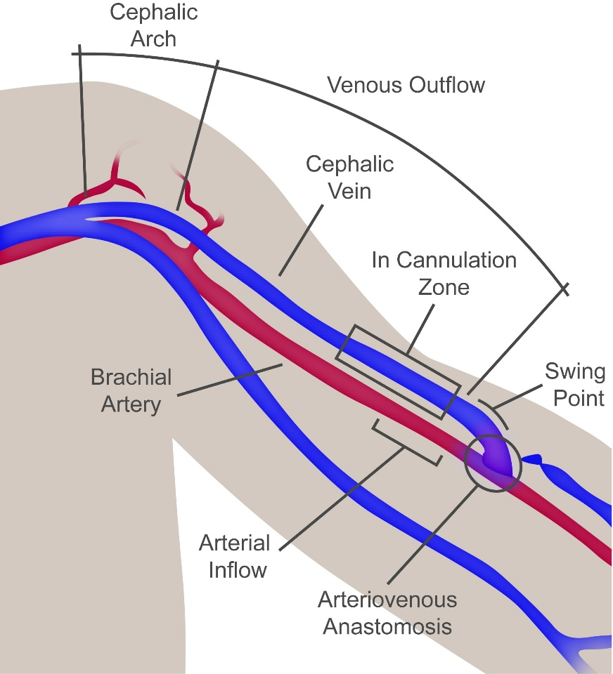

Lesion Location |  | Definitions
Peri-anastomotic | Arterial inflow | Treated segment is isolated to the arterial side
Peri-anastomotic | Anastomosis | Treated segment crosses or meets the arteriovenous anastomosis
Peri-anastomotic | Swing point | Treated segment includes the curved segment of mobilized vessel
Venous outflow | In cannulation zone | Treated segment is isolated to straight segment of vessel where cannulation is performed
Venous outflow | Venous outflow | Treated segment is in basilic vein (non-mobilized) or distal to the cephalo-axillary junction
Cephalic arch | Cephalic arch | Treated segment includes curved segment of cephalic vein as the vein crosses between the pectoralis major and deltoid muscles

Supplementary Figure E1. Schematic representation of AVF and key definitions. AVF, arteriovenous fistula.

