Additional file 1
Figures S1: Representative plots of flow cytometry gating for monocytes and macrophages in liver homogenates. (A) From left to right: cells were selected based on size and granularity (FSC, SSC), identification of singlets, viability by Zombie Aqua staining, and CD45 immunostaining. Subsequently, (B) CD45+F4/80+CD11b+ liver macrophages, (C) CD45+F4/80+CD11b+Tim4+MHCII+ embryonic KCs and CD45+F4/80+CD11b+Tim4- non-embryonic macrophages, and (D) CD45+F4/80-CD11b+Ly6C+ monocytes were identified. Fluorescence minus one (FMO) controls were used as reference for the positive and negative gates.

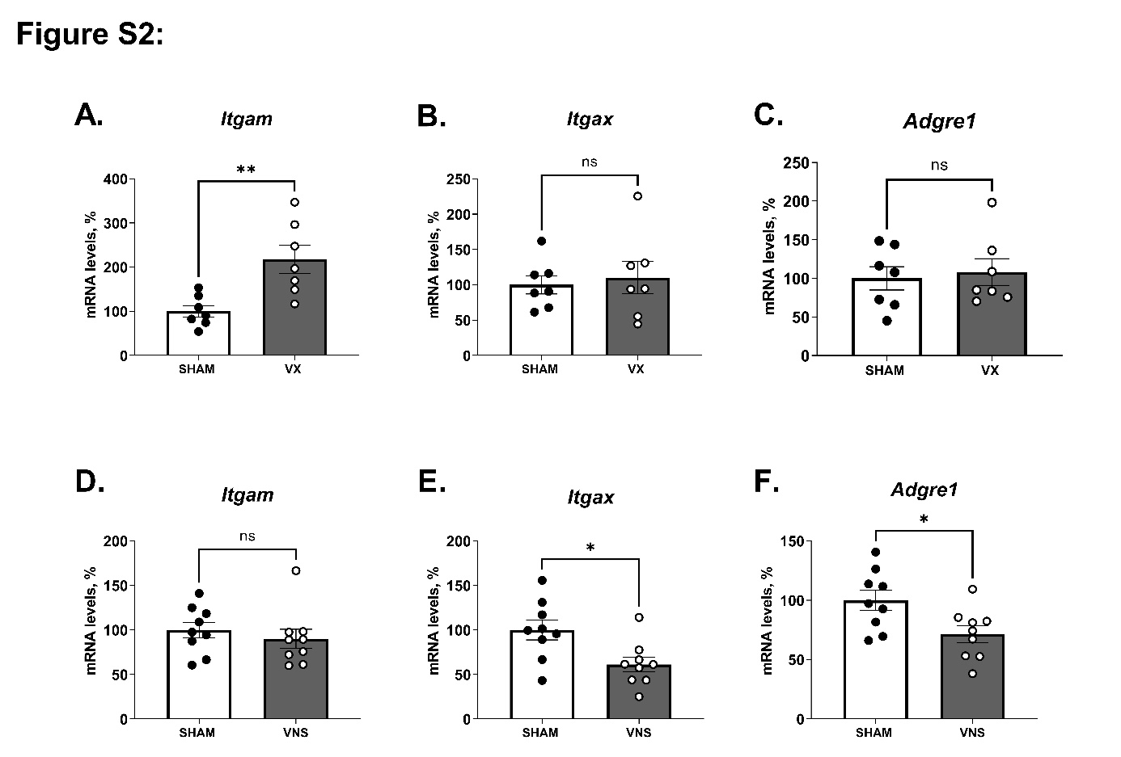
Figure S2: Vagus nerve signals regulated the mRNA levels of immune cell markers in the liver during zymosan-induced peritonitis. (A-C) Hepatic mRNA levels of immune cell markers in wild-type C57BL/6J mice subjected to left cervical unilateral vagotomy (VX, grey bars) or sham surgery (SHAM, white bars) followed by intraperitoneal injection of zymosan (0.1 mg/mouse) 7 days thereafter. (D-F) Hepatic mRNA levels of immune cell markers from wild-type mice subjected to left cervical unilateral vagus nerve stimulation (VNS, grey bars) or sham surgery (SHAM, white bars) followed by intraperitoneal injection of zymosan (0.1 mg/mouse) 1 h thereafter. Liver samples were collected 12 h after zymosan injection and homogenates analyzed by qPCR. n = 7-9 mice per group from two independent experiments. Mean ± SEM was plotted. ns = not significant; * p < 0.05, ** p < 0.01 (two-sided Student´s t-test).
Figure S3. Representative plots of flow cytometry gating for hepatic stellate cells in liver homogenates. Cells were gated from the CD45⁻ population described in Figure S1A. (A) Cells were selected based on the expression of CD146, Desmin, GFAP and SMA for the detection of CD45⁻CD146⁺Desmin⁺GFAP⁺SMA⁺ activated HSC (aHSC) and CD45⁻CD146⁺Desmin⁺GFAP⁺SMA⁺ quiescent HSC (qHSC). (B) CD45⁻ Desmin⁺GFAP⁺ HSC were identified. Fluorescence minus one (FMO) controls were used as reference for the positive and negative gates.

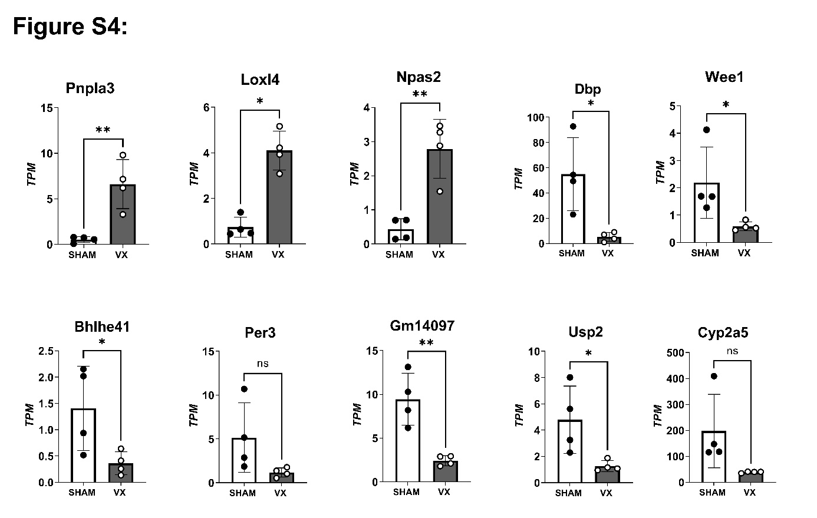Figure S4: The top 10 most significantly differentially expressed genes. Wild-type C57BL/6J mice subjected to left cervical unilateral vagotomy (VX, grey bars) or sham surgery (SHAM, white bars). After 7 days, mice were injected with zymosan (0.1 mg/mouse) and euthanized after 12 h. Liver biopsies were collected and analyzed by RNA sequencing. Levels of the ten most differentially expressed transcripts were plotted. n = 4 per group. Bars show mean±SEM, dots represent individual mice. * p < 0.05; ** p < 0.01 (two-sided Student´s t-test).

Supplementary Table 1. Antibodies for surface and intracellular staining of liver cells for flow cytometry.
Antibody | Clone | Manufacturer | Reference | Dilution (in 1x PBS)
Surface antibodies
Anti-mouse CD45 | 30-F11 | Biolegend | 103149 | 1/200
Anti-mouse CD11b | M1/70 | BD Biosciences | 557396 | 1/200
anti-mouse F4/80 | BM8 | Biolegend | 123132 | 1/200
anti-mouse Tim4 | RMT4-54 | Biolegend | 130010 | 1/200
anti-mouse MHCII | M5/114.15.2 | Biolegend | 107628 | 1/200
anti-mouse Ly6C | AL-21 | BD Bioscience | 563011 | 1/200
anti-mouse CD146 | ME-9F1 | BD Bioscience | 740827 | 1/200
Intracellular antibodies
anti-mouse/human SMA | 1A4 | LS Bio | LS‑C124868 | 1/200
anti-mouse/human Desmin | OTI4G1 | Novus Biologicals | NBP2-70565APC | 1/200
anti-mouse/human GFAP | 2.2B10 | Invitrogen | 51979282 | 1/200

Supplementary Table 2. Primer Sequences for Real-Time PCR
Gene | Forward primers (5ʹ - 3ʹ) | Reverse primer (5ʹ - 3ʹ)
Ccl2 | CAGATGCAGTTAACGCCCCA | TGAGCTTGGTGACAAAAACTACAG
Tnf-α | CCCTCACACTCAGATCATCTTCT | GCTACGACGTGGGCTACAG
Il1b | GCAACTGTTCCTGAACTCAACT | ATCTTTTGGGGTCCGTCAACT
Adgre1 (F4/80) | CTTTGGCTATGGGCTTCCAGTC | GCAAGGAGGACAGAGTTTATCGTG
Itgam | CAGACAGGAAGTAGCAGCTCCT | CTGGTCATGTTGATGAAGGTGCT
Itgax | GGCTATCAAGCATGTCATAACAGAAC | CCCCTTGTTTTCTCCCATCAG
Ppia (Cyclophilin A) | GAT GAG AAC TTC ATC CTA AAG CAT ACA | TCA GTC TTG GCA GTG CAG ATA AA
All primer design was based on mouse sequences. Ccl2 - Chemokine (C-C motif) ligand 2; Tnf-α - tumor necrosis factor alpha; Il1β - Interleukin 1 Beta; Adgre1(F4/80) - Adhesion G Protein-Coupled Receptor E1; Itgam (Cd11b) - Integrin Subunit Alpha M; Itgax (Cd11c) - Integrin Subunit Alpha X and Ppia (Cyclophilin A) - peptidylprolyl isomerase A.

