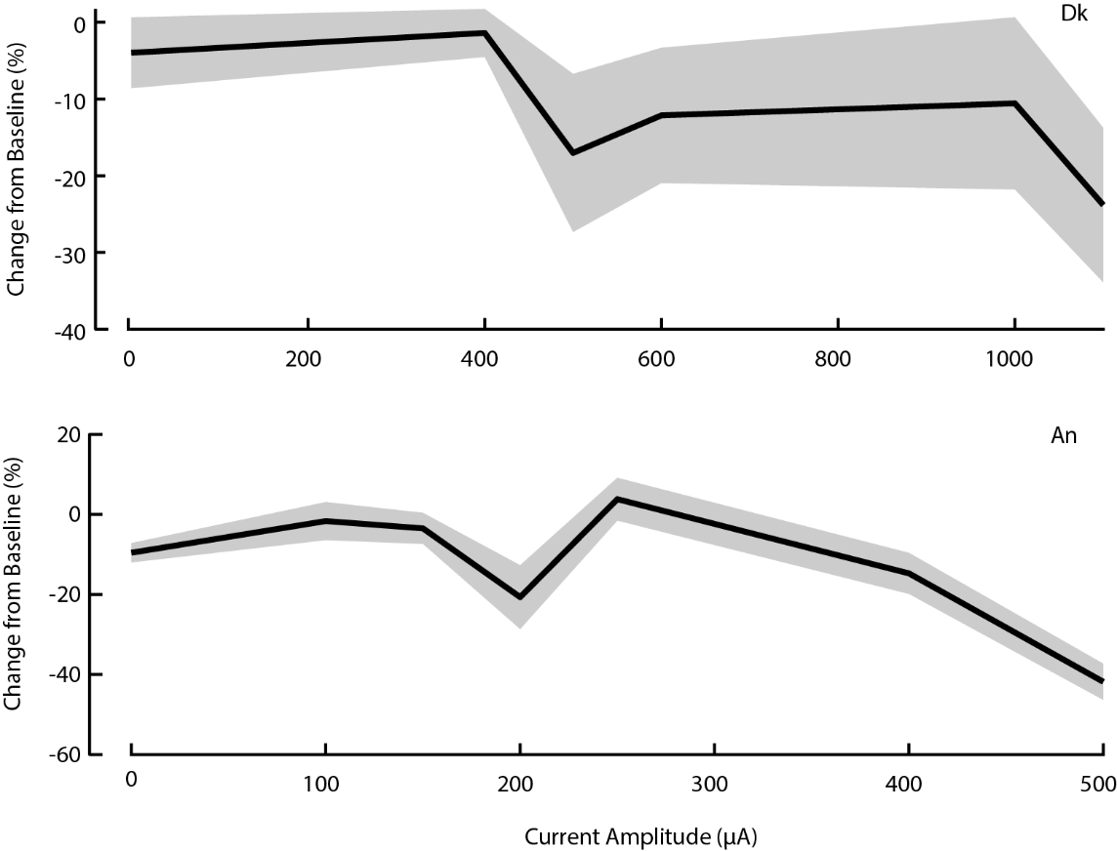
Figure S1. Dose response curves demonstrating changes in respiration rate as a function of VNS current amplitude for monkey Dk (top) and An (bottom).

