Additional file
Table A1. MENP material properties.
 | Symbol | CFO | BTO | Reference
Electrical conductivity | σ | 4.2e-5 S/m | 1e-7 S/m | [1], [2] respectively
Density | r | 5200 Kg/m³ | 5700 Kg/m³ | COMSOL library
Initial magnetic susceptibility | 𝑋! | 70 | Not applicable | [3]
Saturation magnetostriction | 𝜆" | -200 ppm | Not applicable | [4]
Saturation magnetization | 𝑀" | 2.47e5 A/m | Not applicable | [4]
Poisson’s ratio | 𝑣 | 0.48 | Not applicable | COMSOL library
Young’s modulus | 𝐸 | 230 GPa | Not applicable | [5]
Relative permittivity | 𝜀# | {9.0355, 9.0355, 10.5037} | {1115.1; 1115.1; 1251.3} | COMSOL library
Elasticity matrix, voigt notation | {cE11, cE12, cE22, cE13, cE23, cE33, cE14, cE24, cE34, cE44, cE15, cE25, cE35, cE45, cE55, cE16, cE26, cE36, cE46, cE56, cE66}; cEij = cEji | Not applicable | {150.4; 65.6; 150.4; 65.9;  65.9; 145.5; 0; 0; 0; 43.9;  0; 0; 0; 0; 43.9; 0; 0; 0; 0;  0; 42.4} GPa | COMSOL library
Coupling matrix, voig notation | {𝑒𝐸𝑆11; 𝑒𝐸𝑆21; 𝑒𝐸𝑆31;  𝑒𝐸𝑆12; 𝑒𝐸𝑆22; 𝑒𝐸𝑆32;  𝑒𝐸𝑆13; 𝑒𝐸𝑆23; 𝑒𝐸𝑆33;  𝑒𝐸𝑆14; 𝑒𝐸𝑆24; 𝑒𝐸𝑆34;  𝑒𝐸𝑆15; 𝑒𝐸𝑆25; 𝑒𝐸𝑆35;  𝑒𝐸𝑆16; 𝑒𝐸𝑆26; 𝑒𝐸𝑆36} | Not applicable | {0; 0; -4.32;  0; 0; -4.32;  0; 0; 17.4;  0; 11.4; 0;  11.4; 0; 0;  0; 0; 0} C/m² | COMSOL library
Domain wall density | a | 1.5e5 A/m | Not applicable | [6] [7]
Pinning loss | k | 2e5 A/m | Not applicable | [6] [7]
Magnetization reversibility | c | 0.4 | Not applicable | [6] [7]
Interdomain coupling | alpha | 1.4 | Not applicable | [6] [7]

Table A2. Eigenmodes and Q-factor obtained from the Eigenfrequency study for MENP with different core diameters.
d_{CORE} = 25 nm |  | d_{CORE} = 50 nm |  | d_{CORE} = 100 nm
Eigenfrequency (GHz) | Q-factor | Eigenfrequency (GHz) | Q-factor | Eigenfrequency (GHz) | Q-factor
6.447 | 77115 | 5.2733 | 84306 | 3.6589 | 91135
49.049+0.001i | 17115 | 36.135+7E-4i | 27140 | 23.462+3E-4i | 46865
63.827+0.003i | 12394 | 47.341+0.002i | 15478 | 32.247+6E-4i | 25353
70.652+0.003i | 13902 | 52.258+0.001i | 20803 | 34.630+4E-4i | 40480
85.626+0.004i | 12023 | 62.099+0.002i | 14075 | 41.286+0.001i | 18311
89.219+0.003i | 13010 | 64.727+0.002i | 16539 | 43.525+7E-4i | 31739

d_{CORE} = 150 nm |  | d_{CORE} = 200 nm |  | d_{CORE} = 250 nm
Eigenfrequency (GHz) | Q-factor | Eigenfrequency (GHz) | Q-factor | Eigenfrequency (GHz) | Q-factor
2.7137 | 94364 | 2.2940 | 95448 | 1.9274 | 96405
17.302 | 60393 | 13.687 | 68881 | 11.317 | 74450
24.441+3E-4i | 36466 | 19.736+2E-4i | 46187 | 16.497 | 54101
25.739 | 57325 | 20.418 | 68146 | 16.910 | 74916
31.495+6E-4i | 24356 | 25.517+4E-4i | 31086 | 21.455 | 54265
32.703+3E-4i | 48567 | 26.051 | 60060 | 21.628 | 70051

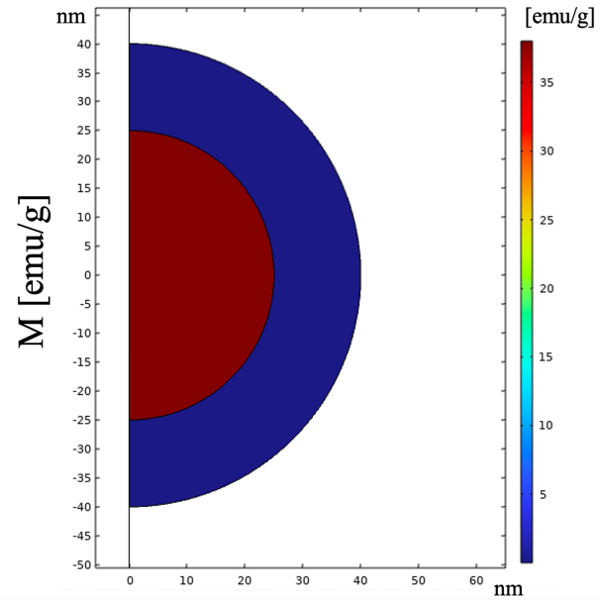
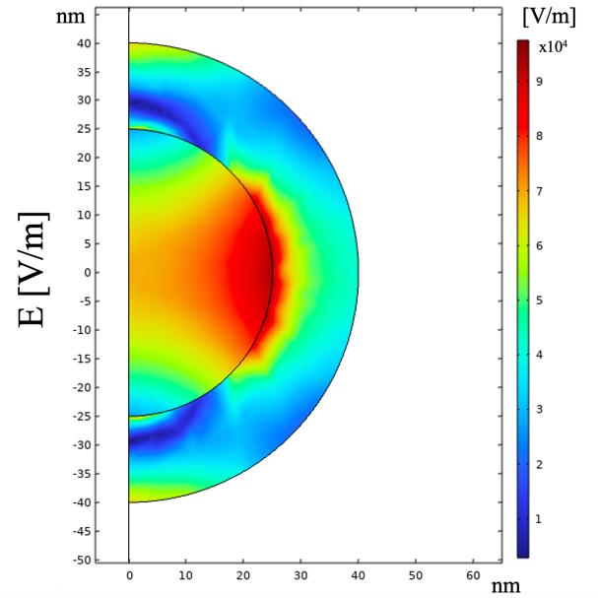
Fig. A1. Characterization of MENP (d_{CORE} = 50 nm, t_{SHELL} = 15 nm) at H_{DC} = 12 kOe in terms of magnetization, electric field norm, electric potential and strain.
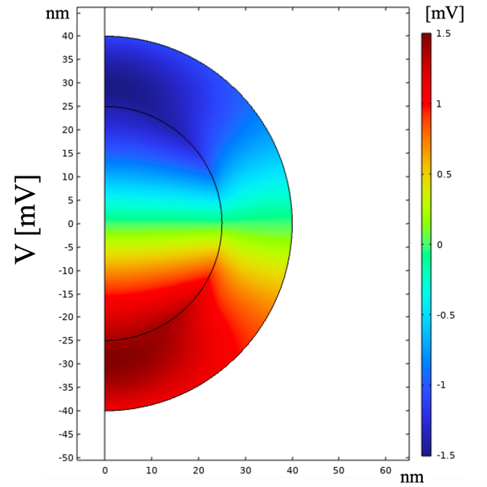
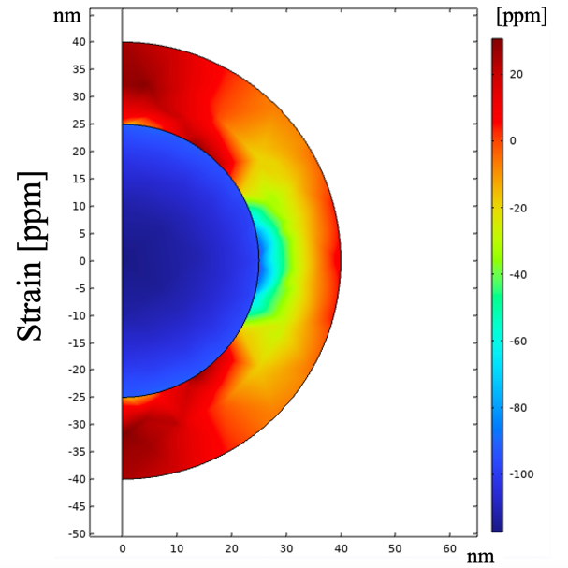

Fig. A2. Electromechanical resonance frequency as a function of static bias magnetic field (H_{DC}) of a MENP with different core diameter values. For each core diameter the maximum shift in resonance frequency and the maximum sensitivity are reported.
