Supporting Information

A Human Microbiota-Associated Translational Mouse Model Reveals Sex-Specific Responses to Cannabidiol and Cannabigerol

Eva Keohane ¹, Lance Poehlein ², Jacqueline M. Chaparro ¹, Scott D. Wrigley ², Elliot L. Graham ², Devin Wahl ³, Phoenix Espinosa ², Ryan Bayer ², Rania Hart ², Christopher L. Gentile², Tiffany L. Weir ², Jessica E. Prenni ^{1*}
*Correspondence: Jessica E. Prenni, Jessica.Prenni@ColoState.EDU

¹ Department of Horticulture and Landscape Architecture, College of Agricultural Sciences, Colorado State University, Fort Collins, CO, USA
² Department of Food Science and Human Nutrition, College of Health and Human Sciences, Colorado State University Fort Collins, CO, USA
³ Department of Health and Exercise Science, College of Health and Human Sciences, Colorado State University Fort Collins, CO, USA

Supplemental Table 1. Retention time, precursor, quantifier ion (m/z), Collision Energy (CE) for the quantifier, Entrance Voltage (EV) for the quantifier, qualifier ion (m/z), CE for the qualifier, and EV for the qualifier for each phyto- and endo- cannabinoid analyzed in the method.

Compound Name | Abbr | Retention Time, min | Precursor (m/z) [M+H] | Quantifier (m/z) | CE, V | EV, V | Qualifier (m/z) | CE, V | EV, V
Cannabinoid | CBD | 3.215 | 315.1 | 193.2 | -29 | 35 | 123.1, 181.2 | -43, -24 | 31, 31
Cannabigerol | CBG | 3.168 | 317.1 | 193.2 | -24 | 15 | 123.2 | -47 | 19
Arachidonoyl ethanolamide | AEA | 3.467 | 348.2 | 79.2 | -86 | 19 | 287.4, 91.1, 62.2 | -3, -57, -26 | 1, 22, 15
2-Arachidonoyl glycerol | 2-AG | 4.335 | 379.3 | 91.1 | -66 | 36 | 287.3, 67.2, 55.1, 269.3 | -3, -57, -69, -12 | 38, 35, 36, 38
1-Arachidonoyl glycerol | 1-AG | 4.582 | 379.3 | 91.1 | -66 | 35 | 287.3, 67.2, 55.1, 269.3 | -3, -57, -69, -12 | 38, 35, 36, 39
Cannabinoid-d3 | CBD-d3 |  | 318.2 | 196.4 | -31 | 23
Cannabigerol-d3 | CBG-d3
2-Arachidonoyl glycerol-d5 | 2-AG-d5 |  | 384.3 | 91.1 | -104 | 36
Arachidonoyl ethanolamide-d4 | AEA-d4 |  | 352.2 | 66.1 | -24 | 24

Supplemental Table 2a. Mice Tissue mean weights and standard deviations split by intervention and sex. Weights include visceral fat (Epi), subcutaneous fat (SAT)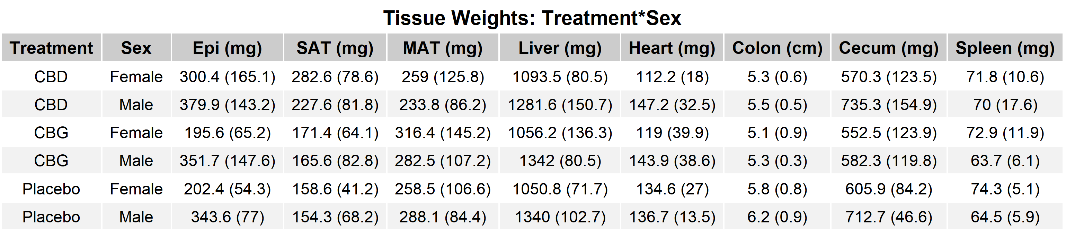

Supplemental Table 2b. Mice weekly weights averaged by treatment and sex over the course of four weeks.

Treatment*Sex | Baseline, grams | Week 1, grams | Week 2, grams | Week 3, grams | Week 4, grams |  | T-test Baseline vs Week 4, FDR Adjust P-values
CBD Female | 20.08 | 19.83 | 20.02 | 20.3 |  | 20.78 | 0.175292
CBD Males | 23.55 | 23.85 | 24.77 | 25.77 |  | 26.37 | 0.00014
CBG Females | 19.33 | 19.63 | 19.68 | 20.18 |  | 20.6 | 0.12924
CBG Males | 22.55 | 23.08 | 23.67 | 24.25 |  | 24.63 | 0.001799
Placebo Females | 19.3 | 19.53 | 20.45 | 20.52 |  | 20.98 | 0.000446
Placebo Males | 22.87 | 23.32 | 23.95 | 24.53 |  | 25.03 | 0.000446

Supplemental Table 2c. Pairwise t-tests between intervention and sex*intervention for SAT with FDR adjusted p-values.

Intervention | Stratification | Adjusted P-Value
CBD |  | 0.00681
CBG |  | 0.00443
Placebo |  | 0.67500
CBD | Sex | 0.789
CBG | Sex | 0.898
Placebo | Sex | 0.898

Supplemental Table 3a-c. Summary of statistical analyses for targeted cannabinoid analysis in plasma and fat. Intervention lists p-values from three-way ANOVA testing the main effects of intervention and sex, as well as the sex × intervention interaction for each metabolite. Intervention, p-values report Tukey’s post hoc comparisons between intervention groups (CBD, CBG, and placebo) for each metabolite. Sex × Intervention presents results from sex-stratified comparisons within each intervention group, using Wilcoxon rank-sum tests or Student’s t-tests as indicated. For each biological matrix (plasma and fat), the table summarizes intervention effects, sex effects, and sex-by-intervention interactions.

Table 3a. Plasma cannabinoid analysis
 | Intervention
Metabolite |  | ANOVA, Intervention | ANOVA, Sex |  | ANOVA, Intervention: Sex
CBD, ART |  | 4.48e-08 | 0.00382 |  | 00.134
CBG, ART |  | 0.00418 | 0.00350 |  | 0.226
AEA, ANOVA |  | 0.00223 | 0.000716 |  | 0.116
1-AG, ANOVA |  | 0.313 | 0.0195 |  | 0.465
2-AG, ANOVA |  | 0.299 | 0.914 |  | 0.413
Intervention, P-values |  | Metabolite, CBD | Metabolite, CBG |  | Metabolite, AEA | Metabolite, 1-AG |  | Metabolite, 2-AG
CBG-CBD |  | 5.71e-07 | 1.5e-02 |  | 0.0111 | 0.776 |  | 0.372
Placebo-CBD |  | 5.71e-07 | 1.00 |  | 0.0111 | 0.776 |  | 0.700
Placebo-CBG |  | 1.00 | 1.50e-02 |  | 0.983 | 0.776 |  | 0.116
Sex*Intervention  Metabolite |  | CBD Intervention | CBG Intervention |  | Placebo Intervention
CBD, Wilcoxn |  | 0.0411 | NA |  | NA
CBG, Wilcoxn |  | NA | 0.126 |  | NA
AEA, t-test |  | 0.000600 | 0.150 |  | 0.821
1-AG, t-test |  | 0.776 | 0.776 |  | 0.776
2-AG, t-test |  | 0.37 | 0.700 |  | 0.347
Microbiome*sex  Metabolite |  | CBD Intervention | CBG Intervention |  | Placebo Intervention
CBD, Wilcoxn |  | 0.53824 | 0.53824 |  | 0.53824
CBG, Wilcoxn |  | 0.92675 | 0.79268 |  | 0.79268
AEA, t-test |  | 0.82937 | 0.53824 |  | 0.82936
1-AG, t-test |  | 0.53824 | 0.53824 |  | 0.82936
2-AG, t-test |  | 0.53824 | 0.53824 |  | 0.94698

Table 3b. SAT cannabinoid analysis (concentration, ng/mg)

Intervention, P-values | ART, CBD |  | ART, CBG | ANOVA, AEA | ANOVA, 1-AG | ANOVA, 2- AG
CBG-CBD | 0.307 | 0.950 |  | 0.482 | 0.923 | 0.997
Placebo-CBD | 0.850 | 0.867 |  | 0.985 | 0.833 | 0.805
Placebo-CBG | 0.613 | 0.696 |  | 0.39 | 0.608 | 0.841
Sex*Intervention  Metabolite | CBD | CBG |  | Placebo
CBD, Wilcoxn | 0.775 | 0.775 |  | 0.775
CBG, Wilcoxn | 0.852 | 0.271 |  | 0.599
AEA, t-test | 0.862 | 0.862 |  | 0.862
1-AG, t-test | 0.662 | 0.662 |  | 0.662
2-AG,t-test | 0.983 | 0.983 |  | 0.983

Table 3c. SAT cannabinoid Analysis (total ng)
Intervention
Metabolite | ANOVA, Intervention | ANOVA, Sex | ANOVA, Intervention:Sex
CBD, ART | 2.76 e-11 | 0.000770 | 0.00660
CBG, ART | 0.00260 | 0.00103 | 0.000818
AEA, ANOVA | 0.234 | 0.803 | 0.922
1-AG, ANOVA | 0.307 | 0.599 | 0.863
2-AG, ANOVA | 0.211 | 0.872 | 0.763
Intervention, P-values | Metabolite, CBD | Metabolite, CBG
CBG-CBD | 0.0001 | 0.377
Placebo-CBD | 0.0001 | 0.547
Placebo-CBG | 0.5477 | 0.0020
Sex*Intervention  Metabolite | CBD | CBG | Placebo
CBD, Wilcoxn | 0.0130 | 0.266 | 0.700
CBG, Wilcoxn | 0.109 | 0.529 | 0.699

Supplemental Figure 1. Partition coefficients (SAT/plasma) of five cannabinoids (CBD, CBG, AEA, 1-AG, and 2-AG) by intervention (CBD, CBG, Placebo) and sex (Male, Female). Significant sex differences within each intervention group are indicated by asterisks (* p < 0.05, ** p < 0.01, *** p < 0.001; FDR-corrected for multiple comparisons). Statistical analyses: ART ANOVA for non-normal metabolites (CBD, CBG, AEA) and log-transformed ANOVA for 1-AG and 2-AG
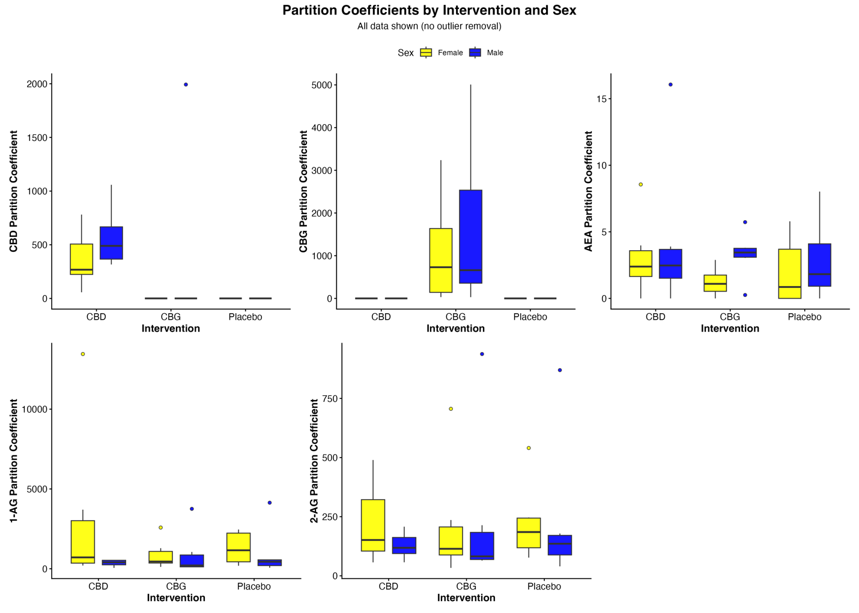

Supplemental Table 4. Partition coefficients (SAT/plasma) adjusted p-values for the ART ANOVA for non-normal metabolites (CBD, CBG, AEA) and log-transformed ANOVA for 1-AG and 2-AG. NaN stands for not significant

 | CBD | CBG | AEA | 1-AG | 2-AG
CBD | 0.3593 | NaN | 0.9372 | 0.3353 | 0.969
CBG | 0.4047 | 0.9372 | 0.1234 | 0.5665 | 0.9988
Placebo | NaN | NaN | 0.7273 | 0.4733 | 0.969

Supplemental Figure 2. Adjusted p-values for partition coefficients (SAT/plasma). Non-normally distributed metabolites (CBD, CBG, and AEA) were analyzed using aligned rank transform (ART) ANOVA, while 1-AG and 2-AG were analyzed using ANOVA following log transformation. NaN indicates no significant comparison was detected.
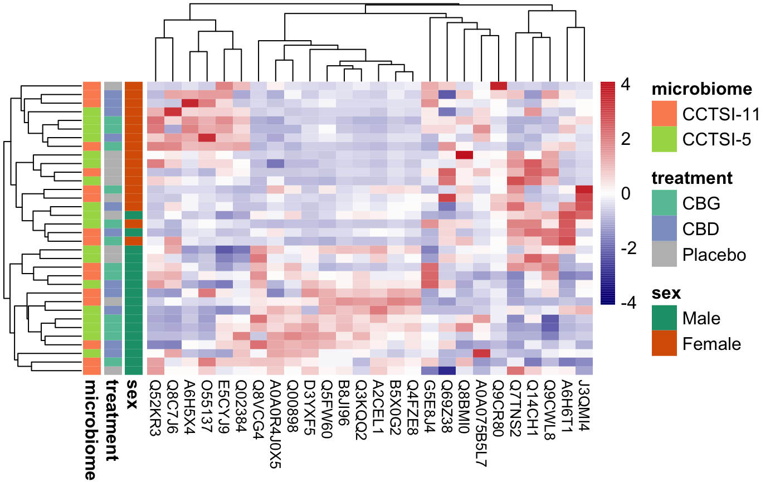

Supplemental Figure 3. Boxplots of proteins a) A0A0R4J0I1, b) O08914, c) A0A0R4J0X5, and d) Q00898 from ileum proteomics analysis. Y axis shows scaled intensity and x axis indicates intervention (CBD, CBG, and placebo) and is split by sex. a) shows protein A0A0R4J0I1 is a serine protease inhibitor statistically significant more abundant in CBD treated males compared to females (p= 0.011). The protein O08914 represented in b) is fatty acid amid hydrolase (FAAH), the proteins that catalyzes the reaction of N-arachidonoylethanolamine (AEA) to arachidonic acid (AA) and ethanolamine (EA). In the ileum tissue this protein is not differently abundant between intervention and/or sex. c) Shows A0A0R4J0X5 which is an inhibitor of serin proteases and is significantly more abundant in all males (CBD p=0.030, CBG p=0.011, and Placebo p=0.020). Finally, d) Q00898 is another serine type endopeptidase that is significantly more abundant among all males (p=0.030)

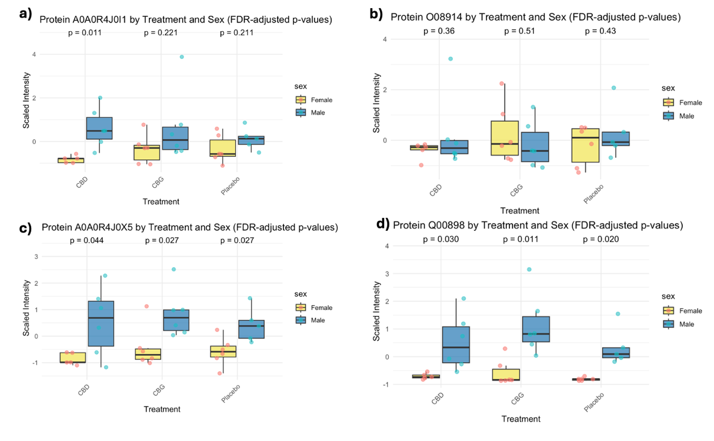

Supplemental Figure 4. At baseline, both CHAO1 (a) and Shannon α-diversity indices (b) were significantly different (p<0.05) between Biome1 and Biome2 but did not differ by sex within each group. When considering allocation to intervention group, there were no sex or intervention differences between groups in CHAO1 (c) or Shannon α-diversity (d). After 4 weeks, CHAO1 biome-based differences persisted in male mice (e), and Shannon α-diversity indices remained significantly different (p<0.05) between both sexes (f). However, when considering allocation to intervention group, there were no sex or intervention differences between the groups (g-h).

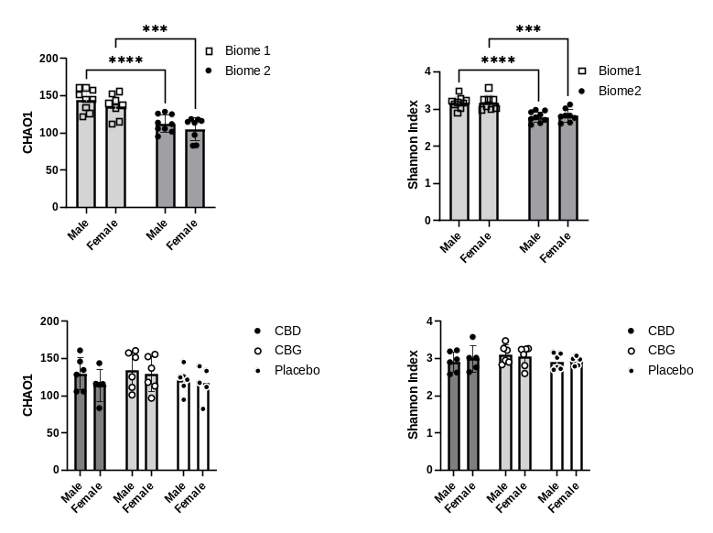
e)
g)
h)
f)
a)
c)
d)
b)
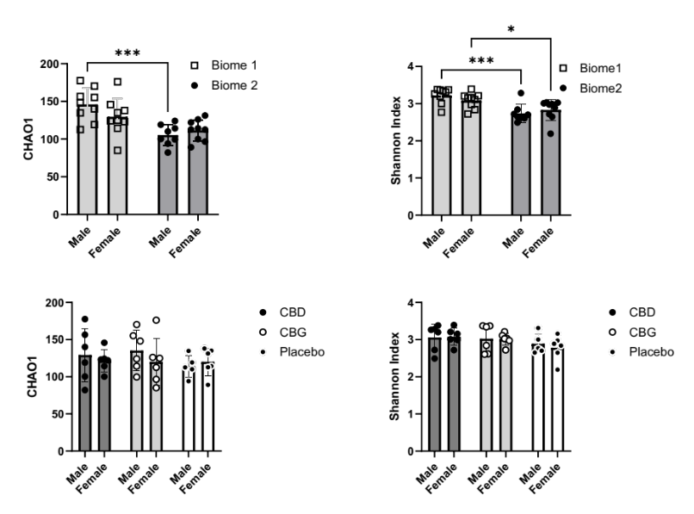

Supplemental Figure 5. At baseline, a) b)PCoA ordination of Bray Curtis distances show clustering by biome but not by sex. C) At baseline, PCoA ordinations of Bray Curtis distances show no clustering between intervention groups.

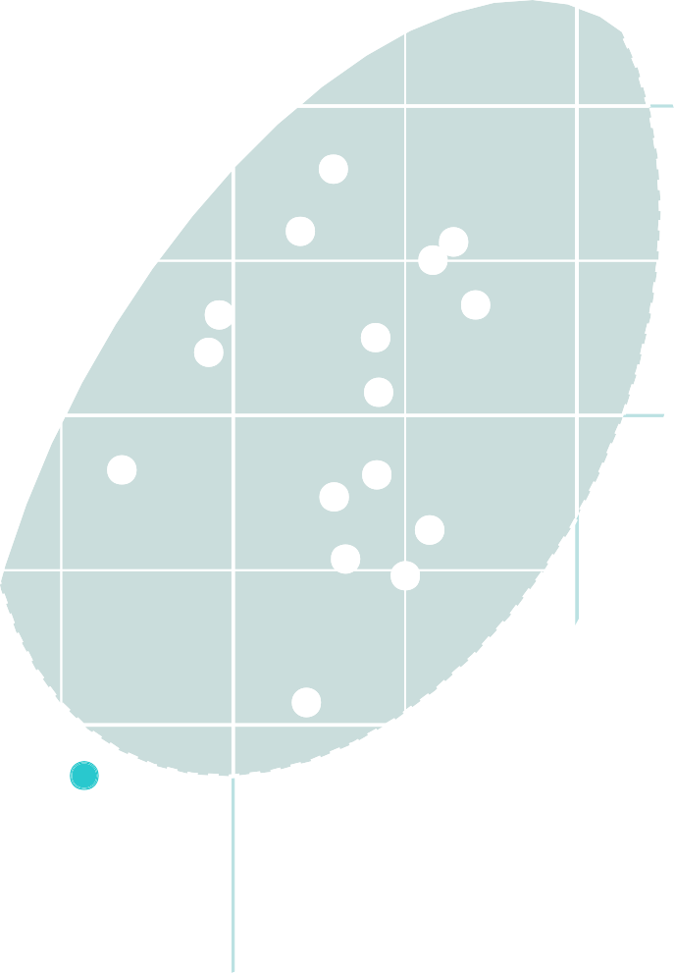

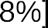
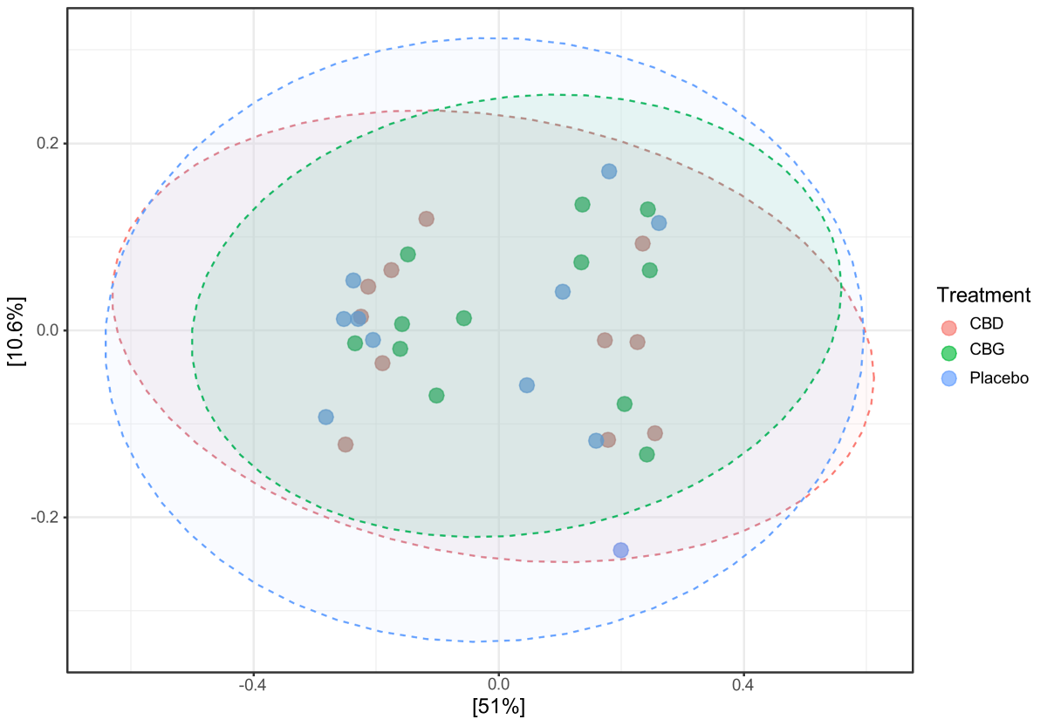
c)
b)
a)

Supplemental Table 5. Complimentary analysis of sex-based taxa associations.
In the analysis column 1) Females (placebo as ref) compare all females and the correlation between phytocannabinoid (PC) intervention groups. 2) Males (placebo as ref) compare all males and the correlation between the PC intervention groups. Taxa positively associated with CBD or CBG intervention in females and males and within intervention sex differences identified by zero-inflated negative binomial (ZINB) and compound Poisson linear models (CPLM). The table lists taxa showing significant positive correlations, model coefficients, and FDR values. This table show coeff which describes the strength of the p-value and FDR corrected p values.

Sex-based taxa associations
Analysis | Association | Taxonomy
Females (placebo as reference) | Positive correlation w/CBD intervention | ZINB and CPLM  Akkermansia.1 (ZINB: coef=6.5, FDR=0.0004),  (CPLM: coef=4.5, FDR=0.007),
Females (placebo as reference) | Positive correlation w/CBG intervention | ZINB and CPLM  Lachnospiraceae NK4A136 group.1* (ZINB: coef=4.8, FDR=8e-6), (CPLM: coef=5, FDR=0.003)  Lachnospiraceae NK4A136 group.19* (ZINB: coef=5.2, FDR=0.002), (CPLM: coef=5.6, FDR=0.02),
Males (placebo as reference) | Positive correlation w/CBD intervention | ZINB and CPLM  Lachnospiraceae FCS020 group s_mouse_gut* (ZINB: coef=6, FDR=2.3e-17)  Oscillospiraceae.3* (ZINB: coef=7.9, FDR=6.8e-7), (CPLM: coef=8, FDR=0.003),
Males (placebo as reference) | Positive correlation w/CBG intervention | ZINB and CPLM  No concurrent significant taxa associations between ZINB and CPLM

