Supplement Data: eMethods, eResults, eFigures and eTables.

INDEX:
- SUPPLEMENT E-METHODS

- SUPPLEMENTAL E-RESULTS
- Total Morphine Consumption and Pain Intensities (Primary Outcomes) - Path analysis - model’s goodness of fit
- Outcome measures following removal of outliers
  - Total Morphine Consumption and Pain Intensities (Primary Outcomes)
  - Anxiety and Nausea (Secondary Outcomes)
- Outcome measures following sensitivity analysis
- Linear Mixed-Effects (LME) results:
  - Morphine consumption during the 24 hours follow-up
  - Pain intensities via VAS during the 24 hours follow-up
  - Anxiety and nausea levels during the 24 hours follow-up
- Additional measurements, collected on subjects’ Case Report Form (CRF):
  - Pain Verbal Rating Scale (VRS)
  - Nausea and vomiting VAS
- Sex-related differences

- SUPPLEMENTAL E-FIGURES
- eFigure 1: Total number of pushes (effective and ineffective) on the PCA pump
- eFigure 2: Pain VAS intensities at rest and movement
- eFigure 3: Anxiety and Nausea &Vomiting levels.
- eFigure 4: Cumulative amounts of morphine consumed via the self-administration PCA pump, at each time-point
- eFigure 5: Pain VAS intensities (averaged across rest and movement) along the 24 hours follow-up
- eFigure 6: Anxiety and PONV levels along the 24 hours follow-up
- SUPPLEMENTAL E-TABLES
  - eTable 1: Baseline characteristics of subjects with and without morphine data at the 24-hours’ time-point
  - eTable 2: Respiratory and cardiovascular data
  - eTable 3: Mean and median difference and confidence intervals for all pairwise multiple comparisons

- SUPPLEMENTAL E-METHODS:
- Path Analysis - the model’s goodness of fit and the key statistical estimator, B value (unstandardized regression coefficient), are reported. The model’s goodness of fit indicates how well the proposed model fits the observed data. The B value represents the expected change in the dependent variable for a one-unit change in the independent variable, holding all other variables constant. Since the independent variables are dummy coded as ‘0’ for the Control and ‘1’ for the treatment groups, the B value represents the difference in the dependent variables between each treatment group and the Control.
- All experimental drugs were verified by an EU-GMP-certified High-Performance Liquid Chromatography (HPLC) and by an EU-GMP-certified Gas Chromatography (GC) at Bazelet (Or Akiva, Israel).

- SUPPLEMENTAL E-RESULTS:
- Total Morphine Consumption and Pain Intensities (Primary Outcomes) - Path analysis - model’s goodness of fit:
The obtained path analysis model was saturated in the ITT analysis, so the model fit was perfect, x2(5)=10.8, p=0.06, χ2/df=2.2, TLI=1, CFI=1, RMSEA[90% C.I.]=0 [0, 0], SRMR=0.

- Outcome measures following removal of outliers:
B.1. Total Morphine Consumption and Pain Intensities (Primary Outcomes)
The obtained pathway analyses model was saturated, so the model fit was perfect, x2(5)=11.5, p=0.04, χ2/df=2.3, TLI=1, CFI=1, RMSEA[90% C.I.]=0 [0, 0], SRMR=0.
A path analysis model revealed a significant difference between the total morphine consumption in the High-Dose and Placebo groups. No significant difference in mean pain intensities (pain at rest and at movement averaged across the 0.5-24h time-points) were evident between these groups (variable D2 significantly predicted morphine consumption (B=-14.7, 95% CI[-27.4, -2.1], p=0.02), but did not predict pain intensities (B=2.5, 95% CI[-13.5, 18.6], p=0.8)). Differences between the Low-Dose and Placebo groups were not significant for either morphine consumption nor pain intensities (D1:(B=-2.6, 95% CI[-15.6, 10.4], p=0.7) and (B=3.5, 95% CI[-12.8, 19.9], p=0.7) for morphine consumption and pain intensities, respectively).

B.2. Anxiety and Nausea (Secondary Outcomes)
No subject demonstrated an outlier behavior in anxiety VAS or PONV scores. Exclusion of the three subjects who demonstrated an outlier behavior in the amount of morphine consumed did not change treatment effect on anxiety, but diminish the treatment trend on nausea levels (Treatment effect on anxiety scores: p=0.62; Treatment effect on PONV scores: p=0.12).

- Outcome measures following sensitivity analysis:
To evaluate the potential impact of missing data on the study results, we conducted a sensitivity analysis using multiple imputation for missing morphine consumption data. This analysis confirmed the primary finding: patients in the High-Dose Group consumed significantly less morphine compared with placebo. A path analysis model performed after imputation, demonstrated a significant difference in total morphine consumption, between the High-Dose and Placebo Groups. Yet, no significant difference in mean pain intensities were evident (variable D2 significantly predicted morphine consumption (B=-13.7, 95% Confidence Interval (CI)[-25.4, -2.1]), p=0.02), but did not predict pain intensities (B=2.7, 95% CI[-9.4, 14.9], p=0.65). Differences between the Low-Dose and Placebo Groups were not significant for either morphine consumption or pain intensities (variable D1: (B=-3.3, 95% CI[-15.7, 9.1], p=0.6) and (B=3.5, 95% CI[-8.8, 15.8], p=0.57) for morphine consumption and pain intensities, respectively)

- Linear Mixed-Effects (LME) results:
LME models were supplementary used to analyze the effect of treatment at each timepoint. In these models, the dependent variable was the outcome criterion, and the fixed factors were the treatment group, the timepoints, and the interaction between them. A random intercept for patient ID was used to account for dependency.

D.1. Morphine consumption during the 24 hours follow-up
Dependent variable: Cumulative amounts of morphine consumed.
Analysis revealed a trend towards a treatment group effect (p=0.08). Furthermore, the interaction between treatment group and time was significant (p=0.02). Pairwise multiple-comparisons revealed that this significant interaction resulted from a significant reduction in the cumulative morphine consumption in the High-Dose group compared to the Placebo group at 18 hours (CI[1.7,20.6], p=0.01, Bonferroni's test) and 24 hours (CI[5.5,24.2], p<0.001, Bonferroni's test) post-treatment. At 24 hours post-treatment, cumulative morphine consumption in the High-Dose group was also significantly reduced as compared to the Low-Dose group (CI[2.4,21.5], p=0.009, Bonferroni's test, eFigure 4).

D.2. Pain intensities via VAS during the 24 hours follow-up
Dependent variable: mean VAS scores.
No significant differences were observed for the main effect of treatment group (p=0.89), nor for the interaction effect (p=0.25; eFigure 5A).
Dependent variable: change from baseline in VAS scores. No significant differences were observed for the main effect of treatment group (p=0.83), nor for the interaction effect (p=0.16; eFigure 5B).

D.3. Anxiety and nausea levels during the 24 hours follow-up
Dependent variable: anxiety levels.
No significant differences were observed for the main effect of treatment group (p=0.88). The interaction effect was significant (p=0.02); however, the differences did not survive correction for multiple comparisons (eFigure 6A).
Dependent variable: nausea and vomiting levels.
Significant differences were observed for the main effect of treatment group (p=0.04). However, no significant interaction was observed (p=0.16). Pairwise multiple-comparisons revealed that this significant main effect resulted from higher nausea and vomiting levels in the Low-Dose group compared to the Placebo group (CI[0.004,0.6], p=0.04, Bonferroni's test. eFigure 6B).

- Additional measurements, collected on subjects’ Case Report Form (CRF):
E.1. Pain Verbal Rating Scale (VRS)
Treatment did not result in significant differences in pain VRS scores (p=0.79, one-way ANOVA). Post-treatment VRS scores (averaged VRS at rest and movement): 2.1±0.7, 2.3±0.9, 2.2±0.7 (mean± SD) for the High-Dose, Low-Dose and Placebo groups, respectively.

E.2 Nausea and vomiting VAS
Treatment did not result in significant differences in nausea and vomiting VAS scores (p=0.16, Kruskal-Wallis test). Post-treatment nausea and vomiting VAS scores: 0.2 [0-9.6], 3.3 [0-23.7], 0 [0-3.4] (median [IQR]) for the High-Dose, Low-Dose and Placebo groups, respectively.

- Sex-related differences
Given the differences in women/ men ratio in the various treatment groups, and the known sex-related differences in response to opioids and cannabinoids, the effect of sex on the various outcome measurements was assessed. Sex-related differences were evident in nausea and vomiting levels, but not in the amount of morphine consumed, nor in pain intensities (primary outcomes) or in anxiety levels. Generalized linear models with a gamma distribution and identity link were applied with treatment group and sex being two independent variables.
Morphine consumption (mg): A significant main effect of group was found (p=0.01). However, no main effect of sex was evident (p=0.27), nor the interaction between group and sex was significant (p=0.1).
Mean pain intensities (VAS): No main effects of sex or group were evident (p=0.17and p=0.92, respectively), nor the interaction between group and sex was significant (p=0.9).
Anxiety: No main effects of sex or group were evident (p=0.14 and p=0.87, respectively), nor the interaction between group and sex was significant (p=0.89).
Nausea and vomiting: Sex-related difference were evident (p=0.03 for the main effect of sex). However, no main effect of group was observed (p=0.43), nor the interaction between group and sex was significant (p=0.71). Women reported higher PONV levels than men (0.5±0.5 and 0.1±0.3 (mean± SD) (averaged across 0.5-24h time-points) for women and men, respectively).

- SUPPLEMENTAL E-FIGURES:
eFigure 1: Total number of pushes (effective and ineffective) on the PCA pump
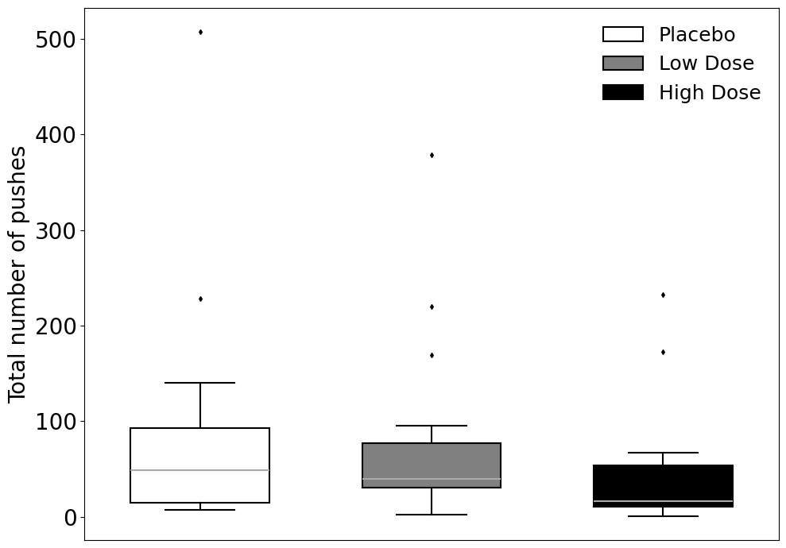
eFigure 1. Total number of pushes (effective and ineffective) on the PCA pump, along the 24 hours post-treatment.

eFigure 2: Pain VAS intensities at rest and movement
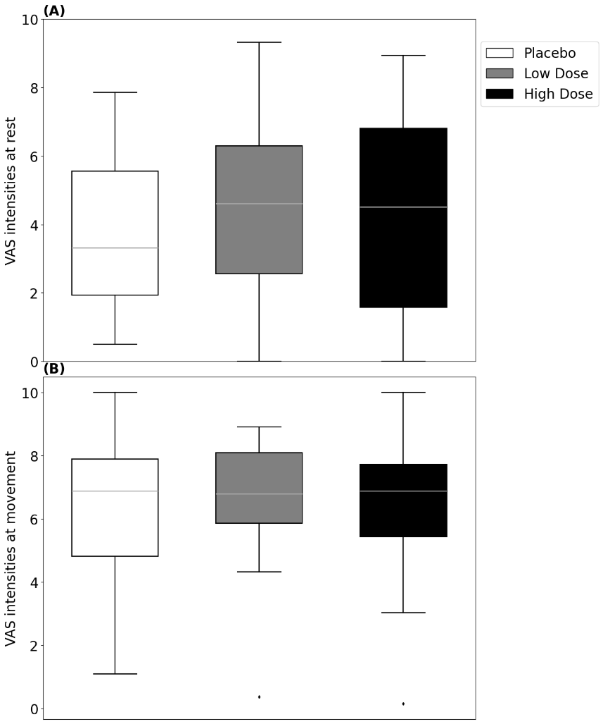
eFigure 2: Pain VAS intensities at rest and movement. (A) Boxplots showing pain VAS intensities at rest (averaged across the 0.5-24h time-points), in the various treatment groups. (B) Boxplots showing pain VAS intensities at movement (averaged across the 0.5-24h time-points), in the various treatment groups. The central line represents the median, boxes indicate the IQR, whiskers extend to the most extreme data points within 1.5×IQR, and dots represent outliers. No significant differences were evident.

eFigure 3: Anxiety and Nausea & Vomiting levels.
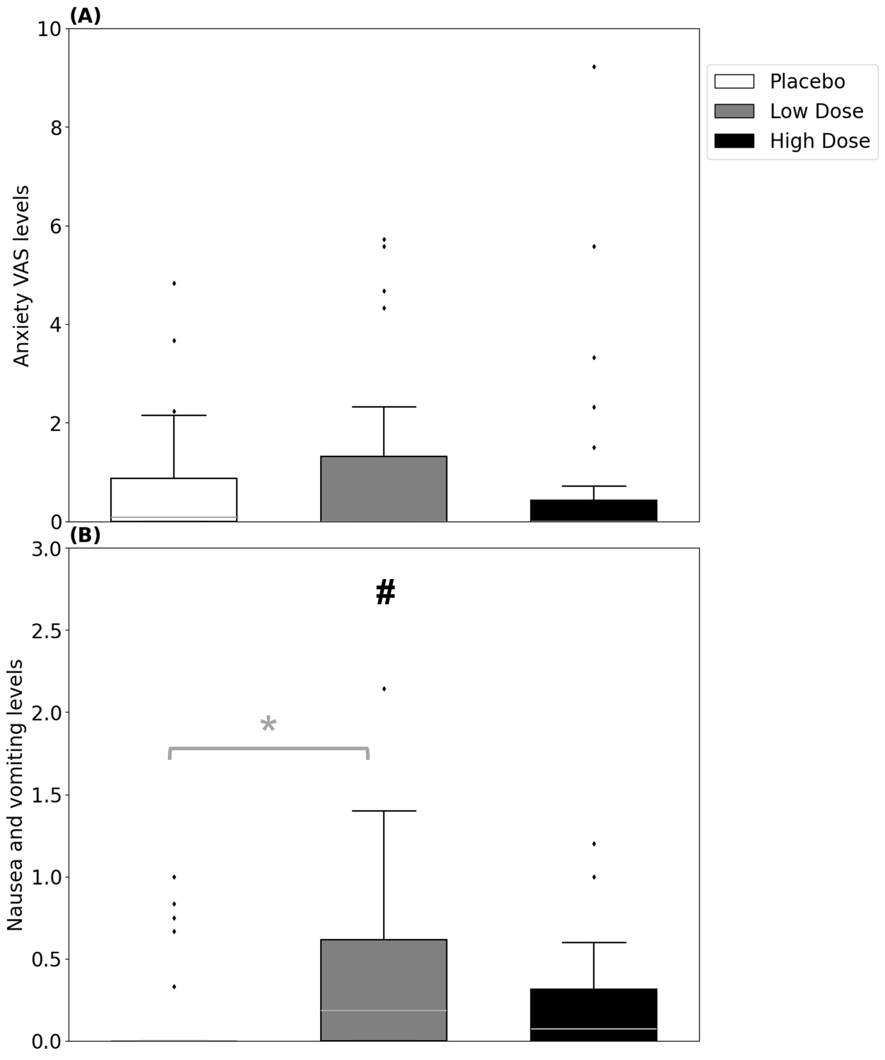
eFigure 3: Anxiety and Nausea & Vomiting levels. (A) Boxplots showing anxiety VAS levels (averaged across the 0.5-24h time-points), in the various treatment groups. No significant differences were evident. (B) Boxplots showing nausea and vomiting levels, via the PONV scale (averaged across the 0.5-24h time-points), in the various treatment groups. The central line represents the median, boxes indicate the IQR, whiskers extend to the most extreme data points within 1.5×IQR, and dots represent outliers. Black mark denotes treatment effect (Kruskal-Wallis test), gray asterisks denote differences between the groups (via the pairwise multiple-comparisons)(# trend, * p<0.05). Somewhat higher PONV levels were evident in the Low-Dose cannabinoid group compared to placebo.

eFigure 4: Cumulative amounts of morphine consumed via the self-administration PCA pump, at each time-point
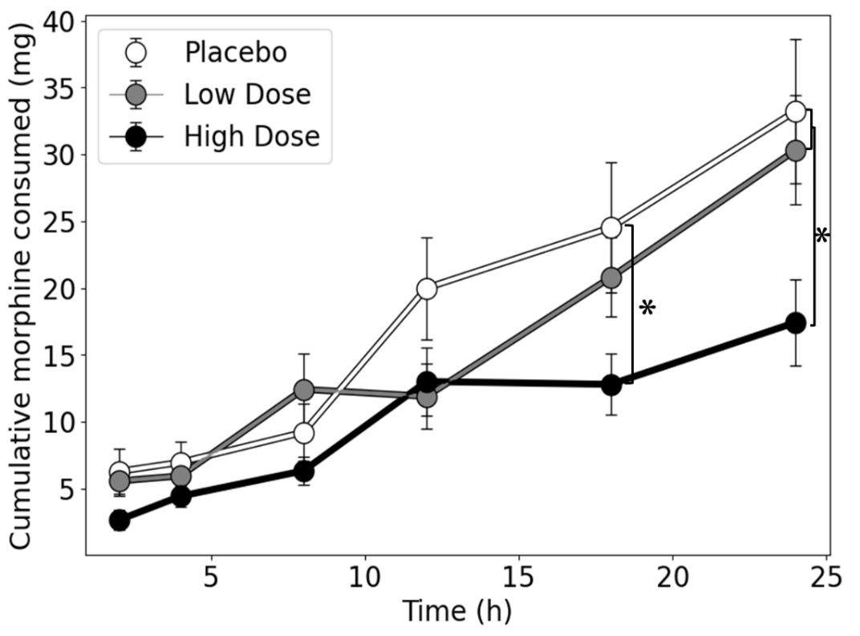
eFigure 4: Cumulative amounts of morphine consumed via the self-administration PCA pump, at each time-point (mean ± SEM). (# trend, * p<0.05)

eFigure 5: Pain VAS intensities (averaged across rest and movement) along the 24 hours follow-up
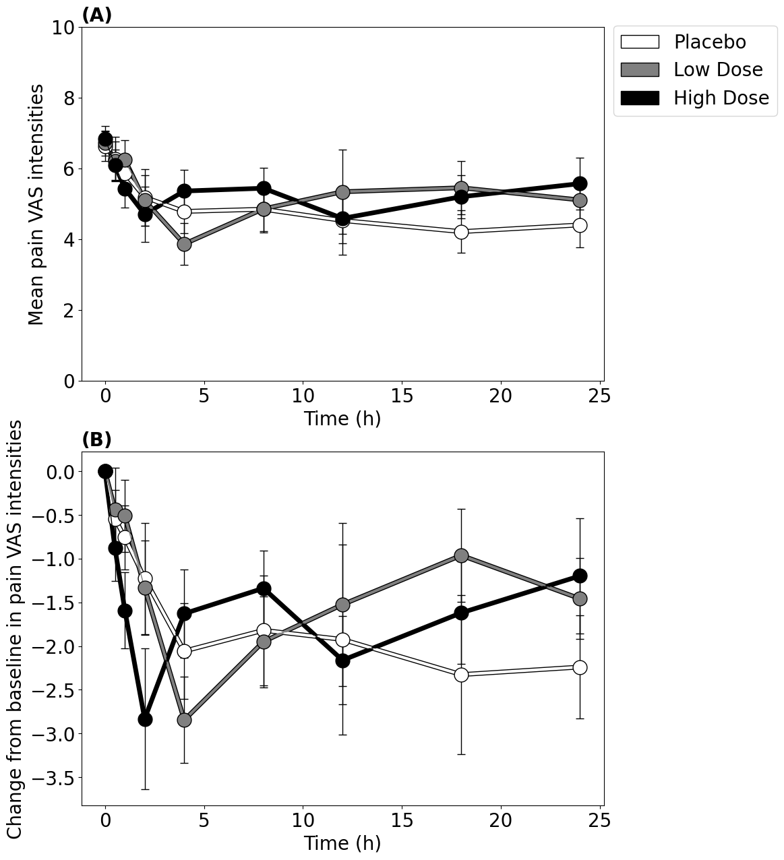
eFigure 5: (A) Mean pain VAS intensities (averaged across rest and movement) along the 24 hours follow-up, in the various treatment groups (mean ± SEM). (B) Change from baseline in pain VAS intensities (VAS averaged across rest and movement) along the 24 hours follow-up, in the various treatment groups (mean ± SEM).

eFigure 6: Anxiety and PONV levels along the 24 hours follow-up
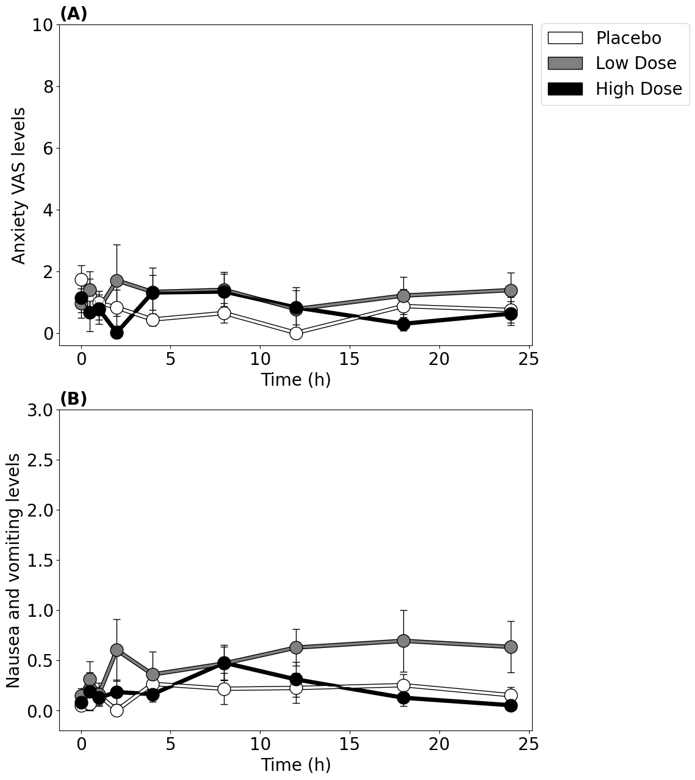
eFigure 6: (A) Anxiety VAS levels along the 24 hours follow-up, in the various treatment groups (mean ± SEM). (B) Nausea and vomiting levels (via the PONV scale) along the 24 hours follow-up, in the various treatment groups (mean ± SEM).

- E-TABLES:
eTable 1: Baseline characteristics of subjects with and without morphine data at the 24-hours’ time-point
 | Morphine Data Present (n=59) | Morphine Data Missing (n=10) | P value
Group (n) | High-Dose: 19  Low-Dose: 19  Placebo: 21 | High-Dose: 7  Low-Dose: 2  Placebo: 1 | 0.07
Age  Mean (SD) | 44.4 (12.3) | 41.1 (11.1) | 0.42
Sex  Women: Men | 24:35 | 7:3 | 0.08
Weight  Mean (SD) | 82.9 (18.7) | 77.4 (14.5) | 0.38
ASA Classification (n) | ASA 1: 31  ASA 2: 27 | ASA 1: 7  ASA 2: 3 | 0.33
Mean pain levels (averaged VAS scores at rest and movement) at baseline  Mean (SD) | 6.69 (1.73) | 6.94 (2.17) | 0.69

eTable 2: Respiratory and cardiovascular data
 | Placebo | Low-Dose | High-Dose
Heart rate ª | 70.8 [66.5-74.1] | 71.5 [66.5-79.7] | 72.3 [65.4-77.5]
Oxygen saturation ª | 96 [95.8-97.2] | 96.7 [95.5-98.2] | 96.6 [94.6-97.6]
Systolic blood pressure ^{b} | 124.6 (13.4) | 121.1 (12.9) | 121.7 (12.3)
Diastolic blood pressure ^{b} | 73.3 (9.9) | 70.9 (7.9) | 68.6 (6.2)

ª Median [IQR]
^{b} Mean (SD)

 | High-Dose vs Placebo  (Mean or Median Difference [95% CI]), p | Low-Dose vs Placebo  Mean or Median Difference [95% CI]), p | High-Dose vs Low-Dose  Mean or Median Difference [95% CI]), p
Total number of pushes ª | -17.5 [ −57.0,2.0], 0.12 | -0.5 [ −37.0,27], 0.99 | -21.5 [-39.0, -2], p=0.04
Change from baseline in pain VAS intensities ^{b} | -0.07 [-11.2,11.04], p=1 | 2.62 [-8.97,14.2], p=0.83 | -2.68 [-13.9,8.58], p=0.82
VAS intensities at rest ª | 3.79 [-11.4,21.3], p=0.66 | 4.71 [-11.0,23.2], p=0.52 | 0.0 [-18.9,15.3], p=1
VAS intensities at movement ª | 1.1 [-11.4,13.7], p=0.88 | 1.9 [-11.4,13.8], p=0.79 | -0.53 [-10.8,10.5], p=0.97
Anxiety VAS levels ª | 0.00 [-4.5,0.00], p=0.31 | 0.00 [-1.25,1.17], p=0.76 | 0.00 [-1.17,0.00], p=0.65
Nausea and vomiting levels ª | 0.00 [0.00,0.2], p=0.16 | 0.17 [0.00,0.42], p=0.03 | 0.00 [-0.33,0.00], p=0.23
Heart rate Median ª | 0.71 [-4.5,5.27], p=0.74 | 0.7 [-4.4,6.25], p=0.86 | -0.37 [-6.08,5.25], p=0.92
Oxygen saturation ª | -0.17 [-1.58,1.2], p=0.68 | 0.5 [-0.83,1.77], p=0.62 | -0.8 [-2.2.0.83], p=0.39
Systolic blood pressure ^{b} | -2.86 [-11.3,5.56], p=0.66 | -3.53 [-12.4,5.33], p=0.57 | 0.67 [-7.89,9.22], p=0.98
Diastolic blood pressure ^{b} | -4.69 [-9.98,0.59], p=0.09 | -2.35 [-7.91,3.22], p=0.54 | -2.35 [-7.71,3.02], p=0.52
eTable 3: Mean and median difference and confidence intervals for all pairwise multiple- comparisons
ª Median Difference [95% CI]
^{b} Mean Difference [95% CI]

