Supporting Information
Carbonized lignosulfonate-based porous nanocomposites for adsorption of environmental contaminants

Jenevieve Yao, Karin Odelius and Minna Hakkarainen *

Department of Fibre and Polymer Technology, KTH Royal Institute of Technology, Teknikringen 56, 100 44 Stockholm, Sweden.
Corresponding author: minna@kth.se

This supporting information contains 9 figures and 3 tables on 7 pages.

1. Construction of Cu(II) calibration curve via UV-vis of cuprammonium complex:
The working standard solution of PEI (90 mg/mL) was prepared by dissolving 9 g of PEI (in 50% H₂O) in 100 mL deionized water. Cu(II) solutions with concentrations ranging from 50 – 500 mg/L were prepared from a 0.02 M stock solution of copper (II) sulfate. Prior to UV-vis analysis, 3 mL of each calibration solution was collected in a small vial and diluted with 1.5 mL of deionized water, and 100 μL of stock PEI solution was then added. The solutions were agitated and a vivid blue color immediately appeared, as seen in the figure below. The UV-vis absorption spectra of the solutions were recorded in the wavelength range of 200 – 800 nm.
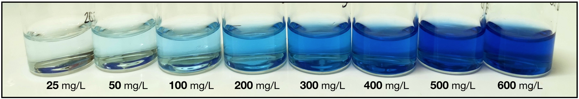

Figure S1: Cuprammonium complex formation at varying Cu(II) concentrations

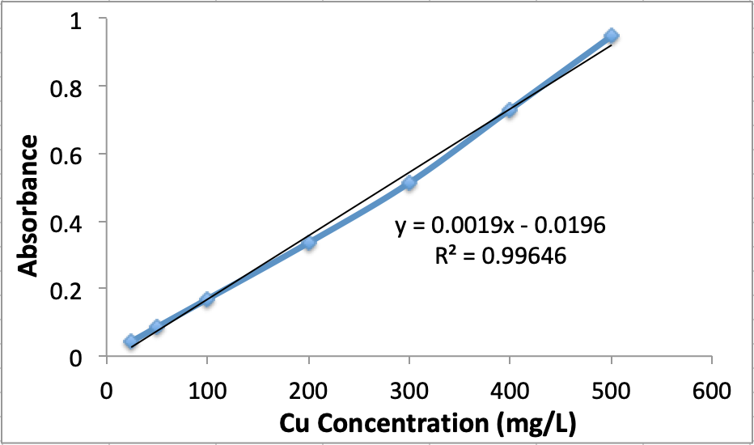

Figure S2: Cu(II) calibration curve

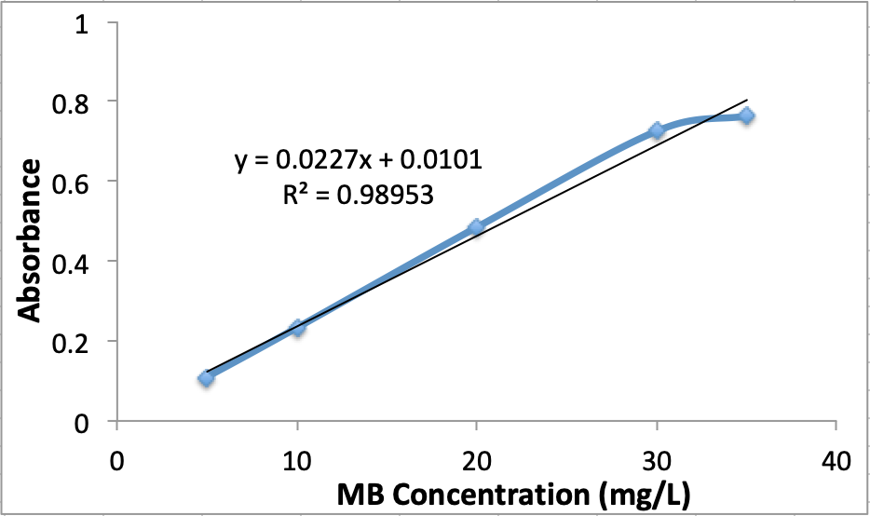

Figure S3: Methylene blue calibration curve

2. Calculation of I_{d}/I_{g} ratio from confocal Raman spectroscopy
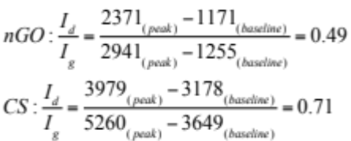

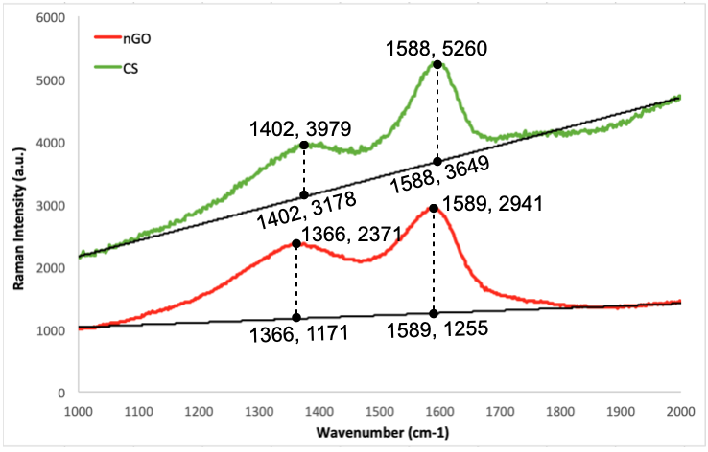

Figure S4. Raman spectra of LS-derived carbon spheres (CS) and nGO (nanographene oxide)

3. Adsorption kinetics and adsorption isotherm
The kinetics of mass transfer of a Cu(II) ion from the liquid phase to the porous composite surface was investigated using three kinetic models – the pseudo-first order model, the pseudo-second order model, and the intraparticle diffusion model. The pseudo-second order model represents the highest correlation coefficient (R²), indicating that it fits experimental data best. This implies that Cu(II) adsorption on nGO1-Gel1-LS0.1 is governed by chemisorption, which involves the formation of chemical bonds between the adsorbent and adsorbate. Adsorption isotherm models were implemented to describe the material’s (nGO1-Gel1-LS0.1) surface properties and adsorption mechanism for Cu(II). The highest correlation coefficient (R²) indicating best fit is obtained from the Langmuir model. The applicability of this model to experimental data implies that a monolayer adsorption takes place on identical and kinetically equivalent sites that have a finite capacity for the adsorbate at equilibrium, and without any lateral interaction or steric hindrance between the solute and the adsorbent.

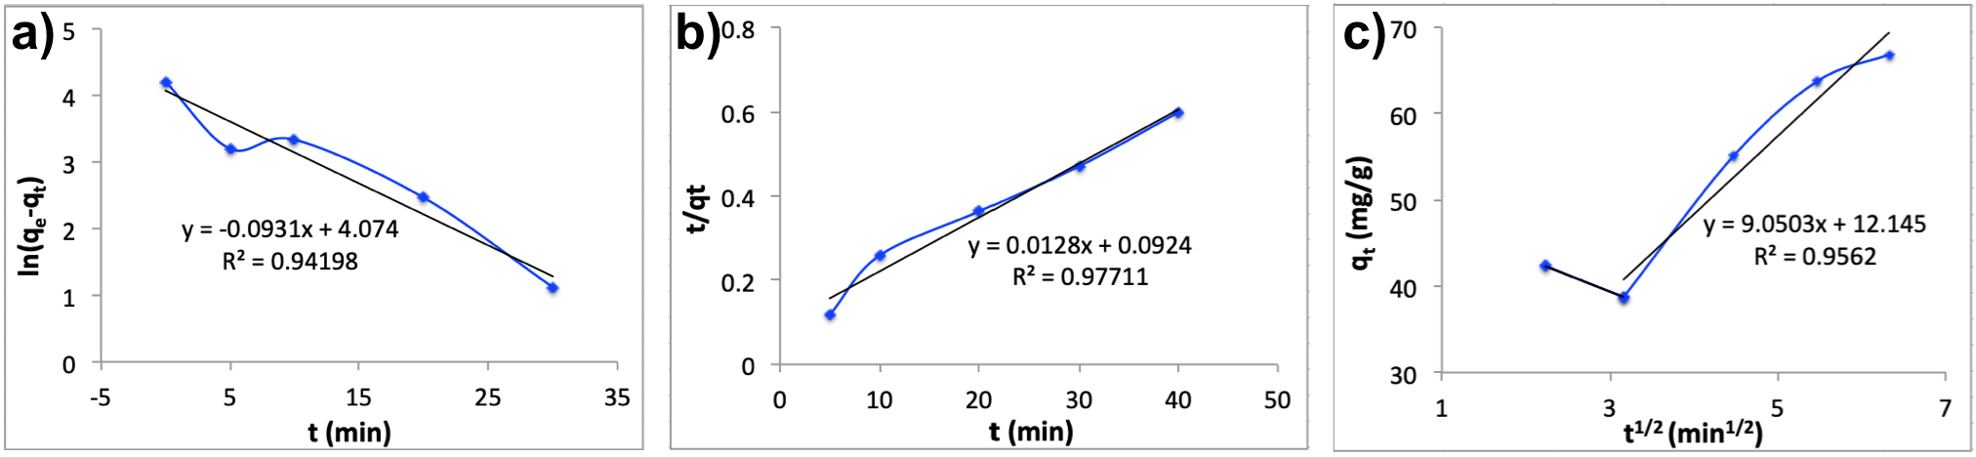

Figure S5. Fitting plots of pseudo-first order model (a), pseudo-second order model (b), and intraparticle diffusion model (c)

Table S1. Kinetic parameters from pseudo-first order model, pseudo-second order model, and intraparticle diffusion model
Kinetic Parameters
Pseudo-first order model |  | Pseudo-second order model |  | Intraparticle diffusion model
Q_{e cal.}  (mg/g) | 58.79 | Q_{e cal.}  (mg/g) | 78.12 | k_{i} | 7.17
k₁ (min⁻¹)  (x10⁻²) | 9.31 | K₂ (min⁻¹)  (x10⁻³) | 1.77 | C | 22.27
R² | 0.94 | R² | 0.98 | R² | 0.90

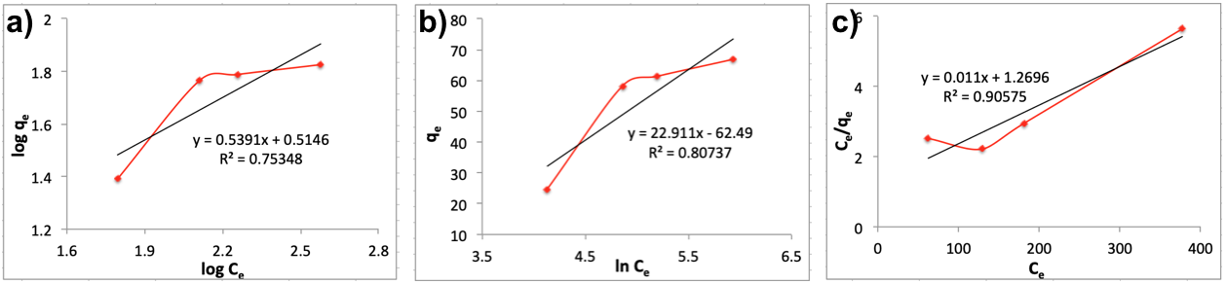

Figure S6. Fitting plots of Freundlich (a), Temkin (b), and Langmuir (c) isotherm models

Isotherm Parameters
Freundlich |  | Temkin |  | Langmuir
K_{F}  (mg/g  (L/mg)^{1/n}) | 3.27 | b_{T} | 106.38 | Q_{max}  (mg/g) | 69.7
n | 1.85 | a_{T} | 15.29 | k_{L}  (L/mg) (x10⁻³) | 22.27
R² | 0.75 | R² | 0.81 | R² | 0.91
 |  |  |  | R_{L}  (50 mg/L) | 0.70
 |  |  |  | R_{L}  (400 mg/L) | 0.22
Table S2. Isotherm parameters from Freundlich, Temkin, and Langmuir models

Table S3. Porosities of lignosulfonate (LS)-functionalized and non-functionalized composites
 | Porosity (%)
nGO1-Gel1 | 57
nGO1-Gel1.5 | 57
nGO1-Gel2 | 57
nGO1-Gel1-LS0.1 | 58
nGO1-Gel1.5-LS0.1 | 58
nGO1-Gel2-LS0.1 | 57
nGO1-Gel1-LS0.05 | 60
nGO1-Gel1-LS0.2 | 53

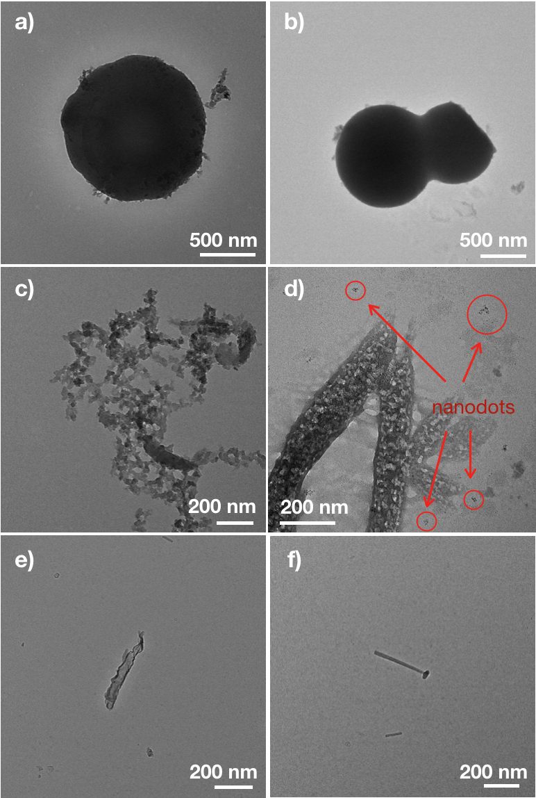

Figure S7. Various structures of carbonized lignosulfonate: carbon spheres (a,b), nanodots (c,d), and nanotubes (e,f).
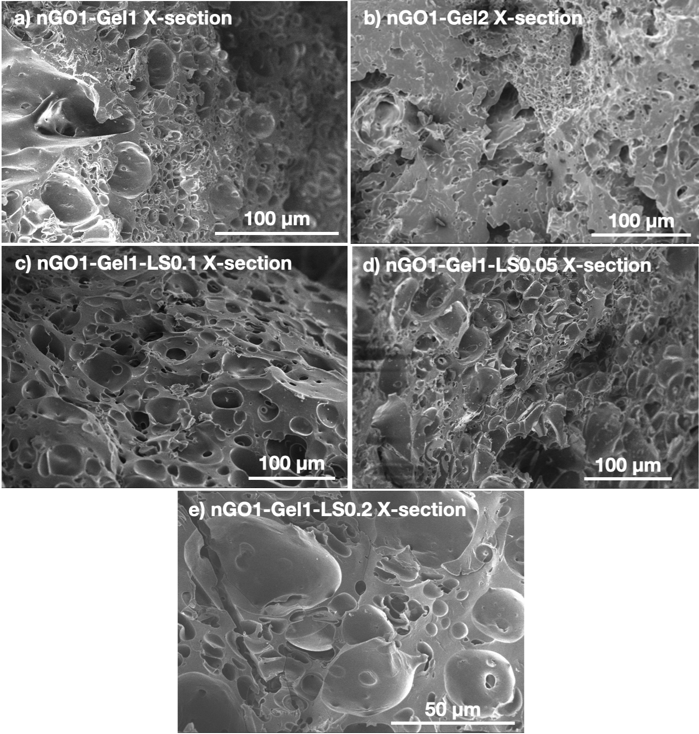

Figure S8. SEM images of cross-sections of nGO1-Gel1 (a), nGO1-Gel2 (b), nGO1-Gel1-LS0.1 (c), nGO1-Gel1-LS0.05 (d), and nGO1-Gel1-LS0.2 (e) porous composites
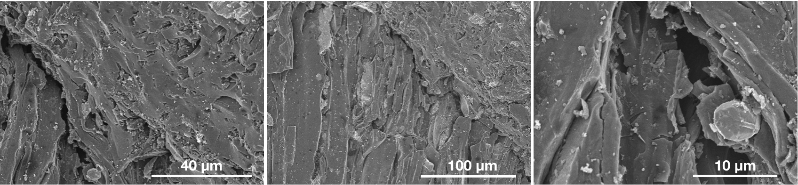
Figure S9. SEM images of cross-section of commercial activated carbon

