Efficient removal of safranin from aqueous solution using
a new type of metalated highly self-doped polyaniline nanocomposite

Hammed H. A. M. Hassanª*, Marwa Abdel Fattah^{b}

ª Chemistry department, Faculty of Science, Alexandria University, P.O. 2, Moharram Beck, Alexandria, Egypt
^{b} Menoufia Higher Institute of Engineering and Technology MNF-HIET, Egypt.

Supplementary 1
2.4. Synthesis of (aniline-co-aniline-2,5-disulfonic acid) polymer 6
Aniline-2,5-disulfonic acid 4 (12.65 g, 0.05 mol) and aniline 5 (2.00 g, 0.021 mol, 15.8 % weight of 1) were dissolved in aqueous 10 % HCl (100 ml), and a solution of ammonium persulfate (14.25 g, 0.0625 mol) dissolved in water (50 ml) was subsequently added over a period of 30 min. The mixture was mechanically stirred for 24 h at rt, and the color change pattern observed during the polymerization reaction from the light yellow, reddish-brawn, light green and then finally dark green precipitate was observed from t ¼ 0 to 24 h. Polymerization was stopped by the addition of methanol (50 ml). The resulting precipitate was subsequently washed with water, aqueous 1 M HCl, water and acetone to remove the unreacted starting materials and short oligomers. Finally, the precipitate was dried in a vacuum oven at 50 °C. Yield: 3.0 g. IR (cm⁻¹, υ): 3469, 2347, 1700, 1639, 1610, 1582, 1490, 1402, 1303, 1239, 1184, 1144, 1043, 1017, 880, 819, 802, 663, 632, 622, 597, 563, 539, 507. UV–vis (λ_{max} nm): 245, 375, 645. Calc. for C₃₆H₄₁N₁₁S₁₀O₃₅ (1492); C, 28.97; H, 2.77; N, 10.32; S, 21.48; S/2N ratio 1.04; Found: C, 28.73; H, 2.70; N, 9.09; S, 22.83; S/2N ratio 1.25.
…………………………………………………………………………………………………………………………………………………………………………
Supplementary 2

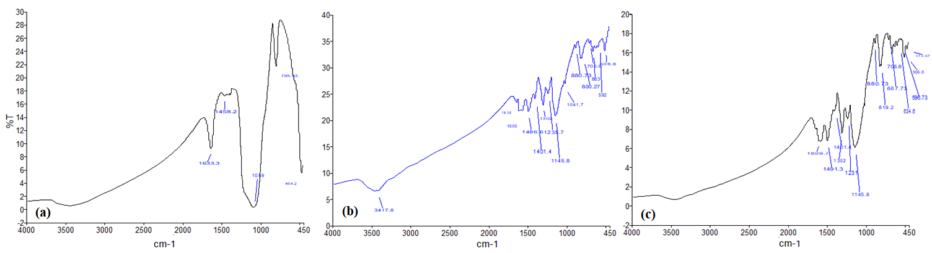
IR spectra of: a) SiO₂@Ag nanocomposite 3; b) copolymer 6; c) copolymer/SiO₂@Ag nanocomposite 7
…………………………………………………………………………………………………………………………………………………………………………

Supplementary 3
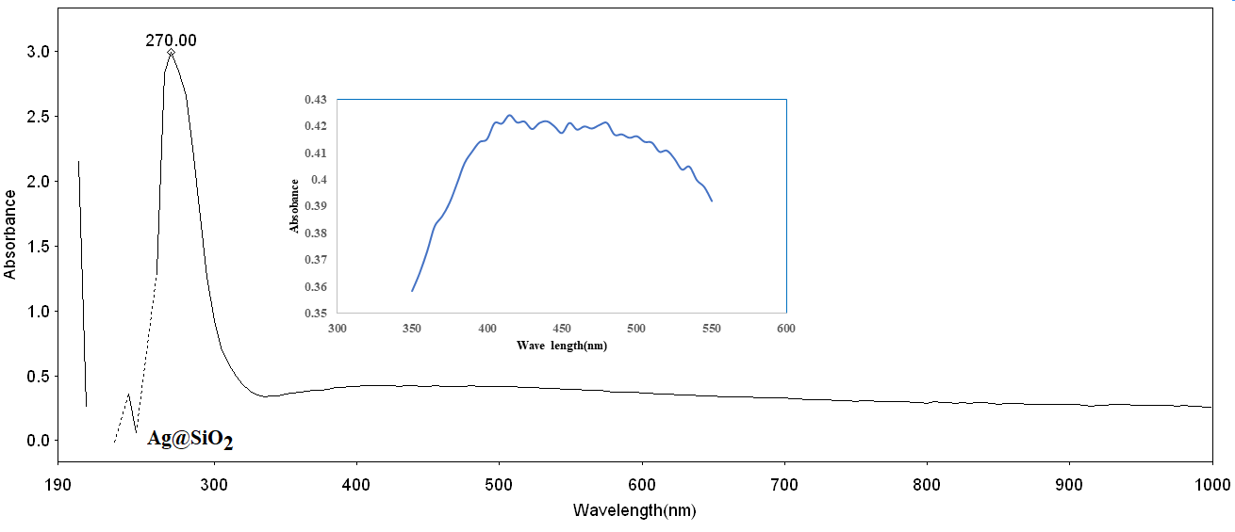
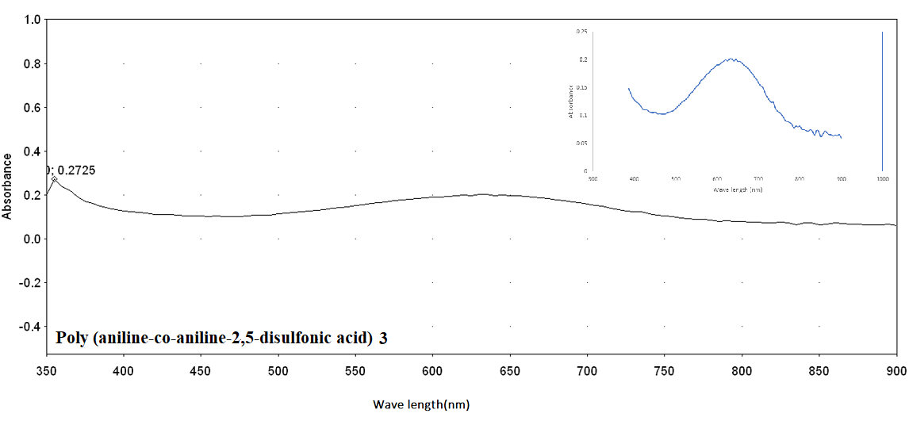
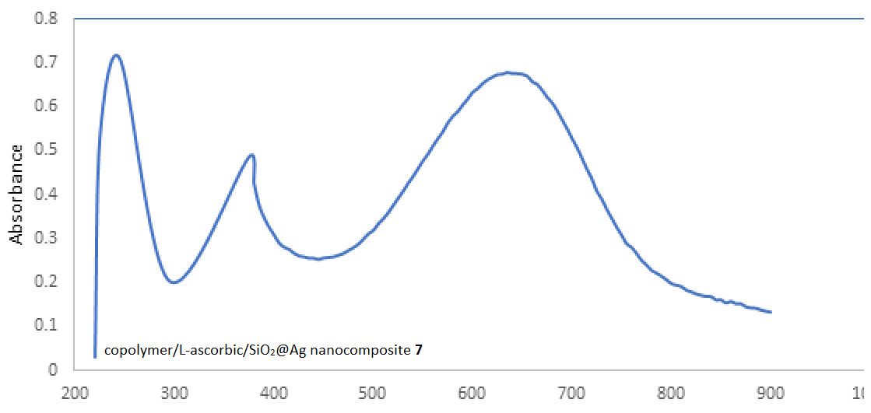
The UV─Vis spectrum of: SiO₂@Ag nanocomposite (up), copolymer 6 (middle), and copolymer/SiO₂@Ag nanocomposite 7 (down).

Supplementary 4

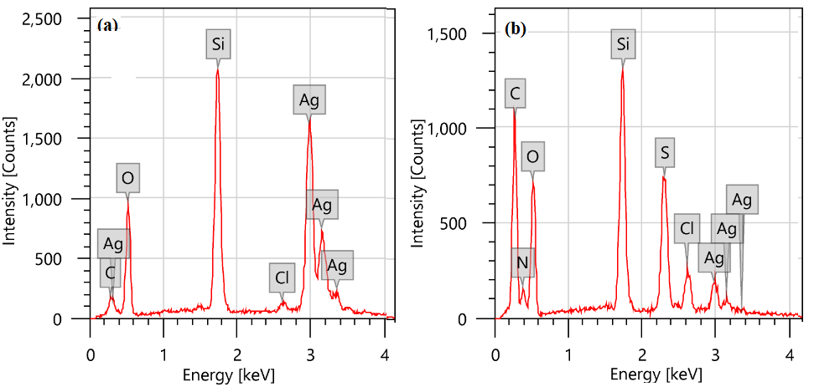

EDXS spectra of: a) Ag@SiO₂ composite 3; b) polymer-Ag@SiO₂ composite 7
…………………………………………………………………………………………………………………………………………………………………………
Supplementary 5
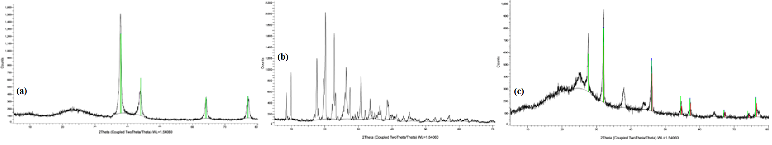
The XRD spectrum in the 2θ range of 5–80° of: (a) Ag@SiO₂ nanocomposite 3; (b) copolymer 6;
(c) copolymer/L-hexuronic acid/SiO₂@Ag nanocomposite 7

Supplementary 6

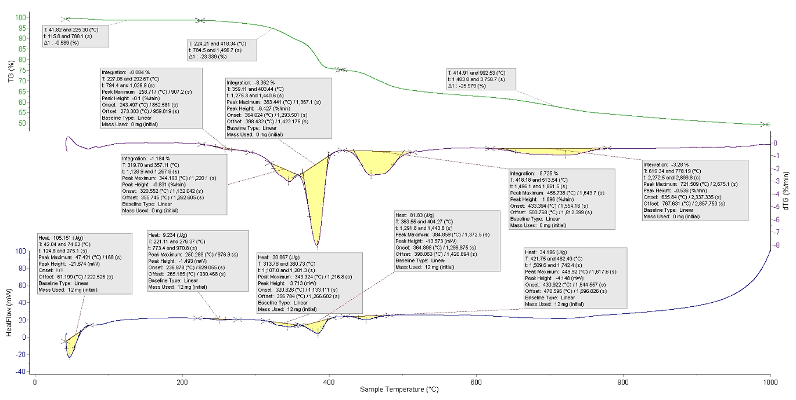
TG, DTG and DSC curves of the (aniline-co-aniline-2,5-disulfonic acid) copolymer 6

Supplementary 7

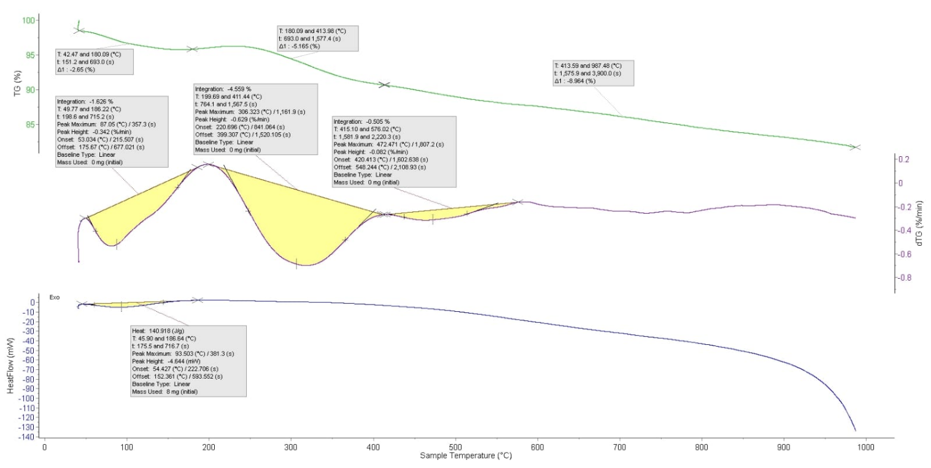
TG, DTG and DSC curves of the copolymer/L-hexuronic acid/SiO₂@Ag nanocomposite 7

