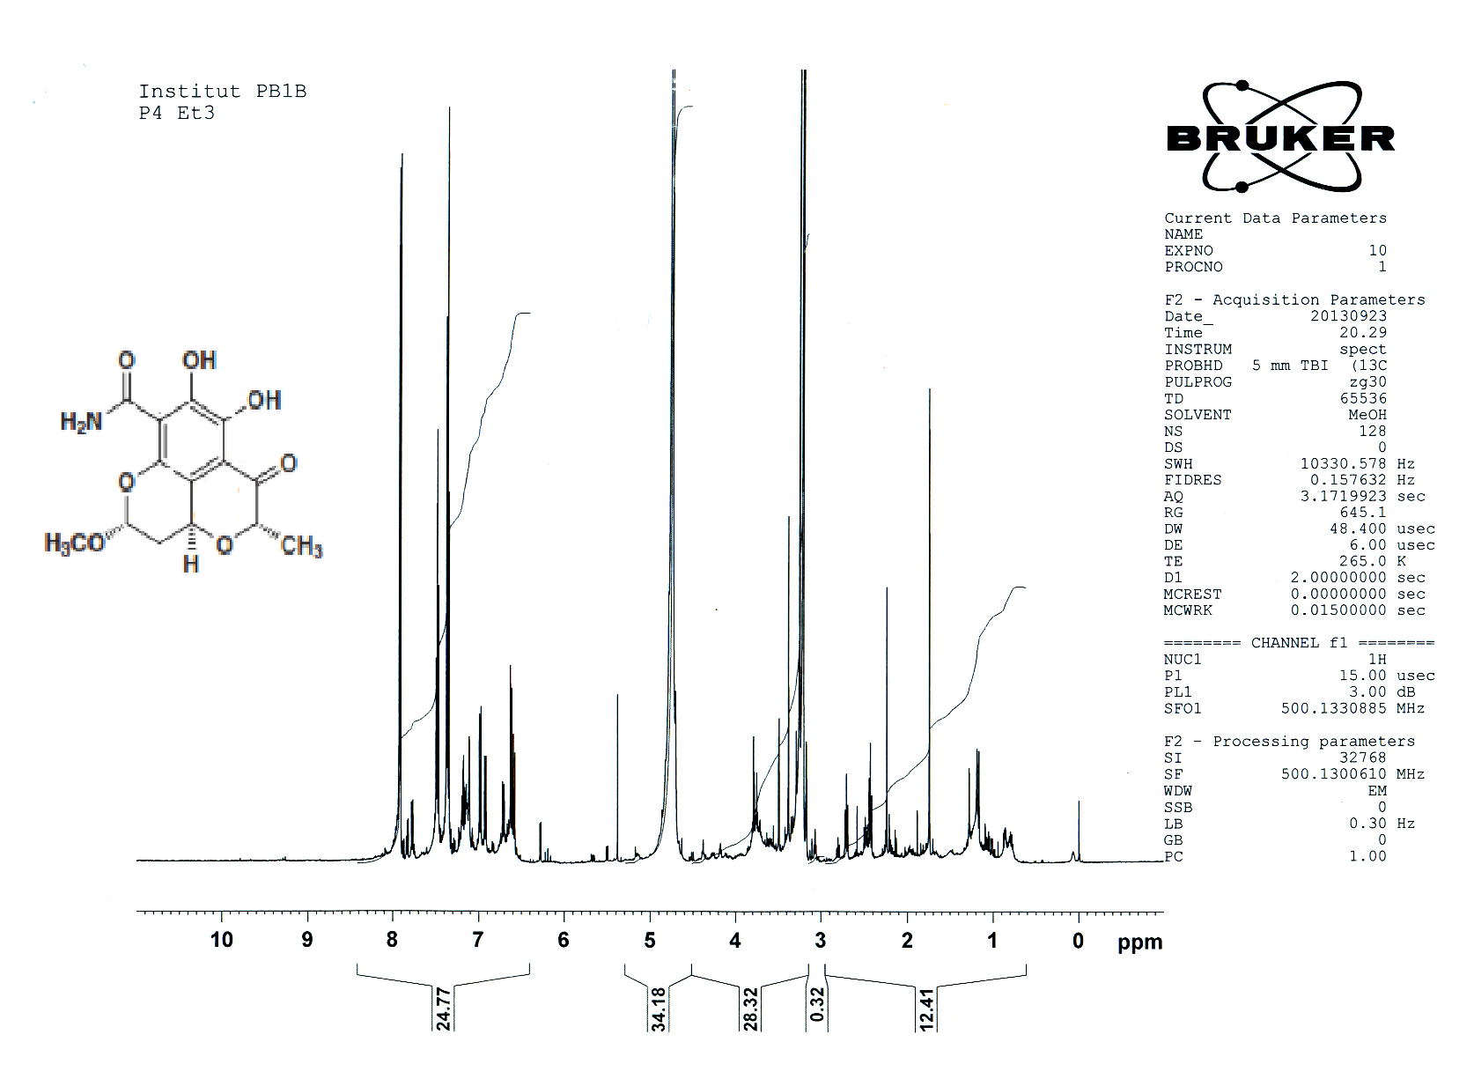
Figure (S3).¹HNMR spectrum of salicylamide derivative JBIR -58

