Supplementary Table 1. History and details of drug history for patients of fibromyalgia
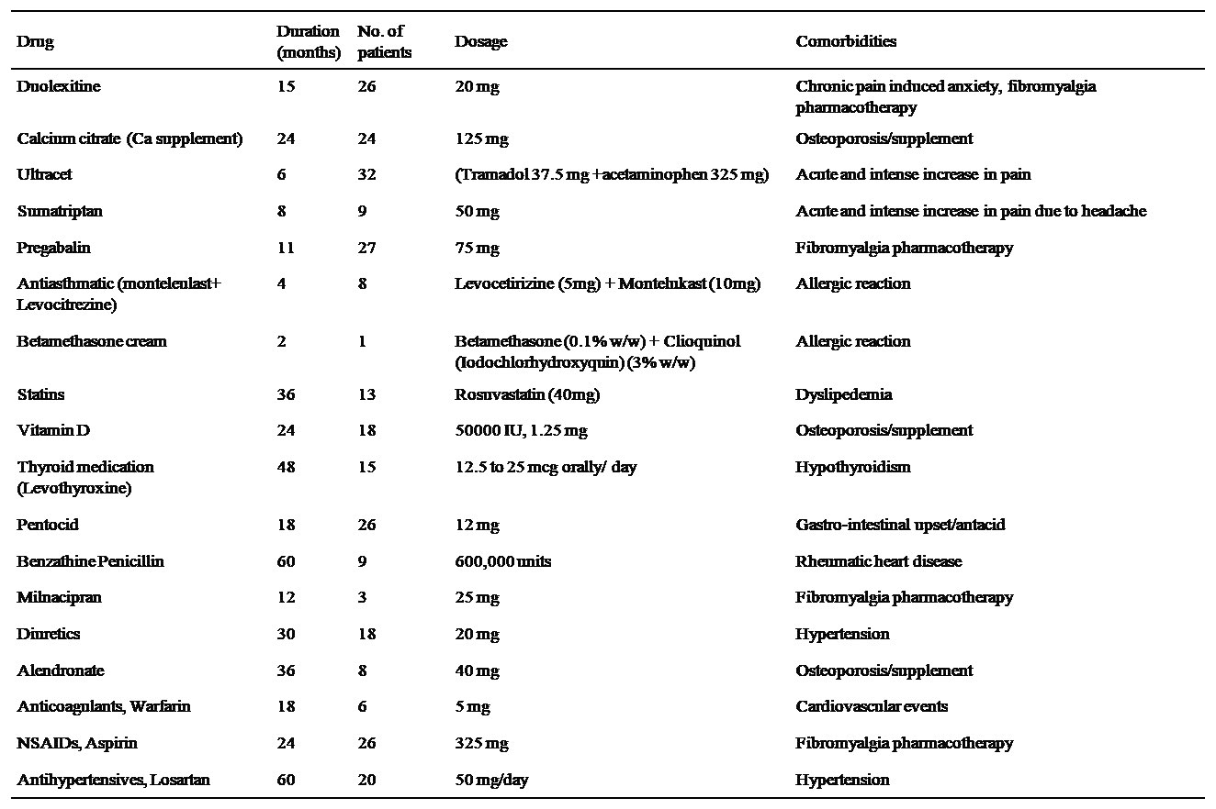
NSAID Non-steroidal anti-inflammatory drugs

