Supplemental table S1 Characteristics of included RCTs
Included RCTs | Trial registration number | Country | Trial duration (years) | Sites | NO. of total parcticipants (female, %) | NO.of total arthroplasty | Intervention group |  |  | Comparator group |  |  | Jadad score
 |  |  |  |  |  |  | Treatment | NO.of patient | NO. of arthroplasty | Treatment | NO.of patient | NO. of arthroplasty | Jadad score
Turajane 2017 [33] | NR | Thailand | 1.0 | knee | 60 (68.3) | 3 | MCS+AAPBSCs+GFA+HA | 20 | 0 | MCS+AAPBSCs+HA | 20 | 0 | 2
 |  |  |  |  |  |  | IA-HA alone | 20 | 3
Schnitzer 2015 [40] | NCT00809354 | USA | 1.2 | knee or hip | 2700 (70.5) | 150 | NSAIDs | 539 | 25 | Tanezumab 5mg | 541 | 24 | 4
 |  |  |  |  |  |  | Tanezumab 5 mg+NSAIDs | 536 | 40 | Tanezumab 10 mg | 542 | 19
 |  |  |  |  |  |  | Tanezumab 10 mg+NSAIDs | 542 | 42
Ekman 2014 [58] | NCT00830063/NCT00863304 | USA | 0.5 | knee | study 1015: 828 (60.2) | 3 | naproxen (500mg twice daily) | 206 | 0 | placebo | 208 | 2 | 2
 |  |  |  |  |  |  | tanezumab 5mg | 206 | 1 | tanezumab 10mg | 208 | 0
 |  |  | 0.5 | knee or hip | study 1018: 840 (63.6) | 3 | naproxen (500mg twice daily) | 211 | 1 | placebo | 209 | 2 | 2
 |  |  |  |  |  |  | tanezumab 5mg | 211 | 0 | tanezumab 10mg | 209 | 0
Nishii 2013 [42] | NR | Japan | 2.0 | hip | 42 (92.9) | 8 | alendronate+calcium lactate | 30 | 7 | calcium lactate | 12 | 1 | 3
Balanescu 2014 [59] | NCT00864097 | Romania | 0.6 | hip or knee | 604 (77.6) | 9 | DSR (150 mg/d)+placebo | 152 | 1 | DSR (150 mg/d)+ tanezumab 2.5mg | 157 | 2 | 2
 |  |  |  |  |  |  | DSR (150 mg/d)+ tanezumab 5mg | 150 | 3 | DSR (150 mg/d)+ tanezumab 10mg | 145 | 3
Wildi 2011 [46] | NCT00604539 | Canada | 0.5 | knee | 70 (59.4) | 0 | Condrosan (800 mg/day) | 35 | 0 | placebo | 35 | 0 | 5
Rozendaal 2008 [50] | ISRCTN54513166 | the Netherlands | 2.0 | hip | 222 (69.4) | 20 | glucosamine sulfate (1500 mg ) | 111 | 13 | placebo | 111 | 7 | 4
ALHO 1988 [57] | NR | Norway | 0.3-0.5 | hip | 252 (71.8) | 38 | piroxicam (20 mg/day) or naproxen (750 mg/day) | 252 | 38 |  |  |  | 2
NO.=number; NR=not report; MCS=arthroscopic microdrilling mesenchymal cell stimulation; AAPBSCs=autologous activated peripheral blood stem cells; GFA=growth factor addition; HA=hyaluronic acid; IA=intra articular; NSAIDs=nonsteroidal anti-inflammatory drugs; DSR=diclofenac sustained release.

Supplemental table S2 Characteristics of included cohort studies
Included cohort study | Country | Sites | Follow-up time (years) | NO. of total participants (female, %) | NO. of total arthroplasty | Exposure group |  |  | Comparator group |  |  | NOS score
 |  |  |  |  |  | Treatment | NO. of participants | NO. of arthroplasty | Treatment | NO. of participants | NO. of arthroplasty | NOS score
Ward 2021 [20] | USA | knee | 5.6 | 988,570 (64.6) | 327,499 | CS | 387702 | 139529 |  |  |  | 6
 |  |  |  |  |  | HA | 187268 | 73436
Concoff 2021 [21] | USA | knee | 2 | 744,734 (58.3) | 184,867 | HA | 181,631 | 52,212 | non-HA | 563,103 | 139,665 | 6
Ong 2019 [22] | USA | knee | 2 | 4,027,848 (NR) | 65,144 | HA | 56,093 | 8,315 | non-HA | 1,941,996 | 51,106 | 6
 |  |  |  |  |  | hylan G-F 20 | 32,408 | 5,723 | non-hylan G-F 20 | 1,998,089 | 59421
Zeng 2019 [23] | China | knee | 2 | 684 (66.2) | 62 | CS | 148 | 33 | non-CS | 536 | 29 | 8
Walter 2019 [24] | USA | hip | ≤1 | 113 (68.0) | 49 | CS | 113 | 49 |  |  |  | 7
Latourte 2019 [25] | France | knee | 5 | 656 (70.3) | 91 | CS, HA | NR | NR | non-CS, non-HA | NR | NR | 7
Schwappach 2018 [26] | USA | knee | 3.2 | 39 (64.1) | 15 | LMWF-5A | 23 | 9 | saline | 16 | 6 | 7
Neogi 2018 [27] | USA | knee | 3 | 4,012 (100.0) | 308 | Bis | 2006 | 138 | non-Bis | 2006 | 170 | 9
Hung 2018 [28] | Taiwan | hip | 1.5 | 35,870 (73.1) | NR | anti-osteoporosis medications | 4829 | NR | non-users | 31041 | NR | 8
 |  |  |  |  |  | Bis | 3162 | NR | non-Bis | 1667 | NR
Dasa2018 [30] | USA | knee | 3 | 36,260 (59.1) | 10286 | HA | 887 | 44 |  |  |  | 8
Bowman 2018 [31] | USA | knee | 2.3 | 102 (72.0) | 20 | HA | 102 | 20 |  |  |  | 6
Annaniemi 2019 [32] | Finland | knee | 1.4 | 180 (61.1) | 36 | PRP | 94 | 5 | HA | 86 | 31 | 8
Shewale 2017 [34] | USA | knee | 2.2 | 13,849 (57.5) | NR | HA users | 797 | NR | HA/CS nonusers | 7725 | NR | 9
 |  |  |  |  |  | CS users | 5327 | NR
Fu 2017 [35] | Taiwan | knee | 2.6 | 140,067 (75.7) | 7301 | Bis | 16276 | 595 | non-Bis | 123791 | 6706 | 8
Delbarre 2017 [36] | France | knee | 3.6 | 14,782 (66.7) | 1662 | HA users | 9476 | 1296 | CS users | 5306 | 366 | 8
Boutefnouchet 2017 [37] | UK | knee | 5 | 77 (82 knees, 53) | 26 knees | hylan G-F 20 | 77 (82 knees) | 26 knees |  |  |  | 7
Hafezi-Nejad 2016 [38] | USA | knee | 8 | 346 (71.0) | 41 | Analgesic | 173 | 29 | non-Analgesic | 173 | 12 | 8
Demehri 2016 [39] | USA | knee | 9 | NR | NR | chondroitin sulfate | NR | NR | non-chondroitin sulfate | NR | NR | 5
 |  |  | 9 |  |  | glucosamine | NR | NR | non-glucosamine | NR | NR
Migliore 2012a [43] | Italy | hip | 5 | 224 (49.1) | 84 | hylan G-F 20 | 224 | 84 |  |  |  | 6
Migliore 2012b [44] | Italy | hip | 4 | 176 (52.8) | 32 | HA | 176 | 32 |  |  |  | 6
Turajane 2009 [48] | Thailand | knee | 4.5 | 183 (74.9) | 52 | HA | 183 | 52 |  |  |  | 7
van den Bekerom 2008 [49] | The Netherlands | hip | 3 | 120 (59.2) | 59 | HA | 120 | 59 |  |  |  | 6
Bruyere 2008 [52] | Belgium | knee | 5.2 | 275 (NR) | 28 | glucosamine sulfate | 144 | 9 | placebo | 131 | 19 | 7
Gaston 2007 [53] | UK | hip | 0.5 | 13 (15 hips, 38.5) | 4 hips | HA | 13 (15 hips) | 4 hips |  |  |  | 5
Villoutreix 2006 [54] | France | hip | ≥0.5 | 24 (28 hips, 91.7) | 27 | CS | 24 ( 28 hips) | 27 |  |  |  | 7
Reijman 2005 [55] | The Netherlands | hip | 6.6 | 1,695 (2514 hips, 50.9) | 116 hips | NSAIDs | 1695 (2514 hips) | 116 hips |  |  |  | 8
 |  | knee | 6.6 | 635 (874 knees, 67.5) | 13 knees | NSAIDs | 635 (874 knees) | 13 knees
Gossec 2005 [56] | France | hip | 2 | 505 (61.2) | 189 | NSAIDs | 331 | 139 | non-NSAIDs | 174 | 50 | 8
NO.=number; NOS=Newcastle-Ottawa quality assessment; CS=corticosteroids; HA=hyaluronic acid; NR=not report; LMWF-5A=low–molecular-weight fraction of 5% human serum albumin; Bis=bisphosphonates; PRP=platelet-rich plasma.

Supplemental table S3 Characteristics of included case-control studies
Included case-control study | Country | Data source | Sites | Time to arthroplasty (years, mean) | Total No. of arthroplasty (female,%) | Total No. of non-arthroplasty (female,%) | Exposure group |  |  | Comparator group |  |  | NOS score
 |  |  |  |  |  |  | Exposure | NO. of arthroplasty | NO. of total participants | Comparator | NO. of arthroplasty | NO. of total participants | NOS score
Dorais 2018 [29] | Canada | the Osteoarthritis Initiative (OAI) database | knee | 4.3 (1.0-8.9), median | 218 (60.6) | 540 (61.1) | Acetaminophen | 48 | 138 | non-Acetaminophen exposure | 113 | 383 | 9
 |  | the Osteoarthritis Initiative (OAI) database |  | 4.3 (1.0-8.9), median |  |  | NSAIDs | 101 | 276 | non-NSAIDs exposure | 60 | 245
 |  | the Osteoarthritis Initiative (OAI) database |  | 4.3 (1.0-8.9), median |  |  | COX-2 inhibitors | 22 | 54 | non-COX-2 inhibitors exposure | 139 | 467
 |  |  |  |  |  |  | Narcotics | 18 | 55 | non-Narcotics exposure | 143 | 466
 |  |  |  |  |  |  | Glucosamine/chondroitin sulfate | 88 | 283 | non-Glucosamine/chondroitin sulfate exposure | 73 | 238
Arends 2017 [41] | USA | from phase III trials | knee or hip | ≤0.5 | 174 (65.5) | 321 (69.2) | NSAIDs | 105 | 266 | non-NSAIDs | 69 | 229 | 8
 |  | from phase III trials | knee |  | 115 (NR) | 254 (NR)
 |  | from phase III trials | hip |  | 59 (NR) | 67 (NR)
Klop 2012 [45] | The Netherlands | the PHARMO Record Linkage System | hip | 7.1 | 16,401 (64.6%) | 30434 (63.2%) | nonselective NSAIDs | 935 | 1361 | coxibs | 164 | 225 | 8
 |  | the PHARMO Record Linkage System | knee | 7.6 | 9,801 (66.4%) | 18120 (65.1%) | nonselective NSAIDs | 588 | 842 | coxibs | 118 | 154
Raynauld 2011 [47] | Canada | patients were from published clinical trial | knee | 4.64 | 18 (56%) | 105 (66%) | Licofelone 200 mg twice a day | 7 | 64 | Naproxen (500 mg twice a day) | 11 | 59 | 8
Pope 2008 [51] | Canada | from Ontario hospitals | hip or knee | NR | 433 (58%) | 195 (72%) | overall treatment | 433 | 628 |  |  |  | 7
 |  |  | hip or knee |  |  |  | at least 1 NSAIDs | 366 | 542
 |  |  | hip or knee |  |  |  | intra-articular steroid use | 69 | 154 | no use of intra-articular steroid | 364 | 474
 |  |  | hip |  | 194 (NR) | 41 (NR) | overall treatment | 194 | 235
 |  |  | hip |  |  |  | Intra-articular steroid use | 26 | 36 | no use of intra-articular steroid | 168 | 199
 |  |  | knee |  | 251 (NR) | 160 (NR) | overall treatment | 251 | 411
 |  |  | knee |  |  |  | Intra-articular steroid use | 46 | 124 | no use of intra-articular steroid | 205 | 287
NO.=number; NOS=Newcastle-Ottawa quality assessment; NSAIDs=nonsteroidal anti-inflammatory drugs; COX-2=cyclooxygenase-2; NR=not report.

Bis=bisphosphonates; PRP=platelet-rich plasma; NO.=number; CI=confidence interval; CS=corticosteroids; HA=hyaluronic acid; NSAIDs=nonsteroidal anti-inflammatory drugs; COX-2=cyclooxygenase-2

Supplementary table 4 The arthroplasty as the objective of each selected study.
Studies | Types of studies | Primary objective | Secondary objective
Turajane 2017 [33] | RCT | +
Schnitzer 2015 [40] | RCT |  | +
Ekman 2014 [58] | RCT |  | +
Nishii 2013 [42] | RCT |  | +
Balanescu 2014 [59] | RCT |  | +
Wildi 2011 [46] | RCT |  | +
Rozendaal 2008 [50] | RCT |  | +
ALHO 1988 [57] | RCT |  | +
Ward 2021 [20] | Cohort study |  | +
Concoff 2021 [21] | Cohort study |  | +
Ong 2019 [22] | Cohort study |  | +
Walter 2019 [24] | Cohort study |  | +
Latourte 2019 [25] | Cohort study | +
Schwappach 2018 [26] | Cohort study | +
Neogi 2018 [27] | Cohort study | +
Hung 2018 [28] | Cohort study | +
Dasa2018 [30] | Cohort study | +
Bowman 2018 [31] | Cohort study |  | +
Annaniemi 2019 [32] | Cohort study |  | +
Shewale 2017 [34] | Cohort study | +
Fu 2017 [35] | Cohort study | +
Delbarre 2017 [36] | Cohort study | +
Boutefnouchet 2017 [37] | Cohort study | +
Hafezi-Nejad 2016 [38] | Cohort study |  | +
Demehri 2016 [39] | Cohort study | +
Migliore 2012a [43] | Cohort study | +
Migliore 2012b [44] | Cohort study | +
Turajane 2009 [48] | Cohort study | +
van den Bekerom 2008 [49] | Cohort study |  | +
Bruyere 2008 [52] | Cohort study | +
Gaston 2007 [53] | Cohort study |  | +
Villoutreix 2006 [54] | Cohort study | +
Reijman 2005 [55] | Cohort study | +
Gossec 2005 [56] | Cohort study | +
Dorais 2018 [29] | Case-control study | +
Arends 2017 [41] | Case-control study |  | +
Klop 2012 [45] | Case-control study | +
Raynauld 2011 [47] | Case-control study | +
Pope 2008 [51] | Case-control study |  | +

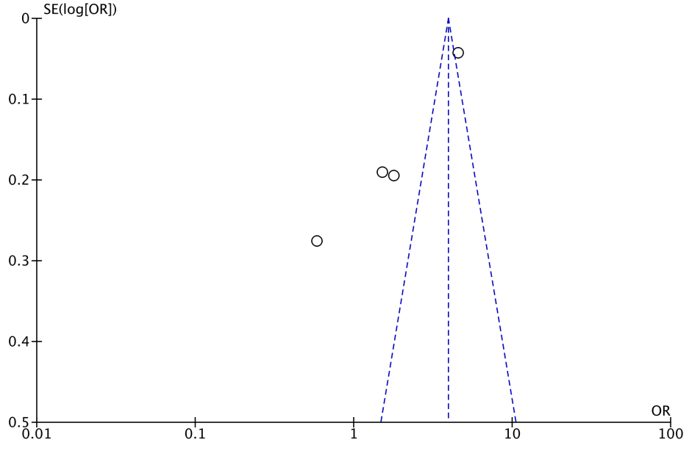
Supplemental figure S1. Funnel plot of the association between the risk of knee/hip arthroplasty and NSAIDs treatment in case control studies. P value of Egger’s test=0.183
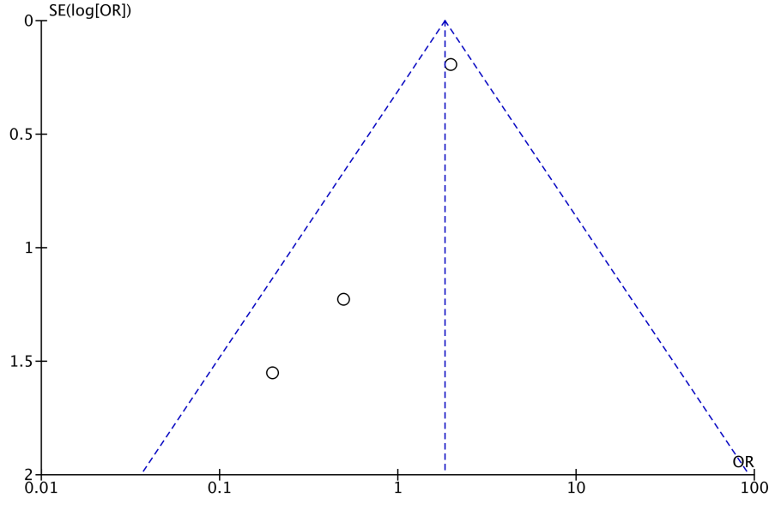
Supplemental figure S2. Funnel plot of the association between the risk of knee/hip arthroplasty and NSAIDs treatment in cohort studies.

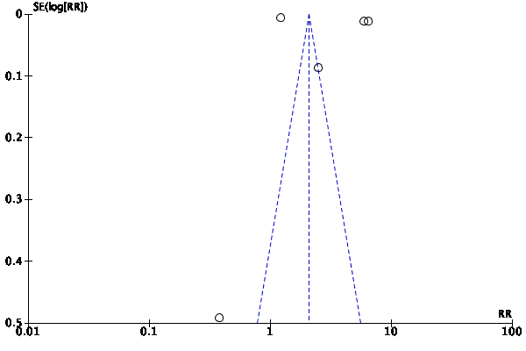
Supplemental figure S3. Funnel plot of the association between the risk of knee arthroplasty and HA treatment in cohort studies. P value of Egger’s test= 0.507

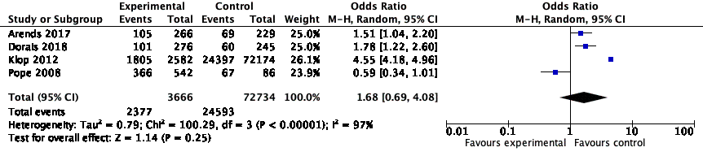
Supplemental figure S4. Forest plot of the association between the risk of hip/ knee arthroplasty and NSAIDs treatment in cast-control studies.
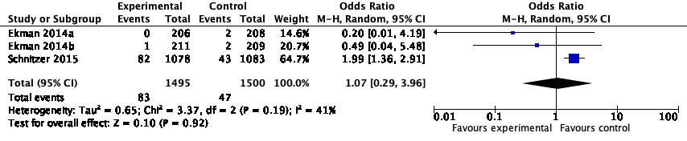
Supplemental figure S5. Forest plot of the association between the risk of hip/ knee arthroplasty and NSAIDs treatment in RCT studies.

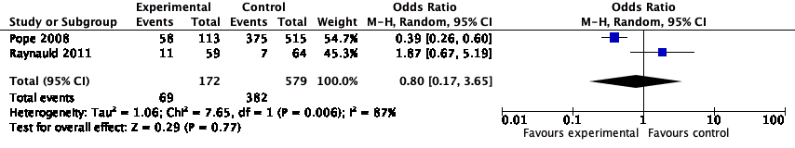
Supplemental figure S6. Forest plot of the association between the risk of hip/ knee arthroplasty and Naproxen treatment in case-control studies.

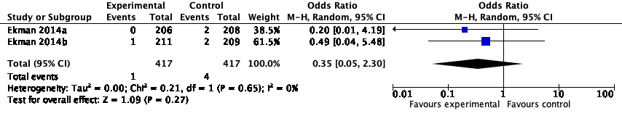
Supplemental figure S7. Forest plot of the association between the risk of hip/ knee arthroplasty and Naproxen treatment in RCT studies.

Search strategy
Search date June 11, 2019
OVID Medline and OVID EMbase
1 osteoarthritis.mp. or exp osteoarthritis/
2 arthrosis.mp.
3 osteoarthr$.mp.
4 (degenerative adj2 arthritis).mp.
5 gonarthrosis.mp.
6 coxarthrosis.mp.
7 or/1-6
8 viscosupplementation.mp. or exp Viscosupplementation/
9 hyaluronic acid.mp. or exp Hyaluronic Acid/
10 hyaluronan.mp.
11 hyaluronate.mp.
12 Hyalgan.mp.
13 Synvisc.mp.
14 Orthovisc.mp.
15 Artzal.mp.
16 Supartz.mp.
17 Suplasyn.mp.
18 BioHy.mp.
19 Euflexxa.mp.
20 Nuflexxa.mp.
21 Hylan GF-20.mp.
22 healonid.mp.
23 hylartil.mp.
24 nrd 101.mp.
25 adant.mp.
26 exp Triamcinolone Acetonide/ or exp Triamcinolone/ or triamcinolone.mp.
27 exp Betamethasone/ or betamethasone.mp.
28 corticosteroid.mp. or exp Adrenal Cortex Hormones/
29 glucocorticoid.mp. or exp Glucocorticoids/
30 hydroxycorticosteroid.mp. or exp Hydroxycorticosteroids/
31 corticoid.mp.
32 exp Ketosteroids/ or ketosteroid.mp.
33 androstenedione.mp. or exp Androstenedione/
34 cortivazol.mp.
35 exp Methylprednisolone/ or methylprenisolone.mp.
36 injections, intra-articular.mp. or exp Injections, Intra-Articular/
37 intraarticular inject$.tw.
38 intra-articular inject$.tw.
39 exp Acetaminophen/
40 ("Acetaminophen" or "paracetamol").mp.
41 Non-steroid anti-inflammatory drug
42 exp Anti-Inflammatory Agents, Non-Steroidal/
43 NSAIDs.mp.
44 cyclooxygenase.mp.
45 cox* inhibitor.mp.
46 *coxib/
47 Lodine.mp.
48 celecoxib.mp.
49 Celebrex.mp.
50 rofecoxib.mp.
51 Vioxx.mp.
52 meloxicam.mp.
53 Mobic.mp.
54 *Naprosyn/
55 Anaprox*.mp.
56 Naprapac Aleve.mp.
57 (Cataflam or Voltaren or Arthrotec or Pennsaid).mp.
58 lumiracoxib.mp.
59 etoricoxib.mp.
60 Motrin.mp.
61 Profen.mp.
62 Vicoprofen.mp.
63 Combunox.mp.
64 Advil.mp.
65 Dolobid.mp.
66 Nalfon.mp.
67 Ansaid.mp.
68 indometacin.mp.
69 Indocin.mp.
70 Indo-Lemmon.mp.
71 Indomethagan.mp.
72 Oruvail.mp.
73 Toradol.mp.
74 Mefenamic Acid.mp. or exp
75 Ponstel.mp.
76 Nabumetone.mp.
77 Relafen.mp.
78 Oxaprozin.mp.
79 Daypro.mp.
80 Piroxicam.mp. or exp Piroxicam/
81 Feldene.mp.
82 Sulindac.mp. or exp Sulindac/
83 Clinoril.mp.
84 Tolmetin.mp. or exp Tolmetin/
85 Tolectin.mp.
86 Valdecoxib.mp.
87 Bextra.mp.
88 Diacerein.mp.
89 Diacerhein.mp.
90 Rhein.mp.
91 Anthraquinones.mp. or exp Anthraquinones/
92 Diacetyilrhein.mp.
93 ART 50.mp.
94 Cyclooxygenase Inhibitors.mp. or exp Cyclooxygenase Inhibitors/
95 exp Cyclooxygenase 2 Inhibitors/ or exp Cyclooxygenase 2 Inhibitors/
96 exp Aspirin/ or Aspirin.mp.
97 naproxen.mp. or exp Naproxen/
98 Diclofenac.mp. or exp Diclofenac/
99 Ibuprofen.mp. or exp Ibuprofen/
100 Diflunisal.mp. or exp Diflunisal/
101 Fenoprofen.mp. or exp Fenoprofen/
102 Flurbiprofen.mp. or exp Flurbiprofen/
103 Indomethacin.mp. or exp Indomethacin/
104 Ketoprofen.mp. or exp Ketoprofen/
105 exp Ketorolac/ or Ketorolac.mp.
106 exp glucosamine/
107 glucosamine. rn, tw.
108 acetylglucosamine.tw, rn.
119 n-acetylglucosamine.tw.
110 n-acetyl-d-glucosamine.tw.
111 exp CHONDROITIN/
112 chondroitin.sh,rn,tw.
113 exp Diphosphonates/ or diphosphonates.mp. or exp bisphosphonate/ or bisphosphonate
114 (diphosphonate* or bisphosphonate*).mp.
115 exp etidronate/ or etidronate.mp.
116 exp alendronate/ or alendronate.mp.
117 exp pamidronate/ or pamidronate.mp.
118 exp clodronate/ or clodronate.mp.
119 exp tiludronate/ or tiludronate.mp.
120 olpadronate.mp.
121 incadronate.mp.
122 exp zoledronate/ or zolendronate.mp.
123 exp risedronate/ or risedronate.mp.
124 zolendronic acid.mp.
125 exp ibandronate/ or ibandronate.mp.
126 medronate.mp.
127 minodronate.mp.
128 neridronate.mp.
129 oxidronate.mp.
130 or/8-129
131 exp ARTHROPLASTY/
132 exp Joint Prosthesis/
133 exp “Prostheses and Orthoses”/
134 tka.tw.
135 (joint AND (replace$ or arthroplast$ or prosthe$ or endoprosthe$ or implant$)).tw.
136 or / 131-135
137 randomized controlled trial.pt.
138 controlled clinical trial.pt.
139 randomized.ab.
140 placebo.ab.
141 clinical trials as topic.sh.
142 randomly.ab.
143 trial.ti.
144 exp Cohort Studies/
145 cohort*.mp.
146 exp Case-Control Studies/
147 (case* and control*).mp.
148 (case* and series).mp.
149 exp cohort analysis/
150 retrospective study/
151 prospective study/
152 (case* and (control* or series)).mp.
153 follow up*.mp.
154 or / 137-153
155 7 and 130 and 136 and 154
156 limit 155 to human

