Table S1. The comparison of mean area, mean diameter, mean density and mean integrated optical density (IOD) of synovia immunohistochemistry in RA and OA patients.
 | OA patients (n=5) | RA patients (n=5) | p
Mean area | 1062.54±717.26 | 781.89±327.18 | 0.449
Mean density | 139.92±20.16 | 127.78±17.46 | 0.101
Mean diameter | 16.91±3.03 | 14.09±1.56 | 0.339
Mean IOD | 135729.61±91885.23 | 98617.62±47283.08 | 0.445
Note: IOD: integrated optical density; RA: rheumatoid arthritis; OA: osteoarthritis.

Table S2. The correlation of syndecn-4 concentration in SF with disease activity in 25 RA patients having SF samples.
 | r | p
TJC | 0.314 | 0.236
SJC | 0.456 | 0.076
PGA (0-100 mm) | 0.500 | 0.048
EGA (0-100 mm) | 0.505 | 0.046
HAQ-DI (0-3) | -0.200 | 0.800
ESR (mm/h) | 0.414 | 0.088
CRP (mg/L) | 0.554 | 0.014
DAS28-ESR | 0.582 | 0.023
DAS28-CRP | 0.565 | 0.023
SDAI | 0.515 | 0.041
CDAI | 0.378 | 0.149
Note: SF: synovial fluid; RA: rheumatoid arthritis; RF: rheumatoid factor; anti-CCP: anti-cyclic citrullinated protein; TJC: tender joint count; SJC: swollen joint count; PGA: patient global assessment; EGA: evaluator global assessment; HAQ-DI: Health Assessment Questionnaire-Disability Index; ESR: erythrocyte sedimentation rate; CRP: C-reactive protein; DAS: disease activity score; SDAI: simple disease activity index; CDAI: clinical disease activity index.
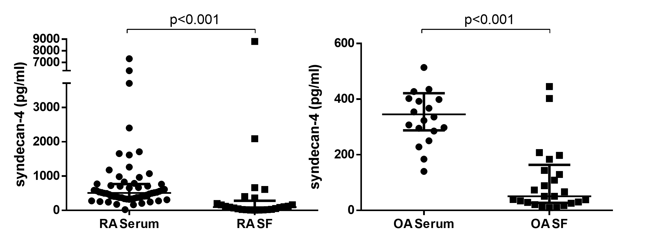Figure S1. The comparison of syndencan-4 concentrations in serum and SF samples from RA patients and OA patients. RA: rheumatoid arthritis; OA: osteoarthriits; SF: synovial fluid.

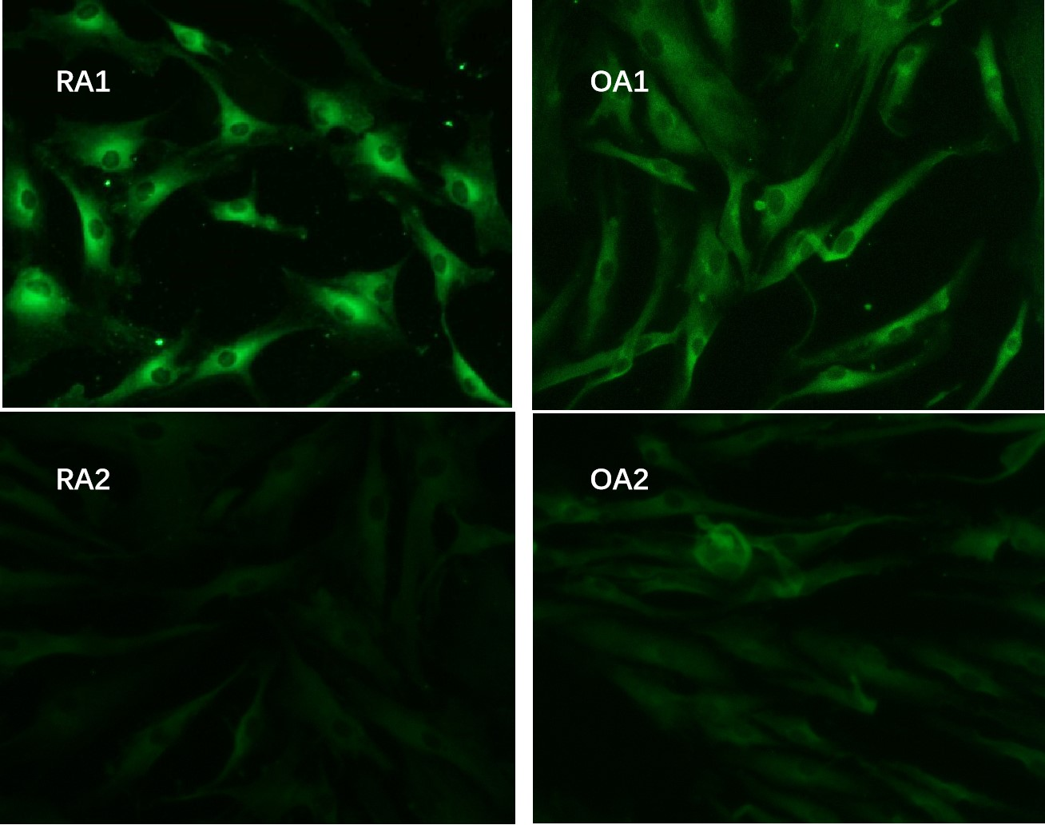
Figure S2. Immunofluorescence: Syndecan-4 can be expressed in the cultured synovial fibroblast of RA and OA patients. The fluorescence intensity was similar between RA and OA patients.RA: rheumatoid arthritis; OA: osteoarthritis.
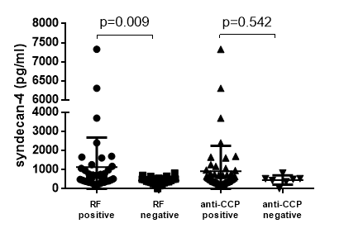
Figure S3. The comparison of serum syndecan-4 between sera-positive and sera-negative RA patients. RA: rheumatoid arthritis. RF: rheumatoid factor; anti-CCP: anti-cyclic citrullinated peptide.

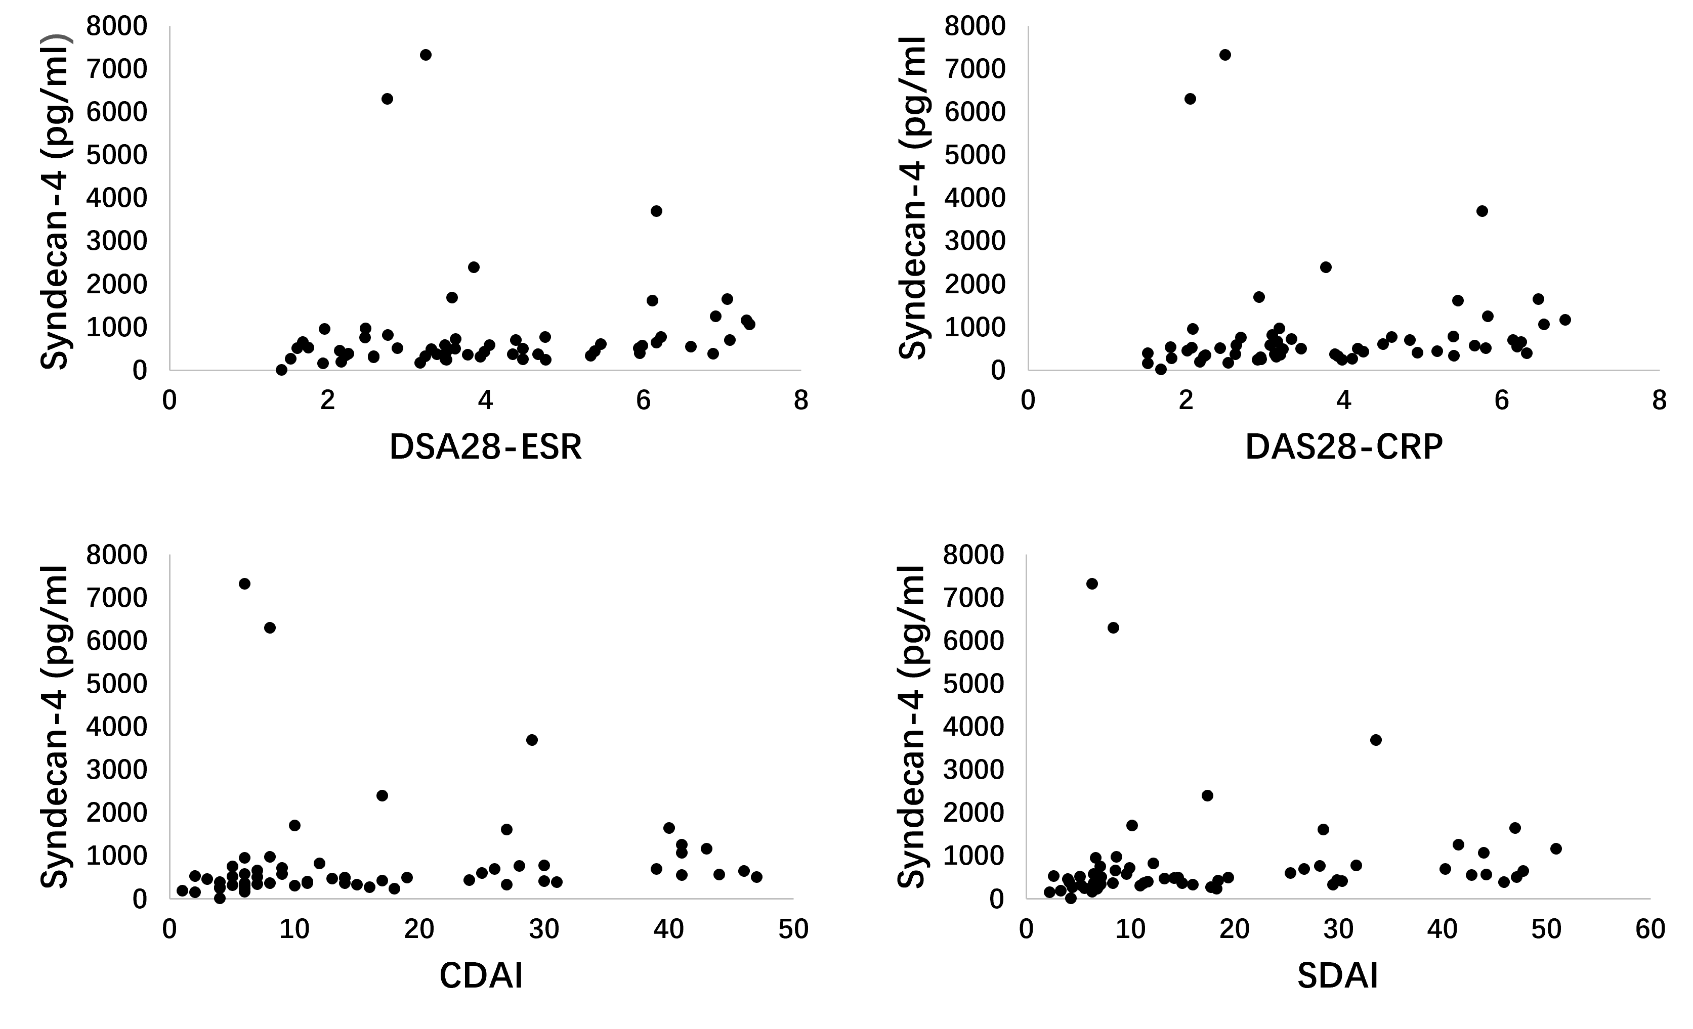
Figure S4. plotted correlation graphs of serum syndecn-4 concentration with disease activity in 60 RA patients. DAS: disease activity; SDAI: simplified disease activity index; CDAI: clinical disease activity index.

