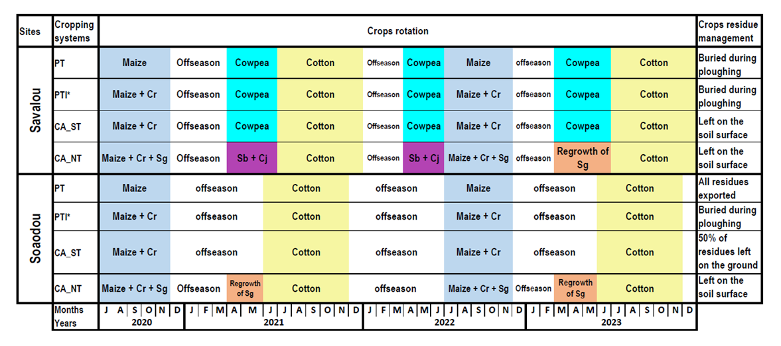
Fig. S1 Land use, crop rotation in four cotton-based cropping systems in the 4 years experimental period.
“+” indicates crops planted in association (at the same or staggered sowing dates); Cr= Crotalaria retusa; Cj= Crotalaria juncea; Sb: Sorghum bicolor; Sg= Stylosanthes guianensis. PT=Plough based Tillage; PTI= Plough based Tillage with biomass Incorporation; CA_ST= Conservation Agriculture with Strip Tillage; CA_NT= Conservation Agriculture with No Tillage. * Application of calcium phosphate amendment of formula 22% P₂O₅, 43% CaO, 4% S at 300 kg·hm⁻² in 2020.

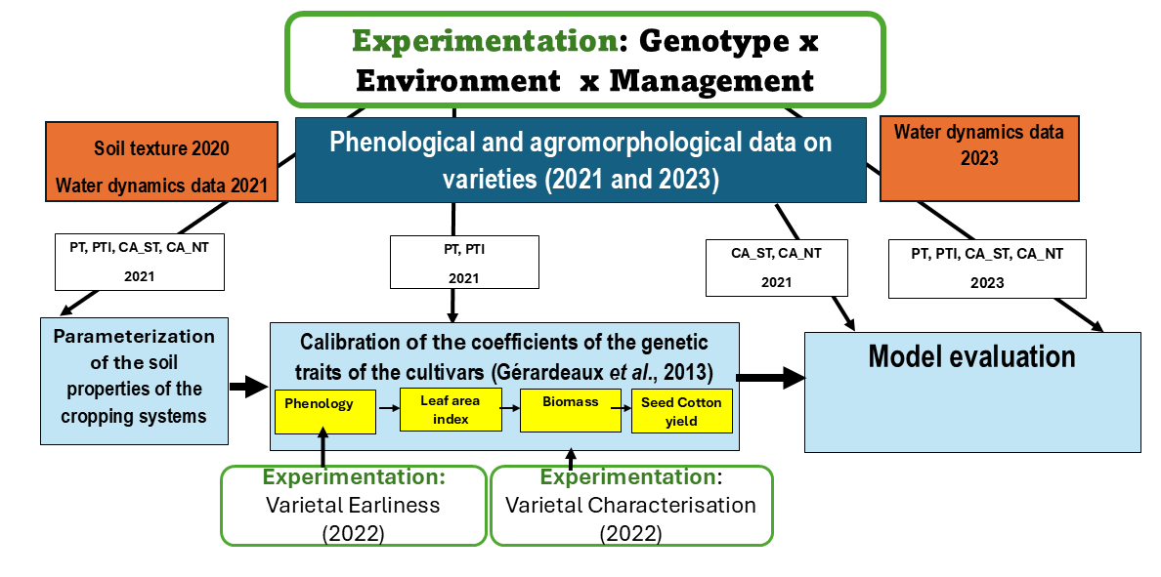
Fig. S2 Model calibration and evaluation using CROPGRO-COTTON
PT=Plough based Tillage; PTI= Plough based Tillage with biomass Incorporation; CA_ST= Conservation Agriculture with Strip Tillage; CA_NT= Conservation Agriculture with No Tillage.

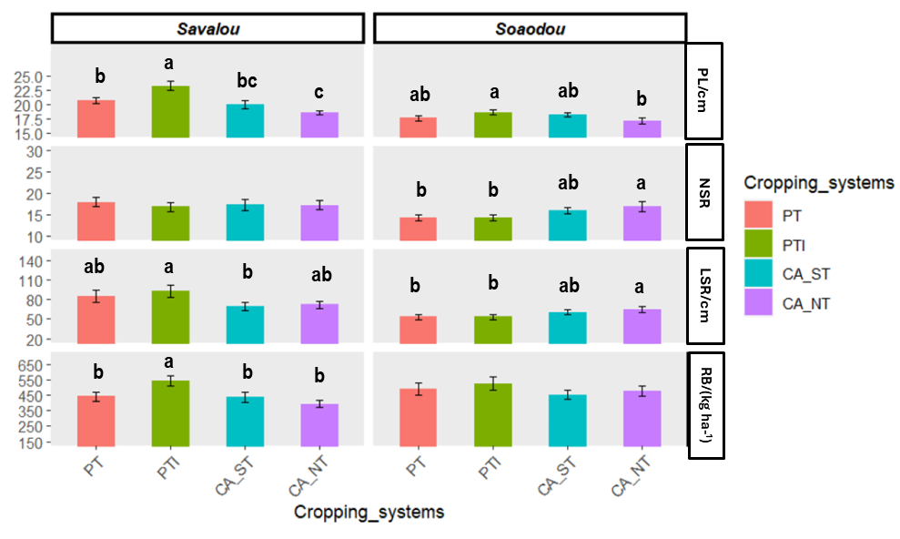
Fig. S3 Results of root measurements at 90 DAP in the different cropping systems
PL= pivot length; NRS= number of secondary roots; LSR= length of secondary roots; RB= root biomass. Values with the same lowercase letter do not differ significantly between cropping systems at P < 0.05. PT=Plough based Tillage; PTI= Plough based Tillage with biomass Incorporation; CA_ST= Conservation Agriculture with Strip Tillage; CA_NT= Conservation Agriculture with No Tillage.

