Electronic supplementary materials to the paper “Fire interval and post-fire climate effects on serotinous forest resilience”

Michelle C. Agne*, Joseph B. Fontaine, Neal J. Enright, Brian J. Harvey
*Corresponding author, USDA Forest Service Pacific Northwest Research Station, Olympia, (Washington), USA, email: Michelle.Agne@usda.gov

Submitted to Fire Ecology

Additional file 1 Extended results from our study in post-fire knobcone pine forests in Oregon and California, USA.

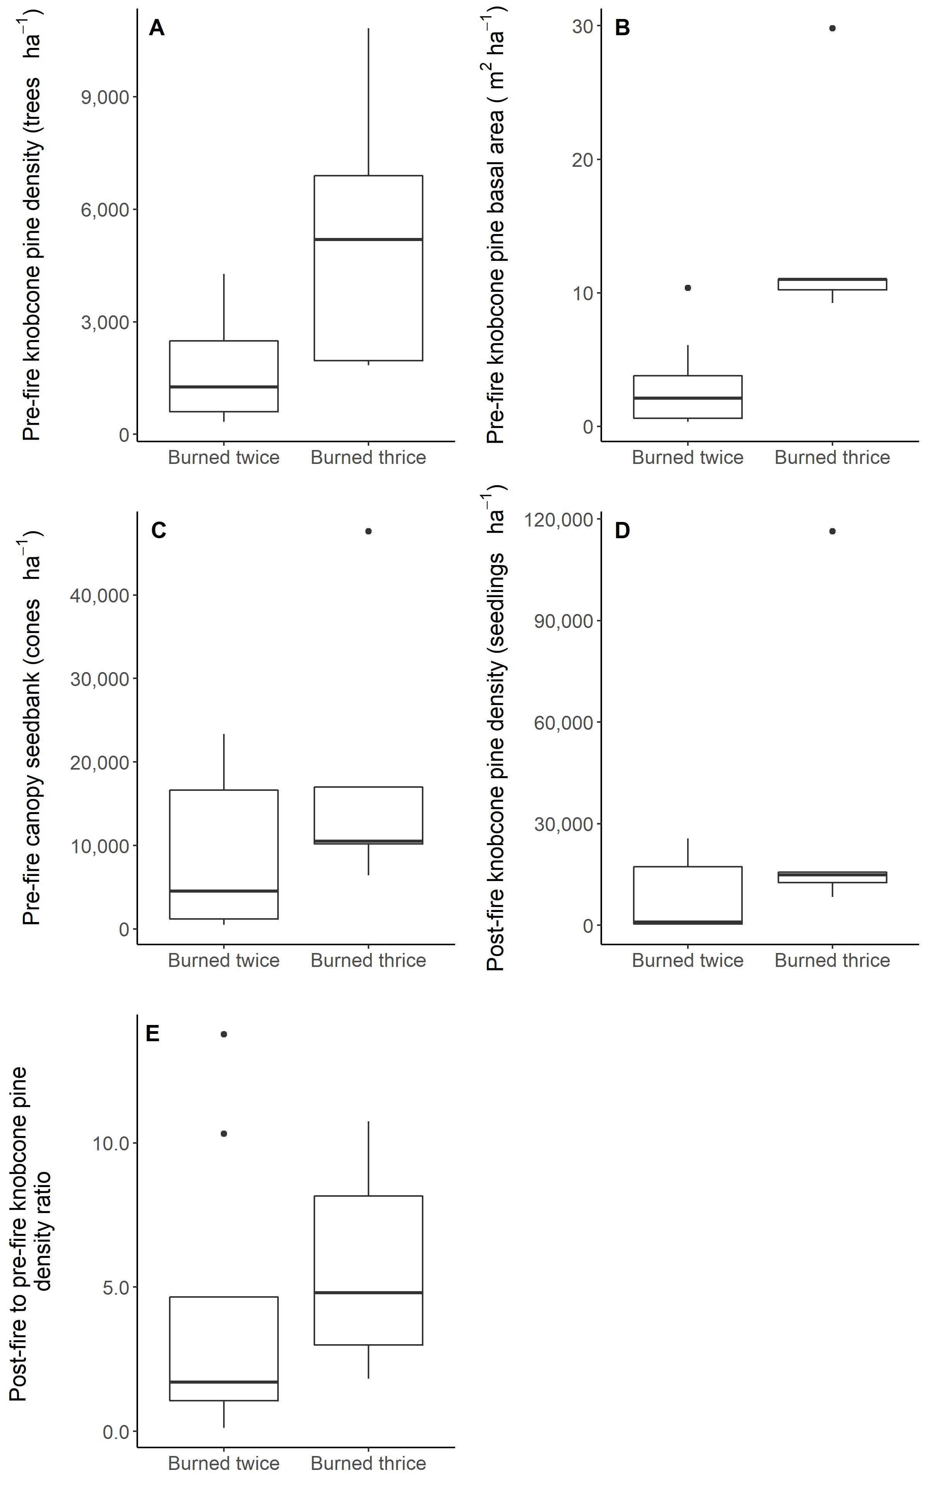
Fig. 1.1. Comparison of pre-fire structure and post-fire regeneration at plots reburned on a 16-year fire interval with no previous recorded fire history (burned in 2002 and 2018; Burned twice) and that experienced stand-replacing fire 15 years prior (burned in 1987, 2002, and 2018; Burned thrice).

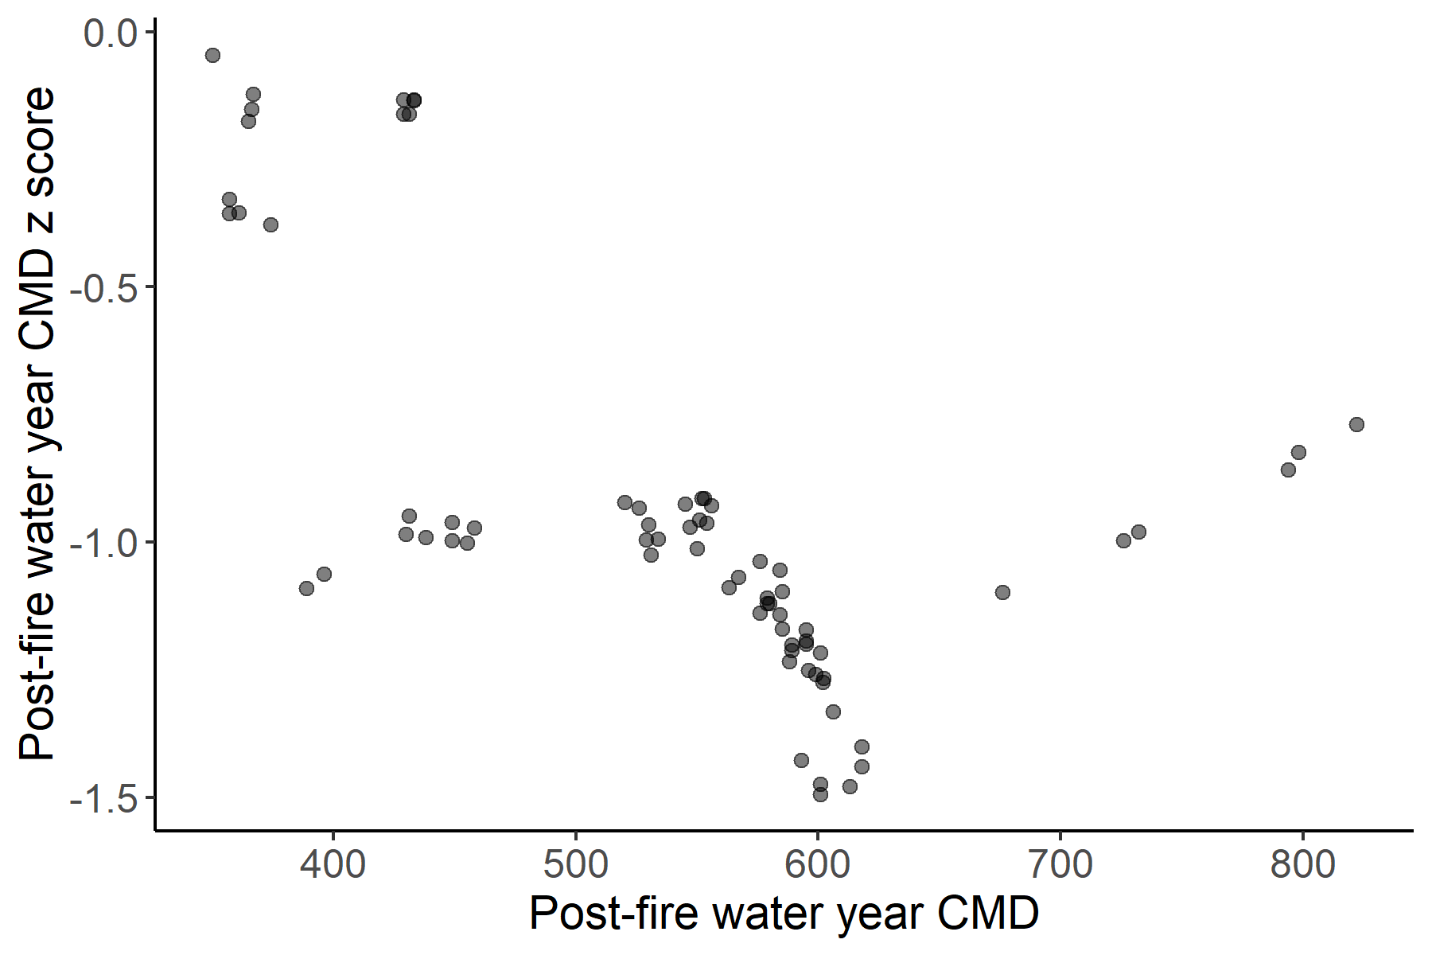
Fig. 1.2. Post-fire water year (October 2018-September 2019) climatic moisture deficit (CMD) versus post-fire water year CMD z score of the mean CMD of the 1981-2010 normal (post-fire relative CMD). While all plots experienced a lower post-fire CMD (cooler and wetter post-fire year) than the 30-year normal, the plots with the lowest post-fire water year CMD had CMD z scores with the lowest deviation from the normal. That is, the sites with the coolest and wettest post-fire year also experienced the least increase in moisture/decrease in moisture deficit as compared to the long-term average for the site.
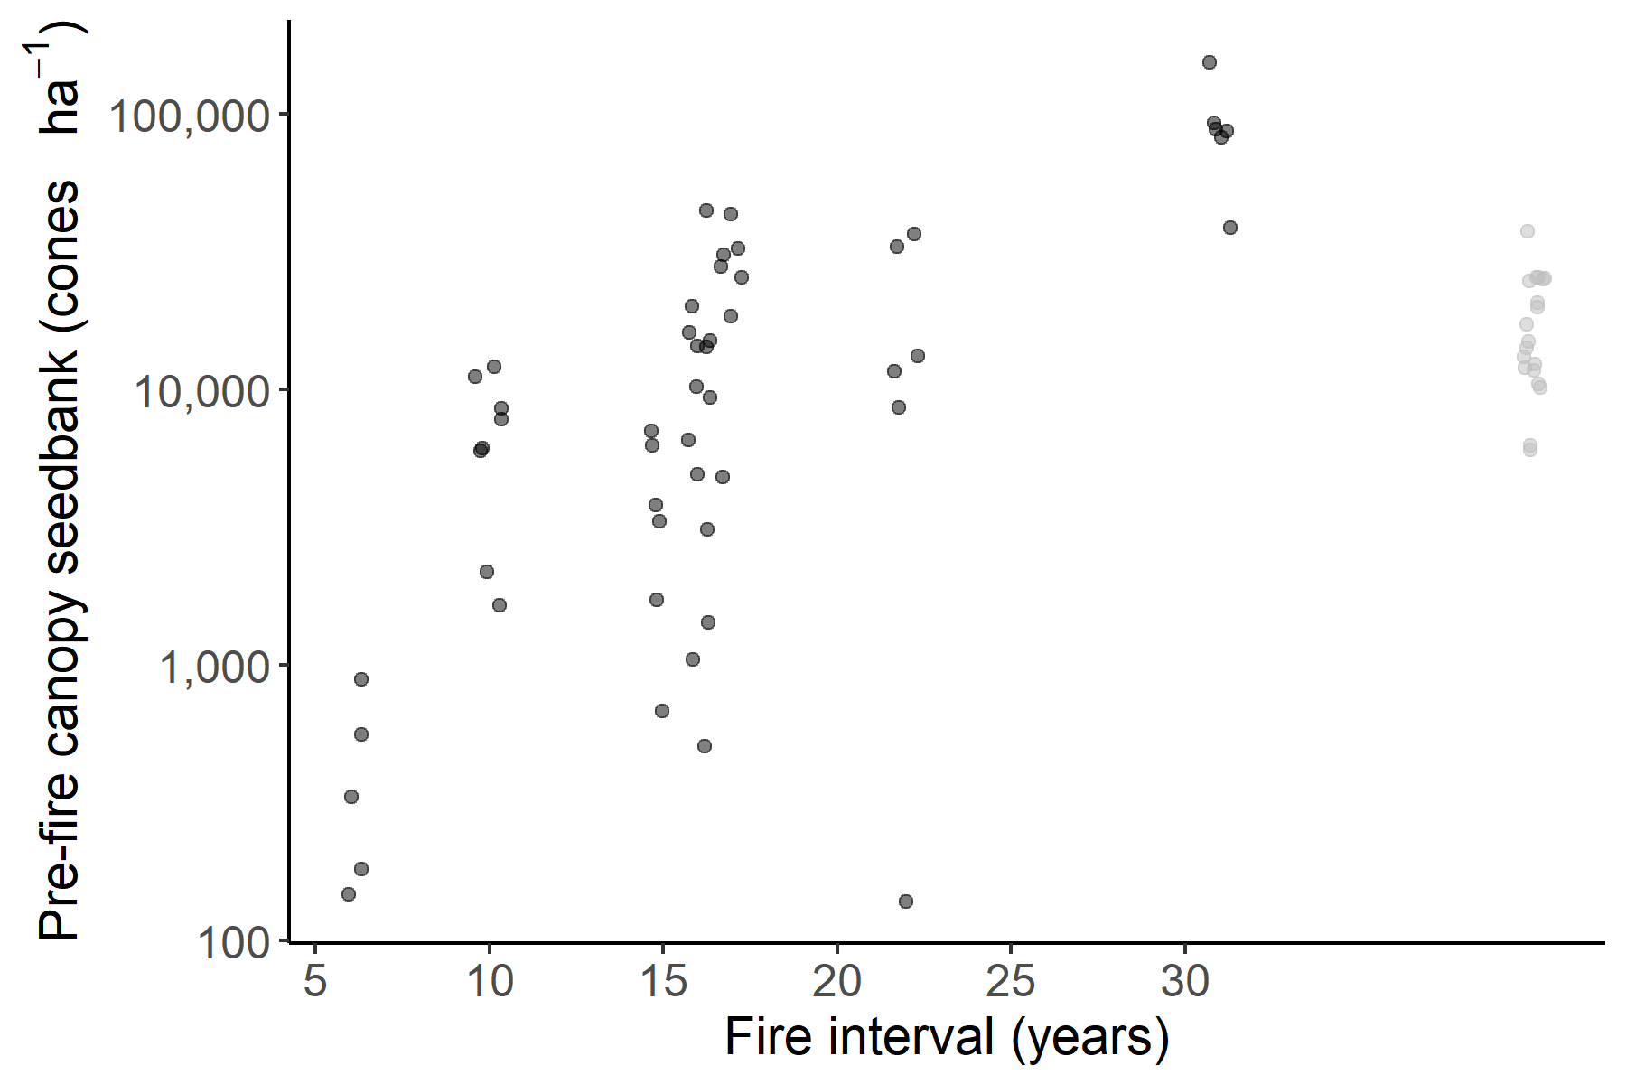
Long
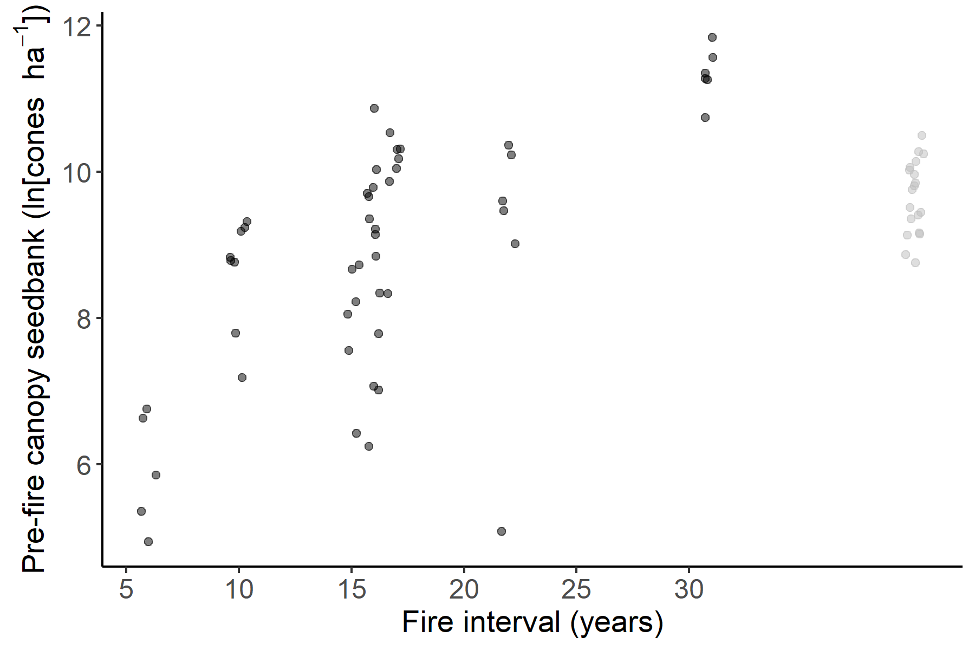
Long
Fig. 1.3. Fire interval versus pre-fire canopy seedbank in cones ha⁻¹ (top) and ln(cones ha⁻¹) (bottom). Pearson correlation coefficient = 0.67. Points from long interval plots with unknown past fire history are included for reference.

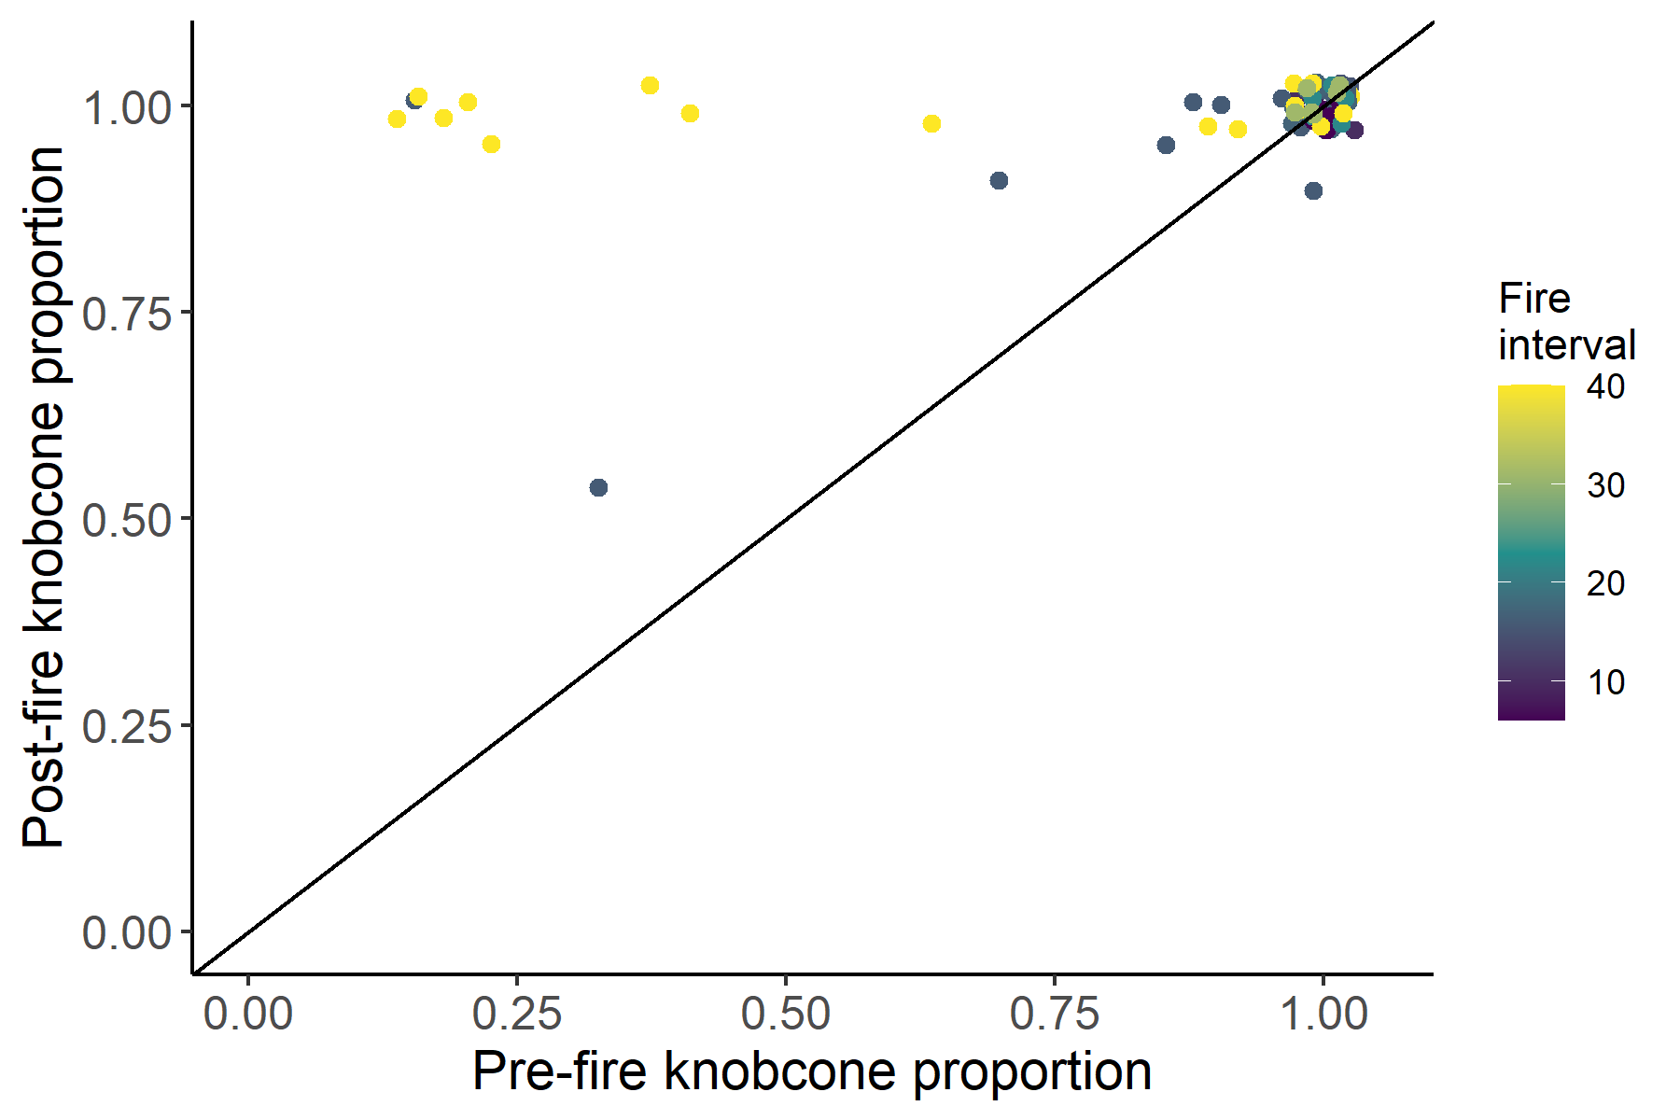
Long
Fig. 1.4. Pre-fire knobcone pine proportion of pre-fire conifer stems versus post-fire knobcone pine proportion of post-fire conifer seedlings colored by fire interval. Points above the diagonal line increased with respect to knobcone pine proportion while points below the diagonal line decreased with respect to knobcone pine proportion. In most plots, post-fire knobcone pine proportion neared 100%. Many long interval plots increased substantially with respect to knobcone pine proportion.

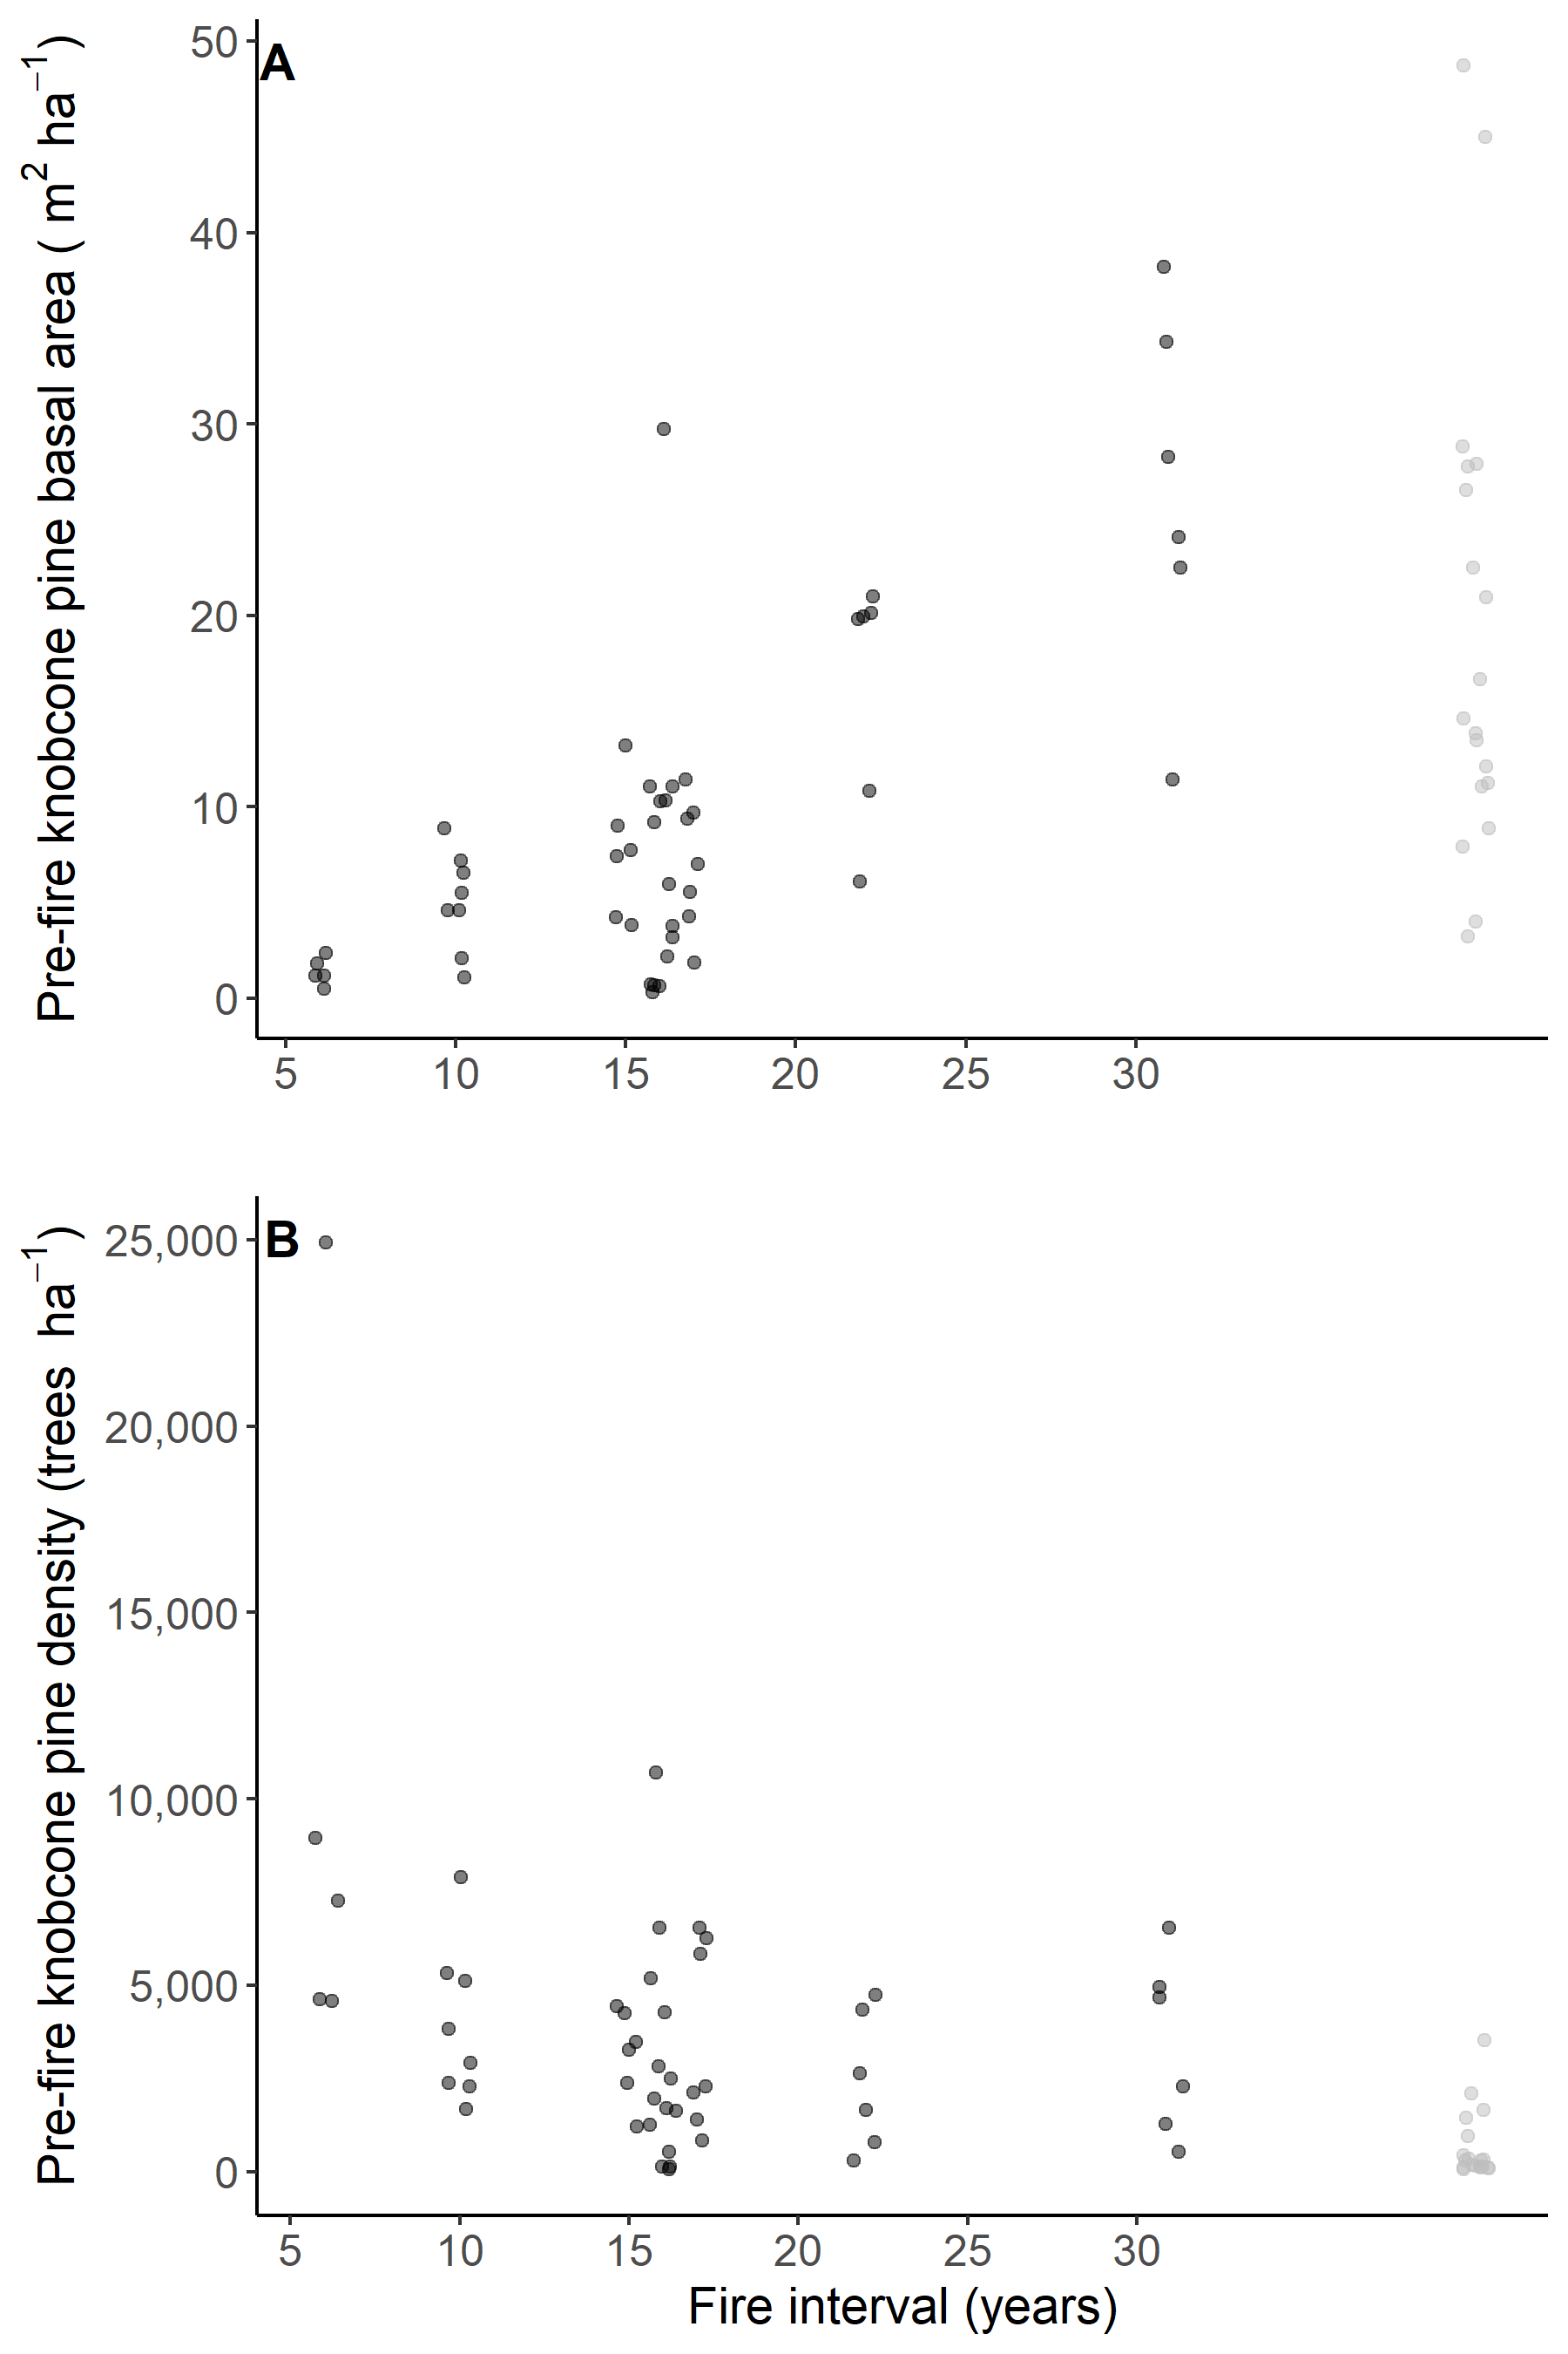
Long
Long
Fig. 1.5. Scatterplot of pre-fire knobcone pine by A) basal area and B) density versus fire interval. Pre-fire basal area increases with fire interval (Pearson correlation coefficient = 0.75) while stand density decreases with increasing fire interval (Pearson correlation coefficient = -0.31). although variation within fire interval appears to meet or exceed the variation among fire intervals for both metrics.
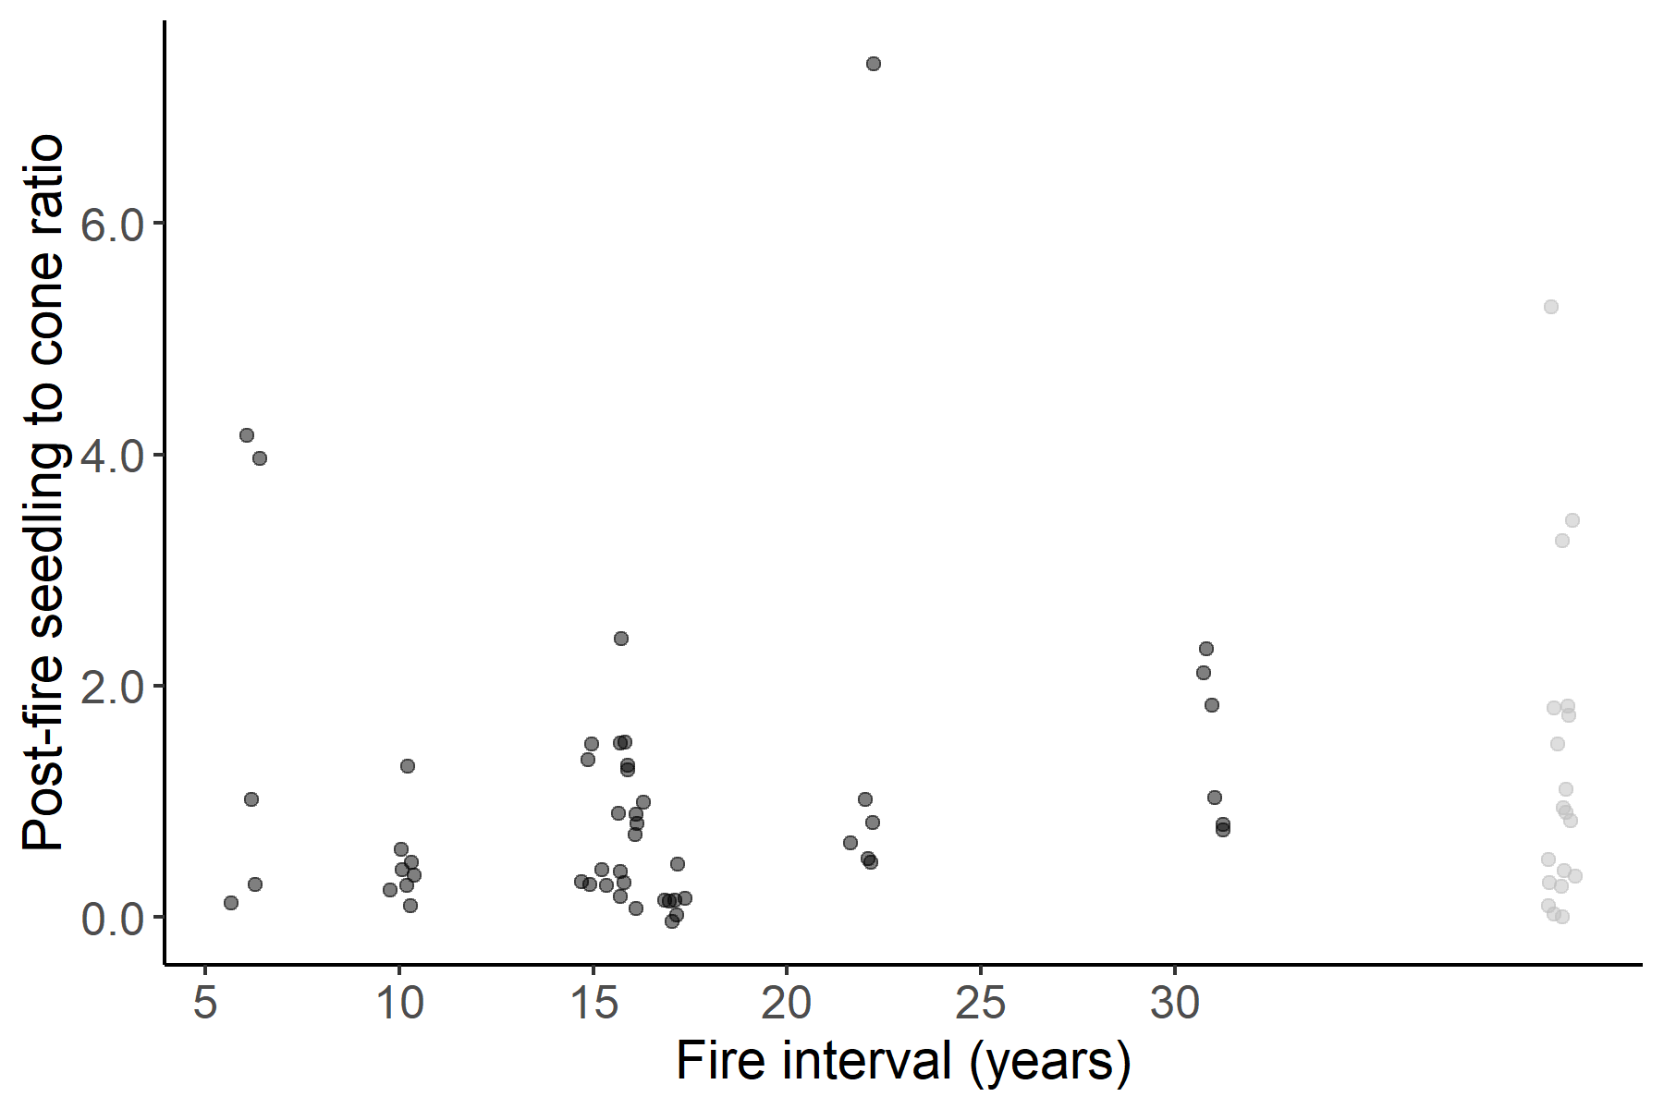
Long
Fig. 1.6. Scatterplot of post-fire seedling to pre-fire cone ratio by fire interval. Values range from 0.05 – 7.5 post-fire seedlings per pre-fire cone (median = 0.7, mean = 1.1). Most plots (95%) fell between 0.05 – 3.3 post-fire seedlings per pre-fire cone, suggesting that values above 4.0 may represent areas with an adjacent seed source not represented by the plot measurement.

