Additional file 1
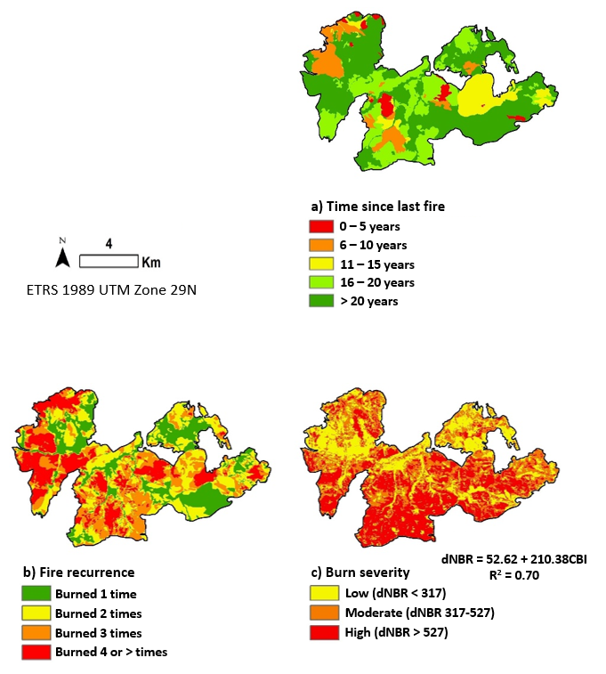
Fig. 1.1 Maps of the fire perimeter showing: (a) time since last fire, (b) fire recurrence, and (c) burn severity (Fernández-García et al. 2019d)

