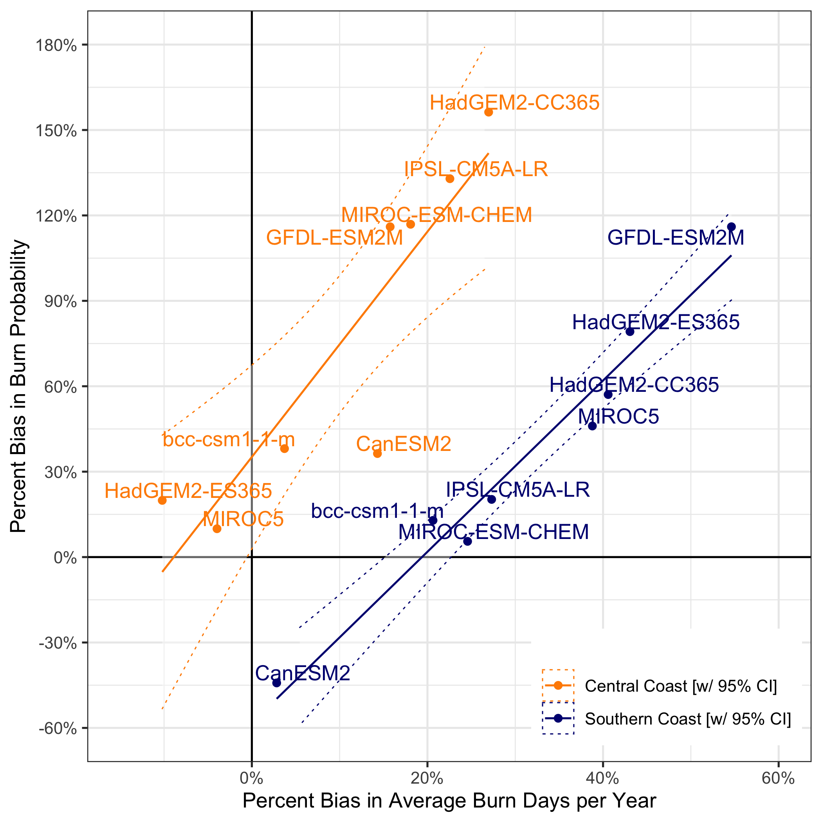
Appendix 4. Scatterplot showing the positive relationship between historical bias in burn days and historical bias in burn probability, where bias is defined as the difference between each historical GCM and the baseline gridMET over the 1979–2005 period.

